­

“Don't cry because it's over, smile because it happened..”

# Payments

Mail your checks to “Toppers Dan­ce Club” with dinner selections and seating requests on the checks by **October 12th** to:

Craig Colby

13047 San Jacinto Street

LA Mirada, Ca 90638

Please note seating desires with your check. We will attempt to satisfy them.

President’s Message…

We welcomed everybody back from our annual summer break and we had a good turnout at The Grand in Long Beach. Although I had to be out of town, the word is everybody had a wonderful time.

We reported that the Christmas Dance (Mistletoe Ball) might be cancelled but do to the great efforts of the Kuhn’s and Woolston’s who found and visited the venue in my absence.

I have booked the Carson Events Center for December 20th for our annual Mistletoe Ball. It’s just a few miles north of us directly off the 405 freeway. Please invite guests to celebrate the holidays with us. More details to follow!

See you on the 18th of October! We will have a spooky good time since Halloween is just around the corner!

Craig

Looking forward to seeing you all on the 15th.💕

Craig

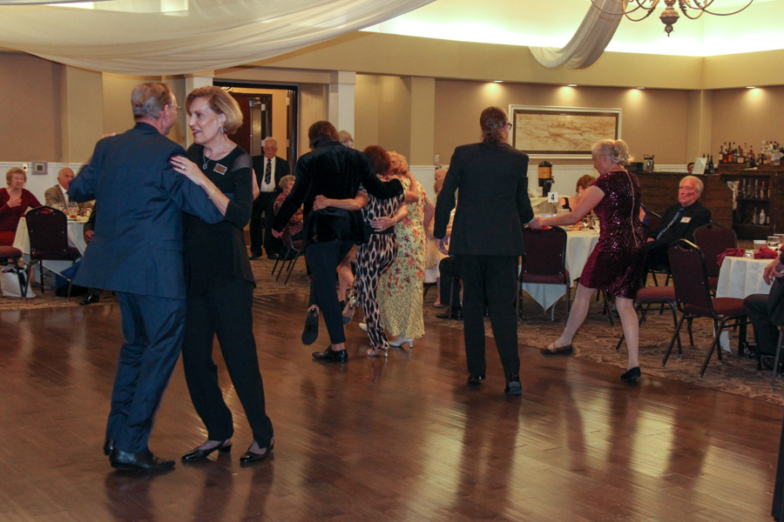

Dancing the night away

Autumn Is Here! Holiday Season Ahead!

Goodbye

# What You Need To Know

The October 18th dance is at the Long Beach Grand and featuring Tony Carinino. The cost is $120/couple (includes tax/tip).

No-host cocktail time is 6 pm & great dance music until 10 pm.

**Dress code is Semi-Formal** (Men, Dark Suits or Sports Coats. Ladies, cocktail attire.)

Toppers Dinner Menu

Main Entree:

**Beef Brisket**: Fork Tender Roasted Beef Brisket with Natural Jus OR

**Mahi Mahi**: Grilled with Topical Salsa OR

**Chefs Selected Vegetarian**.

Salad: Orzo (Pasta) - Cherry Tomatoes, Kalamata Olives, Capers, Grilled Asparagus & Homemade Pesto

Starch: Roasted Garlic Mashed Potatoes

Vegetable: Grilled Zuchinni

Dessert: Tuxedo Trifle Mousse Cake

**Bits and Pieces**

Del Kuhn celebrated his 94th birthday with friends and then headed to see Dionne Warwick at the Cerritos Performing Arts Center!

The Slater’s will be continuing their sabbatical in Europe and we will be missing them!

Bernie Myers celebrated his 98th birthday by dancing every day during his birthday week, At 98, it should be a birthday month!

The Liles’ have made arrangements for a New Years Eve party at Old Ranch Country Club. Like the previous years, they will have a nine-piece orchestra playing wonderful dance music and the evening will include a super buffet and special activities. Interested? Email Paul & Sue for details!

The Zaitz headed to northern California for several days. Ask then about their “train ride” through the forest! Bob has pictures!

**Our Last Dance**

**The Mistletoe Ball Was Saved …Arrangements Are Finalized… We Are On!!!**

The Mistletoe Ball is on for the 20th of December at the Carson Event Center. It is located just of the 405 freeway at Carson and is a very nice venue. As usual, it will be our first formal of the season and we hope everybody brings a new couple to celebrate the season!   
  
Thanks to efforts by the Kuhn’s and Woolston’s for researching, reviewing, and visiting the venue. Craig just made the final arrangements this week and the “Venue Grinch” did not ruin Christmas!

# Want To Know What To Do With A Pumpkin?

Our own Jan Mongel published a “Pumpkin Cookbook” several years ago and it is loaded with interesting receipts! Ask Jan and she will dish up pumpkin appetizers, main courses, soups, salads and of course pumpkin desserts!

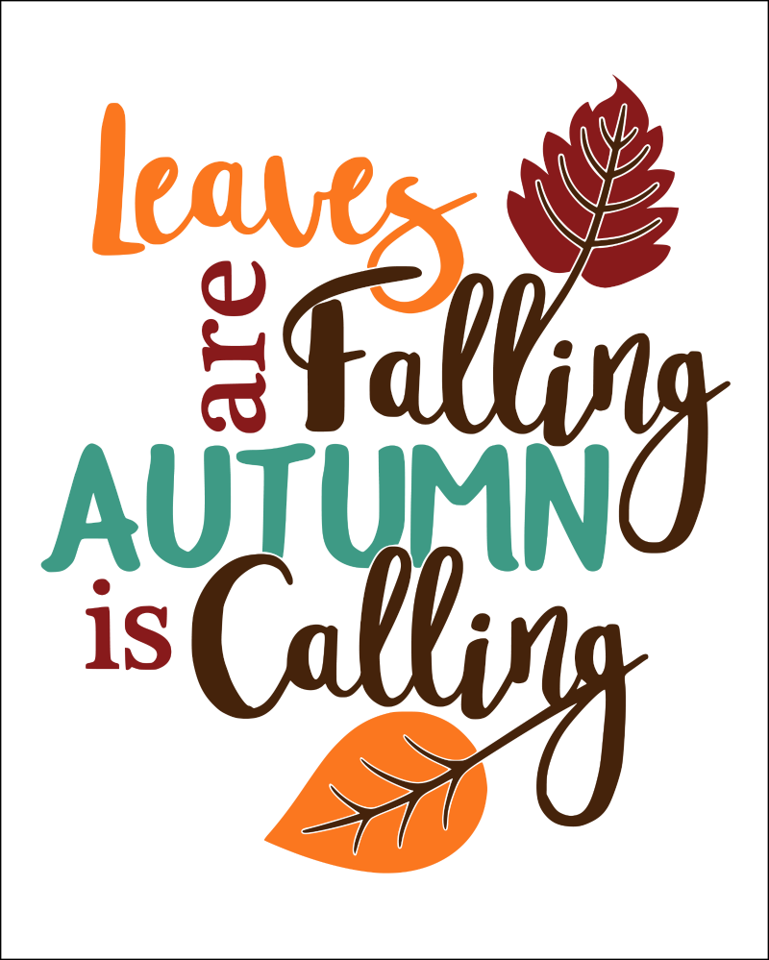

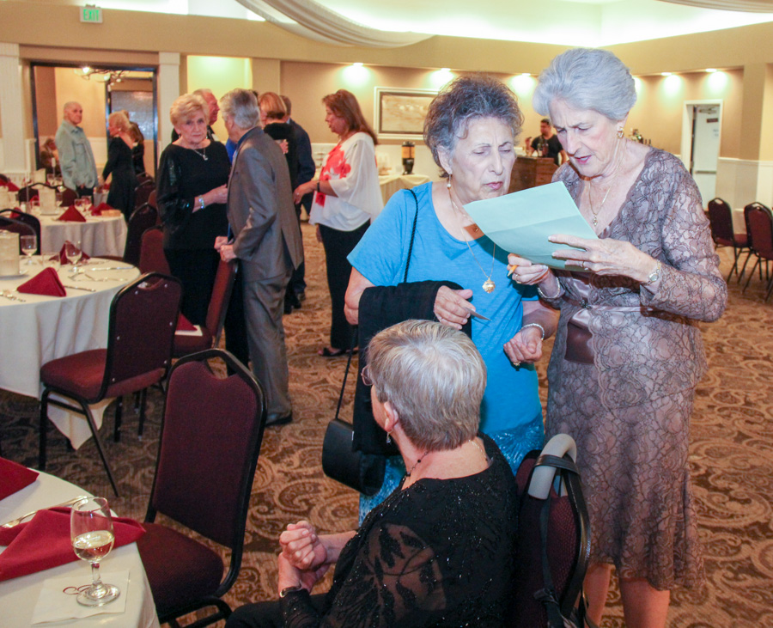

Arriving and check in!

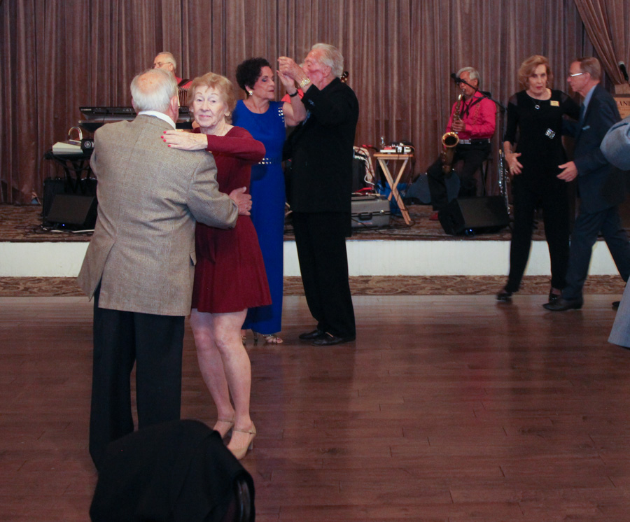

Bernie celebrates his 98th birthday

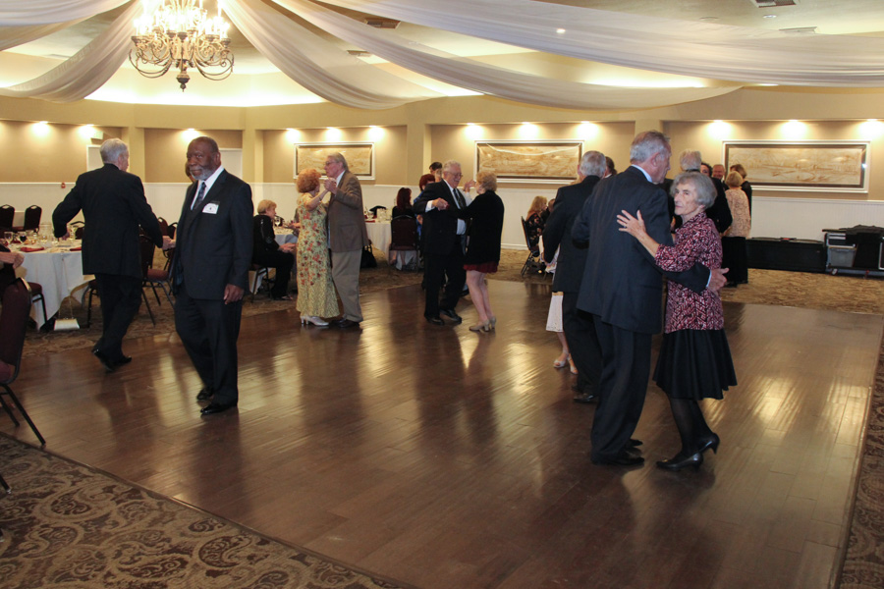

All dance!

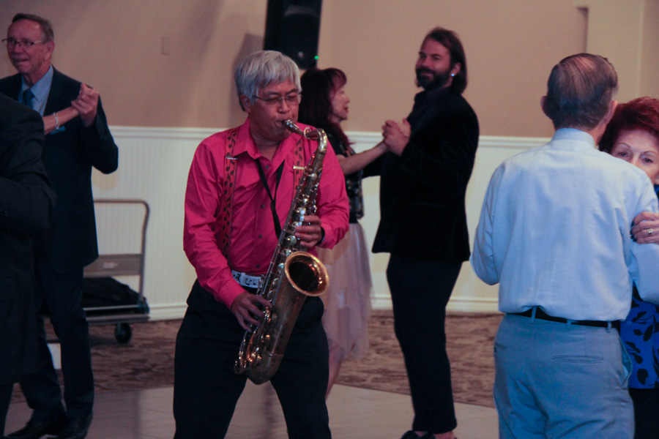  
Tony brings the music to us!

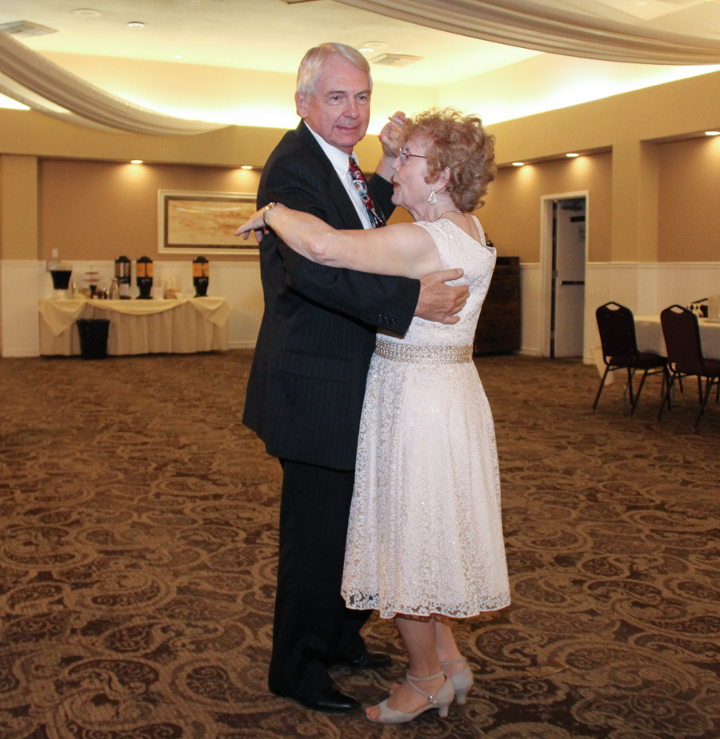

And if the dance floor is full…  
We off road!

Ten Step Polka Anyone?

ccasion!

# Upcoming Dance Schedule

We have a busy season coming up and we will be confirming the dates and bands again with you during the summer “vacation”!

Remember, we will be at The Grand in Long Beach for October and November 2019. December at the Carson Events Center.

11/15/2019 – Tropic Star

12/20/2019 – Time Machine

**YOUR BOARD**

President Craig Colby

Vice President Lucky Harrington

Secretary Sandy Slater

Treasurer Diane Schmitz

Hospitality Neil/Nita Woolston

Membership Vicky Kuhn

Roster Donnis Weygandt

Newsletter Paul/Sue Liles