­

# Payments

Mail your checks to “Toppers Dan­ce Club” with dinner selections and seating requests on the **checks by September 10th** to:

Diane Schmitz

3475 Lilly Avenue

Long Beach Ca 90808-3214

Please note seating desires with your check. We will attempt to satisfy them.

President’s Message…

Welcome Toppers, hope you are all well, had a great summer. I would like to thank you all for the great turnout we had in April and May at The Grand in Long Beach.

Regretfully, I must inform you, that despite my best efforts (and the efforts of the other board members), I have been unable to find a suitable venue for our December dinner dance for this year.

I have booked The Grand again for our September, October and November dances, and am working out a contract with them for all nine of our dances in 2020.

Sorry I will miss you on the 20th, hope you have a wonderful time, and eager to see you again in October.

If you have an idea about the Christmas dance, you can email me at [cchemist@ca.rr.com](mailto:cchemist@ca.rr.com).

Craig

Looking forward to seeing you all on the 15th.💕

Craig

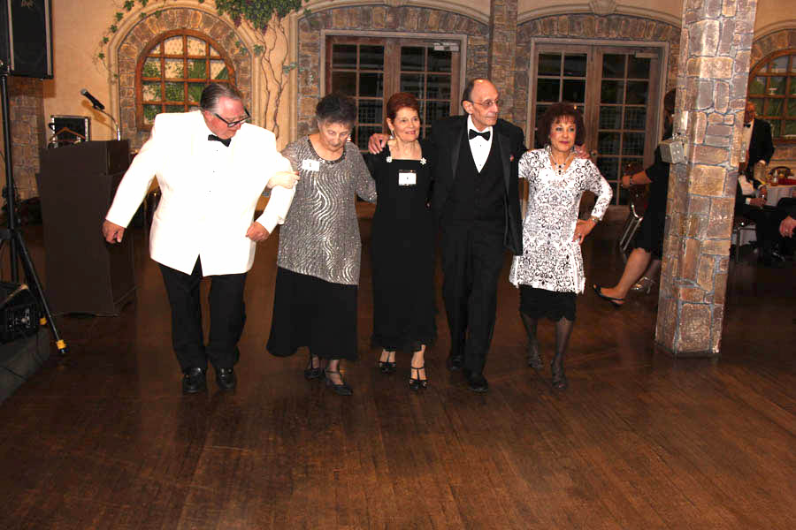

A little Ten Step Polka

“I think it’s wrong that only one company makes the game Monopoly.”

Welcome Back! How Was Your Summer?

Goodbye

# What You Need To Know

The September 20th dance is at the Long Beach Grand and featuring Jim Gilman. The cost is $120/couple (includes tax/tip).

No-host cocktail time is 6 pm & great dance music until 10 pm.

**Dress code is Semi-Formal** (Men, Dark Suits or Sports Coats. Ladies, cocktail attire.)

Toppers Dinner Menu

**Salad:** Spinach Smoked Bacon, Mushrooms, Goat Cheese, & Caramel Onion Bacon Vinaigrette

**Starch/Vegetables:** Wild Rice Pilaf and Spicy Green Beans

**Entrées**

1) Lemon Rosemary Chicken -Bone-in Chicken Breast with Lemon Caper Beure Blanc **OR**

2) Asian Inspired Salmon

Shitake Mushrooms, Bok Choy, & Sweet Soy Reduction **OR**  
3) Chef’s Selected Vegetarian

**Dessert:** Individual Fruit Tarts

**Bits and Pieces**

Irene Kosmetatos spent two weeks in Portland with her daughter so she has had enough rain for a while.

The Liles’, Roberts’ and Zaitz recently visited Temecula to sample the fruit of the vine and found there is a lot of dancing on the weekends at the various wineries. The dances range from Ball Room to Hip-Hop but a least it is dancing!

The Slater’s will be continuing their sabbatical in Europe and we will be missing them! Perhaps they will come back with some new steps for us to try?

Anyone interested in sharing 500 piece jigsaw puzzles. Several of us have begun doing puzzles to keep the ol’ grey matter alive and well. We heard that Paul Liles is selling Exacto Knives for those pesky small pieces that don’t quite fit!

**Snaps From   
Our Last Dance**

**The Dance Season Begins**

72 years ago a group said “Let’s get together and have a dinner dance.” and here we are 72 years later doing the same thing!

**The Mistletoe Ball Arrangements Are Still Being Studied…**

We have no arrangements for December 2019 but we are working hard to finalize the plans. Any Ideas? Let us know!

# The Santa Ana Elks HAs Reopened With A Brand New Lodge

The new lodge is opened and has Sunday afternoon dancing once a month. IF you are interested, contact Paul or Sue Liles for additional information.

# Line Dancing Gets Sophisticated

We have seen recent line dances that use waltz and rhumba music as the beat and the folks look pretty good. Maybe we should find out a little more about these new dance steps?

# Leroy May Join Us!

We have extended an invite to Leroy Freddrick’s and his wife to join us! We hope he can come back and visit everybody!

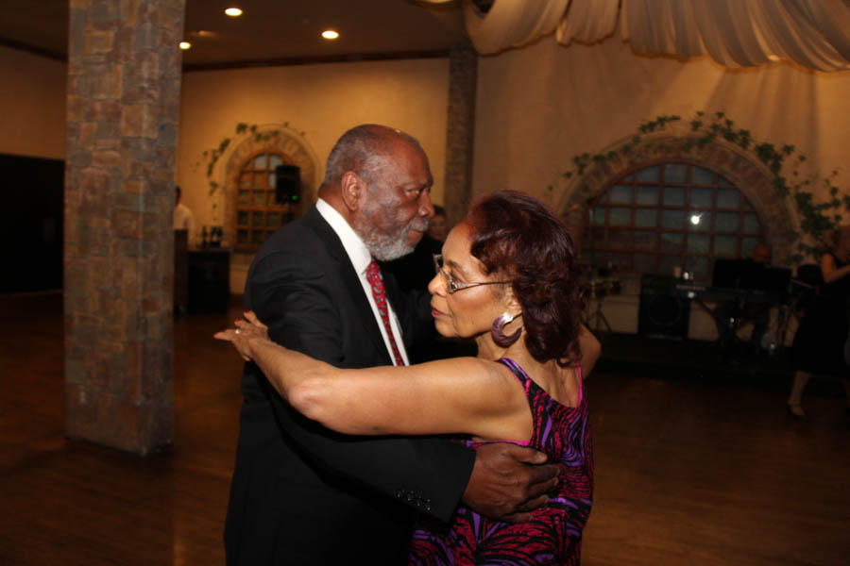

Dancing The Night Away

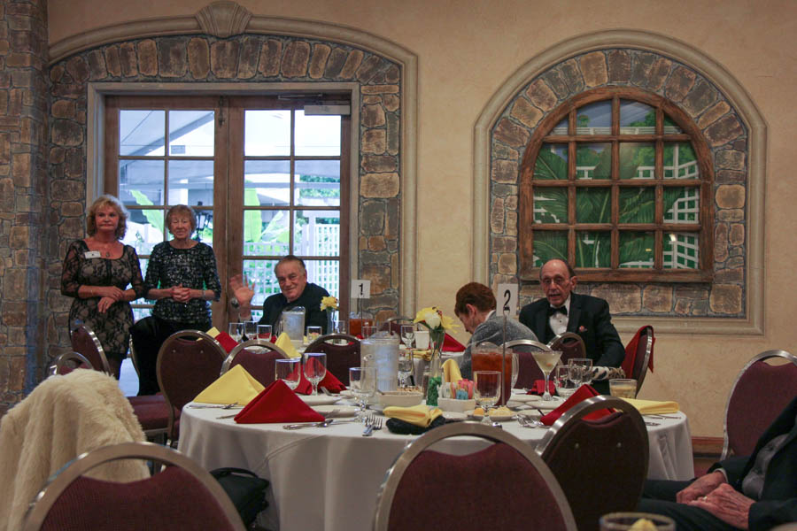

Dinner Is Served!

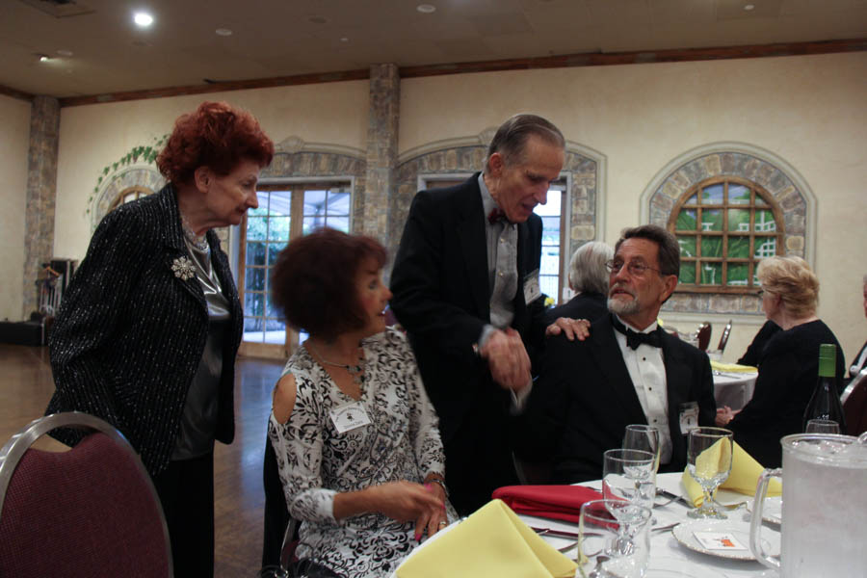

Visiting!

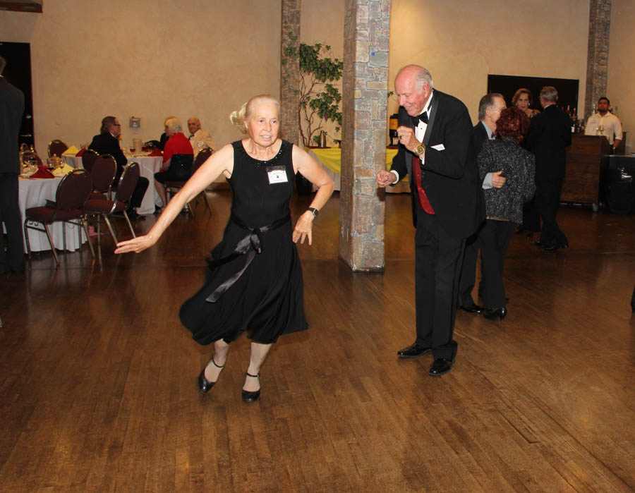

Whooping It Up

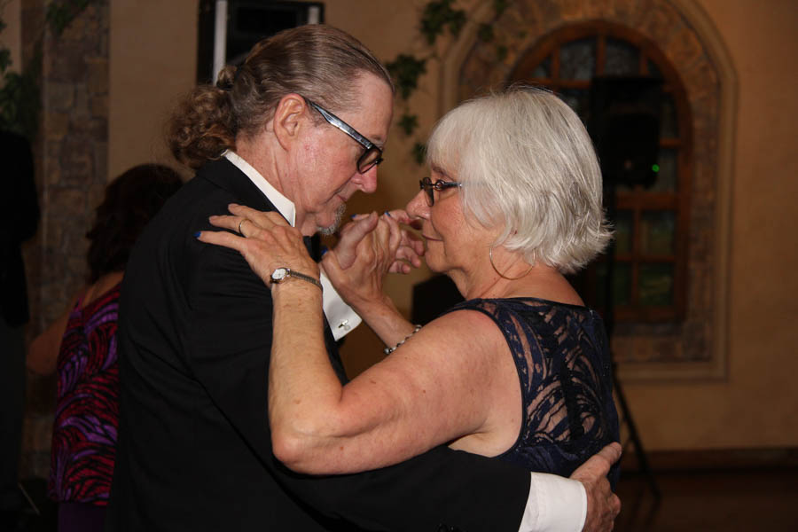  
Romance Was In The Air

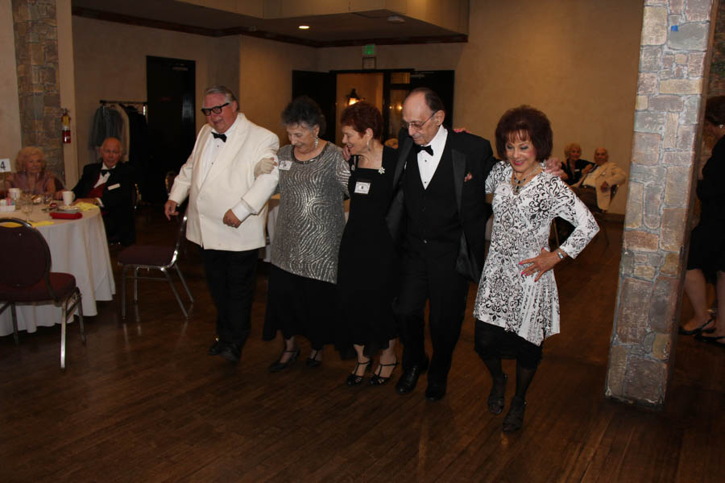

Ten Step Polka Anyone?

ccasion!

# Upcoming Dance Schedule

We have a busy season coming up and we will be confirming the dates and bands again with you during the summer “vacation”!

Remember, we will be at The Grand in Long Beach for October and November 2019.

10/18/2019 – Tony Carinino

11/15/2019 – Tropic Star

**YOUR BOARD**

President Craig Colby

Vice President Lucky Harrington

Secretary Sandy Slater

Treasurer Diane Schmitz

Hospitality Neil/Nita Woolston

Membership Vicky Kuhn

Roster Donnis Weygandt

Newsletter Paul/Sue Liles