­

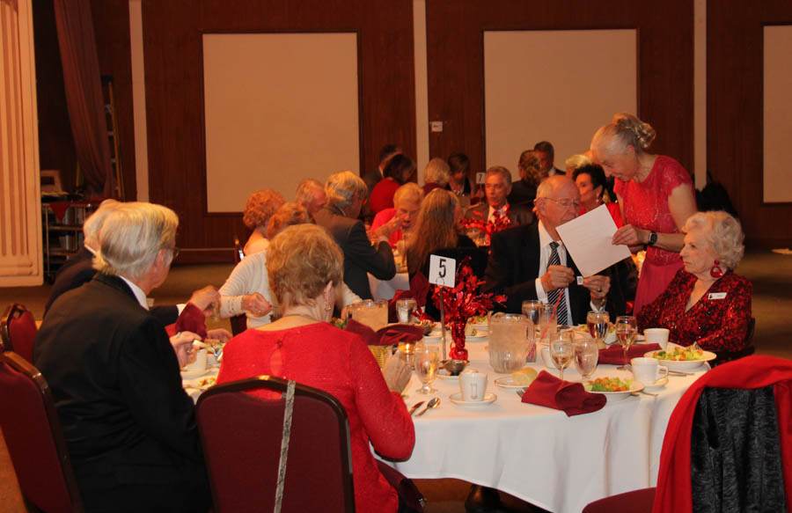

One more dance... Please join us!

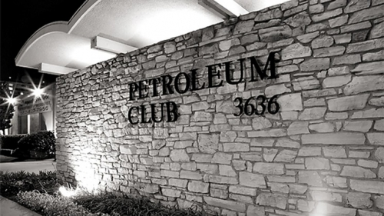

We will miss you!

Change the way you look at things and the things you look at change.

Friends,

“It’s sad to say goodbye” as the song goes. If you haven’t heard March will be our last dance at the Petroleum Club, and the end our long relationship with them. Topper’s Executive Board is looking for a new venue to meet and we have come up with a couple of options (The Grand Event Center or Old Ranch Country Club), though neither is ideal we may be stuck with one or the other for a while as we will have to make a decision soon.

Hope you all can make it, in your Irish Green, for this last dance at the Petroleum Club.

Craig

Looking forward to seeing you all on the 15th.💕

Craig

Goodbye Old Friend…We Leave The Petroleum Club Forever

Goodbye

# Policy Notes

There are no refunds for cancellations made after the Tuesday before the dance as the arrangements are finalized Tuesday evening.

If you desire to sit with someone please note it with your check so we can attempt to satisfy your seating desires!

# What You Need To Know

The March 15th dance is at the Petroleum Club and featuring Sam Conti. The cost is $85/couple (includes tax/tip).

No-host cocktail time is 6 pm & great dance music until 10 pm.

**Dress code is Semi-Formal** (Men, Dark Suits/Sport Coats. Ladies, cocktail attire.)

Toppers Dinner Menu

Garden Green Salad  
Fresh seasonal vegetables   
Hot Bread and Butter

Chicken Marsala w/mashed potatoes OR

Baked White Fish w/rice OR

Veggie Selection

Dessert: Chef’s Choice

Mail your checks to “Toppers Dance Club” with dinner selections and seating requests on the checks by March 9 th to:

Diane Schmitz  
3475 Lilly Avenue

Long Beach Ca 90808-3214

**Bits and Pieces**

The Board is working hard on finding a “permanent” venue for our club and any suggestions ideas would really be appreciated. The burden has fallen on Craig and he is doing a fantastic job.

Many of us dance at the local Elks Lodge on Fridays and Saturdays. If you are interested call Paul & Sue Liles for additional information!

**Snaps From   
Our Last Dance**

**A Gift For Our Servers And Staff**

The Board feels that it would be a nice gesture for us to reward the wait staff who have taken such good care of us over the years. We are suggesting a $20 donation per couple, strictly voluntary.

Of course any amount above or below that would be gratefully accepted. If you would like to donate by check, please make it out to Diane Schmitz and mail it with your check for the March Dance.

Please send two checks, one made out to Toppers and one to Diane. If you are unable to attend but want to donate, please send a check to Diane.

Your other option is to bring cash to the dance and give it to Nita at the sign-in desk.

We will have Thank You Cards for each of the staff to be presented to them when Lucky does his announcements

**Remember…**

This is our last dance at the Petroleum Club. For the remainder of this year, we will be meeting at GRAND LONG BEACH EVENTS CENTER. It is located at 4101 E Willow St, Long Beach, CA 90815.

Their website is <https://thegrandlb.com/> for more information.

More details will be provided at the upcoming dance.

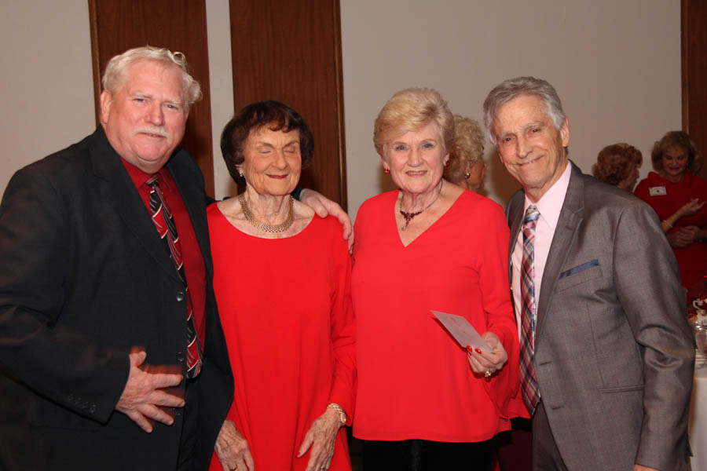

Meeting & Greeting

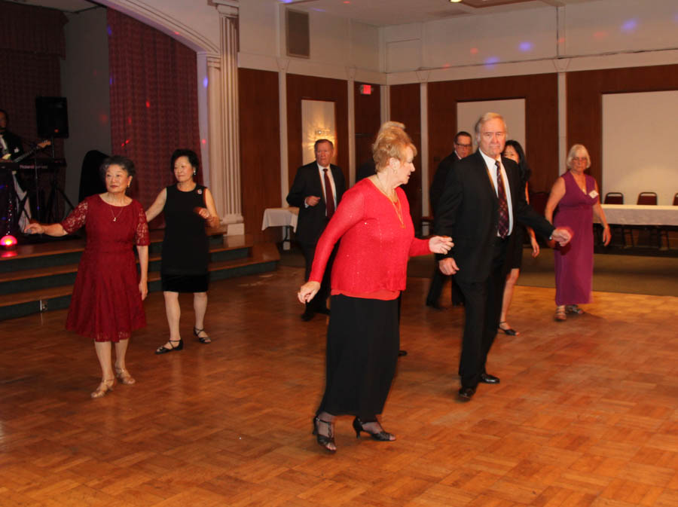

Dancing in a line!

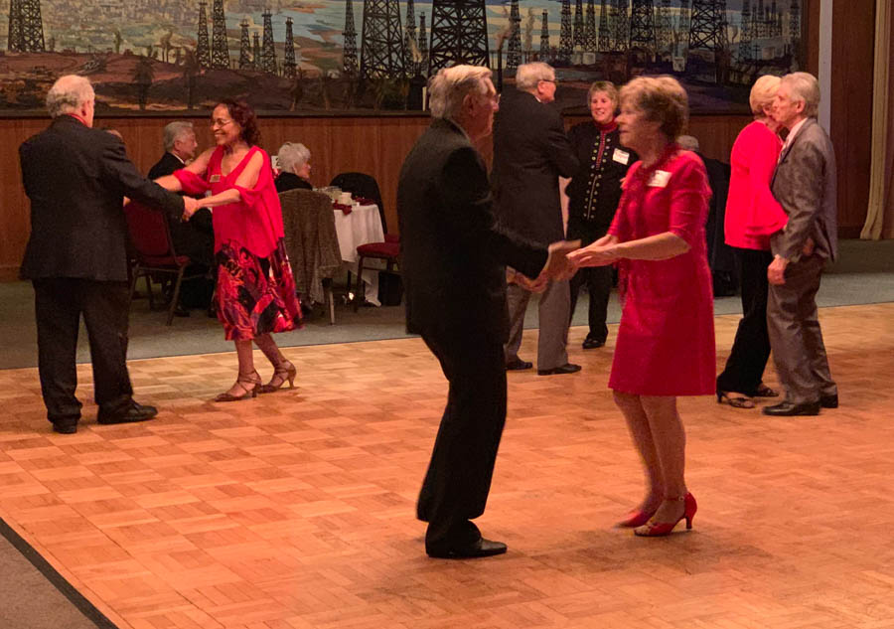

A sea of red this evening

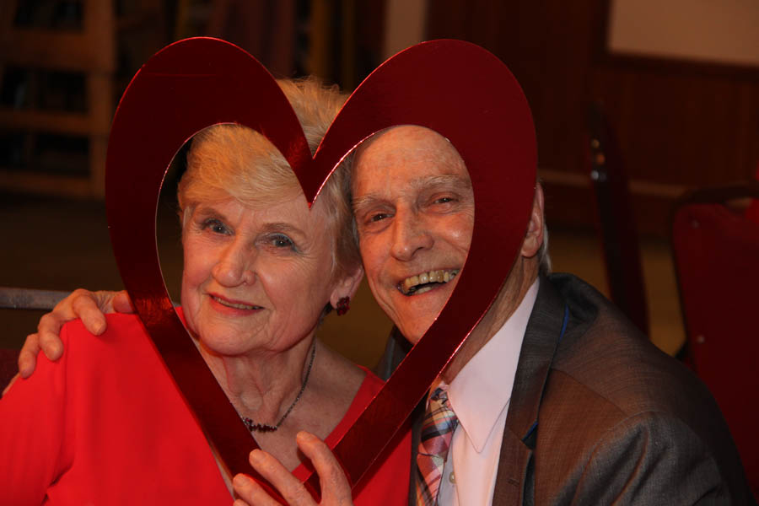In The Mood!



Listen carefully…Things are changing

ccasion!

# Upcoming Dance Schedule

We have a busy season coming up! Get your calendars marked up now. Remember, we will be at The Grand in Long Beach.

4/19/2019 – Arnie Rios

5/10/2019 – Time Machine

We will keep you appraised via the newsletter and at the April dance at the Grand in Long Beach.

**YOUR BOARD**

President Craig Colby

Vice President Lucky Harrington

Secretary Sandy Slater

Treasurer Open

Hospitality Neil/Nita Woolston

Membership Vicky Kuhn

Roster Donnis Weygandt

Newsletter Paul/Sue Liles