­

I was going to quit all my bad habits for the new year, but then I remembered that nobody likes a quitter!

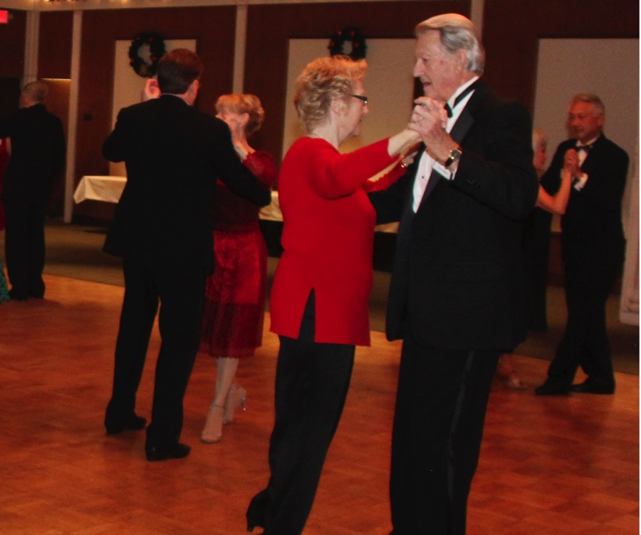

Romance is in the air

Happy New Year Toppers!

Sorry to say the turn out for the Mistletoe Ball was not great and we failed to meet our promised attendance. It is uncertain at this point whether the Petroleum Club will charge us for the shortfall (hopefully not).

Thanks to all who made it and to those who brought guests to boost our attendance.

Hoping the New Year brings you all good health (and the club more members). Looking forward to seeing you all in your dancing shoes on the 18th.  
  
Remember, we have a website and if you happen to have some snapshots of our dance events, email them to Paul & Sue so your artistic talents can be added to the collection!

Craig

# Policy Notes

There are no refunds for cancellations made after the Tuesday before the dance as the arrangements are finalized Tuesday evening.

If you desire to sit with someone please note it with your check so we can attempt to satisfy your seating desires!

# What You Need To Know

The January 18th dance is at the Petroleum Club and featuring Tony Carinio. The cost is $78/couple (includes tax/tip).

No-host cocktail time is 6 pm & great dance music until 10 pm.

**Dress code is Semi-Formal** (Men, Dark Suits/Sport Coats. Ladies, cocktail attire.)

Toppers Dinner Menu

Garden Green Salad  
Fresh seasonal vegetables   
Hot Bread and Butter

Mediterranean Chicken w/mashed potatoes or

Baked White Fish w/ rice or

Vegetarian Selection.

Dessert: Chef’s Choice

Mail your checks to “Toppers Dance Club” with dinner selections and seating requests on the checks by January 14th to:

Diane Schmitz  
3475 Lilly Avenue

Long Beach Ca 90808-3214

2019 Is Here Already!

**Bits and Pieces**

Russell Gill is doing much better. He was not able to make the Mistletoe Ball but we look forward to seeing Russ and Lily out and about again soon!

The Rodecker’s cruised the Caribbean and plan to share their great adventure with us in January!  
  
Paul & Sue Liles sponsored a New Year’s Eve dance at Old Ranch Country Club with 110 people and they danced to the sounds of 9 Carat Gold.  
  
Nancy Adamson joined us for the ball and enjoyed it so much she hopes to come back again soon.

**Mistletoe  
Ball**

**People Do Want To Join Up!** We obtained names of four couples who want to come and see Topper’s early this year as they were interested in dancing after watching the fun at Old Ranch Country Club.   
  
The stand-up-and-wiggle “dancing” gets old…plus it hurts your ears! When you see someone watching you as you are out and about, go talk to them and explain the fun of being a Topper!



**Thoughts To Ponder…**

* I love when they drop the ball in Times Square. It's a nice reminder of what I did all last year
* What happened to the Irish man who thought about the evils of drinking in the New Year? He gave up thinking
* What happened to the man who shoplifted a calendar on New Year's Eve? He got 12 months!

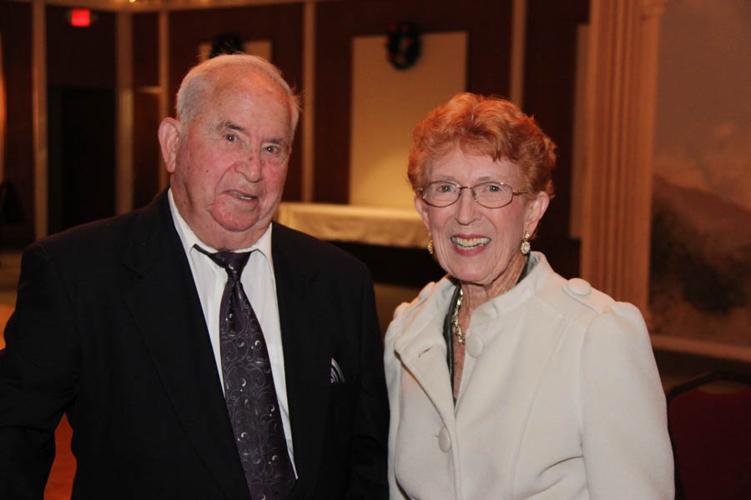

Welcome Bernie & Nancy

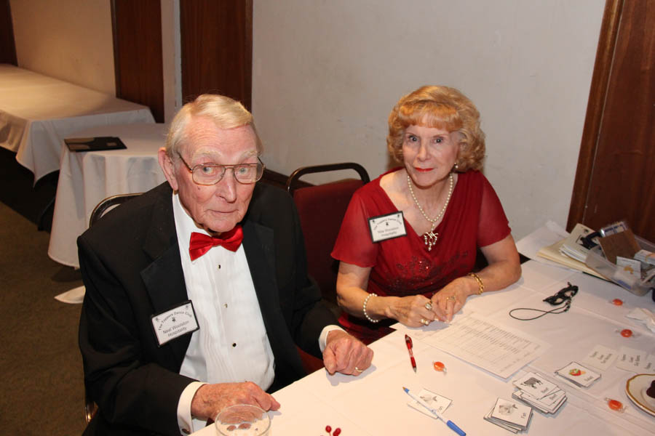

Always hard at work helping the club

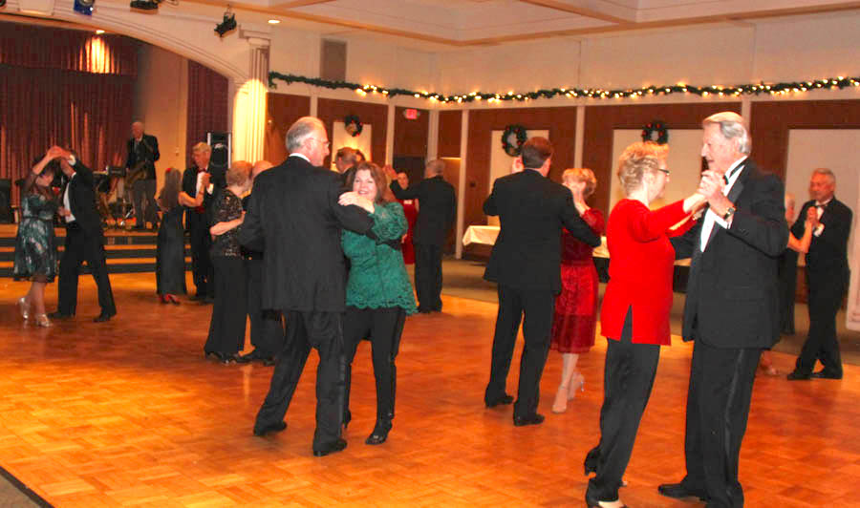

Gliding across the floor

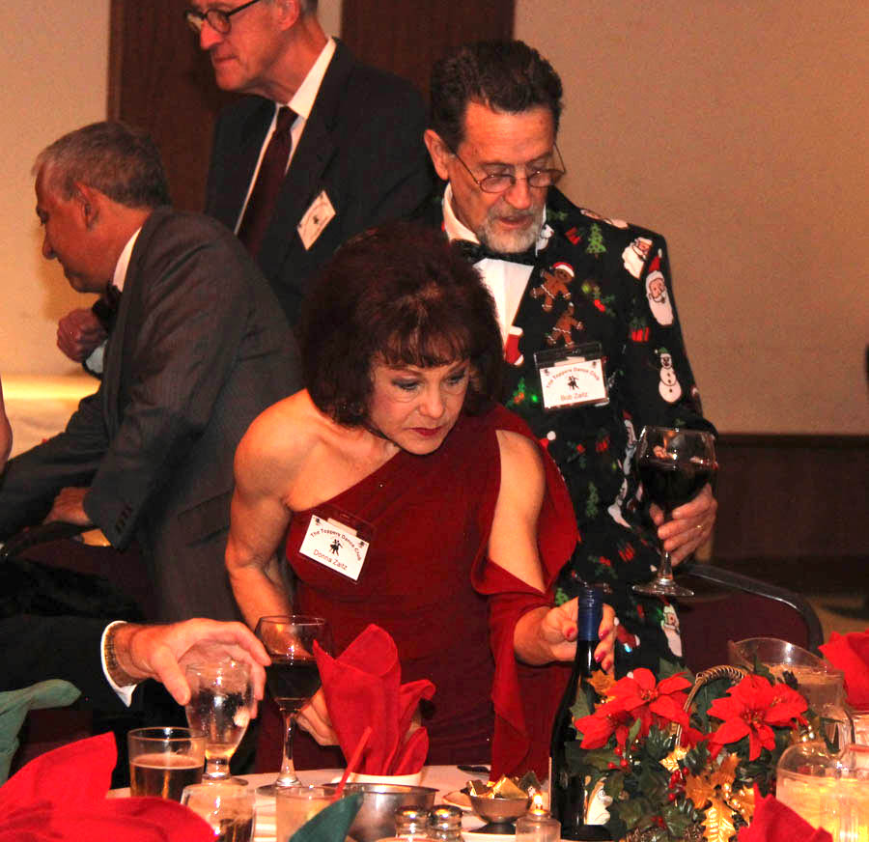All lit up…

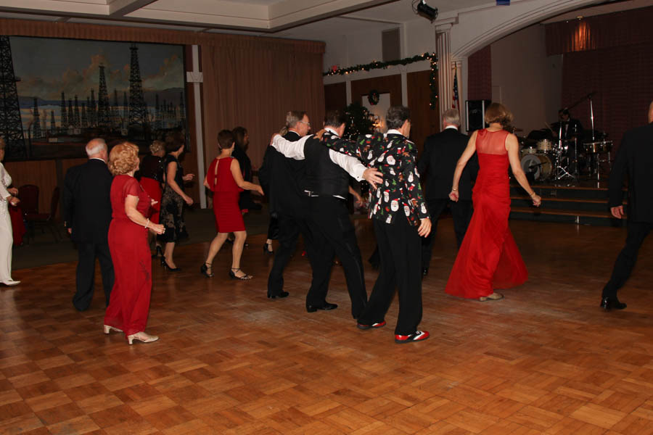

Line dancing lives

ccasion!

# Upcoming Dance Schedule

We have a busy season coming up! Get your calendars marked up now.

1/18/2019 – Tony Carinio

2/15/2019 – Tropic Starr

3/15/2019 – Sam Conti

4/19/2019 – Arnie Rios

5/10/2019 – Time Machine

# Anyone interested in a Sunday afternoon tea dance during the summer when we are “off”? Let Paul & Sue Liles know and perhaps we can trip the light fantastic under the summer stars at Old Ranch Country Club.

**YOUR BOARD**

President Craig Colby

Vice President Lucky Harrington

Secretary Sandy Slater

Treasurer Open

Hospitality Neil/Nita Woolston

Membership Vicky Kuhn

Roster Donnis Weygandt

Newsletter Paul/Sue Liles