­

What is the best Christmas present ever? A broken drum - you can't beat it!?



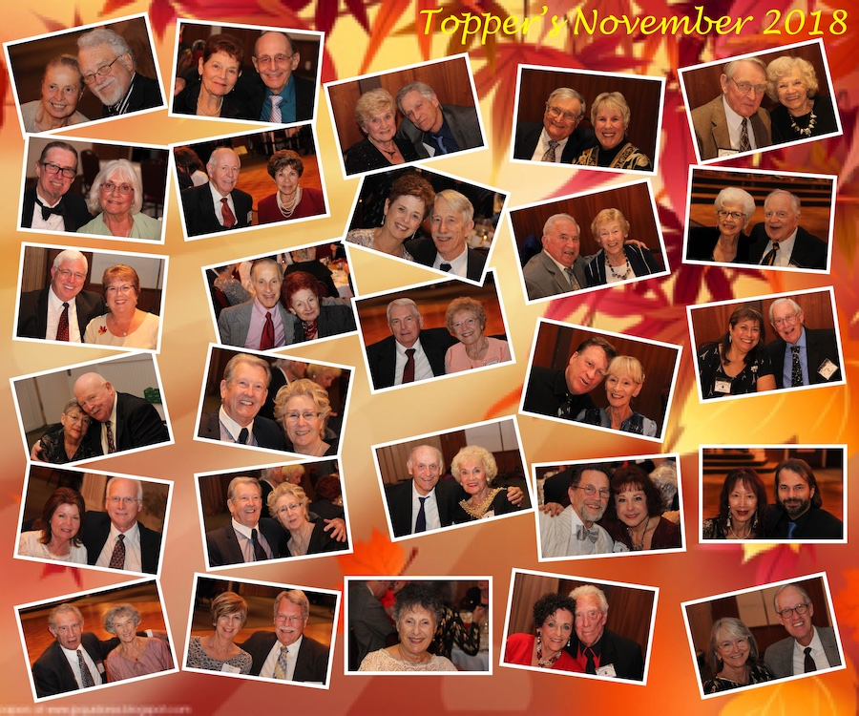

Holidays with friends!

President’s Message

Friends,

It was great to see so many you at the November dance and to meet the guests who joined us. Hope the grand turnout continues at the Mistletoe Ball and into the new year. As 2018 draws to a close I’d like to offer some thoughts to reflect upon. For those of you who like to stay active, you’ll be glad to know your heart beats about 100,000 times a day even when you are doing nothing (quite a bit more when you are dancing).

For those who enjoy travel, remember you get a free trip around the sun every year even when you stay at home.

For those who like the company of others, come to the Mistletoe Ball, you are sure to get the companionship you enjoy. Looking forward to seeing you all on the 21st and wish you all the Joys of the Holiday Season.

Craig

# Policy Notes

There are no refunds for cancellations made after the Tuesday before the dance as the arrangements are finalized Tuesday evening.

If you desire to sit with someone please note it with your check so we can attempt to satisfy your seating desires!

# What You Need To Know

The December 21st dance is at the Petroleum Club and featuring Time Machine. The cost is $85/couple (includes tax/tip).

No-host cocktail time is 6 pm & great dance music until 10 pm.

**Dress code is Formal** (Tuxedos/Dark Suit. Ladies, festive colors are always great!)

Toppers Dinner Menu

Garden Green Salad  
Fresh seasonal vegetables   
Hot Bread and Butter

Roast Tri-Tip with Au Gratin Potatoes or Baked Salmon with Rice or

Vegetarian Selection.

Dessert: Chef’s Choice

Mail your checks to “Toppers Dance Club” with dinner selections and seating requests on the checks by December 14th to:

Diane Schmitz  
3475 Lilly Avenue

Long Beach Ca 90808-3214

Beware Of The Mistletoe!

**Bits and Pieces**

The Finch’s (Brian and Jan) are now in the U.S. and will be joining us for the Mistletoe Ball.

Russell Gill is doing much better. He was on restricted movements after the pacemaker procedure but is going to be “un-grounded” as of the 14th of December. We are anxious to see them out and about again!

The Rodeckers are on a cruise to the Carribbean and plan to visit New Orleans before returning home. They will have much to share at the Mistletoe Ball!

**Our Previous  
Dance**

**Bring A Friend** – We do have a minimum for the Mistletoe Ball because of the popularity of the venue this time of year. So, please ask your friends and family to join us even if just to listen to the great music and have a nice dinner. Tis’ the season you know! Where can you go out to dinner for $43/person and have live music and entertainment?



**In the song Twelve Days of Christmas, what is given on the 7th day?**

Swans a-swimming in todays version! There has been a lot of variation of the lyrics over the years. Some of my favorites include: 11 badgers baiting, 10 asses racing, and 9 bears a beating. Also “calling birds” was originally “colly birds”, with “colly” meaning black.

**According To Shirley Temple**

“I stopped believing in Santa Claus when I was six. Mother took me to see him in a department store, and he asked for my autograph.”

**Anonymous**

“Christmas is the season when you buy this year’s gifts with next year’s money.”

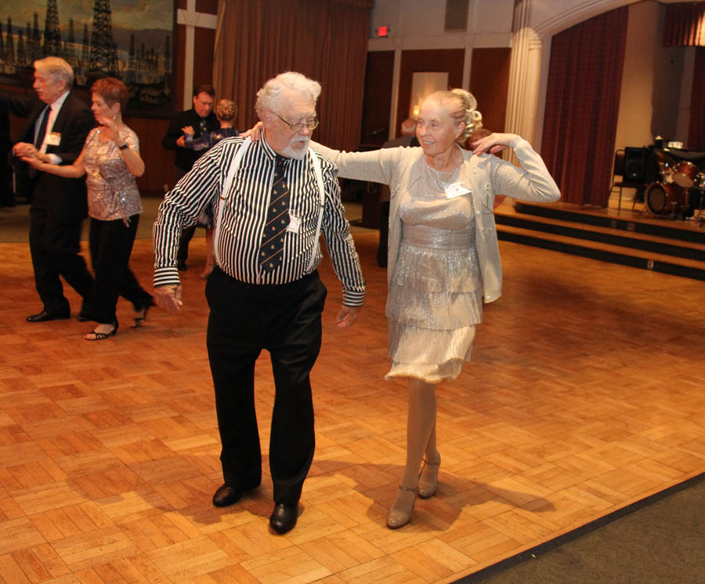

All Smiles



Checking out the dance floor

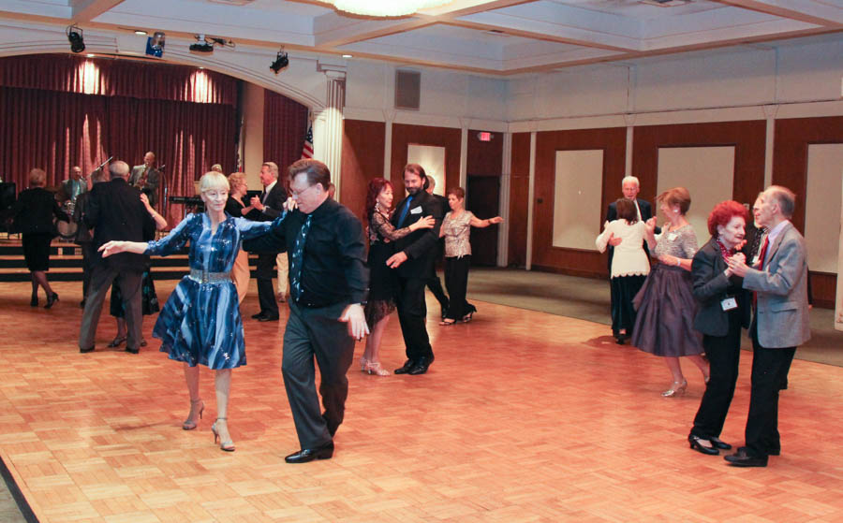

Gliding across the floor

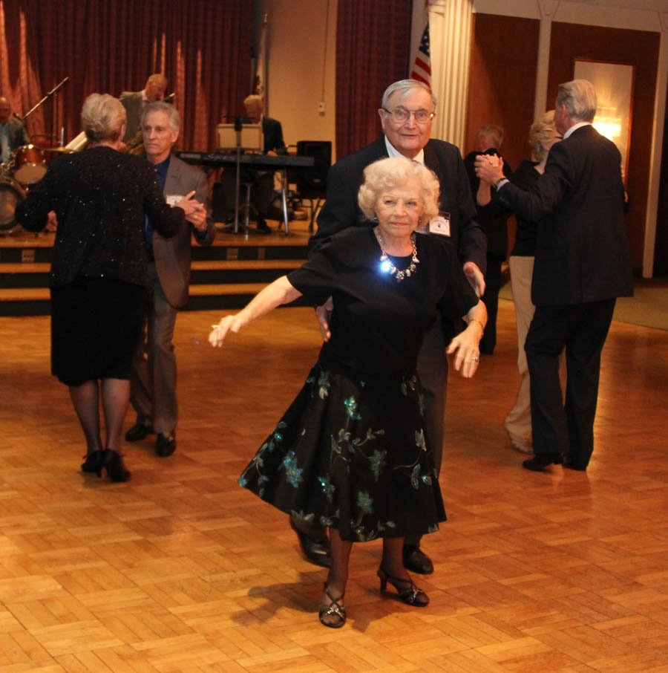Rockin’ and Rollin’

ccasion!

# Upcoming Dance Schedule

We have a busy season coming up! Get your calendars marked up now.

12/21/2018 – Time Machine  
1/18/2019 – Tony Carinio

2/15/2019 – Tropic Starr

# We are always looking for new members to keep social dancing alive and well in Long Beach. If members know of other couples who would like to join please invite them to come as your guests, as they are potential members.

Let Donnis Weygandt know if you have any changes for the Topper’s Roster!

**YOUR BOARD**

President Craig Colby

Vice President Lucky Harrington

Secretary Sandy Slater

Treasurer Open

Hospitality Neil/Nita Woolston

Membership Vicky Kuhn

Roster Donnis Weygandt

Newsletter Paul/Sue Liles