**Presidents Message**: Welcome back for another season of dinners, dancing and the company of what I’ve come to know as a great group of people. As you have decided to honor me by electing me as President of our Social Club, I’ve decided you should know a bit about me.

I grew up as what is known as a military brat. My father was a career Air Force Officer, and I’ve lived in various places around the world. We settled in California when he retired, and I went to college here at the University of California, Irvine, where I received degrees in Chemistry and Biology.

My education led me to work in the pharmaceutical industry and I rose to management level, spending years as a quality manager. I’ve worked for a few well-known companies and eventually ended up running R&D for my current employer where I have been for 24 years. Planning to retire in a few years and being president of Toppers will give me something to do with my time (thank you).

So yes, I am a complete nerd. If you’ve sat with me at dinner you’ve probably discovered I don’t talk a lot, but I assure you I enjoy listening and you’ll have also met my wife, Linda, who I never go anywhere (social) without. She is truly my better half (and is happy to fill in my part of the conversation). Looking forward to seeing you on the 21st.

Craig

Are you ready for the holiday season??

# Policy Notes

There are no refunds for cancellations made after the Tuesday before the dance as the arrangements are finalized Tuesday evening.

If you desire to sit with someone please note it with your check so we can attempt to satisfy your seating desires!

# What You Need To Know

The September 21st dance is at the Petroleum Club and featuring Sam Conti. The cost is $85/couple (includes tax/tip).

No-host cocktail time is 6 pm & great dance music until 10 pm.

**Dress code is Semi-Formal** (Dark suits for the guys)

Toppers Dinner Menu

Garden Green Salad  
Fresh seasonal vegetables   
Hot Bread and Butter

Chicken Piccata with rice, or

Grilled White Fish with rice or

Vegetarian Selection.

Dessert: Chef’s Choice

Mail your checks to “Toppers Dance Club” with dinner selections and seating requests on the checks by September 17th to:

Kathy Roberts

12021 Kibbee Ave

La Mirada Ca 90638

Summer Is Almost Gone! Fall Is Near!

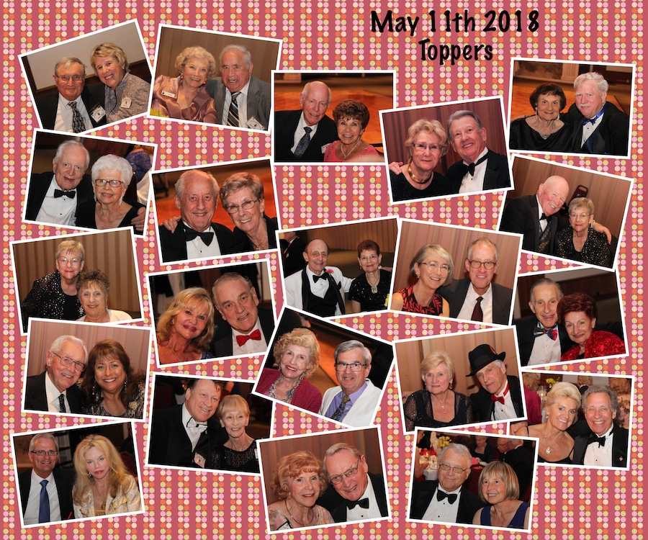

It was a delightful evening it was!

**Bits and Pieces**

Brian and Jan Finch, from the UK, are back in town for the next 6-7 weeks and will be joining us for the upcoming dance. They like getting to see dry weather!

Come to the Phoenix Club on Thursday evenings for a dance with the Big Bands, 7:00 PM to 10:00 PM.

Email Paul & Sue with any news or other tidbits so they can be put into the newsletter!

Sue

**Last Dance**

**Sad News** - Edward Weyer passed away in August at the age of 91. He and Natalie Emery were long time members of Toppers. They enjoyed dancing together and made a beautiful couple.

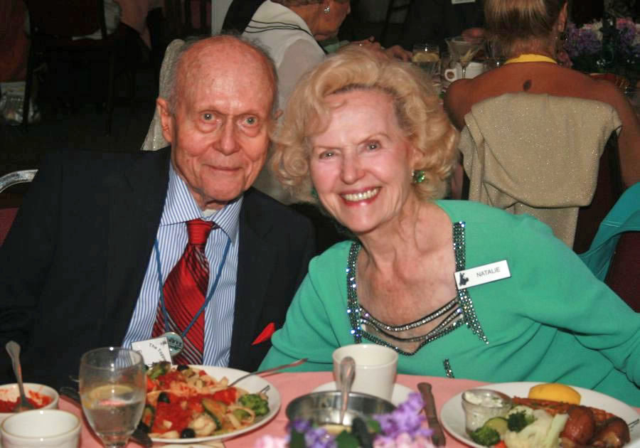

**With Us In Thoughts** - Al and Mickey Araju or Garden Grove, very long-time members, are no longer going to be members as the drive in the evenings at the age of 95 is just too much! We will miss their smiling faces!

**Dance**: The action of moving rhythmically to music with a partner, a skill which a woman possesses naturally, but which a man acquires only for the short time in his young adulthood when he wishes to meet and impress young women and abandons thereafter due to mysterious knee injuries.

**Something to Think About**: If money did grow on trees, autumn would be the best season ever!

**The Holiday Season Is Upon Us:** The next three dances center around Halloween, Thanksgiving and finally the Mistletoe Ball on the 21st of December. Where did the year go?

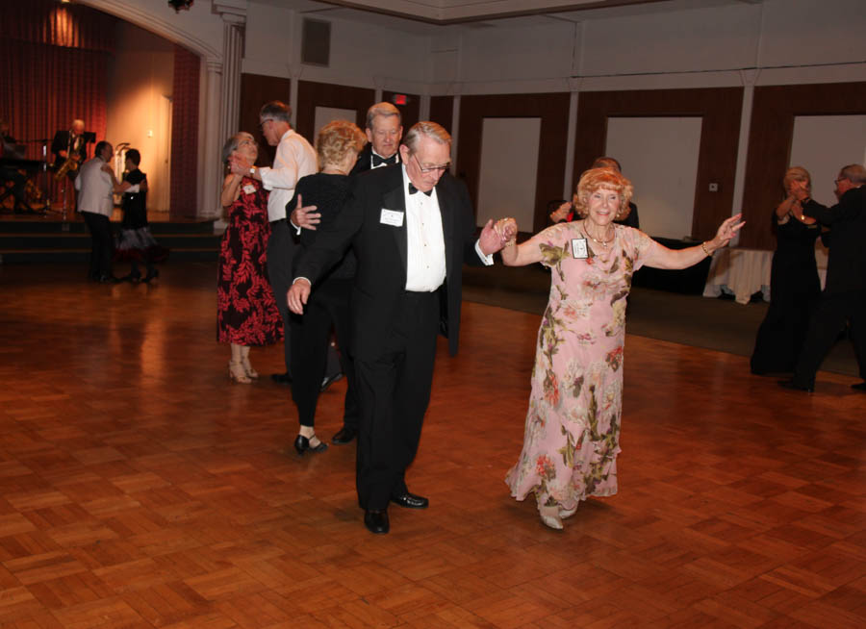

Samba Anyone?

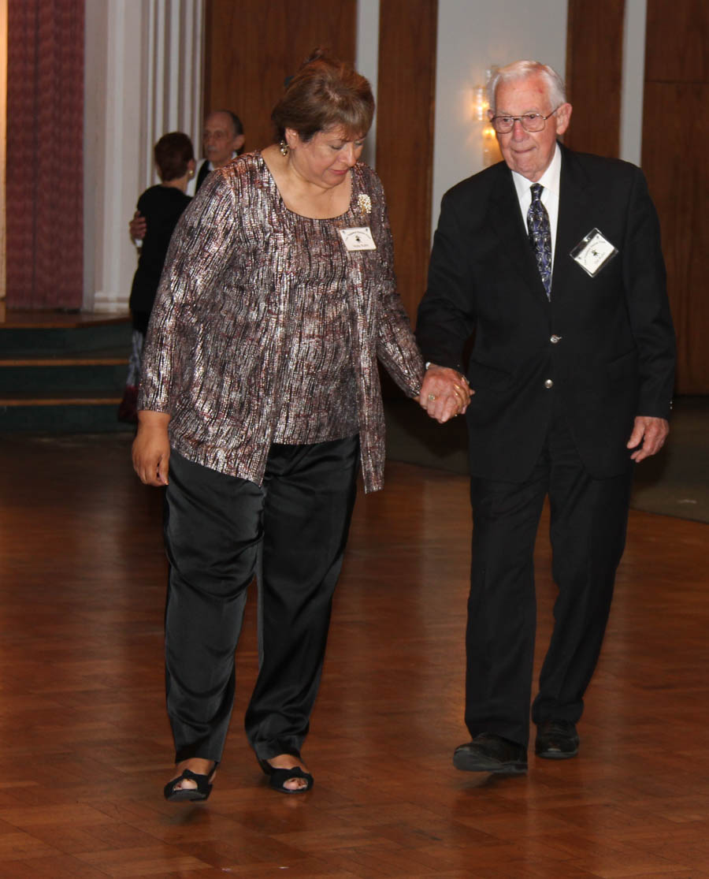

Polka Man at work

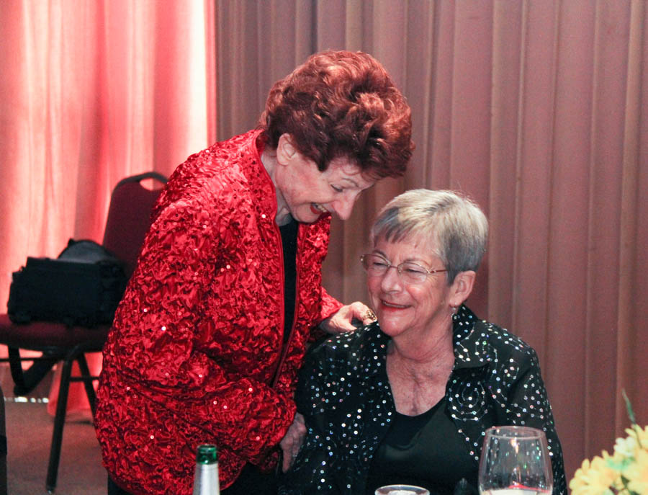

OK, what's so funny??

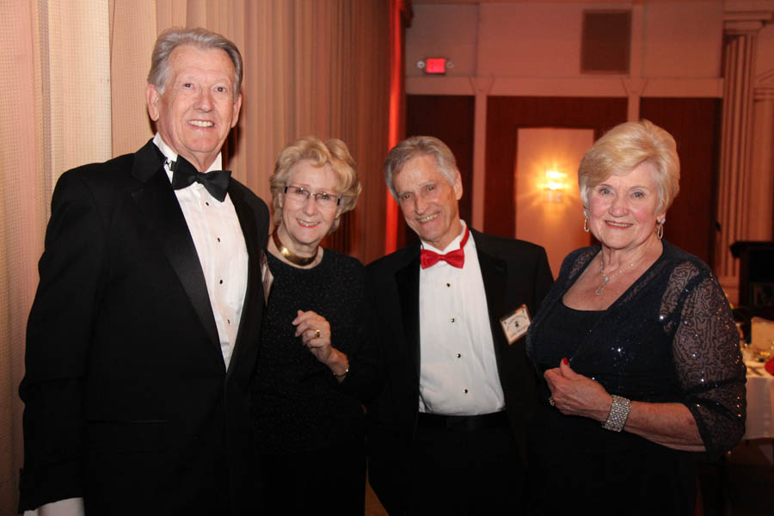

Dressed for the occasion!

ccasion!

# Upcoming Dance Schedule

We have a busy season coming up in September! Get your calendars marked up now.

10/19/2018 – Jim Gilman

11/16/2018 – Arnie Rios

12/21/2018 – Time Machine

To keep the club thriving, we are always looking for new friends to join in and participate in our great parties and keep social dancing alive and well in Long Beach!

# 

Thank you Donnis Weygandt for the effort to put together the new roster which we will be seeing soon.

**YOUR BOARD**

President Craig Colby

Vice President Lucky Harrington

Secretary Sandy Slater

Treasurer Kathy Roberts

Hospitality Neil/Nita Woolston

Membership Vicky Kuhn

Roster Donnis Weygandt

Newsletter Paul/Sue Liles

Members At Linda Colby, Ed Roberts, and Del Kuhn.