­

# *Presidents Message…*

Where does time go… Last week it was Halloween and now it is time for Thanksgiving… and, in a few short weeks it will be time for the 71st Mistletoe Ball.

We hope you invite your friends to the Mistletoe Ball as a big turnout is helpful since the Petroleum Club members no longer attend.

For those of you in other dance clubs, please invite other members in your dance clubs to join us to celebrate this time of year!

Here is a Halloween trick you might want to remember for next year! When cleaning out a pumpkin, take a blade from your hand mixer and put it on an electric drill. Go around the inside of the pumpkin and it gets cleaned out in a matter of minutes!

We hope your Thanksgiving plans are well underway and that your get stuffed with turkey and all the fixin’s.

*Larry Isham,  
 President*

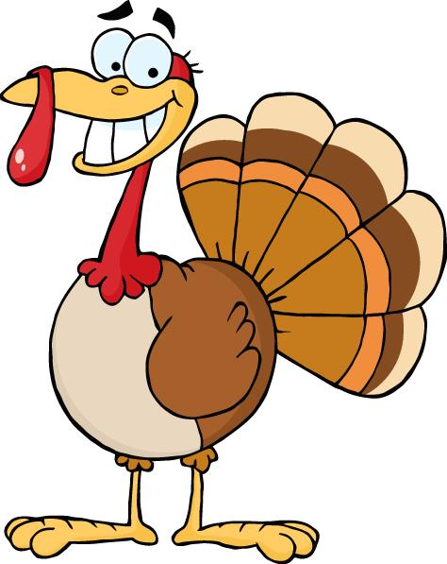

"Thanksgiving, after all, is a word of action." - W.J. Camero

Turkey Day Is Upon Us… Are You Ready?

# What You Need To Know

The November 17th dance is at the Petroleum Club features Gil Gilman. The cost is $76/couple (includes tax/tip). No-host cocktail time is 6 pm & great dance music until 10 pm.

**Dress code is Semi-Formal.**

Toppers Dinner Menu

Garden Green Salad  
Fresh seasonal vegetables   
Hot Bread and Butter

Entrée: Slow-Roasted Turkey Breast w/home-made cornbread stuffing, cranberry sauce and supreme sauce and mashed potatoes, or

Grilled Salmon w/Hollandaise sauce and rice, or

Vegetarian selection.

Dessert: Chef’s choice

Mail (please do not bring them to the dance) your checks made out to “Toppers Dance Club” **with dinner selections on the checks** by November 13th to:

Kathy Roberts

12021 Kibbee Ave

La Mirada CA 90638

# ****Our 71st Fall Season Is Underway!****

# Policy Notes

There are no refunds for cancellations made after the Tuesday before the dance as the arrangements are finalized Tuesday evening.

If you desire to sit with someone please note it with your check so we can attempt to satisfy your seating desires!

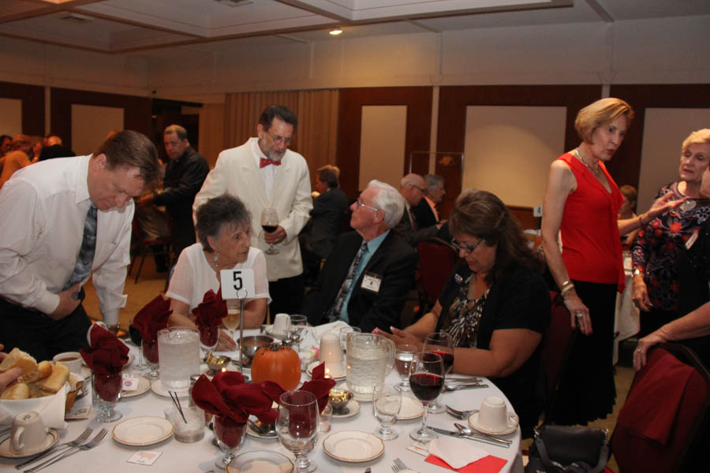

Meet & Greet Goes On For Hours!

Meet & Greet Goes On For Hours!

# Prepare To Be Greeted By

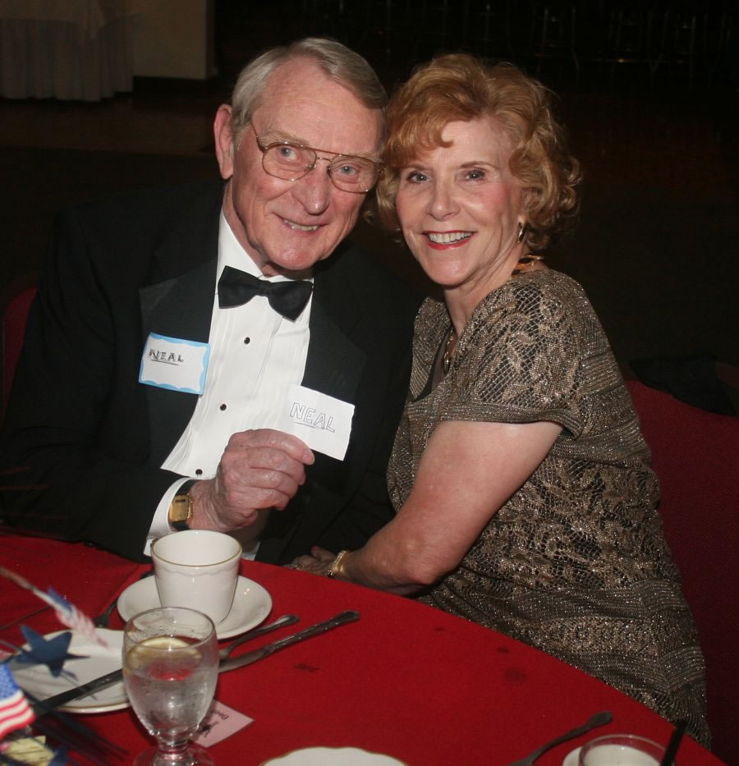

Neal & Nita Woolston

Fun With Friends!

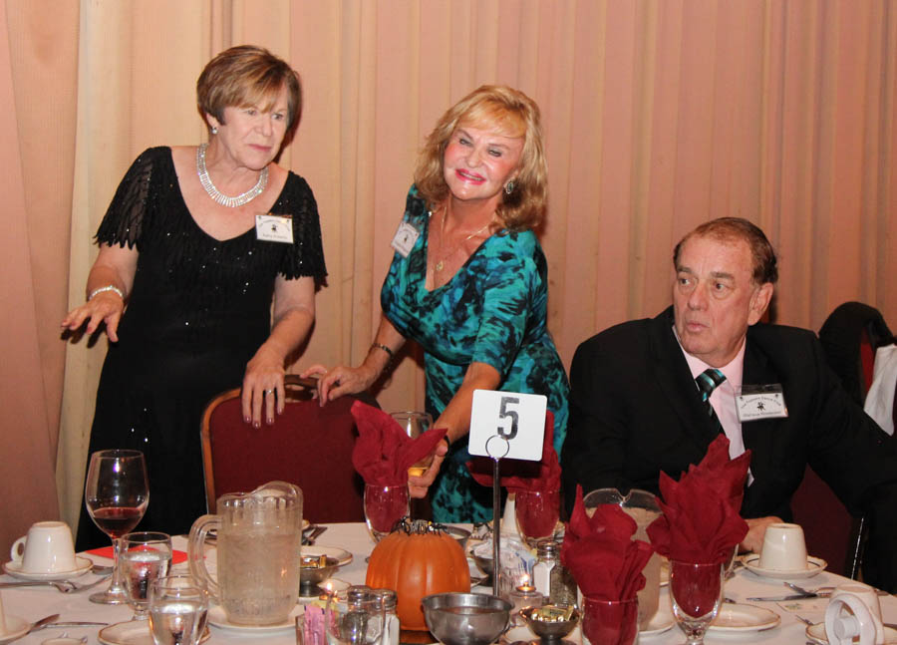

Meeting & Greeting

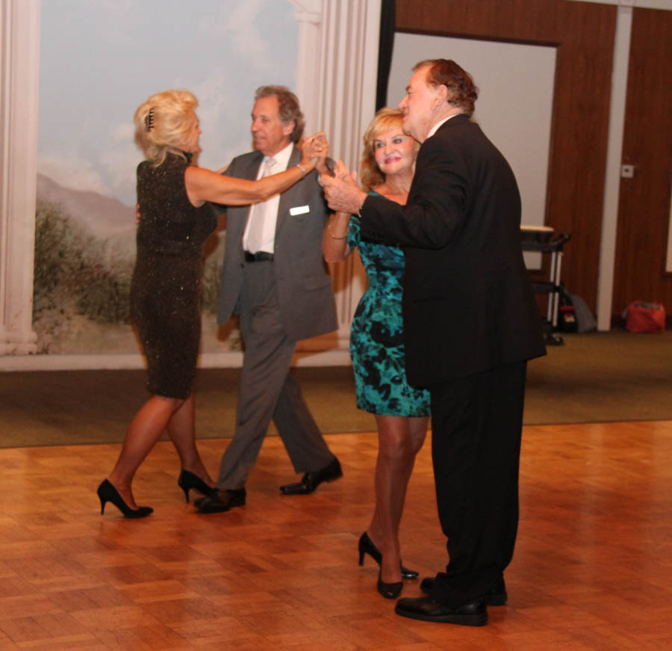

The Anniversary Waltz

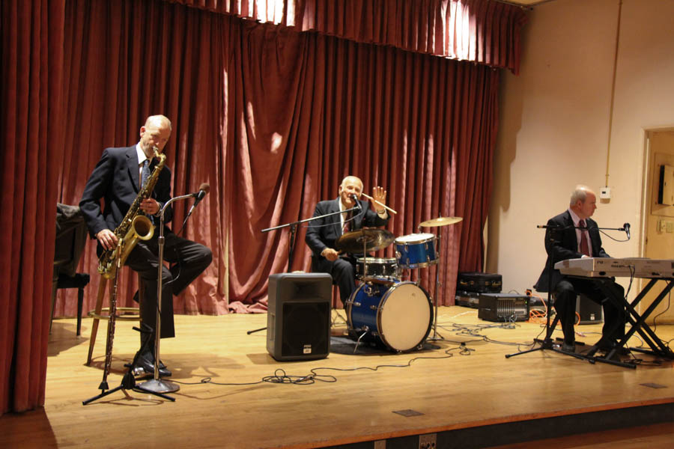  
Great music all night

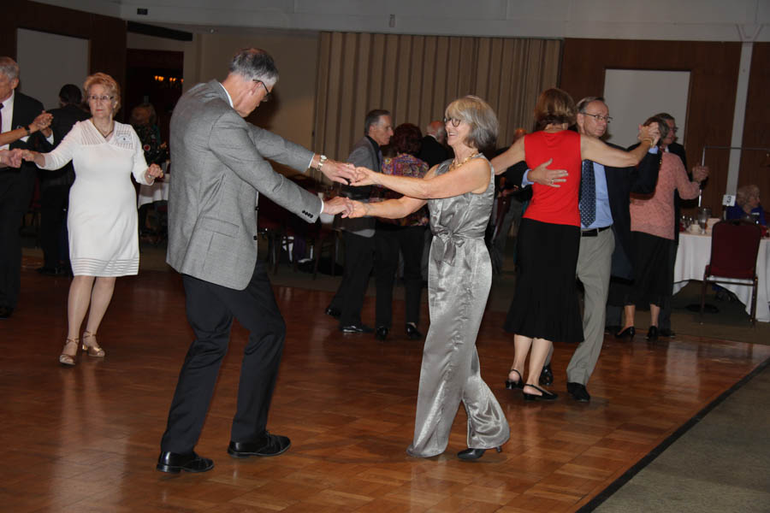  
Rockin’ and Rollin’

# Upcoming Dance Schedule

One more dance until Christmas! Where did the year go?

12/15/2017 – Time Machine at the Mistletoe Ball!

To keep the club thriving, we are always looking for new friends to join in and participate in our great parties and keep social dancing alive and well in Long Beach!

# Thanksgiving Is Here!

Q: What would you get if you crossed a turkey with an ghost?

A: A poultrygeist!

Q: Why did the police arrest the turkey?

A: They suspected fowl play.

Q: What happened when the turkey got into a fight?

A: He got the stuffing knocked out of him!

Q: Which side of the turkey has the most feathers?

A: The outside!

# Did You Know?

Fact #1: There is truly no definitive proof that the bird we wait all year to eat was even offered to guests back in 1621. However, they did indulge in other interesting foods like lobster, seal and swan.

Fact #2: The first Macy's Thanksgiving Day Parade didn't feature any balloons. But when the parade made its big debut in 1924, it did have something that might be even cooler than balloons: animals from the Central Park Zoo.

Fact #3: A Thanksgiving mix-up inspired the first TV dinners.

In 1953, a Swanson employee accidentally ordered a colossal shipment of Thanksgiving turkeys (260 tons, to be exact). To get rid of them all, salesman Gerry Thomas came up with the idea of filling 5,000 aluminum trays with the turkey – along with cornbread dressing, gravy, peas and sweet potatoes. They were sold for 98 cents, and were a hit. Within one year, over ten million were sold.

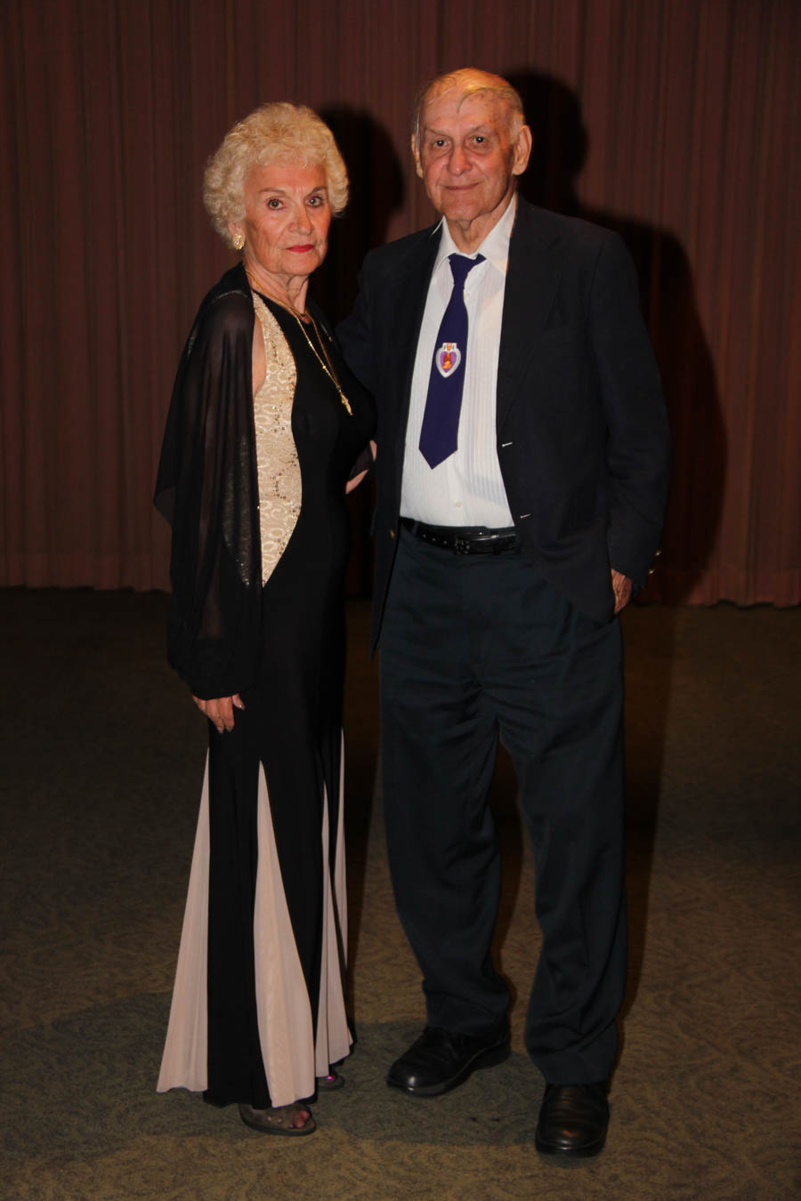

Ready to dance the night away!

**YOUR BOARD**

President Larry Isham

Vice President Lucky Harrington

Secretary Sandy Slater

Treasurer Kathy Roberts

Hospitality Neil/Nita Woolston

Membership Vicky Kuhn

Roster Donnis Weygandt

Newsletter Paul/Sue Liles

Members At Large Gigi Isham, Ed Roberts, Del Kuhn, and Charlie Slater.