

# What You Need To Know

The September 16th dance is at the Petroleum Club and featuring Tony Carinino. The cost is $74/couple (includes tax/tip).

Tony will be prepared to have us dance until the wee hours – OK, ten o’clock!

No-host cocktail time is 6 pm & great dance music until 10 pm.

Dress code is Semi-Formal. Jacket and tie for gentlemen, cocktail attire for the ladies.

Toppers Dinner Menu

Garden Green Salad  
Fresh seasonal vegetables   
Hot Bread and Butter

Entree: Chicken Piccata, boneless breast of chicken in a white wine sauce, lemon butter sauce with capers and rice. OR

Grilled white fish in lemon sauce and rice.

OR

Vegetarian Selection

Dessert: Chefs Choice

Mail your checks made out to “Toppers Dance Club” by September 12th to:

Kathy Roberts

12021 Kibbee Ave

La Mirada Ca 90638

# Policy Notes

There are no refunds for cancellations made after the Tuesday before the dance as the arrangements are finalized Tuesday evening.

# *Presidents Message…*

We hope you had a wonderful summer. Autumn is here and I always enjoy this quote from Sarah Addison - “It looked like the world was covered in a cobbler crust of brown sugar and cinnamon.” It is a real visual statement!

We are now seventy years of age and are looking forward to our club’s birthday year! …

Most of us can’t remember what it was like in 1946 when the soldiers returned home and life was “simple”. We are curious if the dances were in black and white?

We are planning a celebration next month for our 70th birthday!. Many of us are in multiple clubs so please ask members of other clubs to join us for the birthday bash!

We are in search of someone to pop out of the birthday cake… Any volunteers?

Remember to send in old photos of yourself or the club so we can build a vintage photo display. See the enclosed insert for details!

See you on the 16th!

*Larry Isham,  
 President*

*￼*

# Age is a case of mind over matter. If you don't mind, it don't matter.

# Read more at: http://www.brainyquote.com/quotes/topics/topic_birthday.html

Welcome Fall & Club Birthday Season!

We are now 70 years old! The club began in 1946 just after World War II and returning men and women were looking for places to dance!



The Topper’s tribute to Memorial Day

# Prepare To Be Greeted

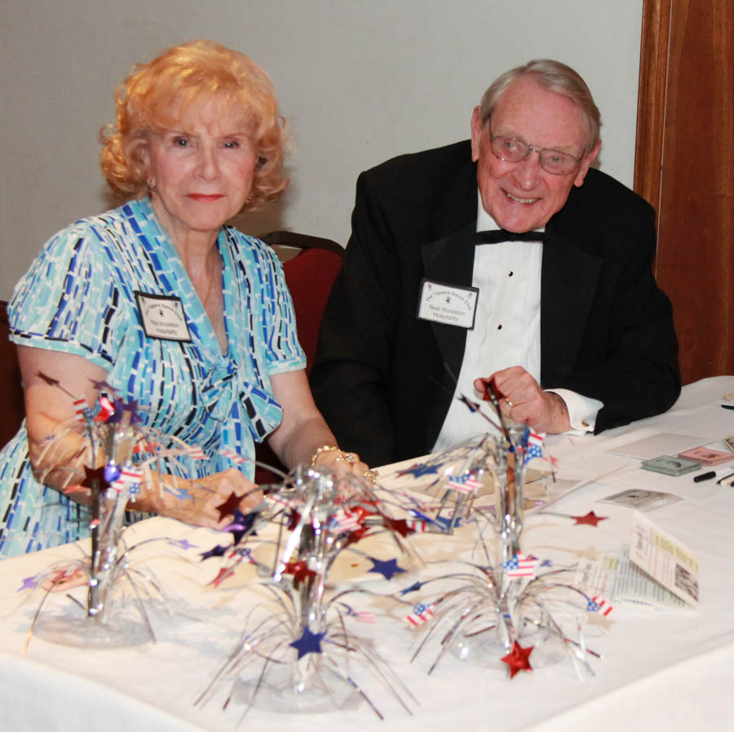

Neil & Nita Woolston

Fun With Friends!

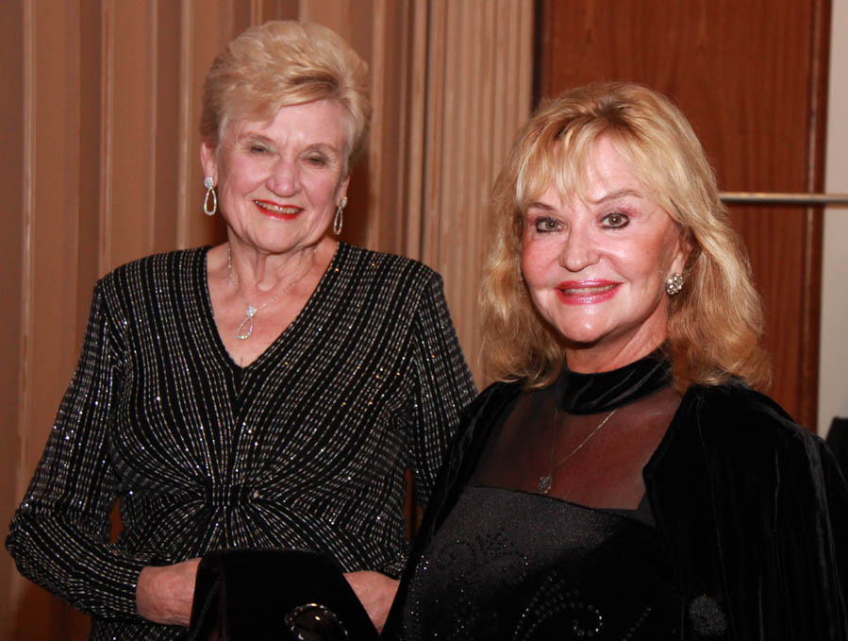

Carolyn & Ghislaine

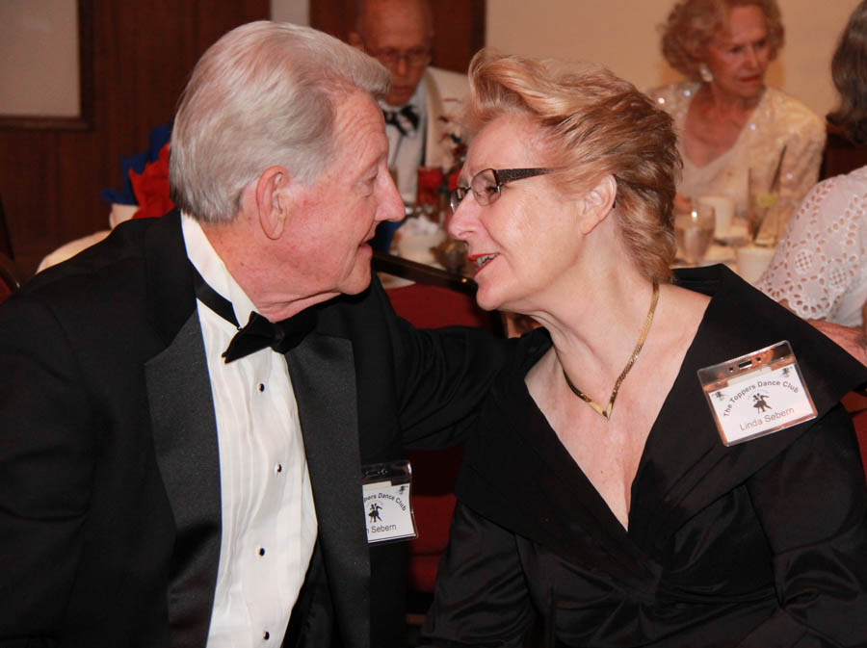

Romance is in the air

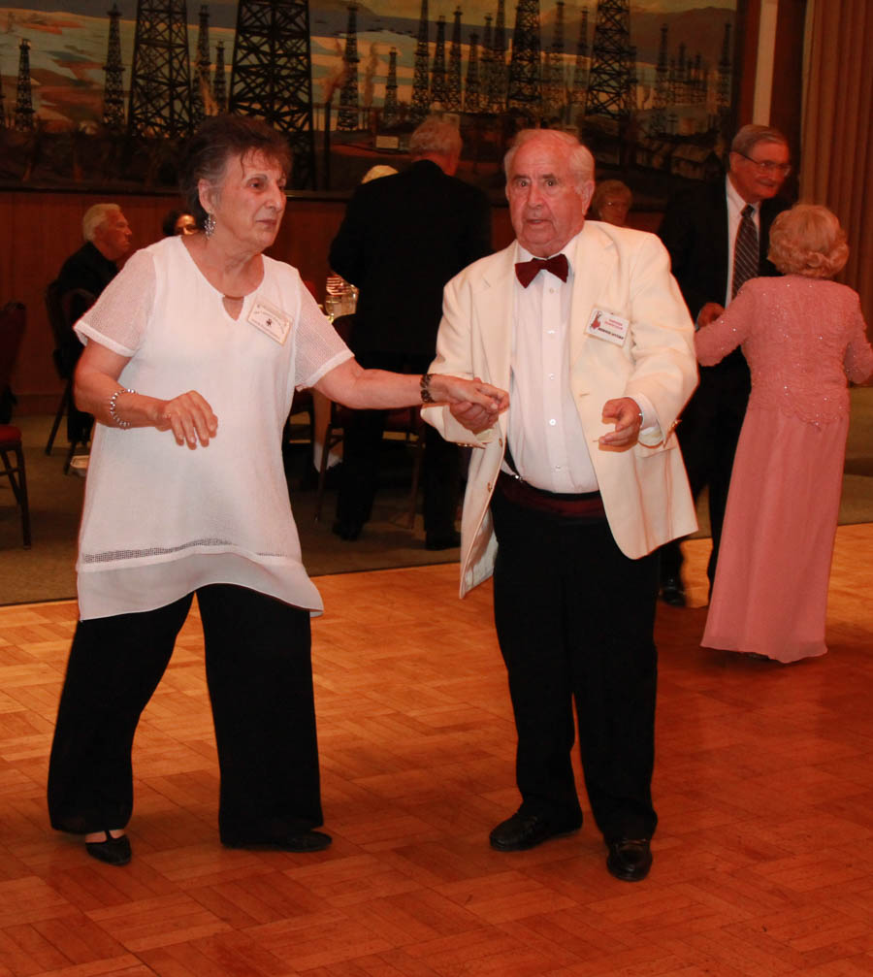  
Irene & Bernie moving fast!

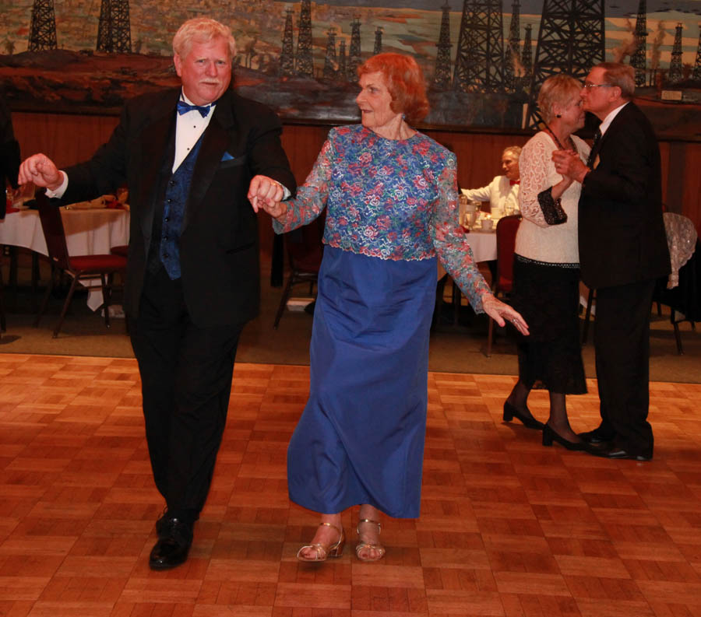  
The dance music was great this evening! The Grays make it look easy!

**Bits And Pieces**

Many of our dance clubs are coming up on their 70th birthday (just like us). You might be receiving an invite to other dance clubs… If you can, come join the celebration, meet some new interesting people, and help celebrate 70 years of dancing!

Hedrina and Cindy Lorenz had a fire at their home. They are staying in Torrance now. Our prayers are with you!

The grandkids of Vicky and Del are tending to their pumpkin garden with a little help from neighbors Paul & Sue!

# Upcoming Dance Schedule

Only three more dance until 2017 arrives. Plan ahead as the Mistletoe Ball is always fun and it is open to other clubs since the Petroleum Club no longer goes to that dance!

10/21/2016 with Howard Solomon

11/18/2016 with Sam Conti

12/15/2016 with The Time Machine

To keep the club thriving, we are always looking for new friends to join us and participate in our great parties!

# Two New Board Officers

We have two new Board Members! Our new Vice President is Lucky… No, really! **Lucky Harrington**! We are so happy to have him join the board!

Keeping track of the meetings and reminding us what happened previously is our new Secretary, **Sandy Slater**!

Your support is so welcomed!

# Old Pictures

Our clubs 70th birthday is next month so if you can, please provide us images of yourselves. Vicky Kuhn is preparing some materials for “the birthday party” and she needs your help.

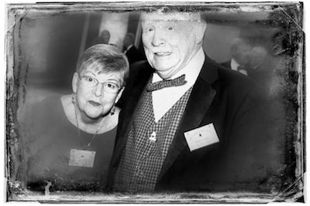

Even scary pictures

# Autumn Is Here

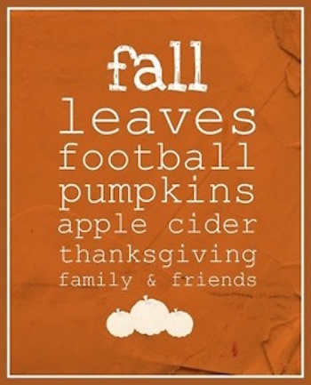

**YOUR BOARD**

President Larry Isham

Vice President Lucky Harrington

Secretary Sandy Slater

Treasurer Kathy Roberts

Hospitality Neil/Nita Woolston

Membership Vicky Kuhn

Roster Donnis Weygandt

Newsletter Paul/Sue Liles

Members At Large Gigi Isham, and Ed Roberts.