# *Presidents Message…*

We had a great time at the last dance. Special thanks to Ed Roberts who captured the event with his camera as our regular photographer was suddenly rushed away for open heart surgery on Wednesday. Paul is doing better and we expect to see him, perhaps moving a little slower than normal, at the upcoming dance.

May marks our Memorial Day tribute dance so dust off those tuxedoes and gowns and join us for a great time to the sounds of “The Time Machine”.

The holiday began after the Civil War, and at that time was known as “Decoration Day.” While it was originally founded to honor the soldiers who died in the Civil War, today, Memorial Day is a day to honor all of the Americans who have died in military service.

Patriotic Americans should take a moment from their day of celebration to reflect on the brave sacrifices of those who have given their lives for this great nation.

Looking forward to seeing all of you on the 20th!

*Larry Isham,  
 President*

*￼*

# A life without love is like a year without summer.

Summer Is Just Around The Corner Anyone?

A perfect summer day is when the sun is shining, the breeze is blowing, the birds are singing, and the lawn mower is broken. ~James Dent

# What You Need To Know

The May 20th dance is at the Petroleum Club and featuring The Time Machine. The cost is $82/couple (includes tax/tip).

No-host cocktail time is 6 pm & great dance music until 10 pm.

**Dress code is Formal.**

Toppers Dinner Menu

Garden Green Salad  
Fresh seasonal vegetables   
Hot Bread and Butter

Entree: New York Cut Steak, broiled steak served with au jus ad baked potatoes OR

Grilled Salmon with Hollandaise sauce and rice OR

Vegetarian Selection

Dessert: Chefs Choice

Mail your checks made out to “Toppers Dance Club” with dinner selections and seating requests on the checks by May 16th to:

Kathy Roberts

12021 Kibbee Ave

La Mirada Ca 90638

# Policy Notes

There are no refunds for cancellations made after the Tuesday before the dance as the arrangements are finalized Tuesday evening.

If you desire to sit with someone please note it with your check so we can attempt to satisfy your seating desires!

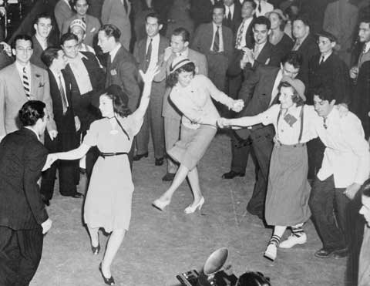

The Topper’s getting ready for their 70th anniversary!...  
Be there or be square… October 2016

# Memorial Day



America is hope. It is compassion. It is excellence. It is valor.

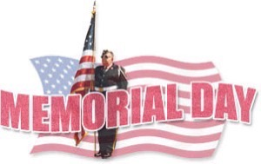

Memorial Day this year is especially important as we are reminded almost daily of the great sacrifices that the men and women of the Armed Services make to defend our way of life.



The story of America's quest for freedom is inscribed on her history in the blood of her patriots. ~Randy Vader



“A hero is someone who has given his or her life to something bigger than oneself.”

**Bits And Pieces**

Many of our dance clubs are coming up on their 70th birthday (just like us). You might be receiving an invite to other dance clubs… If you can, come join the celebration, meet some new interesting people, and help celebrate 70 years of dancing!

The Roberts went off to Washington DC to celebrate their Anniversary and a birthday!

# Upcoming Dance Schedule

**Have a wonderful summer and we will see you again next year to celebrate our 70th year of dining and dancing!**

09/16/2016 with Tony Carinino

10/21/2016 with Howard Solomon

11/18/2016 with Sam Conti

We are off for the summer (June, July, and August). Talk to Paul & Sue for other places to dance during the summer.

To keep the club thriving, we are always looking for new friends to join us and participate in our great parties!

# In The Beginning!

Very few of us will ring in Memorial Day as it was done in the beginning. Today we think of hot dogs, parades, and long weekends. Back then, it was a more solemn occasion born out of the loss and hardship of the Civil War.

John Logan, an obscure figure today, was Commander-in-Chief of the Grand Army of the Republic when he issued General Order No. 11 in 1868, which formally established the holiday on May 30 “for the purpose of strewing flowers, or otherwise decorating the graves of Comrades who died in the defense of their country.” Just 3 years earlier, this long conflict had ended, and the country was still in full recovery.

Imagine taking your carriage to Arlington National Cemetery for the reading of Logan’s General Order, followed by a prayer, hymn, and then speech by General and future President James Garfield. A patriotic song and poem later, you would have joined your friends by walking with the orphaned children of the war and strewing flowers on the graves, ending at the Tomb of the Unknown Soldiers. This too you would have decorated with flowers.

Once at the Tomb, you would have heard Abraham Lincoln’s Gettysburg Address recited, and then gone off to decorate the entire cemetery with flowers, before hearing a performance of the Star Spangled Banner and returning home



**YOUR BOARD**

President Larry Isham

Vice President Dean Fronk

Past President Jerry Ellis

Secretary Lori Fronk

Treasurer Kathy Roberts

Hospitality Neil/Nita Woolston

Membership Vicky Kuhn

Roster Donnis Weygandt

Newsletter Paul/Sue Liles

Members At Large Gigi Isham, Ed Roberts, and Nancy Ellis.