# *Presidents Message…*

We had a great time at the last dance. Special thanks to Ed Roberts who captured the event with his camera as our photographer was suddenly rushed away for open hear surgery on Wednesday. Paul is doing better and we expect to see him, perhaps moving a little slower than normal, at the upcoming dance.

May marks our Memorial Day tribute dance so dust of those tuxedoes and gowns and join us for a great time to the sounds of “The Time Machine”.

The holiday began after the Civil War, and at that time was known as “Decoration Day.” While it was originally founded to honor the soldiers who died in the Civil War, today, Memorial Day is a day to honor all of the Americans who have died in military service.

Patriotic Americans should take a moment from their day of celebration to reflect on the brave sacrifices of those who have given their lives for this great nation.

Looking forward to seeing all of you on the 20th!

*Larry Isham,  
 President*

*￼*

# A life without love is like a year without summer.

Summer Is Just Around The Corner Anyone?

A perfect summer day is when the sun is shining, the breeze is blowing, the birds are singing, and the lawn mower is broken. ~James Dent

# What You Need To Know

The May 20th dance is at the Petroleum Club and featuring The Time Machine. The cost is $74/couple (includes tax/tip).

No-host cocktail time is 6 pm & great dance music until 10 pm.

Dress code is Semi-Formal.

Toppers Dinner Menu

Garden Green Salad  
Fresh seasonal vegetables   
Hot Bread and Butter

Entree: Stuffed Pork Chop (Seasonal stuffing inside center-cut pork chop) with Scalloped Potatoes OR

Grilled White Fish in Lemon Sauce with Rice OR

Vegetarian Selection

Dessert: Chefs Choice

Mail your checks made out to “Toppers Dance Club” with dinner selections and seating requests on the checks by May 12th to:

Kathy Roberts

12021 Kibbee Ave

La Mirada Ca 90638

# Policy Notes

There are no refunds for cancellations made after the Tuesday before the dance as the arrangements are finalized Tuesday evening.

If you desire to sit with someone please note it with your check so we can attempt to satisfy your seating desires!

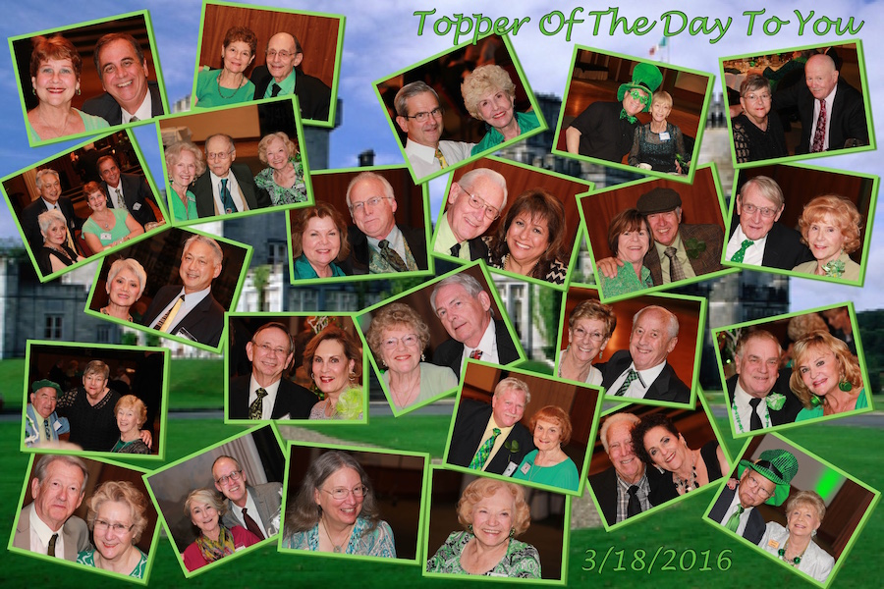

The Topper’s Irish Dance Club in action!

# Prepare To Be Greeted



Irene Kosmetatos

Fun With Friends!

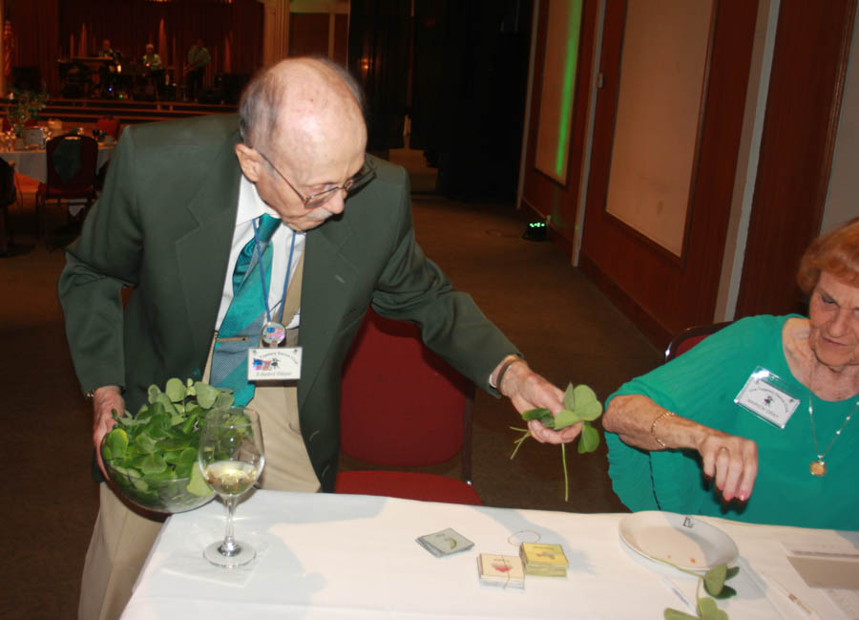

Our own Leprechaun

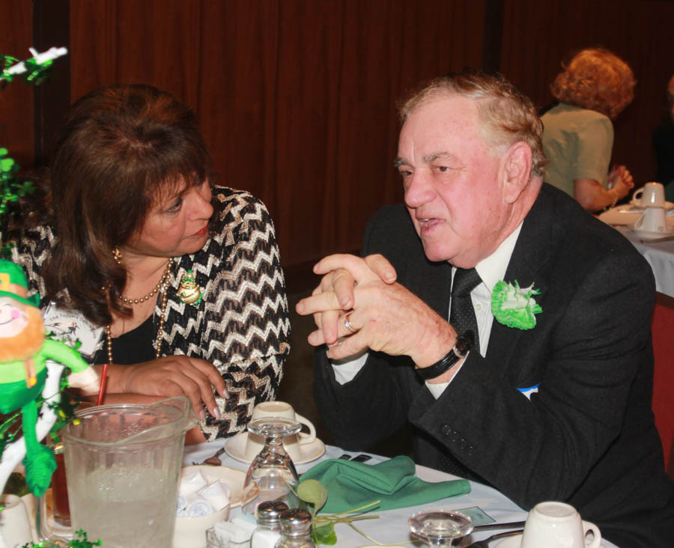

Wally is an expert in malarkey

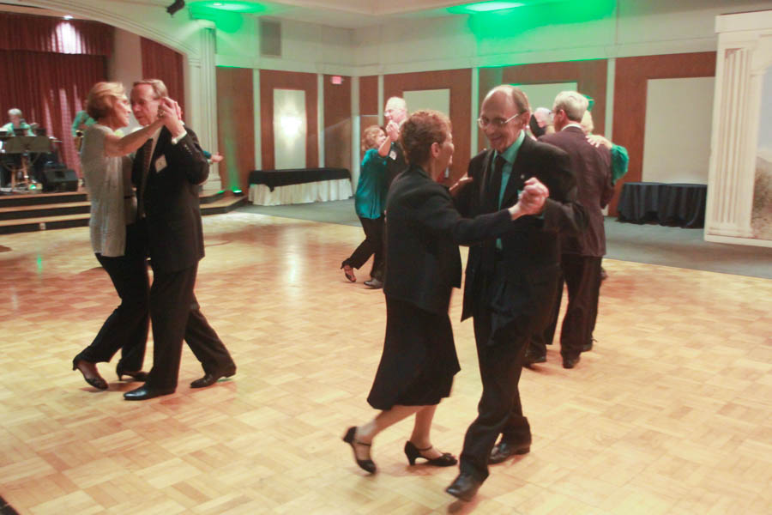  
Dancing the night away

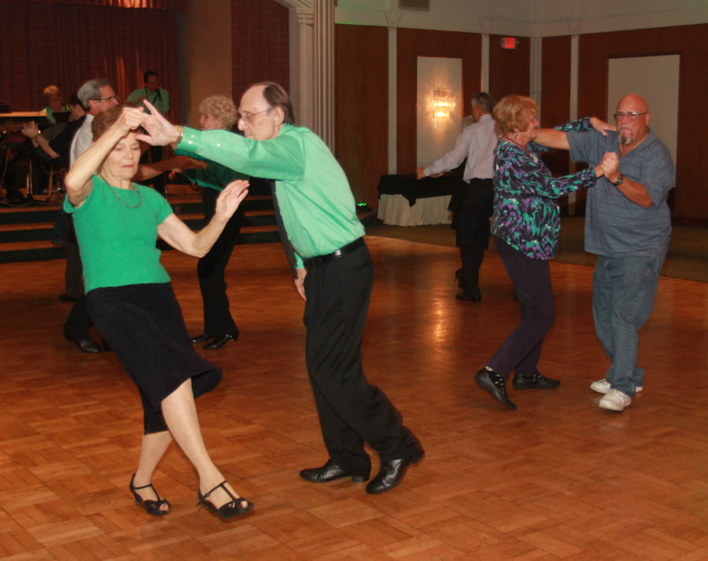  
The dance music was great this evening! The floor was rocking!

**Bits And Pieces**

Many of our dance clubs are coming up on their 70th birthday (just like us). You might be receiving an invite to other dance clubs… If you can, come join the celebration, meet some new interesting people, and help celebrate 70 years of dancing!

Irene visited her daughter in Seattle for two weeks and they attended many of the International Track and Field Games. Ask her about it!

# Upcoming Dance Schedule

Have a wonderful summer and we will see you again next year to celebrate our 70th year of dining and dancing!

05/20/2016 – Time Machine  
(Formal Attire!)

We are off for the summer (June, July, and August). Talk to Paul & Sue for other places to dance during the summer.

# Bring A Friend!

To keep the club thriving, we are always looking for new friends to join us and participate in our great parties!

# In The Beginning!

Very few of us will ring in Memorial Day as it was done in the beginning. Today we think of hot dogs, parades, and long weekends. Back then, it was a more solemn occasion born out of the loss and hardship of the Civil War.

John Logan, an obscure figure today, was Commander-in-Chief of the Grand Army of the Republic when he issued General Order No. 11 in 1868, which formally established the holiday on May 30 “for the purpose of strewing flowers, or otherwise decorating the graves of Comrades who died in the defense of their country.” Just 3 years earlier, this long conflict had ended, and the country was still in full recovery.

Imagine taking your carriage to Arlington National Cemetery for the reading of Logan’s General Order, followed by a prayer, hymn, and then speech by General and future President James Garfield. A patriotic song and poem later, you would have joined your friends by walking with the orphaned children of the war and strewing flowers on the graves, ending at the Tomb of the Unknown Soldiers. This too you would have decorated with flowers.

Once at the Tomb, you would have heard Abraham Lincoln’s Gettysburg Address recited, and then gone off to decorate the entire cemetery with flowers, before hearing a performance of the Star Spangled Banner and returning home



**YOUR BOARD**

President Larry Isham

Vice President Dean Fronk

Past President Jerry Ellis

Secretary Lori Fronk

Treasurer Kathy Roberts

Hospitality Neil/Nita Woolston

Membership Vicky Kuhn

Roster Donnis Weygandt

Newsletter Paul/Sue Liles

Members At Large Gigi Isham, Ed Roberts, and Nancy Ellis.