# *Presidents Message…*

Q: Why can't you borrow money from a leprechaun?

A: Because they're always a little short.

We missed you at the last dance but we heard via the shamrock vine that things went well! We hope you also had time to look through the pictures on our website.

Welcome Al and Colleen Lum and rumor has it you were seen dancing at the Phoenix Club on Thursday! Six Topper couples dance at the Phoenix Club every week!

We hope you had a great Saint Patrick’s Day celebration. Did you know that the very first St. Patrick's Day parade was not in Ireland. It was in Boston in 1737.

If you can, wear something green and spinach between your teeth does not count!

This newsletter is Volume 69. That means our September 2016 dance with be our 70th birthday! Bring your ideas to the next dance… Let’s do something special!

Looking forward to seeing all of you on the 18th!

*Larry Isham,  
 President*

*￼￼*[](https://www.google.com/url?sa=i&rct=j&q=&esrc=s&source=images&cd=&ved=&url=http://www.clipartsfree.net/tag/hearts.html&psig=AFQjCNFA_Uav66zccHlZf0tXuEvk9rGPzQ&ust=1453998963860541)

**

If a man who cannot count finds a four-leaf clover, is he lucky?

Four Leaf Clovers Anyone?

“St. Patrick's Day is an enchanted time - a day to begin transforming winter's dreams into summer's magic.”

Read more at http://www.brainyquote.com/quotes/topics/topic_love.html#AVciDJcRfAe7C8F2.99.”

― Brad Paisley--Irv Kupcine

Read more at http://www.brainyquote.com/quotes/keywords/halloween.html#THt5bFJqK9iSTBHG.99

# What You Need To Know

The March 18th dance is at the Petroleum Club and featuring Jim Gilman. The cost is $74/couple (includes tax/tip).

No-host cocktail time is 6 pm & great dance music until 10 pm.

Dress code is Semi-Formal.

Toppers Dinner Menu

Garden Green Salad  
Fresh seasonal vegetables   
Hot Bread and Butter

Entree: Chicken Marsala baked boneless chick breast with marsala wine sauce and au gratin potatoes OR

Fish of the Day with rice OR Vegetarian Selection

Dessert: Chefs Choice

Mail your checks made out to “Toppers Dance Club” with dinner selections and seating requirements on the checks by February 15th to:

Kathy Roberts

12021 Kibbee Ave

La Mirada Ca 90638

# Policy Notes

There are no refunds for cancellations made after the Tuesday before the dance as the arrangements are finalized Tuesday evening.

If you desire to sit with someone please note it with your check so we can attempt to satisfy your seating desires!



The Topper’s are a romantic bunch!!!

# Prepare To Be Greeted

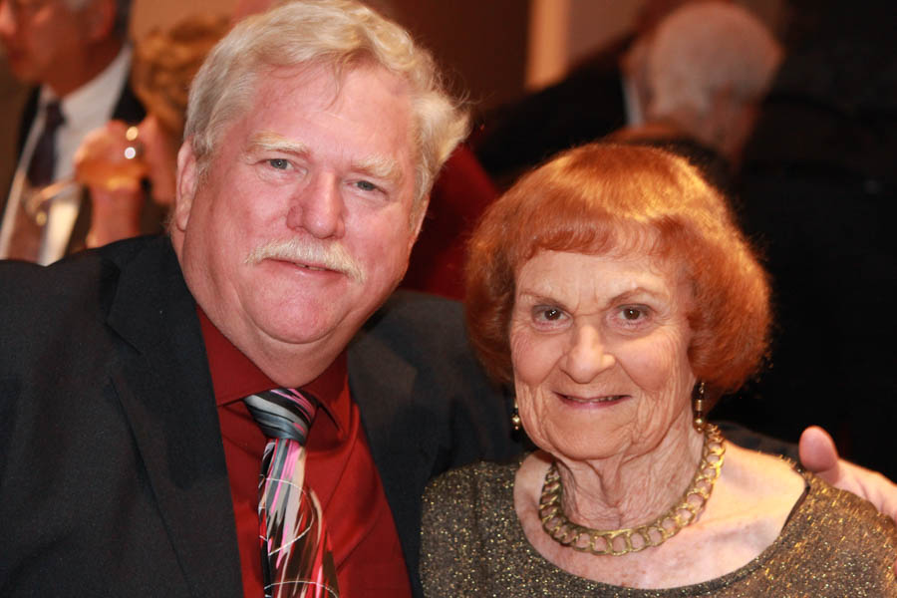

Gary and Marion Gray

Fun With Friends!

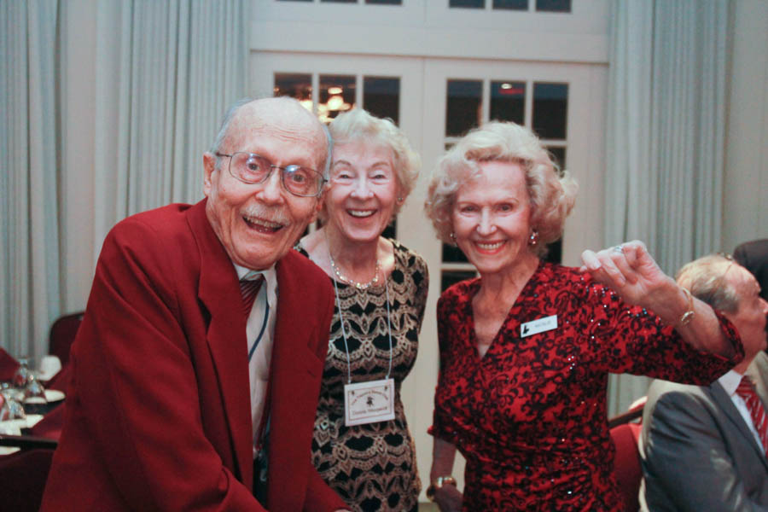

Dressed for Valentine’s Day!

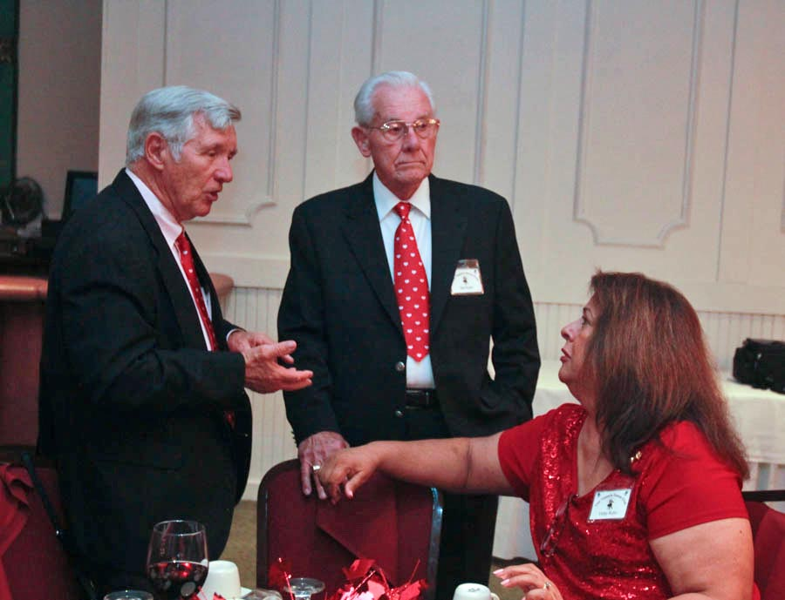

Matching ties!

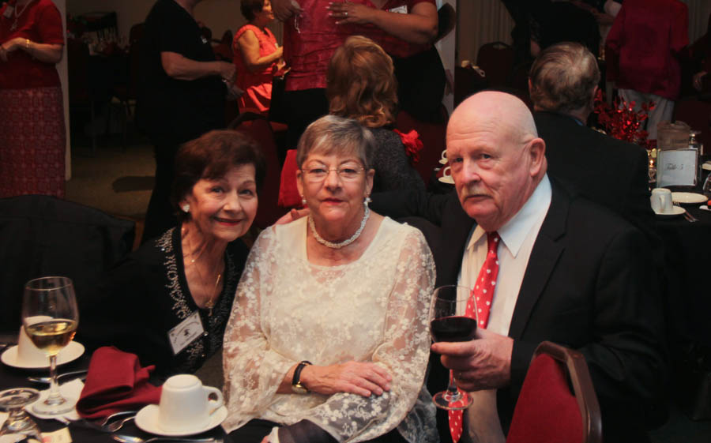  
Jan, Sue, and Paul

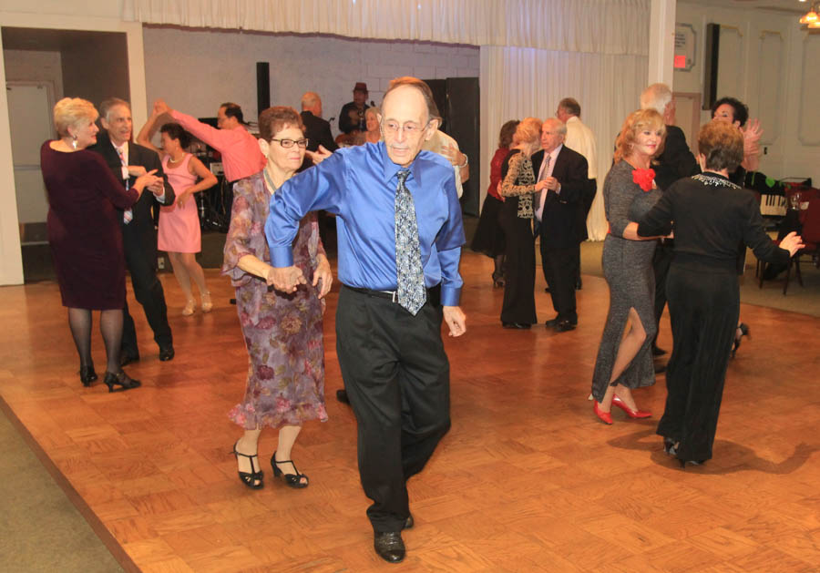  
The dance music was great this evening! Tony was on his game!

**Bits And Pieces**

The Garden Grove Elks were re[resented tonight by Margot and Pat

The Liles’s added a new avocado tree to their yard near the border with Vicky and Del Kuhn. While the guys were planting the tree, Paul went into the house! When he came out, Vicky was talking to the guys and thre tree somehow was listing 45 degrees toward Vicky’s house! Coincidence? We think not!

# Upcoming Dance Schedule

Only two more dances this year and then we celebrate our 70th year!

04/15/2016 – Sam Conti

05/20/2016 – Time Machine

# Bring A Friend!

To keep the club thriving, we are always looking for new friends to join us and participate in our great parties!

# Wearing Of The Green

"The Wearing of the Green" is an Irish street ballad lamenting the repression of supporters of the Irish Rebellion of 1798. It is to an old Irish air, and many versions of the lyric exist, the best-known being by Dion Boucicault. The song proclaims that "they are hanging men and women for the wearing of the green".

The revolutionary Society of United Irishmen adopted green as its color, and supporters wore green-colored garments, ribbons, or cockades.

This was considered sedition by the Dublin Castle administration according to Poynings' Law and often resulted in prosecution by the authorities or violent reprisals by loyalist mobs.

In some versions, the "green" being worn is shamrock rather than fabric.

# In Davy Byrne's pub

A ventriloquist is telling Irish jokes in Davy Byrne's pub in Grafton Street, Dublin, when, O'Leary, an irate Irishman stands up shouting, 'You're making out we're all dumb and stupid. I oughtta punch you in the nose.'

'I'm sorry sir, I...........'

'Not you,' says O'Leary, 'I'm talking to that little fella on your knee.'

# We Need A Secretary

We are still looking for a club secretary to step in for Lori Fronk. It’s an easy task taking only an hour a month. See how your club works! Call Larry Isham and volunteer.

**YOUR BOARD**

President Larry Isham

Vice President Dean Fronk

Past President Jerry Ellis

Secretary Lori Fronk

Treasurer Kathy Roberts

Hospitality Neil/Nita Woolston

Membership Vicky Kuhn

Roster Donnis Weygandt

Newsletter Paul/Sue Liles

Members At Large Gigi Isham, Ed Roberts, and Nancy Ellis.