# *Presidents Message…*

What a great way to start the year! Visiting with friends we haven’t seen since last year, great music, and a delightful evening!

The staff worked hard and made sure the tables were taken care of promptly and the liquid libations were delivered immediately!

Welcome new members! We also had several guest couples and we hope they decide to join in on the fun! Al and Colleen Lum brought two guest couples!

We got some great pictures during the soiree so please visit our website or search Google for “Toppers Dance Club”.

Our dance will miss Valentine’s Day by a few days but you can wear your reds as a reminder of the holiday!

Remember: “True love is like ghosts, which everyone talks about and few have seen.”

This newsletter is Volume 69. That means our September 2016 dance with be our 70th birthday! Bring your ideas to the next dance… Let’s do something special!

Looking forward to seeing all of you on the 19th!

*Larry Isham,  
 President*

*￼￼*[](https://www.google.com/url?sa=i&rct=j&q=&esrc=s&source=images&cd=&ved=&url=http://www.clipartsfree.net/tag/hearts.html&psig=AFQjCNFA_Uav66zccHlZf0tXuEvk9rGPzQ&ust=1453998963860541)

**

You can't blame gravity for falling in love…

The Valentine’s Day Spirit Is In The Air!

“Love is when the other person's happiness is more important than your own.”

Read more at http://www.brainyquote.com/quotes/topics/topic_love.html#AVciDJcRfAe7C8F2.99.”

― Brad Paisley--Irv Kupcine

Read more at http://www.brainyquote.com/quotes/keywords/halloween.html#THt5bFJqK9iSTBHG.99

# What You Need To Know

The February 19th dance is at the Petroleum Club and featuring Tony Carinino. The cost is $74/couple (includes tax/tip).

No-host cocktail time is 6 pm & great dance music until 10 pm.

Dress code is Semi-Formal.

Toppers Dinner Menu

Garden Green Salad  
Fresh seasonal vegetables   
Hot Bread and Butter

Entree: Roast Tri-Tip, lean tender beef served with Bordelaise Sauce and Scalloped Potatoes OR Baked Salmon with Hollandaise Sauce and Rice OR Vegetarian Selection

Dessert: Chefs Choice

Mail your checks made out to “Toppers Dance Club” with dinner selections and seating requirements on the checks by February 15th to:

Kathy Roberts

12021 Kibbee Ave

La Mirada Ca 90638

# Policy Notes

There are no refunds for cancellations made after the Tuesday before the dance as the arrangements are finalized Tuesday evening.

If you desire to sit with someone please note it with your check so we can attempt to satisfy your seating desires!

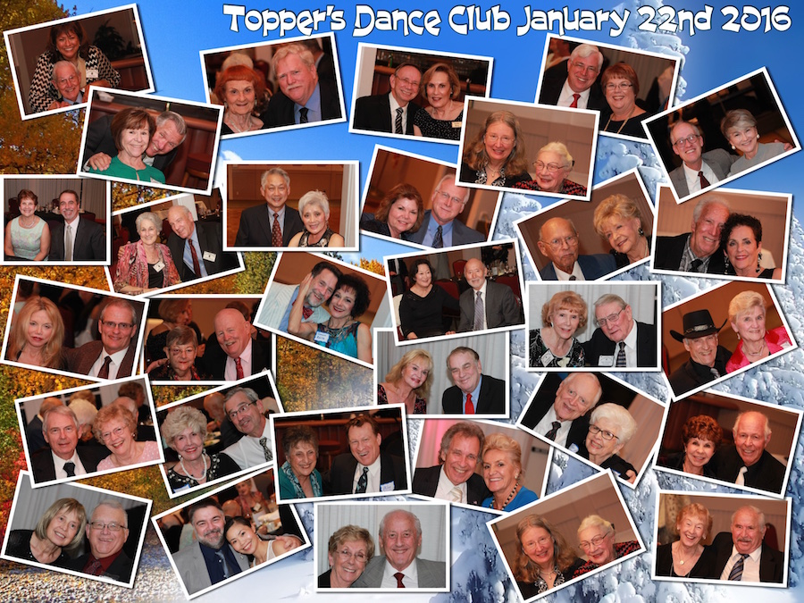

Thedancing kept us warm on this cold California night!

# Prepare To Be Greeted

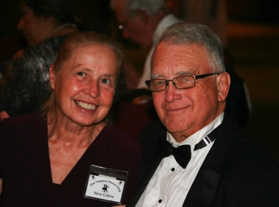

Norm Maclean and Nina Collins

Fun With Friends!

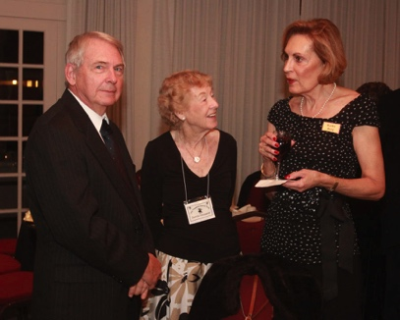

Catching up is essential!

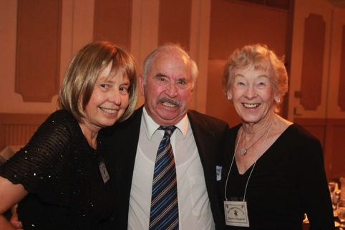

Bernie is surrounded!

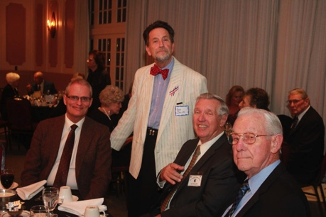  
Bob Zaitz visits friends

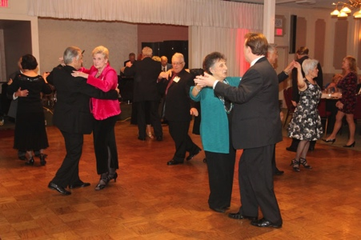  
The dance music kept us moving all evening!

**Bits And Pieces**

The Nighlighter’s dance near LAX every two months and always formal!

The Starlighter’s dance in north orange county at various venue’s and have two formals, two semi-formals, and two casual dances a year.

The Liles’ will have their daughter, granddaughter, and new great grandson visiting in February.

# Upcoming Dance Schedule

Only three more dances this year and then we celebrate our 70th year!

03/18/2016 – Jim Gilman

04/15/2016 – Sam Conti

# Bring A Friend!

To keep the club thriving, we are always looking for new friends to join us and participate in our great parties!

# Welcome New Members

Al and Colleen Lum, Larry and Penny Guentherman, and Iris Feltenberg and Will Tomkeil are now Topper’s! Welcome aboard and be ready for great dancing and loads of friendship.

# We Had VIP’s Joining Us!

Larry and Penny Guentherman are the presidents of The Nightlighter’s Dance Club and Bob and Donna Zaitz are the presidents of The Starlighter’s Dance Club! Welcome to Topper’s!!

# Nuts About Love

Driving through Southern California, I stopped at a roadside stand that sold fruit, vegetables and crafts.

As I went to pay, I noticed the young woman behind the counter was painting a sign. “Why the new sign?” I asked.

“My boyfriend didn’t approve of the old one,” she said. When I glanced at what hung above the counter, I understood. It declared: “Local Honey Dates Nuts” – Contributed by Theodore Bologna

# About Our Website

Just Google “Toppers Dance Club” and our site will be the first on the search list!

# We Need A Secretary

We are still looking for a club secretary to step in for Lori Fronk. It’s an easy task taking only an hour a month. See how your club works! Call Larry Isham and volunteer.

**YOUR BOARD**

President Larry Isham

Vice President Dean Fronk

Past President Jerry Ellis

Secretary Lori Fronk

Treasurer Kathy Roberts

Hospitality Neil/Nita Woolston

Membership Vicky Kuhn

Roster Donnis Weygandt

Newsletter Paul/Sue Liles

Members At Large Gigi Isham, Ed Roberts, and Nancy Ellis.