On Thanksgiving Day, all over America, families sit down to dinner at the same moment!

Read more at http://www.brainyquote.com/quotes/keywords/halloween.html#THt5bFJqK9iSTBHG.99

Almost Turkey Day…

# *Presidents Message…*

We hope your Halloween was not too scary! The scariest part is standing on the scales after eating the candies!

It finally seems like Fall is here after our hot weather. The trees are turning and leaves are dropping.

Our next dance features San Conti and is a semi-formal affair with emphasis on celebrating Thanksgiving.

Paul and Sue Liles are going to be attending their grandsons wedding and will miss the dance which means we encourage you to bring you cameras and take pictures. Email the pictures to Paul and he will complete our website for the upcoming dance!

The Petroleum Club is getting a leg up (no pun intended) on Thanksgiving and are providing a Thanksgiving-like option for the evening! Slow roasted turkey sure sounds good!

As always, please take some time and ask friends to join us and become members of the club.

We welcomed Rita and Ron as guests of the Sebern’s and hope they come back again soon!

We are looking forward to seeing you November 20th and bring your cameras!

*Larry Isham,  
 President*



*￼￼*

An optimist is a person who starts a new diet on Thanksgiving Day.

--Irv Kupcine

Read more at http://www.brainyquote.com/quotes/keywords/halloween.html#THt5bFJqK9iSTBHG.99

# What You Need To Know

The November 20th dance is at the Petroleum Club and features Sam Conti. The cost is $74/couple (includes tax/tip).

No-host cocktail time is 6 pm & great dance music until 10 pm.

Dress code is semi-formal.

Toppers Dinner Menu

Garden Green Salad  
Fresh seasonal vegetables   
Hot Bread and Butter

Entree: Slow Roasted Turkey Breast with Home-Made Corn Bread Stuffing, Cranberry Sauce and Supreme Sauce with Mashed Potatoes OR Grilled Salmon with Hollandaise Sauce and Rice OR Vegetarian Selection

Dessert: Chefs Choice

Mail your checks made out to “Toppers Dance Club” with dinner selections on the checks by September 13th to:

Kathy Roberts

12021 Kibbee Ave

La Mirada Ca 90638

Note: If you can’t get the check in by the 13th call Kathy.

# Policy Notes

There are no refunds for cancellations made after the Tuesday before the dance as the arrangements are finalized Tuesday evening.

If you desire to sit with someone please note it with your check so we can attempt to satisfy your seating desires!

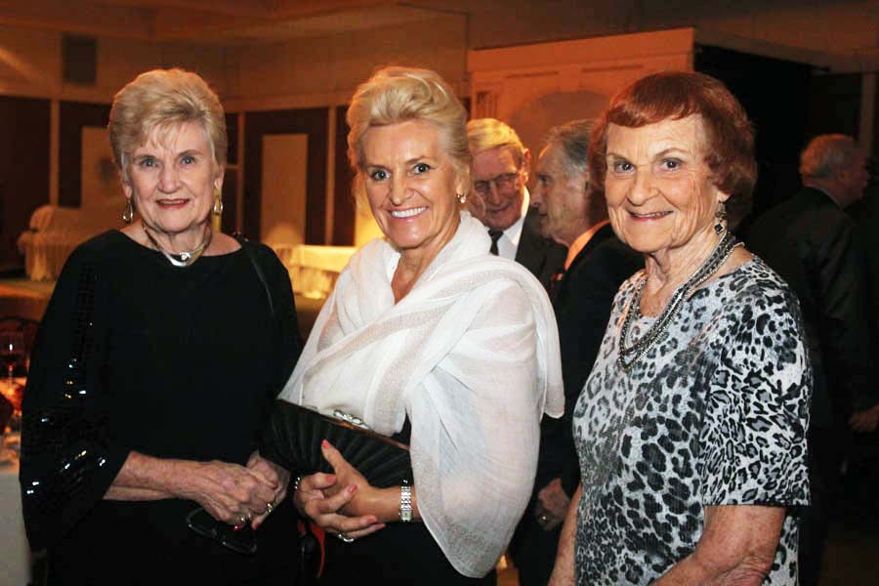

The party can now officially start!

**Bits And Pieces**

Bernie celebrated his 94th birthday with Donnis and the Liles’ and dined on extra-hot jambalaya.

The Roberts just returned from a two week vacation in Florida enjoying mild temperatures and a lot of sun!

We are still looking for a Secretary for the club. It simply involves takes notes at the 30 minute meeting and writing them up. Easy Pizzy!

# Prepare To Be Greeted



Irene Kosmetatos

Fun With Friends!

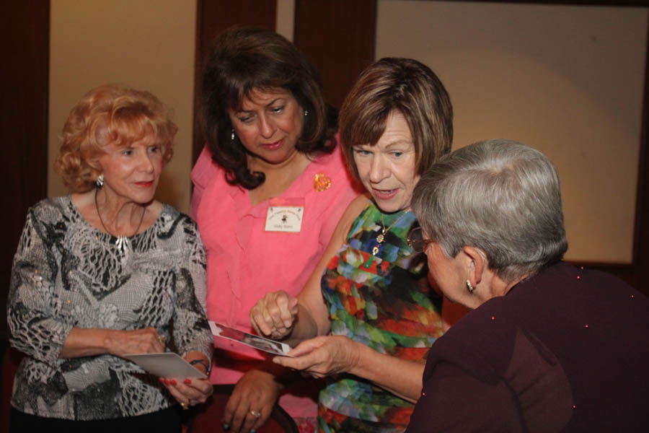

New Grandma Pictures

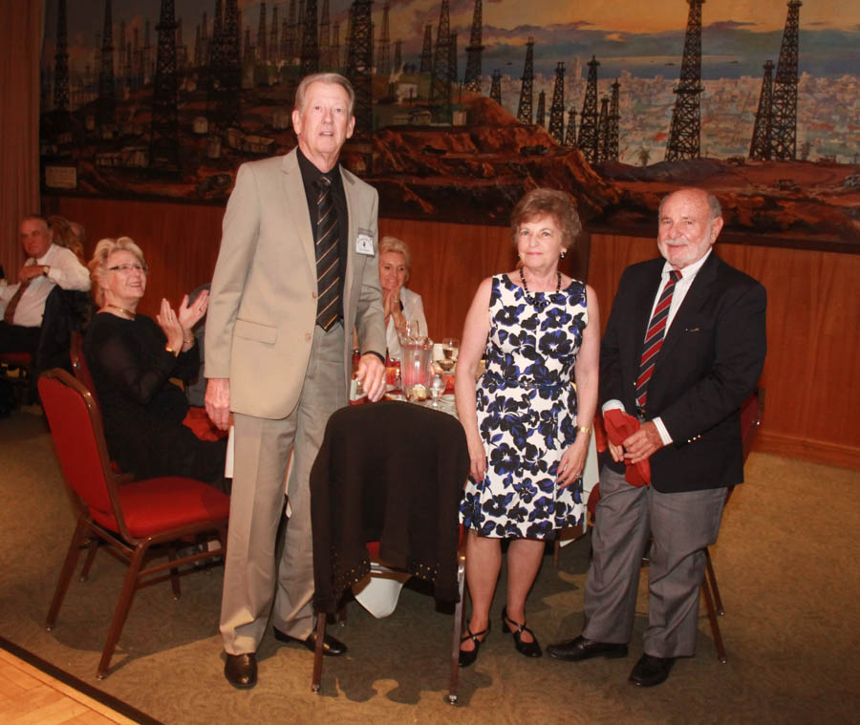

Welcome Guests Ron & Rita

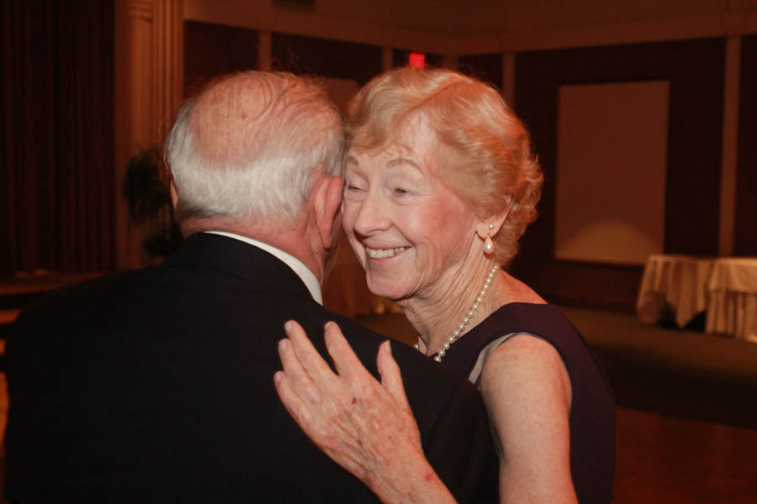  
A Million Dollar Smile

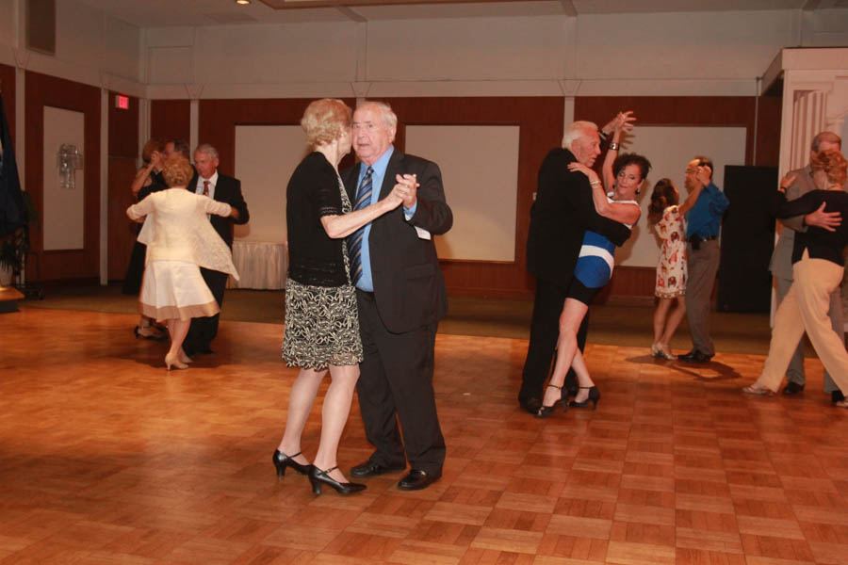Dancing the night away

# Upcoming Dance Schedule

11/20/2015 – Sam Conte

12/18/2015 – The Time Machine

# Bring A Friend!

To keep the club thriving, we are always looking for new friends to join us and participate in our great parties!

# Do You Remember?

When I was a little kid, there was one house in my neighborhood which I both loved and feared trick-or-treating at. Just two blocks over from mine, this home was an unassuming bungalow 364 days of the year.

Come Halloween night, however, and it was transformed.

The family who lived here clearly loved Halloween, and it showed. On walking up the driveway trick-or-treaters were greeted with the usual assortment of cobwebs, tombstones and creepy music.

After knocking (tentatively) on the door, you'd wait with bated breath until it began to open ever-so-slowly, a mangled warlock's hand emerging through the door frame.



This (fake) hand in fact belonged to a friendly, candy-touting suburban dad, but before this was revealed, you were never entirely sure that you weren't about to be snatched off the porch and locked up in a dungeon of terror.

Did you have a favorite Halloween house as a kid? What made it so scary/special?

# About Our Website

Just Google “Toppers Dance Club” and our site will be the first on the search list!

**YOUR BOARD**

President Larry Isham

Vice President Dean Fronk

Past President Jerry Ellis

Secretary Lori Fronk

Treasurer Kathy Roberts

Hospitality Neil/Nita Woolston

Membership Vicky Kuhn

Roster Donnis Weygandt

Newsletter Paul/Sue Liles

Members At Large Gigi Isham, Ed Roberts, and Nancy Ellis.