On Thanksgiving Day, all over America, families sit down to dinner at the same moment!

Read more at http://www.brainyquote.com/quotes/keywords/halloween.html#THt5bFJqK9iSTBHG.99

Almost Turkey Day…

# *Presidents Message…*

We hope your Halloween was not too scary! The scariest part is standing on the scales after eating the candies!

It finally seems like Fall is here after our hot weather. The trees are turning and leaves are dropping.

Our next dance features San Conti and is a semi-formal affair with emphasis on celebrating Thanksgiving.

Paul and Sue Liles are going to be attending their grandsons wedding and will miss the dance which means we encourage you to bring your cameras and take pictures. Email the pictures to Paul and he will complete our website for the November dance!

The Petroleum Club is getting a leg up on Thanksgiving and are providing a Thanksgiving-like option for the evening! Slow roasted turkey sure sounds good!

As always, please take some time and ask friends to join us and become members of the club.

We welcomed Rita and Ron as guests of the Sebern’s and hope they come back again soon!

We are looking forward to seeing you November 20th and bring your cameras!

*Larry Isham,  
 President*

*￼￼*

An optimist is a person who starts a new diet on Thanksgiving Day.

--Irv Kupcine

Read more at http://www.brainyquote.com/quotes/keywords/halloween.html#THt5bFJqK9iSTBHG.99

# What You Need To Know

The November 20th dance is at the Petroleum Club and features Sam Conti. The cost is $74/couple (includes tax/tip).

No-host cocktail time is 6 pm & great dance music until 10 pm.

Dress code is semi-formal.

Toppers Dinner Menu

Garden Green Salad  
Fresh seasonal vegetables   
Hot Bread and Butter

Entree: Slow Roasted Turkey Breast with Home-Made Corn Bread Stuffing, Cranberry Sauce and Supreme Sauce with Mashed Potatoes OR Grilled Salmon with Hollandaise Sauce and Rice OR Vegetarian Selection

Dessert: Chefs Choice

Mail your checks made out to “Toppers Dance Club” with dinner selections on the checks by November 17th to:

Kathy Roberts

12021 Kibbee Ave

La Mirada Ca 90638

Note: If you can’t get the check in by the 13th call Kathy.

# Policy Notes

There are no refunds for cancellations made after the Tuesday before the dance as the arrangements are finalized Tuesday evening.

If you desire to sit with someone please note it with your check so we can attempt to satisfy your seating desires!

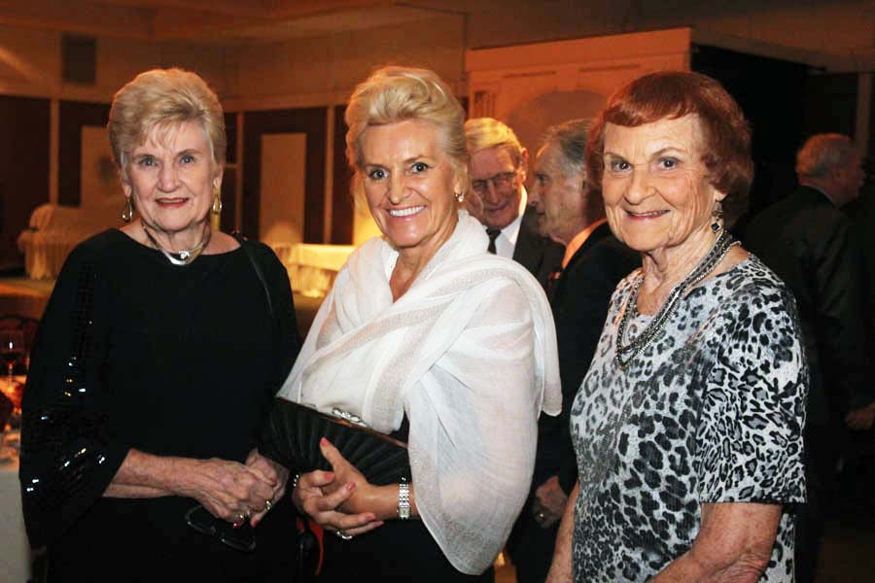

The party can now officially start!

# Prepare To Be Greeted

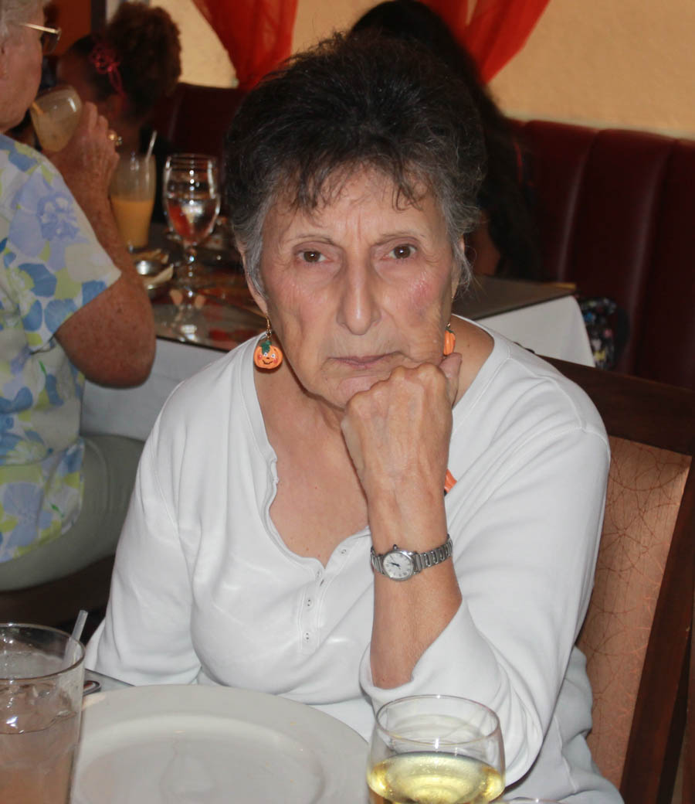

Irene Kosmetatos

Fun With Friends!

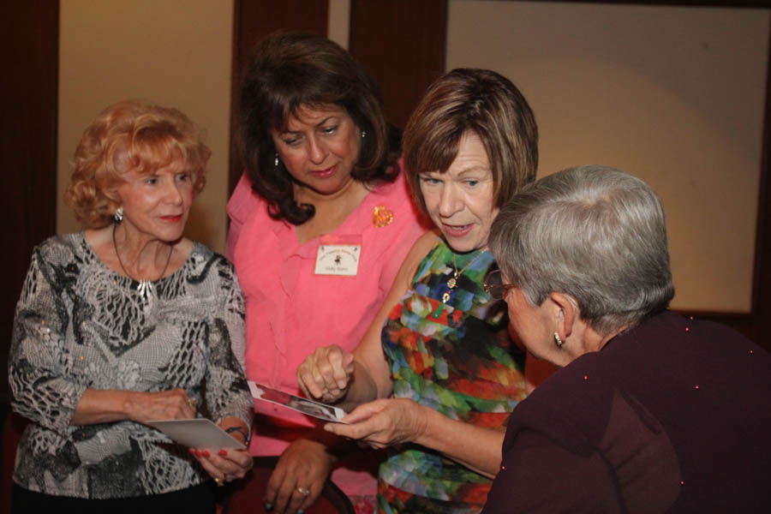

New Grandma Pictures

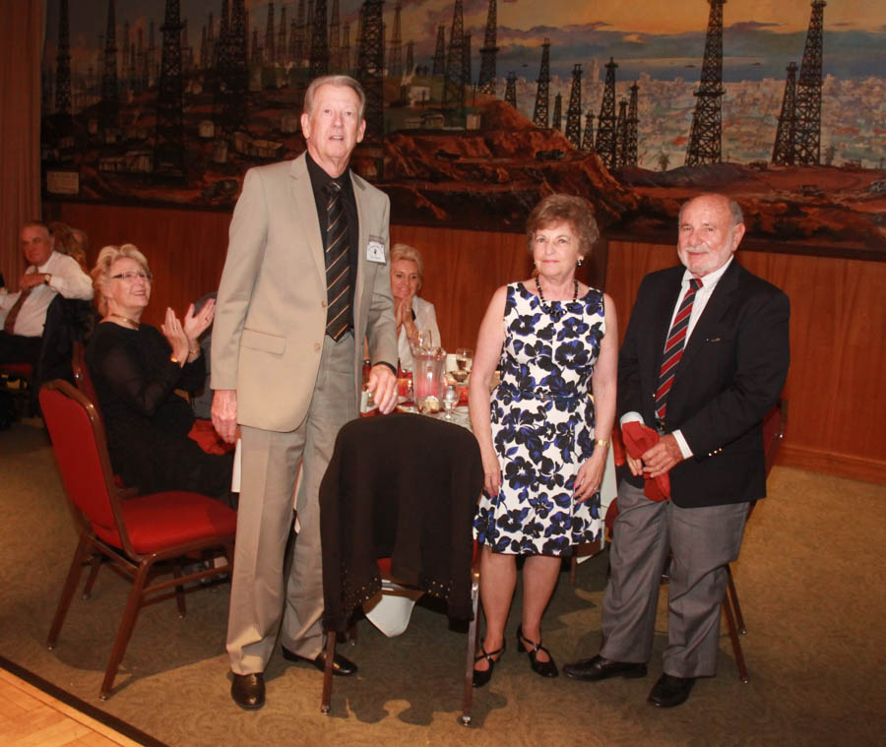

Welcome Guests Ron & Rita

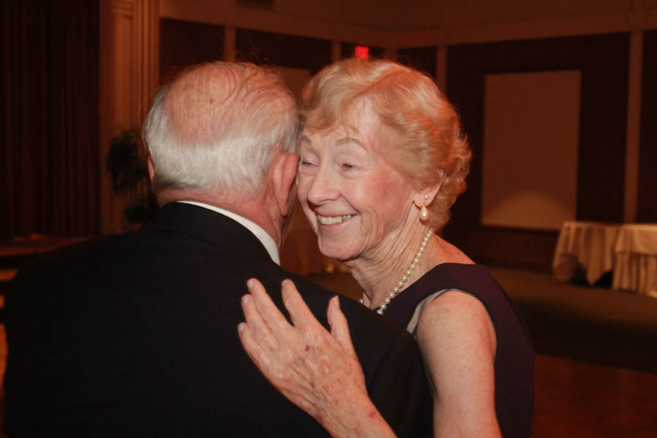  
A Million Dollar Smile

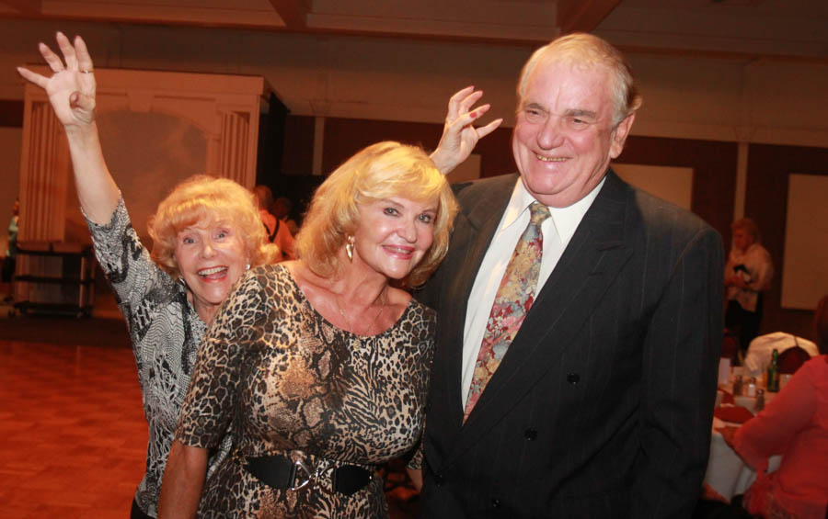Photobombed

**Bits And Pieces**

Vicky and Del Kuhn are grandparents again! Clark was born to their daughter Amber and son-in-law Robbie so Logan has a baby brother!

We are still looking for a Secretary for the club. It simply involves takes notes at the 30 minute meeting and writing them up. Easy Pizzy!  
  
Paul and Sue Liles are dressing up in western attire and attending their grandson’s wedding in Lyttle Creek on November 21st.

# Upcoming Dance Schedule

12/18/2015 – The Time Machine

1/22/2015 – Howard Solomon

2/19/2016 – Tony Carinino

3/18/2016 – Jim Gilman

4/15/2016 – Sam Conti

5/20/2016 – Time Machine

No dances in June, July or August

# Bring A Friend!

To keep the club thriving, we are always looking for new friends to join us and participate in our great parties!

# Time To Give Thanks…

There is one day that is ours. There is one day when all we Americans who are not self-made go back to the old home to eat saleratus biscuits and marvel how much nearer to the porch the old pump looks than it used to. Thanksgiving Day is the one day that is purely American. ~O. Henry

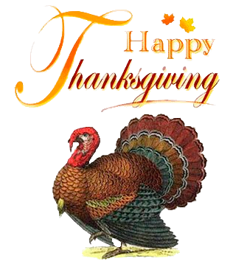

# Towns Named “Turkey”

This land is my land: There are four places in the United States named Turkey.

Louisiana's Turkey Creek is the most populous, with a whopping 435 residents. There's also Turkey, Texas; Turkey, North Carolina; and Turkey Creek, Arizona.

Oh, let's not forget the two townships in Pennsylvania: the creatively named Upper Turkeyfoot and Lower Turkeyfoot!

# About Our Website

Just Google “Toppers Dance Club” and our site will be the first on the search list!

Become famous and get your pictures published! Remember to bring a camera and take some pictures of the next dance as our photographer has to miss the next dance!

**YOUR BOARD**

President Larry Isham

Vice President Dean Fronk

Past President Jerry Ellis

Secretary Lori Fronk

Treasurer Kathy Roberts

Hospitality Neil/Nita Woolston

Membership Vicky Kuhn

Roster Donnis Weygandt

Newsletter Paul/Sue Liles

Members At Large Gigi Isham, Ed Roberts, and Nancy Ellis.