“Autumn...the year's last, loveliest smile."

If you dance with your heart, your body will follow...

# What You Need To Know

The September 18th dance is at the Petroleum Club and features Tony Carinio. The cost is $80/couple (includes tax/tip).

No-host cocktail time is 6 pm & great dance music until 10 pm.

Dress code is semi-formal.

Toppers Dinner Menu

Garden Green Salad  
Fresh seasonal vegetables   
Hot Bread and Butter

Entree: Chicken Piccata, boneless breast of chicken with wine sauce, lemon butter sauce with capers, and rice OR Grilled Whitefish in lemon sauce and rice OR Vegetarian selection

Dessert: Chefs Choice, Coffee, tea or decaffeinated coffee.

Mail your checks made out to “Toppers Dance Club” with dinner selections on the checks by September 15th to:

Diane Schmitz

3475 Lilly Avenue

Long Beach Ca 90808-3214

Note: If you can’t get the check in by the 15th call Diane.

# Policy Notes

There are no refunds for cancellations made after the Tuesday before the dance as the arrangements are finalized Tuesday evening.

If you desire to sit with someone please note it with your check so we can attempt to satisfy your seating desires!

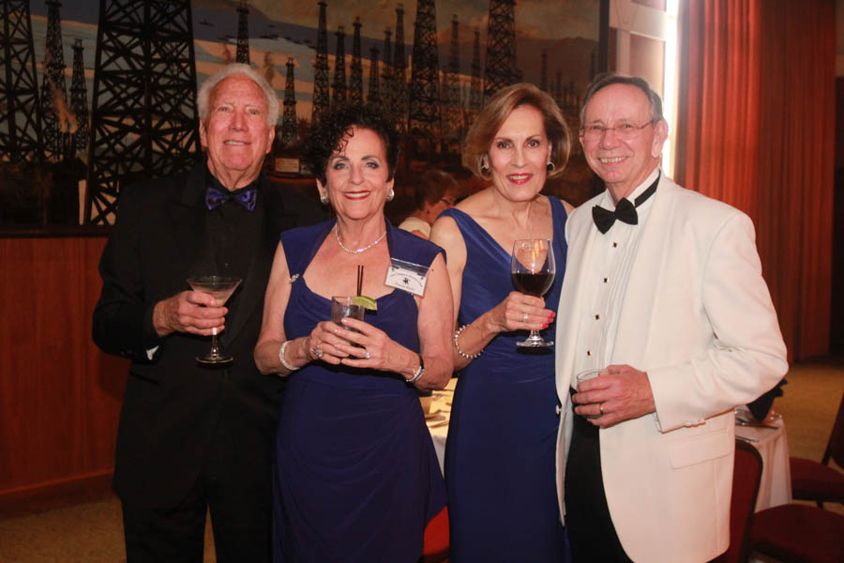

It’s time to dance!

# *Presidents Message…*

Welcome back to our new dance season. The hot days of summer seem to have gone away and the cooler days are here. In November the time changes and we will be dancing in the dark.

We hope you had a great summer vacation and that you found places to keep your dancing skills honed for the upcoming season.

Our next dance features Tony Carinio and is a semi-formal affair with emphasis on celebrating being back together again.

We welcome Kathy Roberts as our new Treasurer!

If you have any good stories about your vacation, see Paul or Sue Liles so we can add it to the Toppers Topics and share with the club.

As always, please take some time and ask friends to join us and become members of the club.

We are looking forward to seeing you September 18th,

*Larry Isham,  
 President*



*￼￼*

Welcome Back From Summer!

**Bit’s And Pieces**

Vicky Kuhn is going to be a grandmother again! Another boy! She is in heaven.

The Liles and Roberts had a great visit to the Trump Annual Beer and Wine Festival where the music was quite danceable!

We are still looking for a Secretary for the club. It simply involves takes notes at the 30 minute meeting and writing them up. Easy Pizzy!

# Prepare To Be Greeted

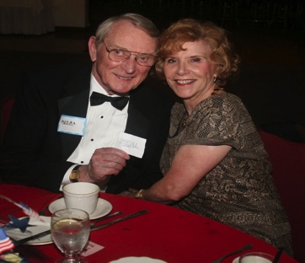

Neal and Nita Woolston

What A Great Dance!

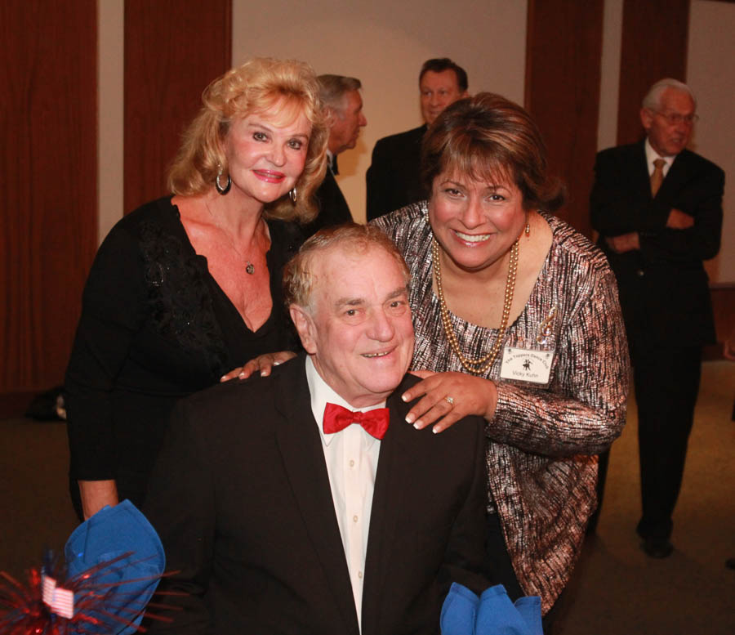

Wally, Ghislaine, and Vicky

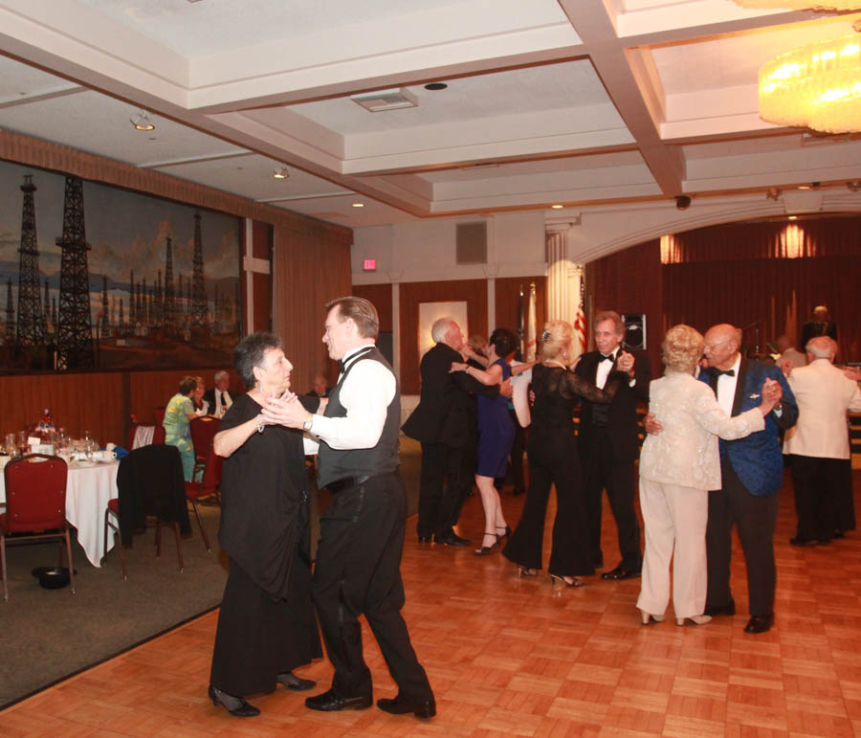

Floating across the floor

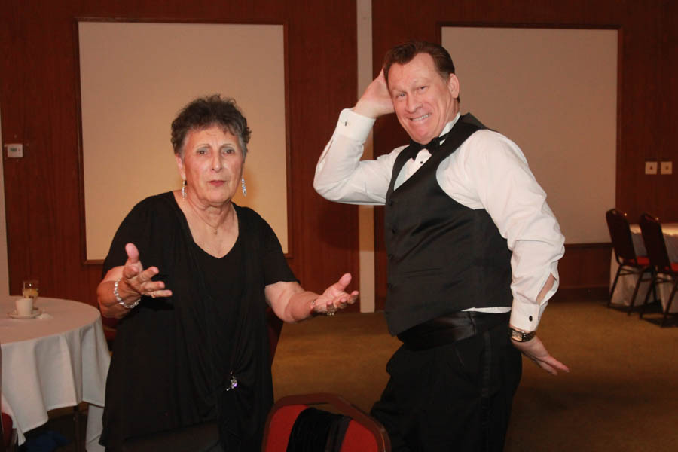  
Irene and Mike learn a new step

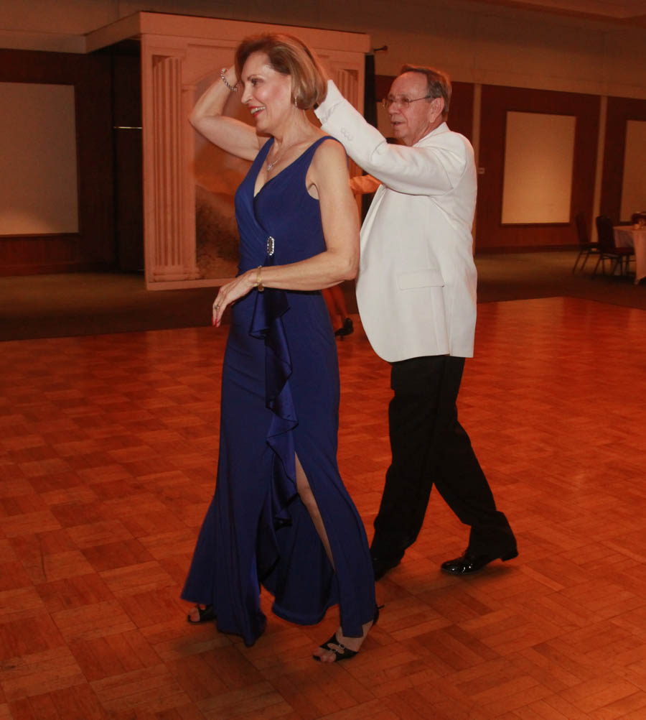  
Making it look so easy

# Upcoming Dance Schedule

10/16/2015 – Howard Solomon

11/20/2015 – Sam Conte

12/18/2015 – The Time Machine

# Bring A Friend!

To keep the club thriving, we are always looking for new friends to join us and participate in our great parties!

# Thoughts About Seasons…

“Spring passes and one remembers one’s innocence. Summer passes and one remembers one’s exuberance. Autumn passes and one remembers one’s reverence. Winter passes and one remembers one’s perseverance.” ~ Yoko Ono

“What good is the warmth of summer, without the cold of winter to give it sweetness.” ~ John Steinbeck

“People don’t notice whether it’s winter or summer when they’re happy.” ~ Anton Chekhov

# We Do Rumba…

# Rumba is a family of percussive rhythms, song and ballroom dance that originated in Cuba as a combination of various musical traditions. The name derives from the Cuban Spanish word rumbo which means "party" or "spree". It is secular, with no religious connections

# People of African descent in Havana and Matanzas originally used the word rumba as a synonym for party

# Olavo Alén states that over time, "rumba ceased to be simply another word for party and took on the meaning both of a defined Cuban musical genre and also of a very specific form of dance”

# The term spread in the 1930s and 1940s to the faster popular music of Cuba (the "Peanut Vendor" was a classic), where it was used as a catch-all term, rather like salsa today.

# About Our Website

Just Google “Toppers Dance Club” and our site will be the first on the search list!

**YOUR BOARD**

President Larry Isham

Vice President Dean Fronk

Past President Jerry Ellis

Secretary Lori Fronk

Treasurer Kathy Roberts

Hospitality Neil/Nita Woolston

Membership Vicky Kuhn

Roster Donnis Weygandt

Newsletter Paul/Sue Liles

Members At Large Gigi Isham, Dennis Schmitz, and Nancy Ellis.