Spring is nature's way of saying, 'Let's party!'

If you dance with your heart, your body will follow...

# What You Need To Know

The May 22nd dance is at the Petroleum Club and features The Time Machine. The cost is $82/couple (includes tax/tip).

No-host cocktail time is 6 pm & great dance music until 10 pm.

Dress code is formal.

Toppers Dinner Menu

Garden Green Salad  
Fresh seasonal vegetables Rolls and butter

Entree: New York Cut Steak (broiled streak au jus and scalloped potatoes) OR Grilled Salmon with Hollandaise Sauce OR Vegetarian selection.

Dessert: Chefs Choice, Coffee, tea or decaffeinated coffee.

Mail your checks made out to “Toppers Dance Club” with dinner selections on the checks by May 17th to:

Diane Schmitz

3475 Lilly Avenue

Long Beach Ca 90808-3214

Note: If you can’t get the check in by the 17th call Diane.

# Policy Notes

There are no refunds for cancellations made after the Tuesday before the dance as the arrangements are finalized Tuesday evening.

If you desire to sit with someone please note it with your check so we can attempt to satisfy your seating desires!

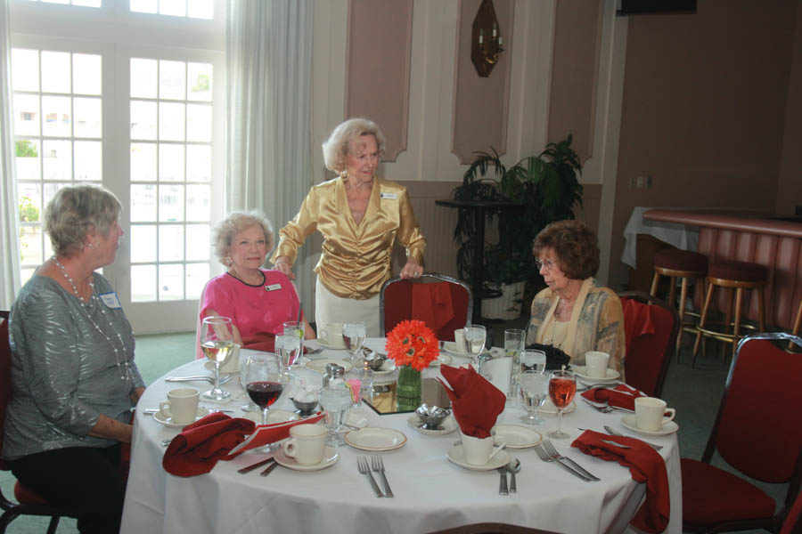

It’s time to dance

# *Presidents Message…*

We missed you at the last dance as I was surprised with a medical condition that popped up suddenly. All is better now and I am looking forword to seeing you at the next and final dance of the season.

From what I hear we had a small turnout and need to work a little harder at bringing guests and ourselves.

It seems this dance season went very fast but that’s what happens when you are having fun!

Our next dance features The Time Machine and it is a formal affair with emphasis on celebrating Memorial Day.

We reminded you that we are looking for some new Board members specifically the Treasurer and Secretary. We did get a volunteer to become treasurer. Kathy Roberts was so kind as to volunteer!

Make sure you all do your visiting because the next dance after May is in September.

See you soon and have a great summer!

*Larry Isham,  
 President*



*￼￼*

It’s The End Of Our Dance Season

**Bit’s And Pieces**

Paul & Sue Liles are beginning to harvest from the Spring garden with peas, green beans, and cauliflower producing well.

Diane is back home after another great vacation! Ask her to share her trip with you.

We are still looking for a Secretary for the club. It simply involves takes notes at the 30 minute meeting and writing them up. Easy Pizzy!

Bernie is moving from his PCH location to be adjacent to the Petroleum Club. He says it is an easy walk!

# Prepare To Be Greeted

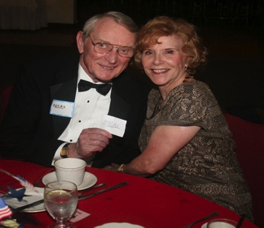

Neal and Nita Woolston

What A Great Dance!

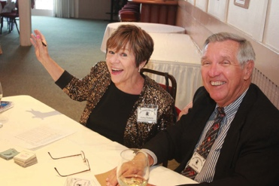

Welcome to the dance

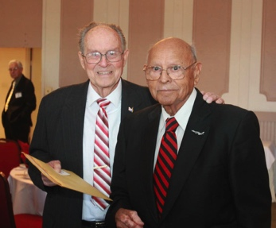

Heading to their table and getting ready to dance

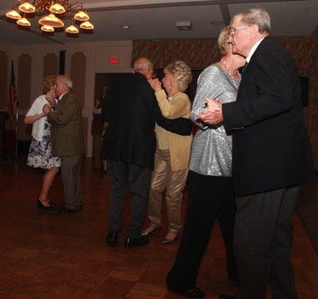  
The Toppers keep moving

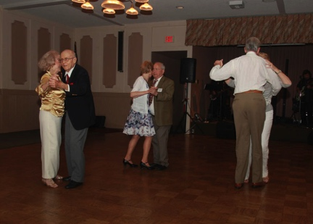  
Dancing is underway

# Upcoming Dance Schedule

5/22/2015 – Time Machine

# Bring A Friend!

This will be the last dance of the 2014-2015 season!

To keep the club thriving, we are always looking for new friends to join us and participate in our great parties!

# Put On Your Thinking Cap…

The following are the first words to which dance songs?

a. You move it to the left

b. My baby moves at midnight

c. Before this dance is through

d. Heaven, I'm in heaven

e. Three nights ago I was at a disco

f. Hot sun beating down.

The following lines are spoken at the close of which popular film?

"Teach me to dance will you" "Dance, did you say dance? Come on my boy!"

# We Do Latin…

Latin dance is a general label, and a term in partner dance competition jargon. It refers to types of ballroom dance and folk dance that (with few exceptions) originated in Latin America.

The category of Latin dances in the international dancesport competitions consists of the cha-cha-cha, rumba, samba, paso doble, and also the jive of United States origin.

Social Latin dances include salsa, mambo, merengue, tumba, bachata, bomba, plena, and the Argentine tango. There are many dances which were popular in the first part of the 20th century, but which are now of only historical interest..

# About Our Website

Just Google “Toppers Dance Club” and our site will be the first on the search list!

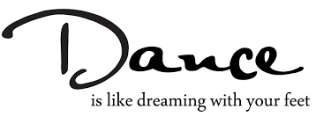

**YOUR BOARD**

President Larry Isham

Vice President Dean Fronk

Past President Jerry Ellis

Secretary Lori Fronk

Treasurer Diane Schmitz

Hospitality Neil/Nita Woolston

Membership Vicky Kuhn

Roster Donnis Weygandt

Newsletter Paul/Sue Liles

Members At Large Gigi Isham, Dennis Schmitz, and Nancy Ellis.