Spring is nature's way of saying, 'Let's party!'

Spring is when you feel like whistling even with a shoe full of slush. ~Doug Larson

# What You Need To Know

The April 17th dance is at the Petroleum Club and features The Batavia Band. The cost is $82/couple (includes tax/tip).

No-host cocktail time is 6 pm & great dance music until 10 pm.

Dress code is semi-formal

Toppers Dinner Menu

Garden Green Salad  
Fresh seasonal vegetables Rolls and butter

Entree: Stuffed Pork Chops. Seasonal stuffing inside center cut pork chop with baked potato OR Grilled White Fish in Lemon Butter and Rice OR Vegetarian selection.

Dessert: Tequila Flan. Coffee, tea or decaffeinated coffee.

Mail your checks made out to “Toppers Dance Club” with dinner selections on the checks by May 16th to:

Larry Isham

2023 Ruhland Ave

Redondo Beach Ca 90278

Note: If you can’t get the check in by the 10th call Larry.

# Policy Notes

There are no refunds for cancellations made after the Tuesday before the dance as the arrangements are finalized Tuesday evening.

If you desire to sit with someone please note it with your check so we can attempt to satisfy your seating desires!



Everyone was Irish at our last dance!

# *Presidents Message…*

We sure enjoyed our last dance with the sea of green celebrating St. Patrick’s Day. Jim Gilman, and his red wig, kept us jumping all evening.

It’s about time to consider nominations for your Board of Directors. We are looking for a new Treasurer as Diane has done a magnificent job but after three years she would like a change.

Spring has sprung and the flowers are making our neighborhoods beautiful again. Spring and "springtime" refer to the season, and also to ideas of rebirth, rejuvenation, renewal, and regrowth.

Are you ready for The Batavia Band on April 17th? Great music and an evening of dancing and visiting with friends.

Speaking of friends, bring your friends to the Toppers and introduce them to dinner dancing!

See you soon!

*Larry Isham,  
 President*



*￼￼*

It’s Springtime… Time To Dance

**Bit’s And Pieces**

Vicky Kuhn is busy introducing her grandson Logan to springtime. They visited their next-door neighbors, the Liles, for a garden tour.

Contrary to popular folklore, Jim Gilman’s red hair was not really his! It did work to put him in the Irish spirit for the evening!

The Avalon Ball is coming in May and several Toppers are going to make the voyage across the sea. Who are they?

Paul and Sue finished planting 32 different kinds of tomatoes in their garden

# Prepare To Be Greeted

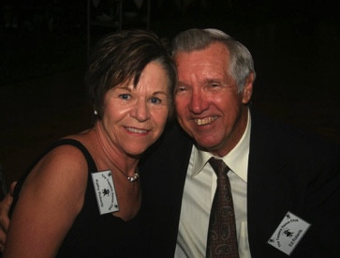

Kathy and Ed Roberts

What A Great Dance!



Welcome to the dance



He could have danced all night!  
Everyone loved his bonnet

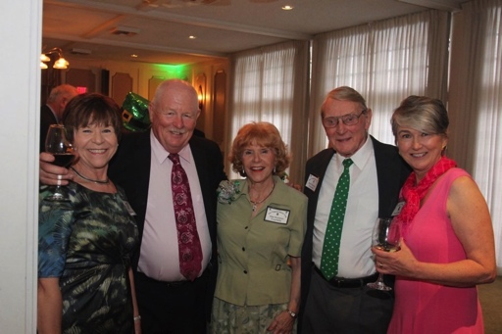  
The Toppers friendships are special!

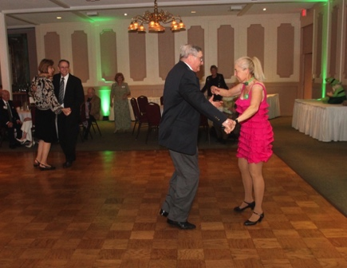  
Dancing is underway

# Upcoming Dance Schedule

04/17/2015 – The Batavia Band

5/22/2015 – Time Machine

# Bring A Friend!

We only have two dances remaining in this 2014-2015 season!

To keep the club thriving, we are always looking for new friends to join us and participate in our great parties!

# Join The Board!

Every organization has a “leadership committee” and ours is called The Board. Members served on the board to assist the club and its members. Many of us have served multiple times and we are always looking for fresh faces.

If you have an interest please call Larry Isham. The work is minimal and our meetings last less than 30 minutes and occur immediately before the dance. We laugh, we giggle, and we serve! Please consider joining the board.

# With Great Sadness, We Lost Jim Mongell

Jim Mongell, long time Toppers member passed peacefully at home on the March 20th surrounded by his wife and family. He will be missed.



# Dancing Is Old!

Archeological evidence for early dance includes 9,000 year old paintings in India at the Rock Shelters of Bhimbetka, and Egyptian tomb paintings depicting dancing figures, dated c. 3300 BC.



**YOUR BOARD**

President Larry Isham

Vice President Dean Fronk

Past President Jerry Ellis

Secretary Lori Fronk

Treasurer Diane Schmitz

Hospitality Neil/Nita Woolston

Membership Vicky Kuhn

Roster Donnis Weygandt

Newsletter Paul/Sue Liles

Members At Large Gigi Isham, Dennis Schmitz, and Nancy Ellis.