If a man who cannot count finds a four-leaf clover, is he lucky?

# What You Need To Know

The March 20th dance is at the Petroleum Club and features Jim Gilman. The cost is $82/couple (includes tax/tip).

No-host cocktail time is 6 pm & great dance music until 10 pm.

Dress code is semi-formal

Toppers Dinner Menu

Garden Green Salad  
Fresh seasonal vegetables Rolls and butter

Entree: Chicken Marsala (baked boneless chicken breast with Marsala wine sauce and au gratin potatoes) or Fish Of The Day with Rice or Vegetarian selection.

Dessert: Chocolate Fudge Cake. Coffee, tea or decaffeinated coffee.

Mail your checks made out to “Toppers Dance Club” with dinner selections on the checks by March 14th to:

Diane Schmitz

3475 Lilly Avenue

Long Beach Ca 90808-3214

Note: If you can’t get the check in by the 14th call Diane.

# Policy Notes

There are no refunds for cancellations made after the Tuesday before the dance as the arrangements are finalized Tuesday evening.

If you desire to sit with someone please note it with your check so we can attempt to satisfy your seating desires!

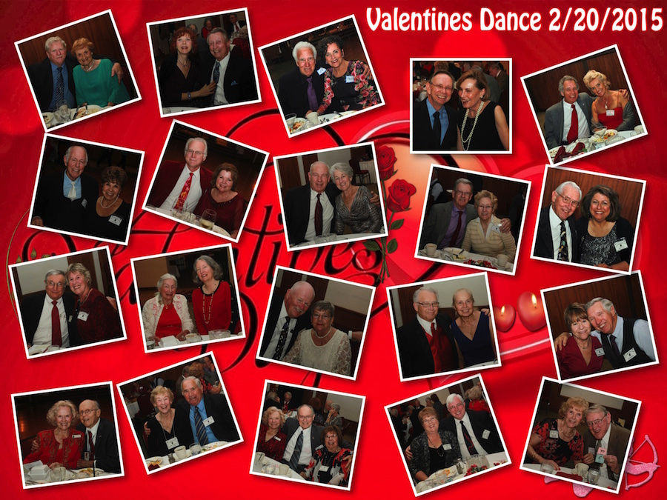

Dancing with our Valentines

What do you get when you cross poison ivy with a four-leaf clover? A rash of good luck.

# *Presidents Message…*

Well, we made it through all of Cupid’s tiny arrows from the last dance! It must be that dancing and romance go together!

Tony Carinino certainly gave us an opportunity to celebrate and dance. Tony just retired form the Garden Grove School District where he taught for many years! Happy retirement but Tony will keep on playing great music for his audiences!

Are you ready for the wearin’ of the green?! It’s not dangerous to do today but turn back the clock and you might have been considered a revolutionary and against the crown!

Remember: “An Irishman is never drunk as long as he can hold onto one blade of grass to keep from falling off the earth.” ~Irish Saying

Please join us on the 20th of March for our next dance and brings some friends and meet our newest members!

See you soon!

*Larry Isham,  
 President*

**

*￼￼*

It’s Time To Dance An Irish Jig

**Bit’s And Pieces**

It’s time to update your rosters with our newest members:

Nina Collins  
2412 Hill Lane  
Redondo Beach, Ca 90278  
Email:ninacollins@verizon.net  
(310) 372-0178

Normal McLean  
3526 Michele Dr  
Torrance, Ca  
Email:nmclean@gte.net  
(310) 542-5751

Richard Steiner & Frieda Mau  
3933 Via Solano  
Palos Verdes Estates Ca 90274  
(310) 378-3086  
Email: Rjsarrow@aol.com

# Prepare To Be Greeted

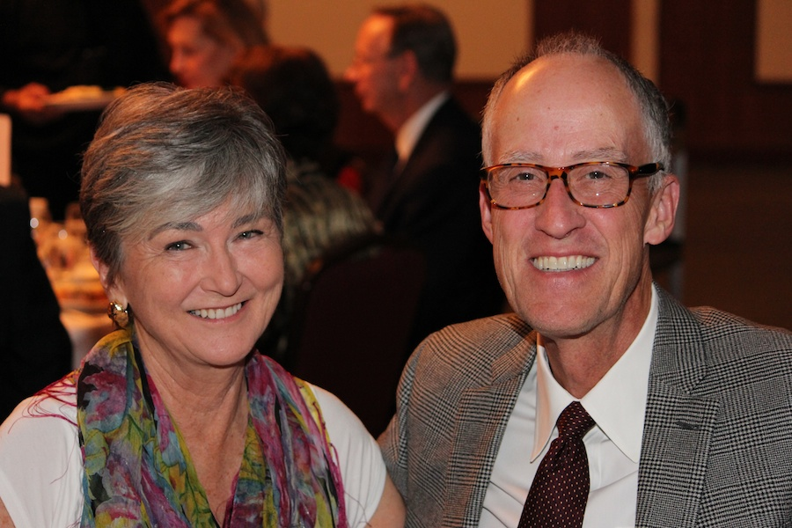

Sandy and Charlie Slater

What A Great Dance!

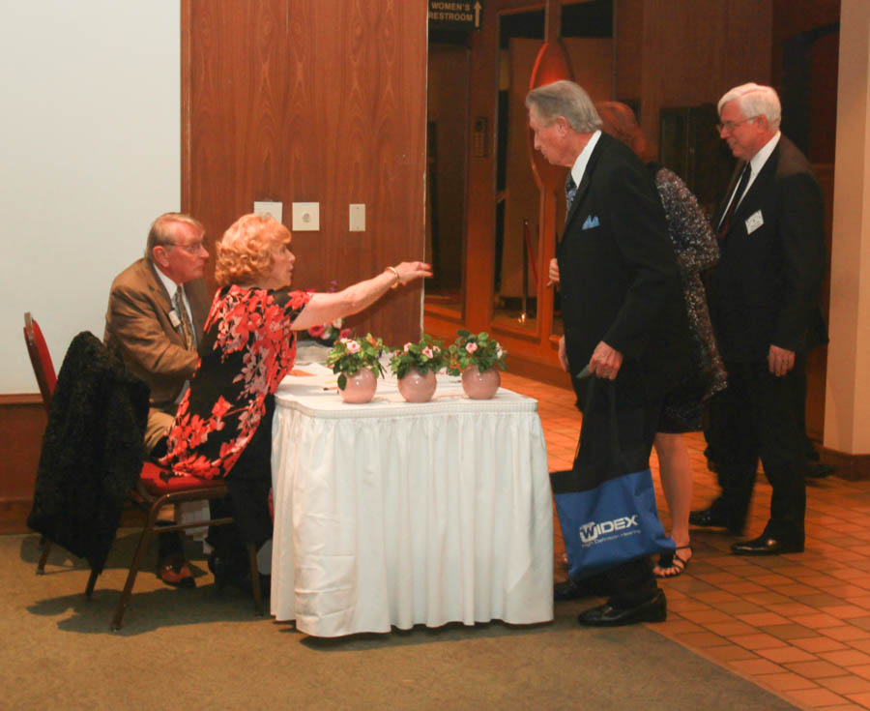

Welcome to the dance

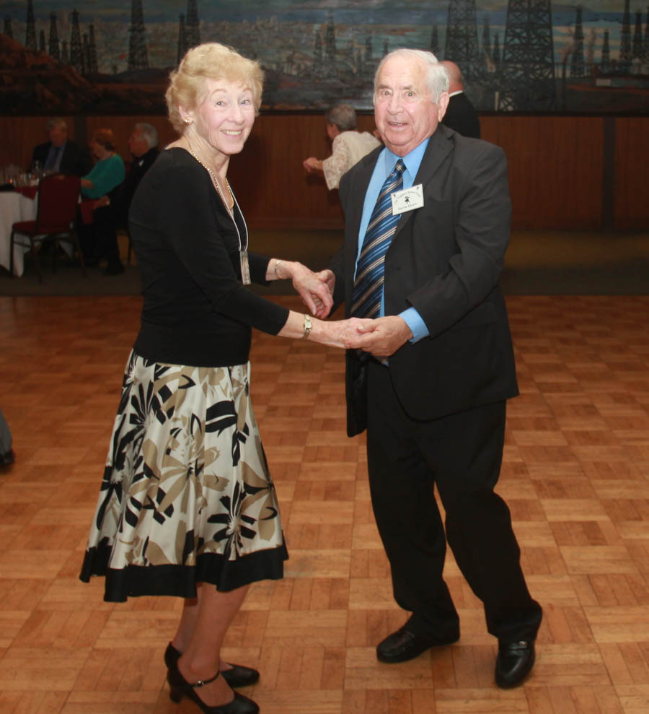

We could have danced all night!  
Great title for a song!

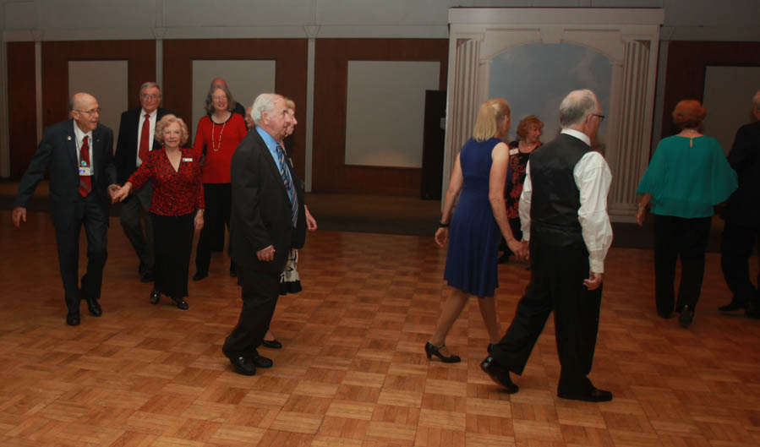  
The mixer gets under way  
Follow the couple in front!

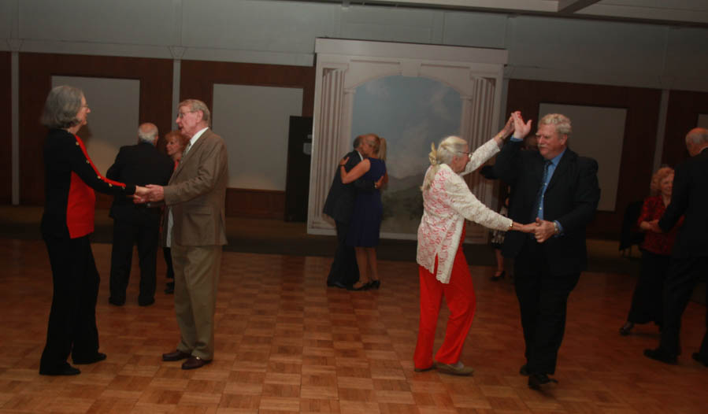  
Line Dancing is underway

# Upcoming Dance Schedule

04/17/2015 – The Batavia Band

5/22/2015 – Time Machine

# Bring A Friend!

We only have three dances remaining in this 2014-2015 season!

To keep the club thriving, we are always looking for new friends to join us and participate in our great parties!

# Bring Your Fiddle!

An Irish jig is done to jig fiddle music, which often has a beat of 6/8. There are other beats that are still considered to be jigs as well; however, the most common jig music/dance is one of a 6/8 beat.

A jig is danced with a lot of hopping, making it into a joyful dance; jigs are often danced at weddings and other types of celebrations.

# We Are About To Have A Birthday!

In 1903, Saint Patrick's Day became an official public holiday in Ireland. This was thanks to the Bank Holiday (Ireland) Act 1903, an act of the United Kingdom Parliament introduced by Irish Member of Parliament James O'Mara

O'Mara later introduced the law that required that pubs and bars be closed on 17 March after drinking got out of hand, a provision that was repealed in the 1970s.

The first Saint Patrick's Day parade held in the Irish Free State was held in Dublin in 1931 and was reviewed by the then Minister of Defence Desmond Fitzgerald.

# About Our Website

Just Google “Toppers Dance Club” and our site will be the first on the search list!



**YOUR BOARD**

President Larry Isham

Vice President Dean Fronk

Past President Jerry Ellis

Secretary Lori Fronk

Treasurer Diane Schmitz

Hospitality Neil/Nita Woolston

Membership Vicky Kuhn

Roster Donnis Weygandt

Newsletter Paul/Sue Liles

Members At Large Gigi Isham, Dennis Schmitz, and Nancy Ellis.