# What You Need To Know

The February 20th dance is at the Petroleum Club and features Tony Carinino.

The cost is $85/couple (includes tax/tip).

No-host cocktail time is 6 pm & great dance music until 10 pm.

Dress code is semi-formal

Toppers Dinner Menu

Garden Green Salad  
Fresh seasonal vegetables Rolls and butter

Entree: Roast Tri-Tip Of Beef with Bordelaise Sauce and Mashed Potatoes or Baked Salmon with Hollandaise Sauce and Rice or Vegetarian selection

Dessert: Chef’s choice. Coffee, tea or decaffeinated coffee.

Mail your checks made out to “Toppers Dance Club” with dinner selections on the checks to:

Diane Schmitz

3475 Lilly Avenue

Long Beach Ca 90808-3214

# *Presidents Message…*

The year is moving quite fast, in fact, it only eleven months until Christmas!

It was nice to meet Dean and Nina, guests of Richard Stein and Frieda Mau. We hope they return and become members.

We still have room for Greeters at the upcoming dances. Please get in touch with Neal Woolston and volunteer! It is a fantastic way of meeting everyone!

Special thanks to our Vice President, Dean Fronk, who does such a great job of being the MC for the dances. His messages are concise and his humor is certainly good for the digestion after a nice dinner!

We hope your Valentine’s Day will be special and you have a chance to kick up your heels! Tony Carinino will certainly give you an opportunity to celebrate at the February 20th dance.

As Charles Schultz once said “All you need is love. But a little chocolate now and then doesn't hurt.”

Please join us on the 20th of February for our next dance and brings some friends and meet our newest members!

See you soon!

*Larry Isham,  
 President*

**

*￼￼*

The new year stands before us, like a chapter in a book, waiting to be written. ~ Melody Beattle

It’s Time To Dance

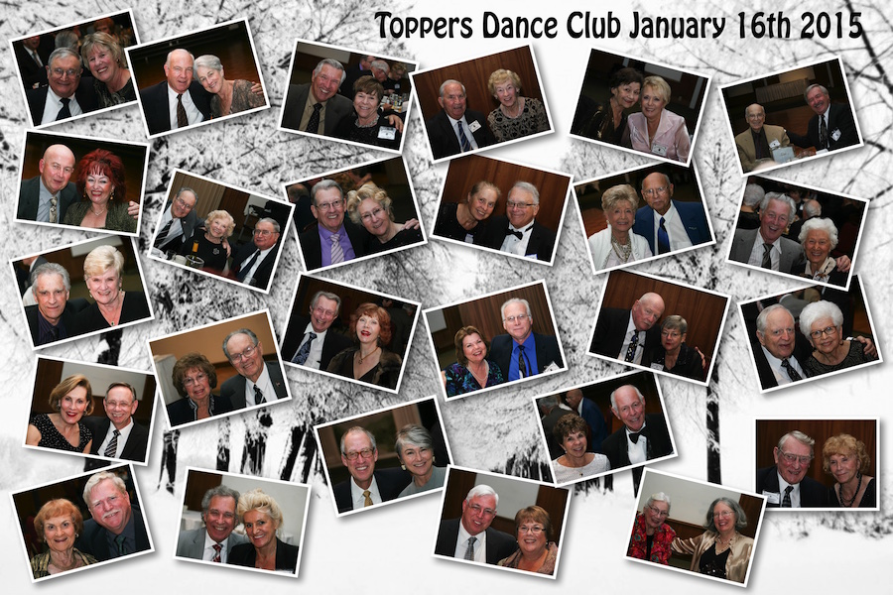

The proper way to begin a new year!

The February dance was excellent

Bring A Friend!

# Policy Notes

There are no refunds for cancellations made after the Tuesday before the dance as the arrangements are finalized Tuesday evening.

If you desire to sit with someone please note it with your check so we can attempt to satisfy your seating desires!

**Bit’s And Pieces**

Best wishes to Howard Solomon who had a fall just before the last dance. He came and played making for a great evening!

Hats off to Tracy Wells for arranging and performing a wonderful New Year’s Eve dance at the Long Beach Airport Marriott. Tracy and the orchestra kept us moving all night!

It was great to see Lynne Brandt back with Jim. We hope you can continue joining us for the future dances.

# Prepare To Be Greeted

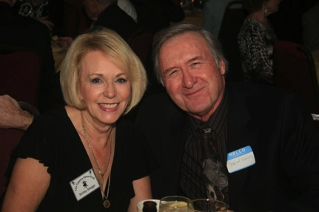

Shirley and Brian Skeggs

What A Great Dance!

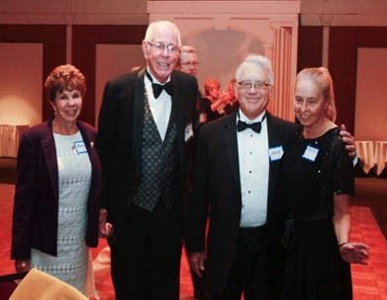

Welcome guests Norm and Nina

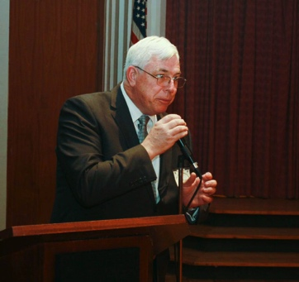

Dean keeps us informed

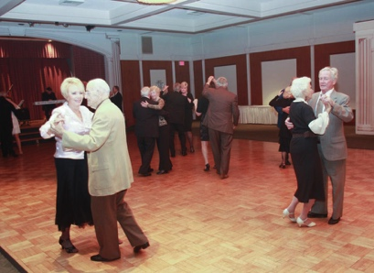  
The dancing gets under way

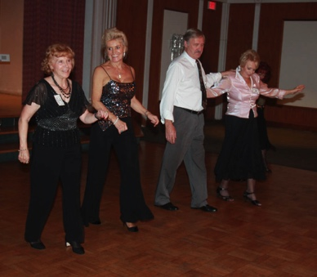  
Line Dancing is underway

# Upcoming Dance Schedule

03/20/2015 – Jim Gilman

04/17/2015 – The Batavia Band

5/22/2015 – Time Machine

# Keep You New Years Resolutions…

Come to the dance and bring friends.

We have a suggestion! Come to all of the 2015 Topper's dinner dances!

# Never Thought Of It That Way!

“I don't understand why Cupid was chosen to represent Valentine's Day. When I think about romance, the last thing on my mind is a short, chubby toddler coming at me with a weapon. ”

~Author Unknown.

# We Are About To Have A Birthday!

Did you know that in 2016, just a year away, our club will be seventy years old?

Those we amazing times. Project Diana, January 1946, bounces radar waves off the Moon, measuring the exact distance between the Earth and the Moon, and proves that communication is possible between Earth and outer space, effectively opening the Space Age.

The Tokyo Telecommunications Engineering (later renamed Sony) is founded with about 20 employees in May 1946.

There has been lots of changes but we are still dancing the same dances to a lot of the same 1940’s music.

# About Our Website

Just Google “Toppers Dance Club” and our site will be the first on the search list!



**YOUR BOARD**

President Larry Isham

Vice President Dean Fronk

Past President Jerry Ellis

Secretary Lori Fronk

Treasurer Diane Schmitz

Hospitality Neil/Nita Woolston

Membership Vicky Kuhn

Roster Donnis Weygandt

Newsletter Paul/Sue Liles

Members At Large Gigi Isham, Dennis Schmitz, and Nancy Ellis.