There are short-cuts to happiness, and dancing is one of them. ~Vicki Baum

# *Presidents Message…*

We had our first band no-show in as long as any of us could remember but Jerry Benton of Fullerton saved the day. In fact, he made the day by playing wonderful dance music all evening! Thank you again Jerry!

Goodness… The holidays are here. Halloween, Thanksgiving, Christmas and New Years are but days away!

We will keep you posted about the possibility of the Tracy Wells Big Band playing on New Years Eve. Under his leadership the band sounds fantastic and will guarantee a great way of seeing in the new year!

This December we will be putting on the Mistletoe Ball without the Petroleum Club and we need to have seventy guests in order to break even so PLEASE invite your friends and neighbors or members from other clubs to celebrate the season with us in December!

*Larry Isham,  
 President*

**

The Holiday Season Has Begun…

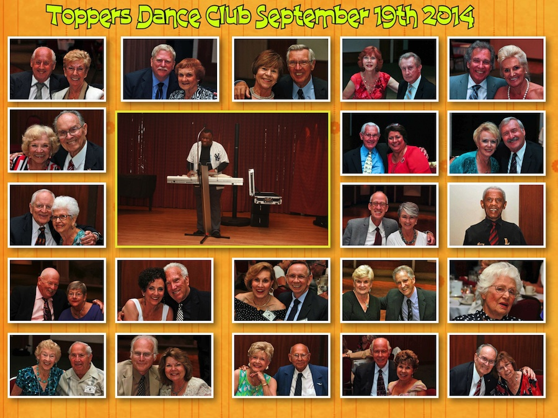

Remember our last dance?

# Policy Notes

There are no refunds for cancellations made after the Tuesday before the dance as the arrangements are finalized Tuesday evening.

If you desire to sit with someone please note it with your check so we can attempt to satisfy your seating desires!

# What You Need To Know

The October 17th dance will be at the Petroleum Club and will feature the Tony Carinio Band

The cost is $76/couple (includes tax/tip).

No-host cocktail time is 6 pm & great dance music until 10 pm.

Dress code is sem-formal

Toppers Dinner Menu

Fresh Green Garden Salad w/ Dressings

Stuffed Pork Chops with Red Rose Potatoes or Grilled White Fish with Lemon Butter and Rice or Vegetarian selection. Served with Chefs fresh seasonal vegetables. Warm bread and butter.

Chefs Choice Dessert, coffee and tea.

# Mail your checks made out to “Toppers Dance Club” With Dinner Selections on the checks To

Diane Schmitz   
3475 Lilly Ave

Long Beach Ca 90808

# Prepare To Be Greeted

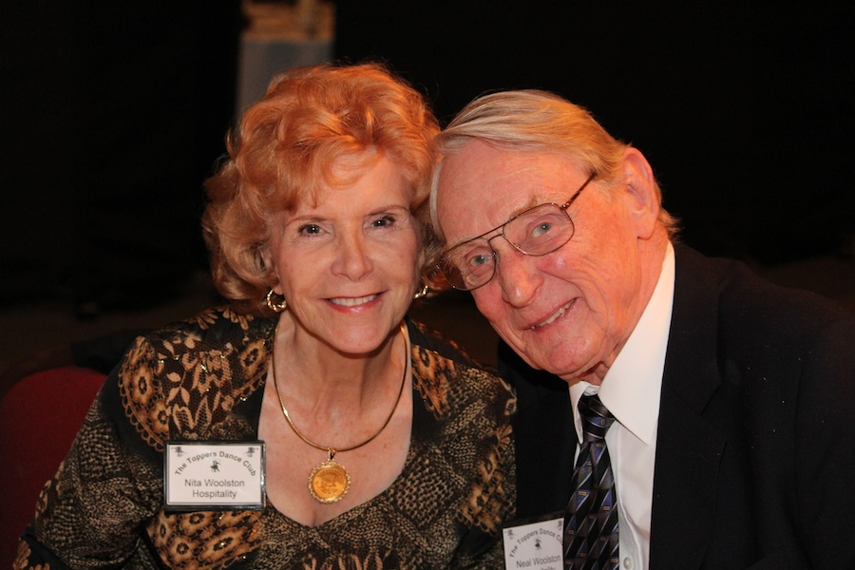

Nita and Neal Woolston

What A Great Dance!

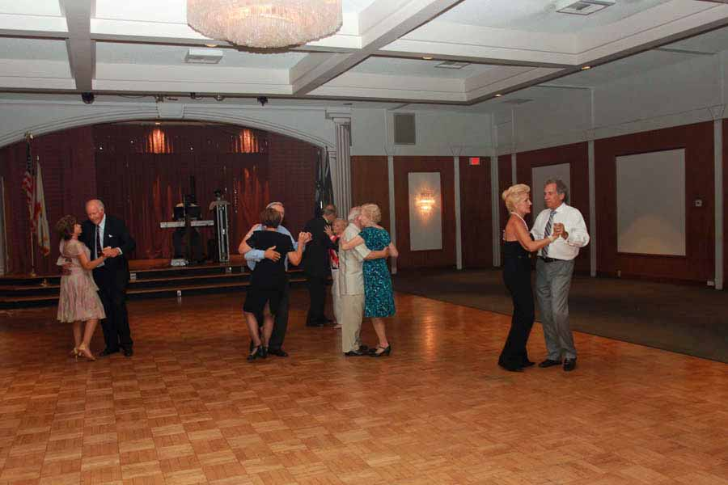

Dancing to wonderful music

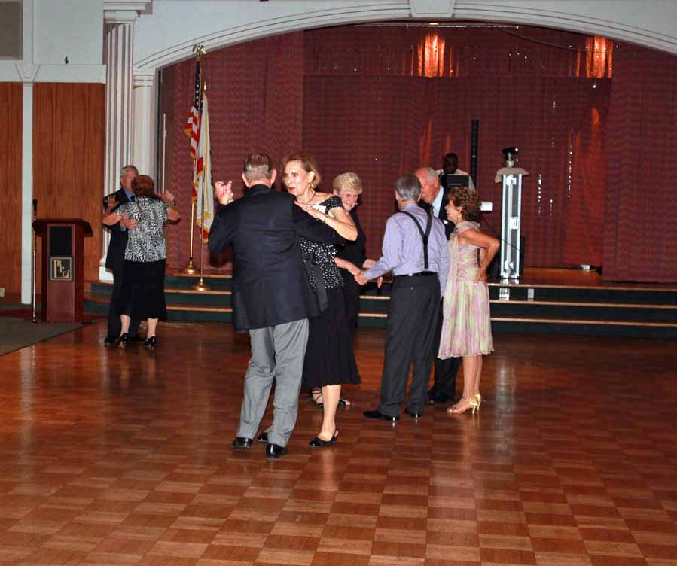

Topper’s dance to everything!

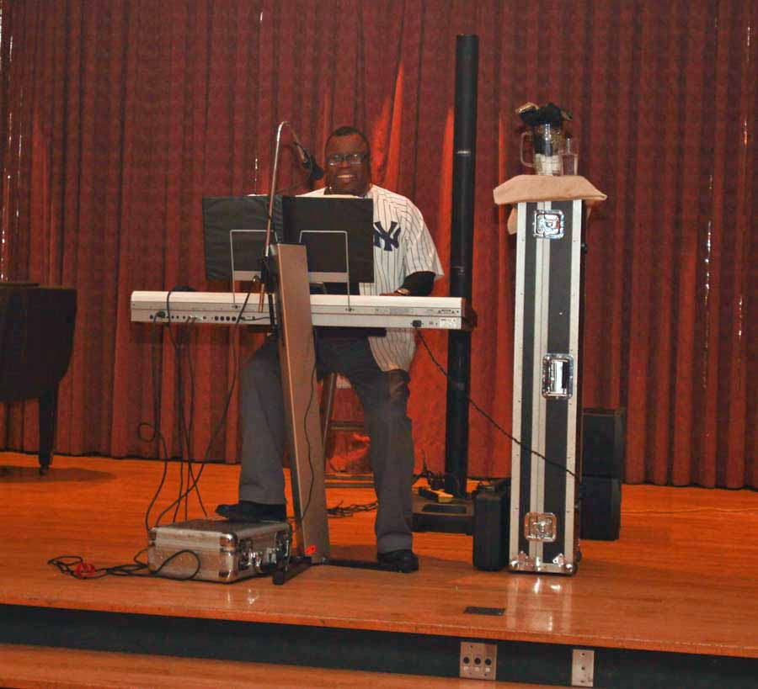  
Jerry Benton saved the day

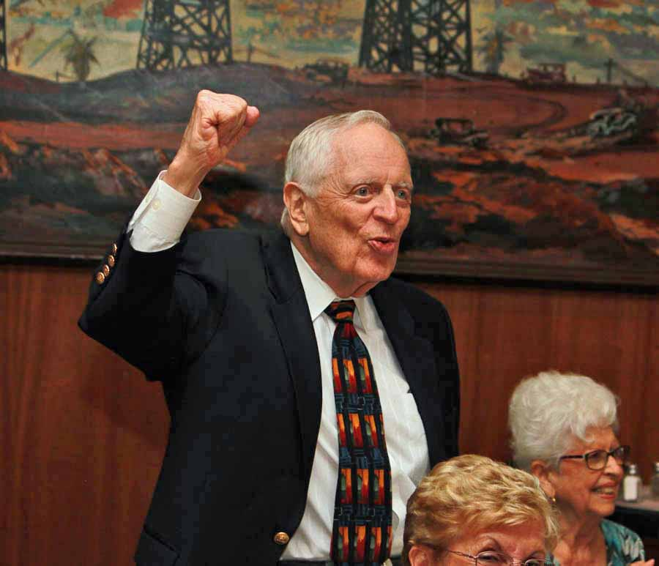  
The Head Cheerleader   
Tracy Wells

Halloween Cometh…



Pumpkins also come in white, blue and green. Great for unique monster carvings!

The common little brown bat of North America has the longest life span for a mammal it's size, with a life span averaging 32 years.

Halloween was brought to North America by immigrants from Europe who would celebrate the harvest around a bonfire, share ghost stories, sing, dance and tell fortunes.

Did You Know?

Which of the following automotive men brought square dancing back into society during the 1930's?

(a) Randsom Eli Olds  
(b) Louis Chevrolet  
(c) Henry Ford  
(d) Walter Chrysler

The daughter of this famous dancer married Henry Heimlich, who created the Heimlich Maneuver for choking.

(a) Arthur Murray  
(b) Fred Astaire  
(c) Gregory Hines  
(d) Mikhail Baryshnikov

# About Our Website

Just Google “Toppers Dance Club” and our site is first on the search list!

# Your Board

President Larry Isham  
Vice President Dean Fronk  
Past President Jerry Ellis  
Secretary Lori Fronk  
Treasurer Diane Schmitz  
Hospitality Neil/Nita Woolston  
Membership Vicky Kuhn  
Roster Donnis Weygandt  
Newsletter Paul/Sue Liles  
Members At Large Gigi Isham, Dennis Schmitz, Nancy Ellis, and Jack Taylor.

The Executive Board meets at 5:30 p.m. before each dance. Need a Toppers name badge, let Neal Woolston know!

# Notes

Donnis Weygant is putting the finishing touches on this years directory and will be distributing it at the October dance.

We have a date change for the May dance… It will be held on 5/22/2015.

If anyone has news to put into the Toppers Topics please email it to Paul and Sue Liles

# The Answers…

Modern square dancing actually has ties to Henry Ford. Henry Ford is best remembered for his development of the automobile and the production line, new things for his time. However, Ford actually was passionate about historic things including old-time country dances of his youth.

Heimlich married Jane Murray, daughter ballroom dancing entrepreneur Arthur Murry.