I love spring anywhere, but if I could choose I would always greet it in a garden. ~Ruth Stout.

Read more: http://www.irishcentral.com/roots/irish-sayings-proverbs-and-prayers-for-st-patricks-day-117923469-237375661.html#ixzz2uXqubcv9

Follow us: @IrishCentral on Twitter | IrishCentral on Facebook

Spring Has Sprung!



We had the Luck Of The Irish!

The February dance was excellent

Spring is nature's way of saying, "Let's party!”

# *Presidents Message…*

Spring has definitely arrived. Seeing the new flowers in the garden is always amazing. Then we turn on the TV and it is snowing on the east coast! We are indeed lucky!

Spring and "springtime" refer to the season, and also to ideas of rebirth, rejuvenation, renewal, resurrection and regrowth. So, please bring a friend to our dances and let’s continue to grow the club. The more the merrier!

We enjoyed the St Patrick’s Day dance and our club did well with their colors… Green was everywhere!

We got many positive comments about the new band. We did have to make a few sound-level adjustments at first but everyone seemed to be pleased at the repertoire of the group and they certainly understood dance music!

We are looking forward to seeing you on April 18th with the Tony Carinio band! Remember, try to bring a guest couple! We love to meet new friends and introduce them to the fun of a dance club!

See you soon!

*Larry Isham,  
 President*

**

# Policy Notes

There are no refunds for cancellations made after the Tuesday before the dance as the arrangements are finalized Tuesday evening.

If you desire to sit with someone please note it with your check so we can attempt to satisfy your seating desires!

# What You Need To Know

The April 18th dance will be at the Petroleum Club and will feature Tony Carinio.

The cost is $78/couple (includes tax/tip).

No-host cocktail time is 6 pm & great dance music until 10 pm.

**Dress code is semi-formal**

Toppers Dinner Menu

Garden Green Salad  
Fresh seasonal vegetables. Rolls and butter.

Entree: Center Cut Port Chops stuffed with seasonal stuffing and Lyonaise Potatoes OR Grilled White Fish with Lemon Sauce and Rice OR a Vegetarian Selection.

Dessert: Chefs Selection. Coffee, tea or decaffeinated coffee.

# Mail your checks made out to “Toppers Dance Club” With Dinner Selections on the checks To

Diane Schmitz  
3475 Lilly Ave  
Long Beach, CA 90808

**Bit’s And Pieces**

The Executive Board meets at 5:30 p.m. before each dance.

We currently have 61 members in the club as of 3/1/2014

May 17th is the 11th annual Avalon Ball. Enjoy an evening of dancing in the great Avalon Ball Room with a 24-piece orchestra. See Paul or Sue Liles for details.

If you are interested in serving on the board, please see one of the current board members. (See Page Two)

Remember to bring a guest as we love to meet new people and potentially increase the size of the club

# Prepare To Be Greeted

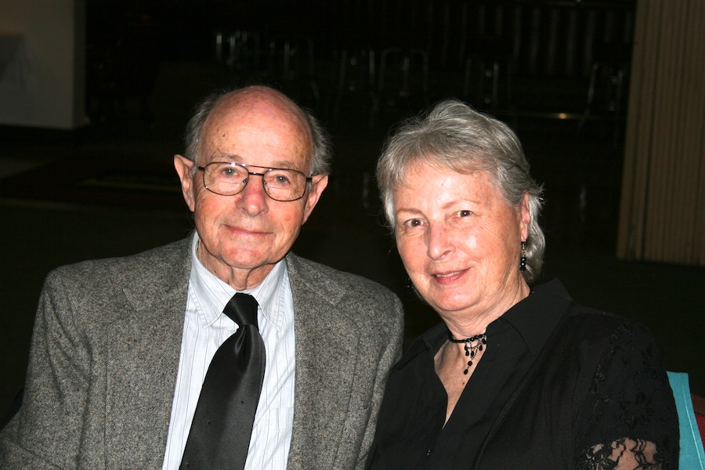

Irv and Jacque Kurman

What A Great Dance!

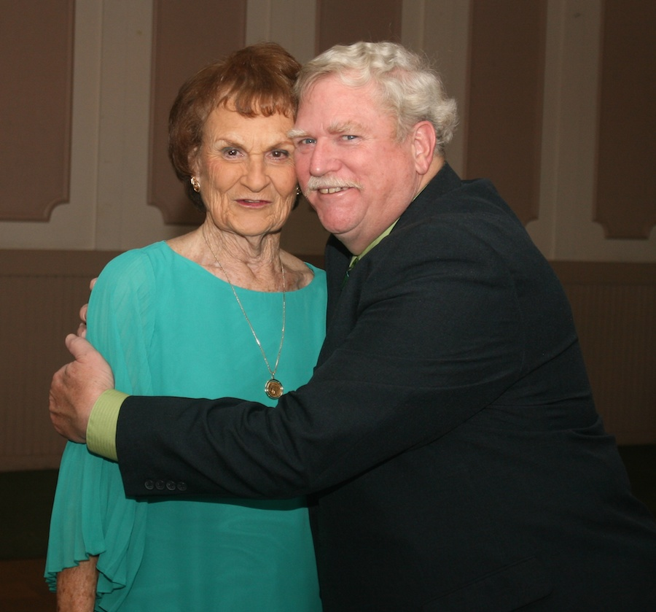

Romance is in the air

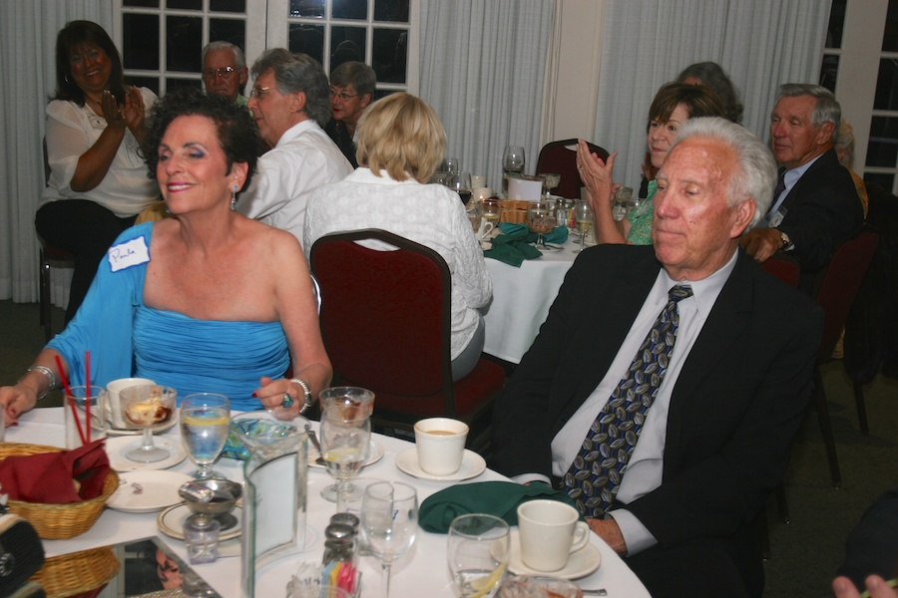

Welcome guests

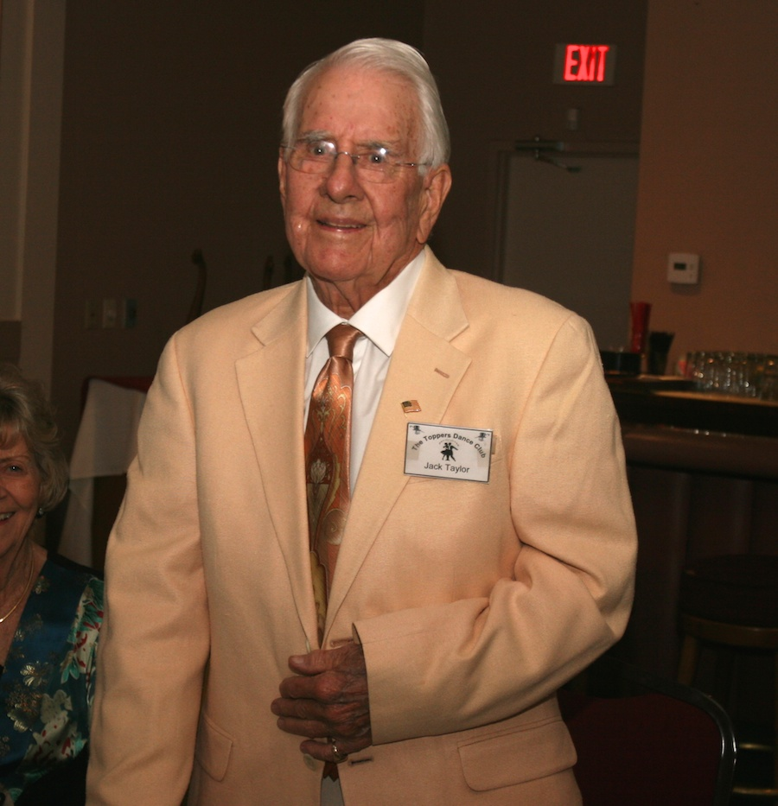  
Birthday boy turns 94

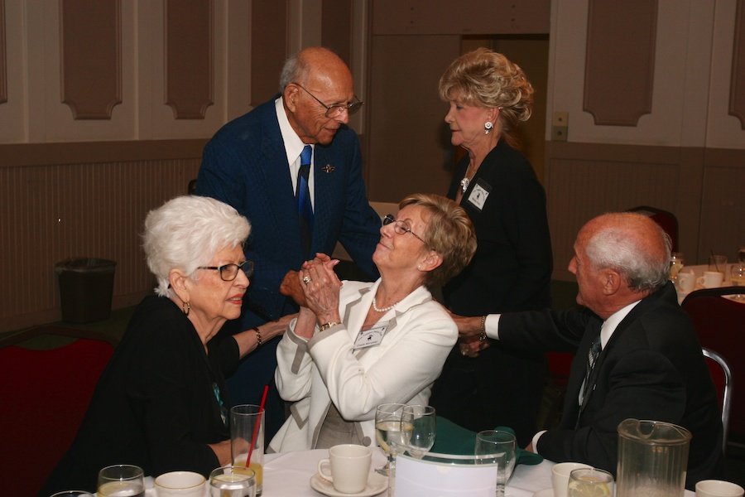  
Catching up with friends

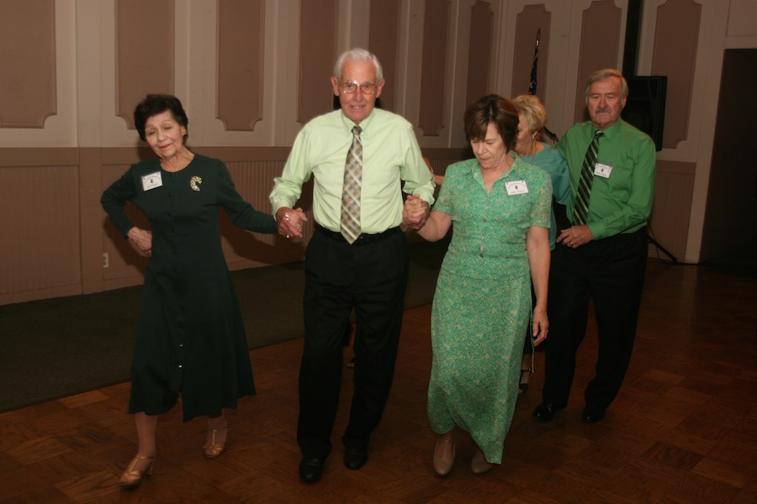

The Ten Step Polka   
is alive and well

Thoughts About Spring…

"Spring makes its own statement, so loud and clear that the gardener seems to be only one of the instruments, not the composer." - Geoffrey B. Charlesworth

"Spring is the time of the year, when it is summer in the sun and winter in the shade." - Charles Dickens

"Science has never drummed up quite as effective a tranquilizing agent as a sunny spring day." - W. Earl Hall

About Tony Carinio…

Tony started on the alto sax at age 10 because sax was “cool”. He played for his first dance at 13. In high school, he added the tenor sax and picked up the guitar and keyboards. In college, he pursued music studies, completed his teaching credentials, and began teaching music.

He took a break to go on the road with a few Vegas-type lounge show groups, and later formed a combo, "Free and Easy" which is where he met Jim Gilman back in 1972.

Jim and Tony toured throughout the Midwest and West Coast. Tony is currently a music director of band and orchestra in Orange County, but Tony’s first love is still performing live with his friends.

# About Our Website

Just Google “Toppers Dance Club” and our site is first on the search list!

**YOUR BOARD**

President Larry Isham

Vice President Dean Fronk

Past President Jerry Ellis

Secretary Lori Fronk

Treasurer Diane Schmitz

Hospitality Neil/Nita Woolston

Membership Vicky Kuhn

Roster Donnis Weygandt

Newsletter Paul/Sue Liles

Members At Large Gigi Isham, Dennis Schmitz, Nancy Ellis, and Jack Taylor.

# Upcoming Dance Schedule

4/18/2014 – Tony Carinio

5/16/2014 – Time Machine and a formal dance…. Brush off those tuxedos and gowns!

Jun – July - August – Dark

9/19/2014 – Howard Solomon

10/17/2014 – Tony Carinio

11/21/2014 – Time Machine