May you live as long as you want,

And never want as long as you live.

Read more: http://www.irishcentral.com/roots/irish-sayings-proverbs-and-prayers-for-st-patricks-day-117923469-237375661.html#ixzz2uXqubcv9

Follow us: @IrishCentral on Twitter | IrishCentral on Facebook



The February dance was excellent

“It time for the wearing of the green!”

# *Presidents Message…*

Red for Valentines Day and green for Saint Patrick’s Day… The guys have it easy, we get to wear our basic black!

We spoke to Martha Yeam and she does plan to attend a future dance. It will be nice to see her!

How about a little history lesson?

Originally, the color associated with Saint Patrick was blue. Over the years the color green and its association with Saint Patrick's Day grew. Green ribbons and shamrocks were worn in celebration of St Patrick's Day as early as the 17th century Saint Patrick is said to have used the shamrock, a three-leaved plant, to explain the Holy Trinity to the pagan Irish, and the ubiquitous wearing and display of shamrocks and shamrock-inspired designs has become a feature of the day.

We are looking forward to seeing you on the March 21st and if you can, bring a guest couple! We love to meet new friends and introduce them to the fun of a dance club!

The more the merrier!

*Larry Isham,  
 President*

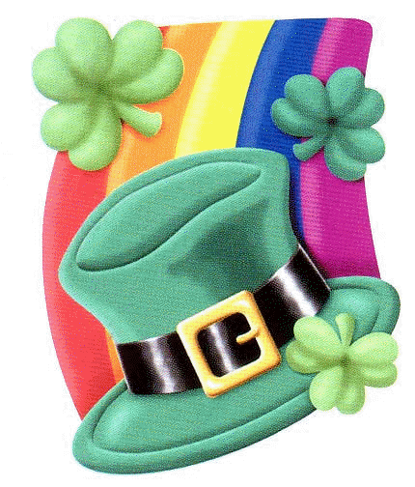

It’s Time For Saint Patrick’s Day

# Policy Notes

There are no refunds for cancellations made after the Tuesday before the dance as the arrangements are finalized Tuesday evening.

If you desire to sit with someone please note it with your check so we can attempt to satisfy your seating desires!

# What You Need To Know

The March 21st dance will be at the Petroleum Club and will feature Jim Gilman.

The cost is $78/couple (includes tax/tip).

No-host cocktail time is 6 pm & great dance music until 10 pm.

**Dress code is semi-formal**

Toppers Dinner Menu

Garden Green Salad  
Fresh seasonal vegetables. Rolls and butter.

Entree: Chicken Marsala (baked boneless chicken breast with marsala sauce and au’gratin potatoes) OR Fish of the Day with Rice OR a Vegetarian Selection.

Dessert: Chefs Selection. Coffee, tea or decaffeinated coffee.

# Mail your checks made out to “Toppers Dance Club” With Dinner Selections on the checks To

Larry Isham   
2023 Ruhland

Redondo Beach Ca 90278

**Bit’s And Pieces**

The Executive Board meets at 5:30 p.m. before each dance.

Need a Toppers name badge, let Neal Woolston know!

May 17th is the 11th annual Avalon Ball. An evening of dancing in the great Avalon Ball Room with a 24 piece orchestra. See Paul or Sue Liles for details.

We are still looking for a fearless leader to head up the club next year! Do we hear any volunteers???

Remember to bring a guest as we love to meet new people and potentially increase the size of the club

# Prepare To Be Greeted



Cindy and Hedrina

What A Great Dance!

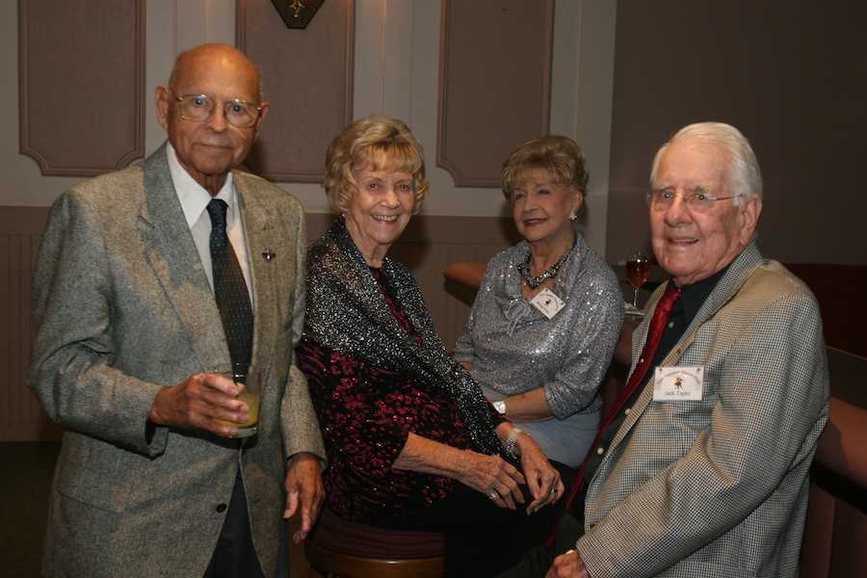

Smiles and smiles

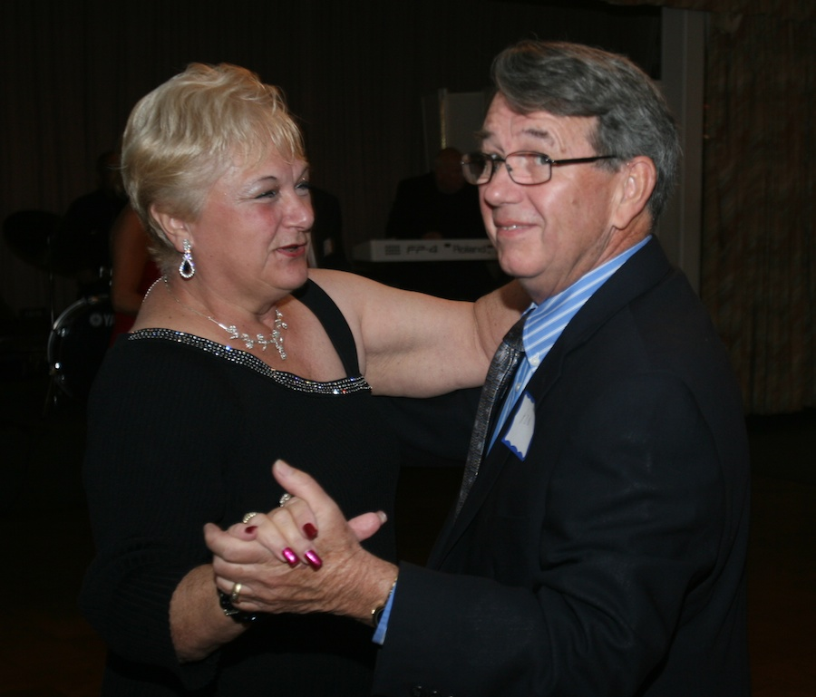

Welcome guests

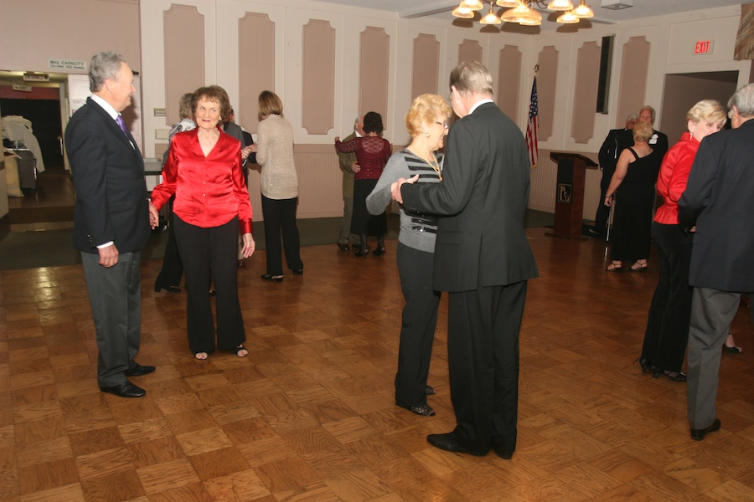  
Dancing the night away

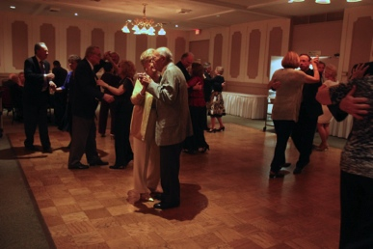  
Catching up with friends

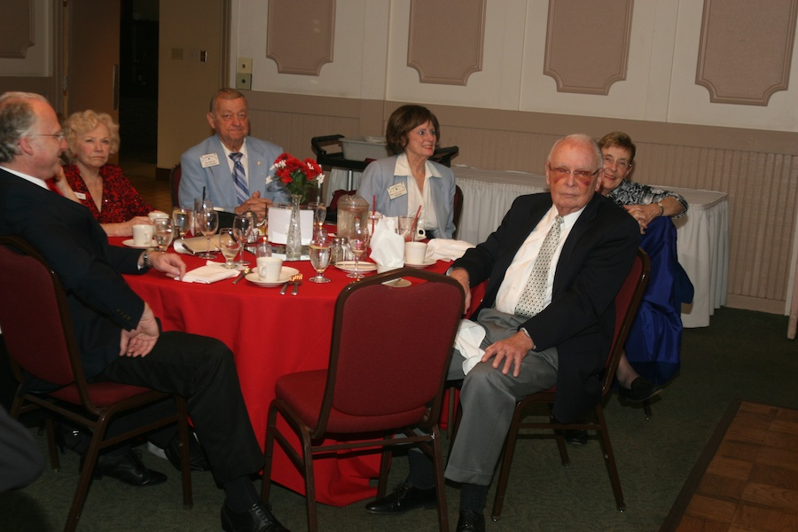

Waiting to see a new step

We Are Kind Of A Supper Club?!

In the U.S., a supper club is a dining establishment generally found in the Upper Midwestern states of Wisconsin, Minnesota, Ohio, Michigan, Illinois and Iowa. These establishments typically are located on the edge of town in rural areas.

They were traditionally thought of as a "destination" where patrons would go to spend the whole evening, from cocktail hour to enjoying night club style entertainment after dinner. They feature a casual and relaxed atmosphere.

About Jim Gilman

Jim got started in music at the age of 7 with 6 weeks of free accordion lessons. While in college, he played at Knott’s Berry Farm after his father saw an ad in the newspaper, "Wanted - Accordion Player". After graduating, he added electronic keyboards. Jim met Tony Carinio through a 3 x 5 card on a bulletin board. They toured as “Free and Easy” for several years throughout the Midwest with Holiday Inns.

Jim formed "The Associates" with Gordon Powers and Paul Reed 1976. Gordon has retired and Mick Waller is their most recent member joining us in 2010. They played for clubs, cruise ships, hotels, country clubs, and private parties all over.

# About Our Website

We keep a history of our dances “on-line” so we can go back in time and visit the good times.

Just Google “Toppers Dance Club” and our site is first on the search list!

# Humor Time:

Q: Why can't you borrow money from a leprechaun?

A: Because they're always a little short.

Q: Why don't you iron 4-Leaf clovers?

A: Because you don’t want to press your luck.

# Upcoming Dance Schedule

4/18/2014 – Tony Carinio

5/16/2014 – Time Machine and a formal dance…. Brush off those tuxedos and gowns!

Jun – July - August – Dark

The Mistletoe Ball must be hosted by Topper’s this year and we need to have 75 people. So please think about friends, other dance clubs that we can invite.