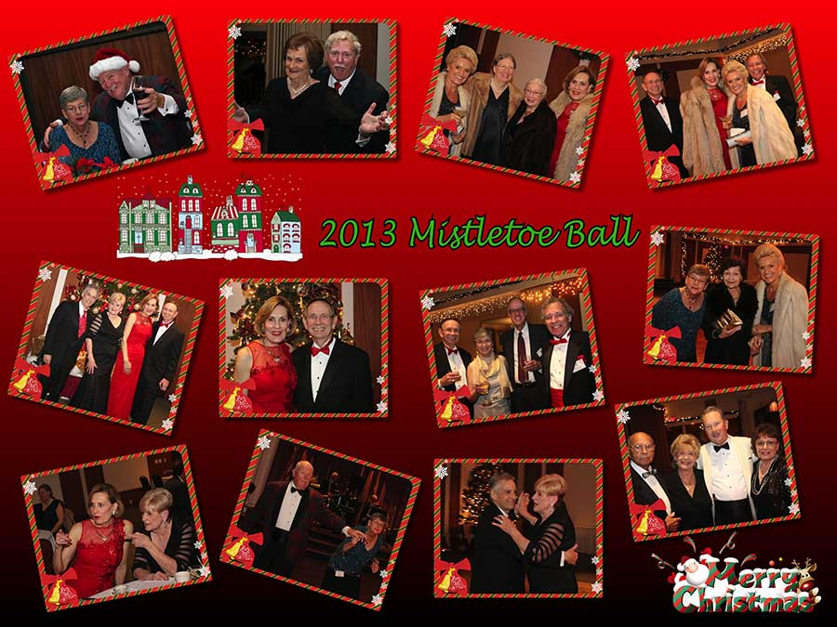

The Mistletoe Ball was a ball!

Remember our last dance?

“Happy New Year To Everyone…..”

# *Presidents Message…*

Poof! It’s 2013 and all of a sudden it’s a year later! Where does time go?

We must remember that year's end is neither an end nor a beginning but a going on, with all the wisdom that experience can instill in us.

The Mistletoe Ball was so much fun and we had a perfect storm… Gene DeValle, Howard Clauson, and Joe.

Gigi and I want to wish you all a very happy and healthy 2014! See you at the January 17th dance.

Try and bring a friend

*Larry Isham,  
 President*

*A New Year Begins*

Henry Ward Beecher had an excellent observation:

Every man should be born again on the first day of January. Start with a fresh page. Take up one hole more in the buckle if necessary, or let down one, according to circumstances; but on the first of January let every man gird himself once more, with his face to the front, and take no interest in the things that were and are past. ~

**

It’s 2014 Already!

# Policy Notes

There are no refunds for cancellations made after the Tuesday before the dance as the arrangements are finalized Tuesday evening.

If you desire to sit with someone please note it with your check so we can attempt to satisfy your seating desires!

# What You Need To Know

The January 17th dance will be at the Petroleum Club and will feature Don Sigarlati.

The cost is $76/couple (includes tax/tip).

No-host cocktail time is 6 pm & great dance music until 10 pm.

**Dress code is semi-formal**

Toppers Dinner Menu

Garden Green Salad  
Fresh seasonal vegetables.

Entree: Choice of Chicken Vallentine (Baked boneless chicken breat stuffed with seasonal rice) OR

Grilled White Fish in Lemon Butter and Rice OR a Vegetarian Selection.

Dessert: Chefs Selection. Coffee, Tea or decaffeinated coffee.

# Mail your checks made out to “Toppers Dance Club” With Dinner Selections on the checks To

Diane Schmitz   
3475 Lilly Ave

Long Beach Ca 90808

# Your Board

President Larry Isham  
Vice President Dean Fronk  
Past President Jerry Ellis  
Secretary Lori Fronk  
Treasurer Diane Schmitz  
Hospitality Neil/Nita Woolston  
Membership Vicky Kuhn  
Roster Donnis Weygandt  
Newsletter Paul/Sue Liles  
Members At Large Gigi Isham, Dennis Schmitz, Nancy Ellis, and Jack Taylor.

The Executive Board meets at 5:30 p.m. before each dance. Need a Toppers name badge, let Neal Woolston know!

# Prepare To Be Greeted

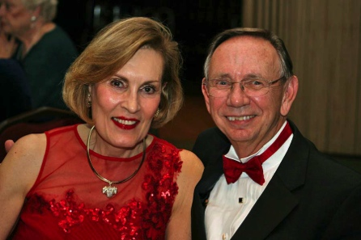

Tom and Kathy Berg

What A Great Dance!

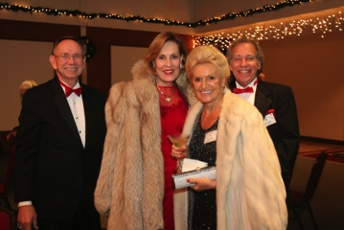

Smiles and smiles

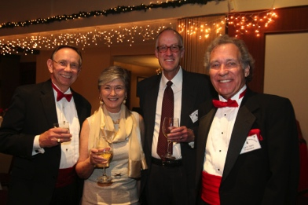

Welcome to the ball!

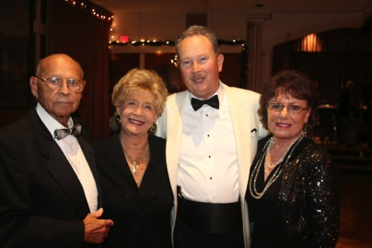  
Meeting & Greeting

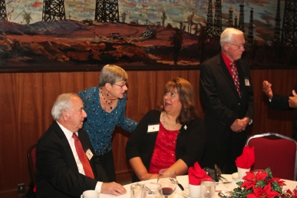  
Catching up with friends

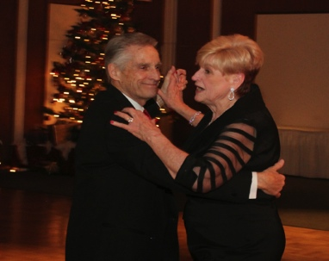

Dance time!

We Need Your Help…

Membership is an essential part of running a social club and keeping the membership refreshed in important.

In todays world people are “busy” with life but slowing down once a month and joining others in turning back the clock is a refresher.

Invite a guest or come and meet a guest! Invite them back and enjoy seeing new people meld into the fabric of our great club.

Keeping the club viable is everybody’s responsibility.

Why Dance?

Being in general an aerobic exercise, dance brings well known benefits, such as reducing the risk of cardiovascular disease, weight control and other ones commonly associated with physical fitness.

In addition, a considerable effect of dancing on psychological well-being is noted. Why you ask? The guys have to figure out the next step and the gals have to try to figure out what in the world he is doing!

# About Our Website

We keep a history of our dances “on-line” so we can go back in time and visit the good times.

Just Google “Toppers Dance Club” and our site is first on the search list!

# New Members!

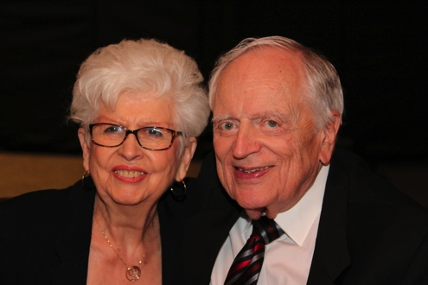

Carmen and Tracy Wells

Please consider inviting friends to our future dances as we want to meet new people.

# Herb Silverstein Passed 12/2/2013

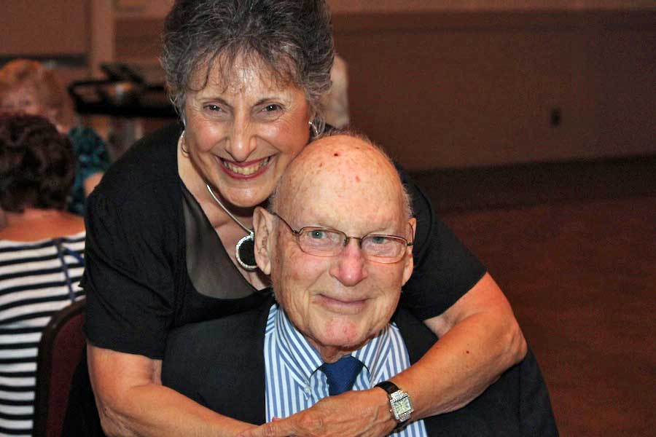

Irene and Herb October 2013

# Upcoming Dance Schedule

2/21/2014 – Dance to the tunes of Howard Solomon