

The dance was wonderful and prepared us for Thanksgiving

Remember our last dance?

“Season’s Greeting To Everyone…..”

# *Presidents Message…*

Where has the year gone and so quickly. There is an old saying, “Time passes quickly when you are having fun” !

We had a lot of fun at the Thanksgiving dance and it was nice to have guests and potential new members!

The Mistletoe Ball is our joint dance with the Petroleum Club so please join us and meet some new folks.

Gigi and I want to wish you all a very happy holiday season and will be looking forward to a new year of dancing!

*Larry Isham,  
 President*

*Christmas Questions To Ponder*

What special delivery arrived in a package marked "fra-gi-le" (fragile)

What happened to the Parker family's Christmas turkey?

It would of been a laugh to see Mommy doing what last night?

**

Christmas Is Here! Happy Holiday!

# Policy Notes

There are no refunds for cancellations made after the Tuesday before the dance as the arrangements are finalized Tuesday evening.

If you desire to sit with someone please note it with your check so we can attempt to satisfy your seating desires!

# What You Need To Know

The December 13th dance will be at the Petroleum Club and will feature The Rhythm Kings.

The cost is $128/couple (includes tax/tip).

No-host cocktail time is 6 pm & great dance music until 10 pm.

**Dress code is formal**

Toppers Dinner Menu

Caesar salad

Entree: Choice of Bacon Wrapped Filet Mignon OR

Crab Crusted Salmon.

Includes twice baked potatoes, Fresh seasonal vegetables.

Dessert: Cherry cobbler. Coffee, Tea or decaffeinated coffee.

# Mail your checks made out to “Toppers Dance Club” With Dinner Selections on the checks To

Diane Schmitz   
3475 Lilly Ave

Long Beach Ca 90808

# Your Board

President Larry Isham  
Vice President Dean Fronk  
Past President Jerry Ellis  
Secretary Lori Fronk  
Treasurer Diane Schmitz  
Hospitality Neil/Nita Woolston  
Membership Vicky Kuhn  
Roster Donnis Weygandt  
Newsletter Paul/Sue Liles  
Members At Large Gigi Isham, Dennis Schmitz, Nancy Ellis, and Jack Taylor.

The Executive Board meets at 5:30 p.m. before each dance. Need a Toppers name badge, let Neal Woolston know!

# Prepare To Be Greeted

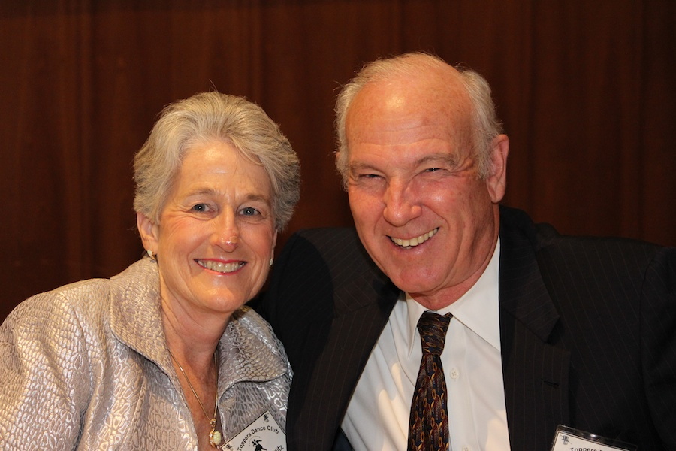

Diane and Dennis Schmitz

What A Great Dance!

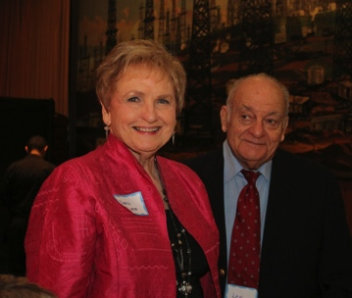

Smiles and smiles

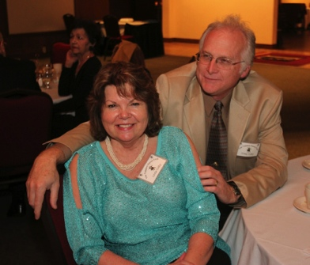

Looking for new steps to try

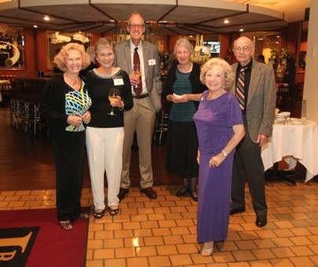  
Meeting & Greeting

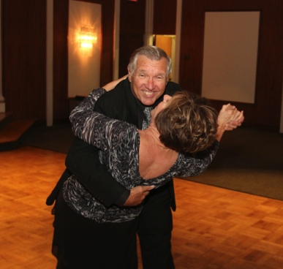  
We love fancy steps!

Winter Arrives December 21st…

Precisely on December 21st at 12:11 P.M. EST! The word solstice comes from the Latin words for "sun" and "to stand still.” In the Northern Hemisphere, as summer advances to winter, the points on the horizon where the Sun rises and sets advance southward each day; the high point in the Sun’s daily path across the sky, which occurs at local noon, also moves southward each day.

That’s Cold!

1683–1684, "The Great Frost", when the Thames, hosting one of many River Thames frost fairs, was frozen all the way up to the London Bridge and remained frozen for about two months. Ice was about 27 cm (11 in) thick in London and about 120 cm (47 in) thick in Somerset. The sea froze up to 2 miles (3.2 km) out around the coast of the southern North Sea, causing severe problems for shipping and preventing use of many harbors.

Roster Change

New members Sandy and Charlie Slater should be 2121 E. 1st Street Unit #201 Long Beach, Ca 90803 and the phone is 562-343-1812. Email is granby2468@aol.com

# About Our Website

We keep a history of our dances “on-line” so we can go back in time and visit the good times.

Just Google “Toppers Dance Club” and our site is first on the search list!

# Upcoming Dance Schedule

1/17/2014 – Dance to the tunes of Don Sigariati

# Our Guests!

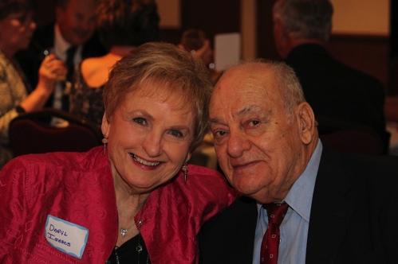

Daryl and Len Issacs

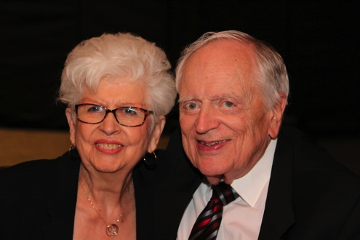

Carmen and Tracy Wells

Please consider inviting friends to our future dances as we want to meet new people.