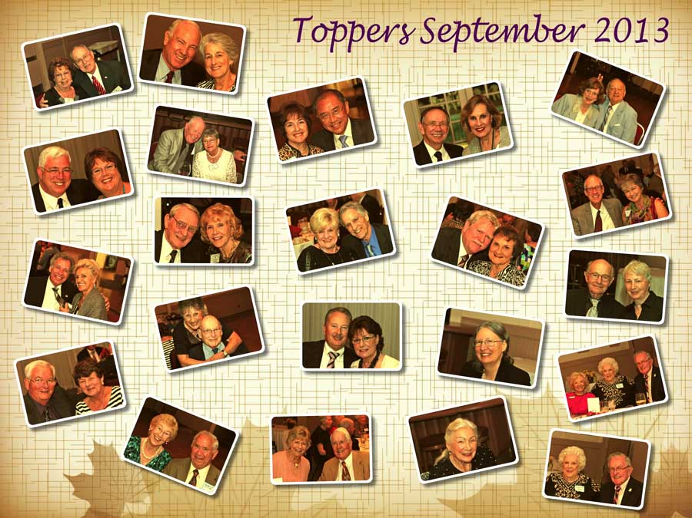

Autumn has arrived

Remember our last dance?

“Autumn...the year's last, loveliest smile.”

# *Presidents Message…*

Fall has arrived and the days are getting shorter which means more time to dance in the cool of the evenings!!

We have lost several members due to various reasons and hope you will redouble your efforts to bring in new guests and new members so we can keep our club active and vibrant. The more the merrier!

Our membership roster is in the final throws of being prepared thanks to Donnis and the board members!

Hope to see you in October and bring a friend!

*Larry Isham,  
 President*

*As Oliver Would Say….*

The foliage has been losing its freshness through the month of August, and here and there a yellow leaf shows itself like the first gray hair amidst the locks of a beauty who has seen one season too many.... September is dressing herself in showy dahlias and splendid marigolds and starry zinnias. October, the extravagant sister, has ordered an immense amount of the most gorgeous forest tapestry for her grand reception. ~Oliver Wendell Holmes

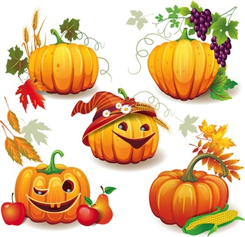

Autumn Is Here….

# Policy Notes

There are no refunds for cancellations made after the Tuesday before the dance as the arrangements are finalized Tuesday evening.

If you desire to sit with someone please note it with your check so we can attempt to satisfy your seating desires!

# What You Need To Know

The October 18th dance will be at the Petroleum Club and will feature Sam Conti.

The cost is $72/couple (includes tax/tip).

No-host cocktail time is 6 pm & great dance music until 10 pm.

Dress code is semi-formal

Toppers Dinner Menu

Fresh Green Garden Salad w/ Dressings

Chef’s Famous Lasagna or Baked Salmon with Hollandaise Sauce or Vegetarian selection. Served with fresh seasonal vegetables and rice or various potato selections. Warm bread and butter.

Chef’s selection Dessert, coffee and tea.

# Mail your checks made out to “Toppers Dance Club” With Dinner Selections on the checks To

Diane Schmitz   
3475 Lilly Ave

Long Beach Ca 90808

# Prepare To Be Greeted

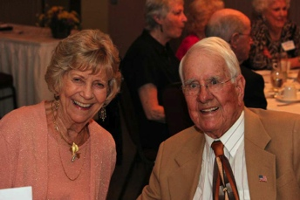

Joyce and Jack will greet everyone

What A Great Dance!

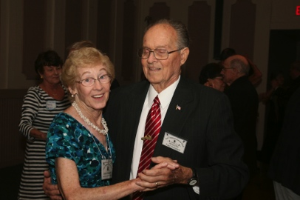

Smiles and smiles

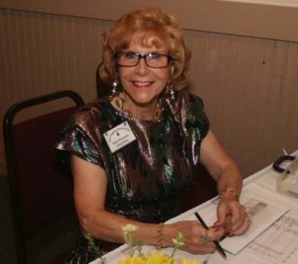

Hello there and welcome!!

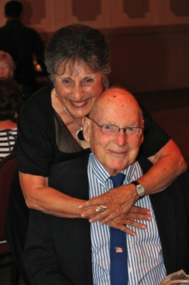  
Herb and Irene

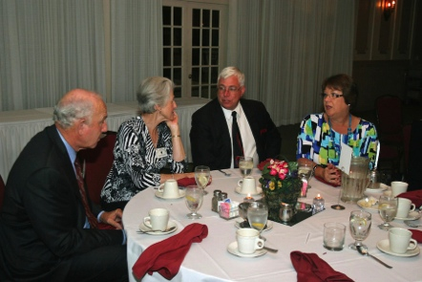  
Friends catching up

It’s Cha Cha Time

The modern style of dancing the cha-cha-chá comes from studies made by dance teacher Monsieur Pierre (Pierre Zurcher-Margolle), who partnered Doris Lavelle.

Pierre, then from London, visited Cuba in 1952 to find out how and what Cubans were dancing at the time. He noted that this new dance had a split fourth beat, and to dance it one started on the second beat, not the first. He brought this dance idea to England and eventually created what is now known as ballroom cha-cha-cha.

Styles of cha-cha-cha dance may differ in the place of the chasse in the rhythmical structure. The original Cuban and the ballroom cha-cha-cha count is "two, three, chachacha" or "four-and-one, two, three". The dance does not start on the first beat of a bar, though it can start with a transfer of weight to the lead's right.

Thoughts About Autumn

“I want to say something so embarrassing about September that even the leaves start blushing and turning red.”

― Jarod Kintz

# About Our Website

We keep a history of our dances “on-line” so we can go back in time and visit the good times.

Just Google “Toppers Dance Club” and our site is first on the search list!

# Your Board

President Larry Isham  
Vice President Dean Fronk  
Past President Jerry Ellis  
Secretary Lori Fronk  
Treasurer Diane Schmitz  
Hospitality Neil/Nita Woolston  
Membership Vicky Kuhn  
Roster Donnis Weygandt  
Newsletter Paul/Sue Liles  
Members At Large Gigi Isham, Dennis Schmitz, Nancy Ellis, and Jack Taylor.

The Executive Board meets at 5:30 p.m. before each dance. Need a Toppers name badge, let Neal Woolston know!

# Be A Greeter And Meet Everyone

See Neal or Nita and volunteer to be a greeter for one of the upcoming dances. It’s fun to meet everyone and a great way to remember names and faces!

# Our Guests!

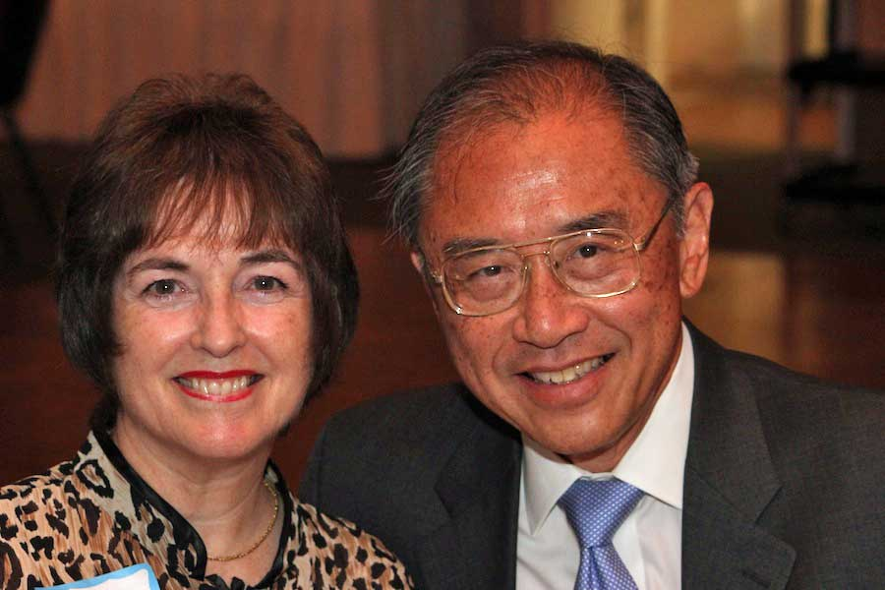

Guests are always welcome

Please consider inviting friends to our future dances as we want to meet new people.

# Upcoming Dance Schedule

10/18/2013 – Halloween time with Sam Conti