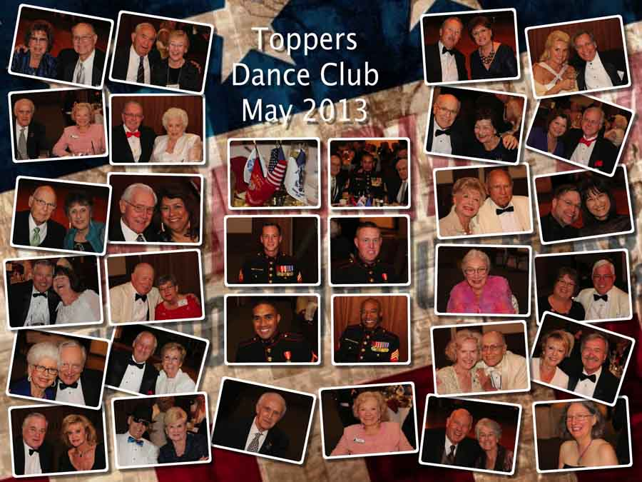

Honoring our soldiers on Memorial Day

Remember our last dance?

“Autumn...the year's last, loveliest smile.”

# *Presidents Message…*

We hope you had a delightful summer full of dancing and merriment! It seems like summer flew by this year. Remember, summer is officially over on the 21st and the holiday season is upon us!

Just think…. Three months until Christmas!

This season we start with three new member couples: Roy Mabee & Dori Miller, Gary & Marion Gray, and Wally & Ghislaine Rodecker!

Get your dancing shoes ready and we will see you on the 20th and find out how the summer break went!

*Larry Isham,  
 President*

*We Have New Board Members*

We are very pleased to announce that we have two new board members for this dance season.

Vicky Kuhn has offered to be the Membership Officer taking over from Bob Potthast. Thank you Bob for your service!

Joyce Rothrock has done a super job in providing us a roster but she is ready to move on and Donnis Weygandt has volunteered.

*Khoury’s Is Open For Thursday Evening Dancing*

Khoury’s has reopened on Thursday evenings from 5-9 for dancers. They no longer serve food but they have a good DJ and a nice wooden floor and a group of 50-60 people who come to visit and dance!

The Summer Is Almost Gone….

# Policy Notes

There are no refunds for cancellations made after the Tuesday before the dance as the arrangements are finalized Tuesday evening.

If you desire to sit with someone please note it with your check so we can attempt to satisfy your seating desires!

# What You Need To Know

The September 20th dance will be at the Petroleum Club and will feature Howard Solomon.

The cost is $75/couple (includes tax/tip).

No-host cocktail time is 6 pm & great dance music until 10 pm.

Dress code is semi-formal

Toppers Dinner Menu

Fresh Green Garden Salad w/ Dressings

Chicken Piccata in White Wine Lemon Butter with Capers or Grilled White Fish with Lemon Butter or Vegetarian Selection. Served with fresh seasonal vegetables and Chef’s choice of rice or potatoes. Warm bread and butter.

Chef’s selection Dessert, coffee and tea.

# Mail your checks made out to “Toppers Dance Club” With Dinner Selections on the checks To

Diane Schmitz   
3475 Lilly Ave

Long Beach Ca 90808

# Your Board

President Larry Isham  
Vice President Dean Fronk  
Past President Jerry Ellis  
Secretary Lori Fronk  
Treasurer Diane Schmitz  
Hospitality Neil/Nita Woolston  
Membership Vicky Kuhn  
Roster Donnis Weygandt  
Newsletter Paul/Sue Liles  
Members At Large Gigi Isham, Dennis Schmitz, Nancy Ellis, and Jack Taylor.

The Executive Board meets at 5:30 p.m. before each dance. Need a Toppers name badge, let Neal Woolston know!

# Prepare To Be Greeted

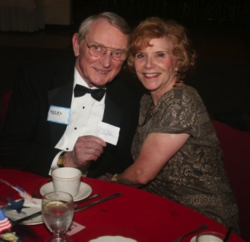

Neal & Nita Woolston will greet everyone

What A Great Dance!

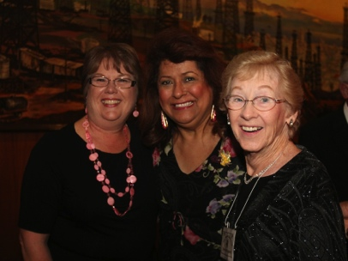

Smiles and smiles

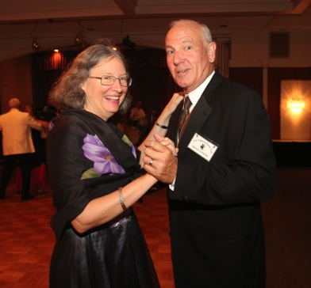

Hitting the floor early

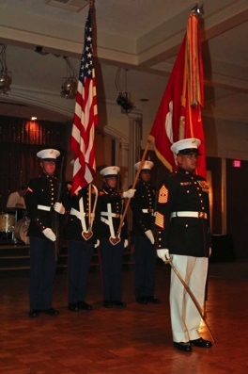  
The Marines have landed

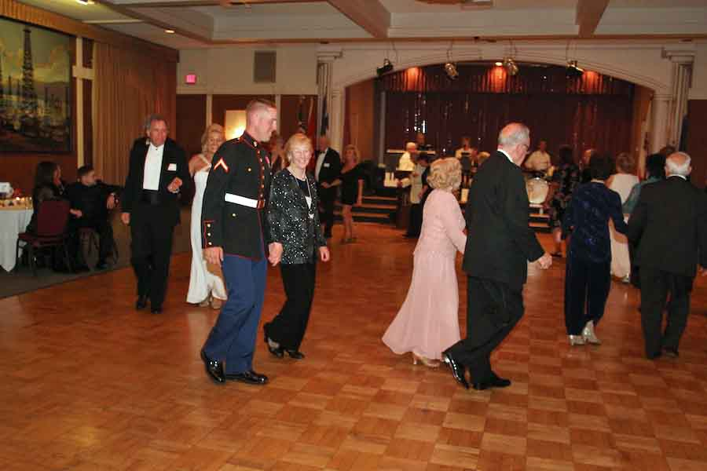  
The Mixer is always popular

The Word Autumn…

The word autumn comes from the Old French word autompne (automne in modern French), and was later normalised to the original Latin word autumnus. There are rare examples of its use as early as the 12th century, but it became common by the 16th century.

Before the 16th century, harvest was the term usually used to refer to the season, as it is common in other West Germanic languages to this day. However, as more people gradually moved from working the land to living in towns (especially those who could read and write, the only people whose use of language we now know), the word harvest lost its reference to the time of year and came to refer only to the actual activity of reaping, and autumn, as well as fall, began to replace it as a reference to the season.

Thoughts About Autumn

“Autumn is a season for big decisions -- like whether or not it's too late to start spring cleaning.” ~ Unknown

“Autumn is a great time of the year. Soon those ugly patches of dead grass in your lawn will be covered up -- with ugly patches of dead leaves.” ~ Unknown

# About Our Website

We keep a history of our dances “on-line” so we can go back in time and visit the good times.

Just Google “Toppers Dance Club” and our site is first on the search list!

# Be A Greeter And Meet Everyone

See Neal or Nita and volunteer to be a greeter for one of the upcoming dances. It’s fun to meet everyone and a great way to remember names and faces!

# Our Guests!

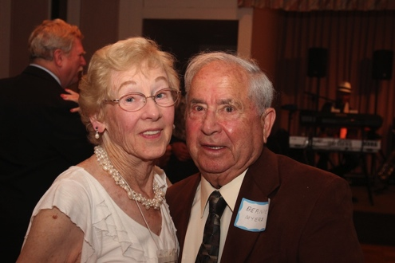

Donnis invited Bernie Myers as a guest

Please consider inviting friends to our future dances as we want to meet new people.

# Upcoming Dance Schedule

10/18/2013 – Halloween time with Sam Conti