# *Presidents Message…*

Hearts and flowers and chocolate candies? It must be Valentines season! Sam Conti will be making beautiful music for us at the next dance on the 15th of February. We will have a sea of red and another great time with friends.

It is with a heavy heart that I must say we lost Meretta Potthast in January. It was sudden and shocked us all. We will miss her magical smile and artistic centerpieces. Our condolences to Bob.

We are looking forward to seeing you all at the next dance!

See you on the 17th of February!

*Larry Isham,  
 President*

*Valentine’s Thoughts*

I don't understand why Cupid was chosen to represent Valentine's Day. When I think about romance, the last thing on my mind is a short, chubby toddler coming at me with a weapon. ~Author Unknown

For you see, each day I love you more… Today more than yesterday and less than tomorrow.

~Rosemonde Gerard

Love is a symbol of eternity. It wipes out all sense of time, destroying all memory of a beginning and all fear of an end. ~Author Unknown

Valentines Day, Yeah!

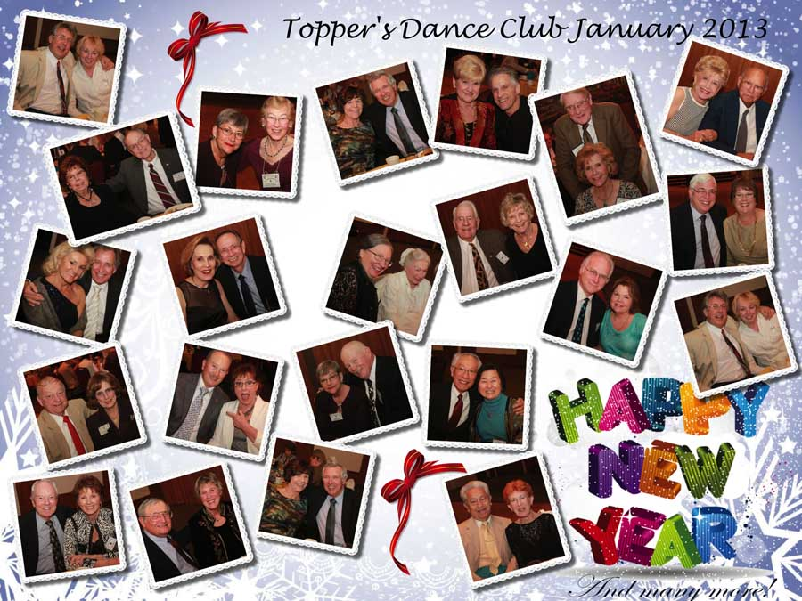

Remember our last dance?

Figure 1Sea

Figure 2 We danced in a sea of red

# Policy Notes

There are no refunds for cancellations made after the Tuesday before the dance as the arrangements are finalized Tuesday evening.

If you desire to sit with someone please note it with your check so we can attempt to satisfy your seating desires!

# What You Need To Know

The February 15th dance will be at the Petroleum Club and will feature the Sam Conti.

The cost is $70/couple (includes tax/tip).

No-host cocktail time is at 6 pm and great dance music until 10 pm.

Dress code is semi-formal

Toppers Dinner Menu

Caesar Salad

Swiss Steak or Fish of the Day or Vegetarian

Red Rose Potatoes

Baby Carrots

Mint Chocolate Chip Ice Cream

Hot bread and butter, coffee and tea.

# Mail your checks made out to “Toppers Dance Club” With Dinner Selections on the checks To

Larry Isham   
2023 Ruhland Ave

Redondo Beach Ca 90278

Love is the magician that pulls man out of his own hat.  ~Ben Hecht

# Your Board

President Larry Isham  
Vice President Dean Fronk  
Past President Jerry Ellis  
Secretary Lori Fronk  
Treasurer Diane Schmitz  
Hospitality Neil/Nita Woolston  
Membership Bob Potthast  
Roster Joyce Rothrock  
Newsletter Paul & Sue Liles  
Member At Large Gigi Isham, Dennis Schmitz, Nancy Ellis, Jack Taylor, and Meretta Potthast

The Executive Board meets at 5:30 p.m. before each dance. Need a Toppers name badge, let an officer know!

**Prepare To Be Greeted**

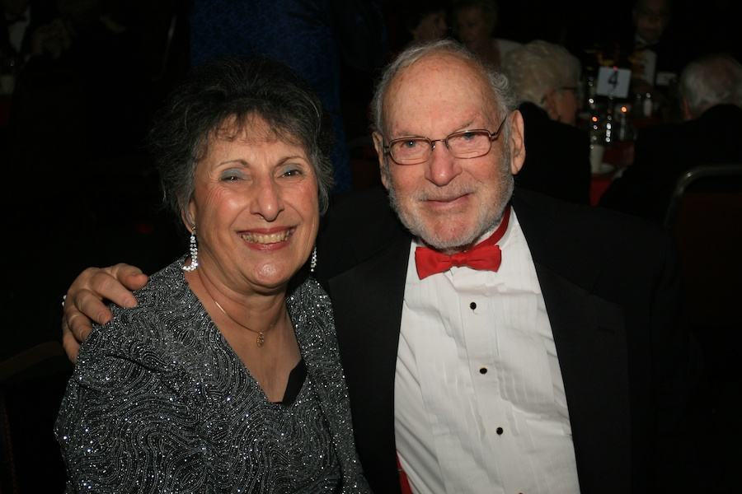

Irene Kosmetatos &   
Herb Silverstein

What A Great Dance!

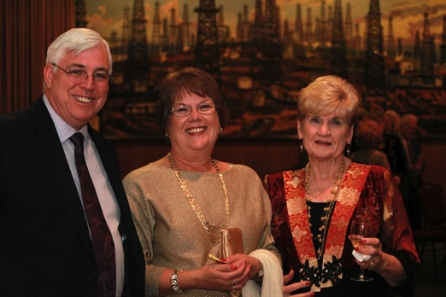

Tripping the light fantastic

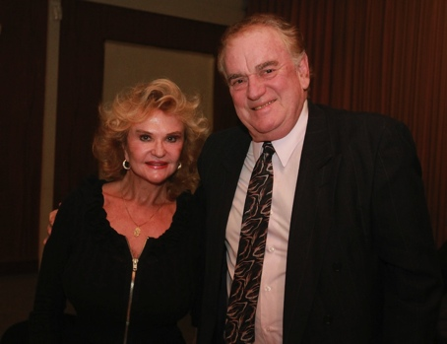

Miles of smiles

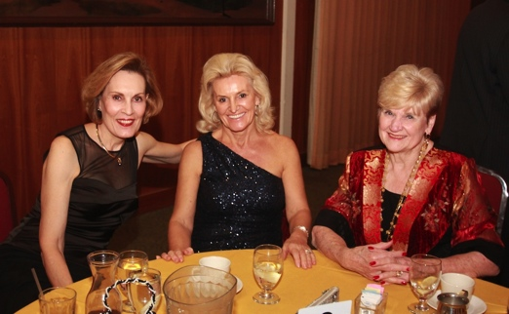Watching the dancers

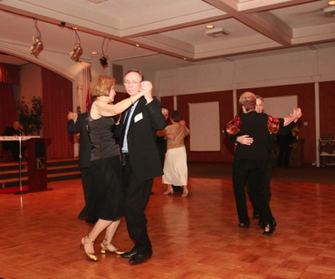  
Dancing is fun and keeps us warm

Chaucer’s Love Birds!

The first recorded association of Valentine's Day with romantic love is in Parlement of Foules (1382) by Geoffrey Chaucer. Chaucer wrote:

For this was on seynt Volantynys day

Whan euery bryd comyth there to chese his make.

["For this was on Saint Valentine's Day, when every bird cometh there to choose his mate."]

This poem was written to honor the first anniversary of the engagement of King Richard II of England to Anne of Bohemia. A treaty providing for a marriage was signed on May 2, 1381. (When they were married eight months later, they were each only 15 years old).

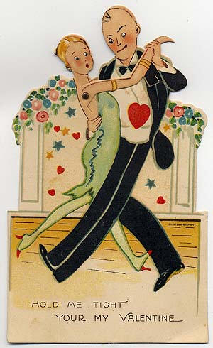

Valentines Day and Dancing – A Perfect Match!

# Be My Valentine

My heart to you is given:  
Oh, do give yours to me;  
We'll lock them up together,  
And throw away the key.  
~Frederick Saunders

# Bites & Pieces

We had several guests last dance including:

Wally and Ghislaine Rodecker (Silverstein)

Brian and Jan Finch (Liles)

Vince and Nancy Adamson (Kuhn)

Roy Maybee & Dori Miller! (Liles)

Please consider inviting friends to our future dances as we want to meet new people.

.



# Upcoming Dance Schedule

3/16/2013 – Now and Then