

Dancing at the Mistletoe Ball

Figure Sea

Figure We danced in a sea of red

It’s Time For New Resolutions

# *Presidents Message…*

Our Christmas dance, the Mistletoe Ball, was well attended and the band did an excellent job. Sometimes I felt like St. Nick was just in the next room but perhaps it was Leroy taking care pf things.

We hope your Christmas festivities we all you hoped for and that this new year will bring us many more dances and perhaps some new friends and members.

Wishing everyone a very prosperous new year and the wherewithal to keep those pesky resolutions!!

See you on the 18th of January with Howard Solomon!

*Larry Isham,  
 President*

*New Year’s Thoughts…*

New Year's eve is like every other night; there is no pause in the march of the universe, no breathless moment of silence among created things that the passage of another twelve months may be noted; and yet no man has quite the same thoughts this evening that come with the coming of darkness on other nights.

~Hamilton Wright Mabie



# Policy Notes

There are no refunds for cancellations made after the Tuesday before the dance as the arrangements are finalized Tuesday evening.

If you desire to sit with someone please note it with your check so we can attempt to satisfy your seating desires!

# What You Need To Know

The January 18th dance will be at the Petroleum Club and will feature The Howard Solomon Band.

The cost is $74/couple (includes tax/tip).

No-host cocktail time is at 6 pm and great dance music until 10 pm. Dress code is Semi-formal

Toppers Dinner Menu

Fresh garden green salad with dressings

Chicken Cordon Bleu or Fish of the day or Vegetarian dish

Seasonal Vegetables and scalloped potatoes.

Cheese cake with raspberry sauce

Warm bread and butter, coffee and tea

# Mail your checks made out to “Toppers Dance Club” With Dinner Selections on the checks To

Diane Schmitz   
3475 Lilly Ave

Long Beach Ca 90808

A New Year's resolution is something that goes in one year and out the other. ~Author Unknown

# Your Board

President Larry Isham  
Vice President Dean Fronk  
Past President Jerry Ellis  
Secretary Lori Fronk  
Treasurer Diane Schmitz  
Hospitality Neil/Nita Woolston  
Membership Bob Potthast  
Roster Joyce Rothrock  
Newsletter Paul & Sue Liles  
Member At Large Gigi Isham, Dennis Schmitz, Nancy Ellis, Jack Taylor, and Meretta Potthast

The Executive Board meets at 5:30 p.m. before each dance. Need a Toppers name badge, let an officer know!

**Prepare To Be Greeted**

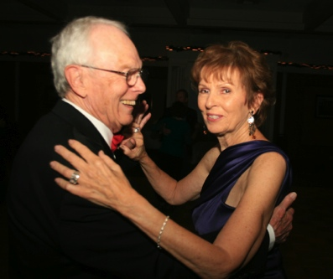

Nick Thomas & Kay Quick

What A Great Dance!

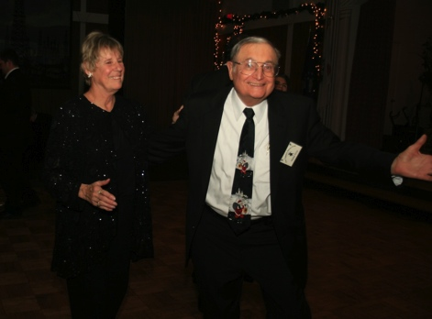

Tripping the light fantastic

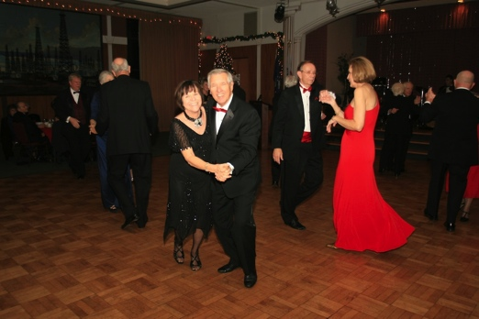

Miles of smiles

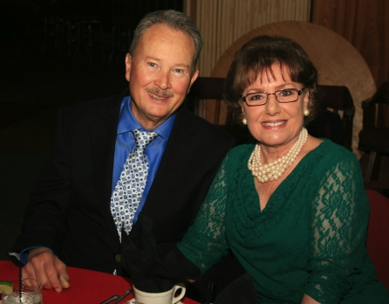Guests Roy and Dorri

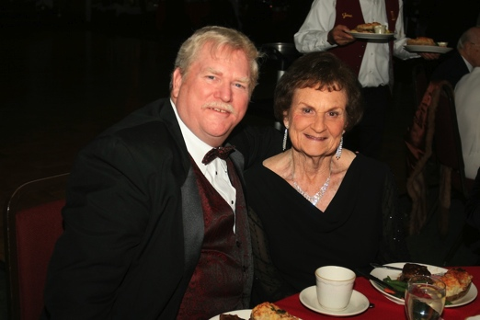Guests Gary and Marion Grey

December? How Interesting!

January (JAN-ew-AIR-ee) is the first month of the year in the Julian and Gregorian calendars and one of seven months with the length of 31 days. The first day of the month is known as New Year's Day.

It is, on average, the coldest month of the year within most of the Northern Hemisphere (where it is the second month of winter) and the warmest month of the year within most of the Southern Hemisphere (where it is the second month of summer).

In the Southern hemisphere, January is the seasonal equivalent of July in the Northern hemisphere.

January starts on the same day of the week as October in common years, and starts on the same day of the week as April and July in leap years.

In a common year, January ends on the same day of the week as February and October, and ends on the same day of the week as July in a leap year.

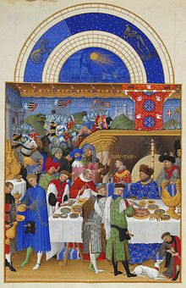

January, from the Très Riches Heures du Duc de Berry

# Bites & Pieces

Paul and Sue Liles hosted their grandson Jon and his lady Sarah who are out for a Christmas visit all the way from cold and snowy New Hampshire.

Gary and Marion Gray, members of Nightlighter’s and friends of the Berg’s, joined us this evening!

Tracy & Carmen Wells and Gilles & Gisele Mongeau were guests of Al & Mickey Arauj.

Roy Maybee and Dori Miller were guests of Herb Silversteon and Irene Kosmetatos.



# Upcoming Dance Schedule

2/15/2013 – Sam Conti