It’s Time For Christmas Already

# *Presidents Message…*

Christmas is only a few days away. The chill is in the air and the trees are losing their leaves. You know what that means…. Time to dance with the Topper’s.

We are looking forward to seeing all of you at the Mistletoe Ball on December 14th as we join in celebrating with members of the Petroleum Club.

The custom of decorating a Christmas tree has been traced back to the 15th century.

Wishing everyone a very happy holiday and a prosperous new year!

See you on the 14th!

*Larry Isham,  
 President*

# 

# ***Christmas Thoughts****…*

I have always thought of Christmas time, when it has come round, as a good time; a kind, forgiving, charitable time; the only time I know of, in the long calendar of the year, when men and women seem by one consent to open their shut-up hearts freely, and to think of people below them as if they really were fellow passengers to the grave, and not another race of creatures bound on other journeys.  ~Charles Dickens

**



Remember our last dance?

Figure 1Sea

Figure 2 We danced in a sea of red

# Policy Notes

There are no refunds for cancellations made after the Tuesday before the dance as the arrangements are finalized Tuesday evening.

If you desire to sit with someone please note it with your check so we can attempt to satisfy your seating desires!

# What You Need To Know

The December 14th dance will be at the Petroleum Club and will feature the Rhythm Kings.

The cost is $112/couple (includes tax/tip).

No-host cocktail time is at 6 pm and great dance music until 10 pm.

Dress code is formal

Toppers Dinner Menu

Caesar Salad

Bacon Wrapped Filet Mignon or Orange Roughy or Vegetarian

Twice Baked Potatoes

Fresh Vegetables

Peach Cobbler

Hot bread and butter, coffee and tea.

# Mail your checks made out to “Toppers Dance Club” With Dinner Selections on the checks To

Diane Schmitz   
3475 Lilly Ave

Long Beach Ca 90808

Christmas is a time when you get homesick - even when you're home.  ~Carol Nelson

# Your Board

President Larry Isham  
Vice President Dean Fronk  
Past President Jerry Ellis  
Secretary Lori Fronk  
Treasurer Diane Schmitz  
Hospitality Neil/Nita Woolston  
Membership Bob Potthast  
Roster Joyce Rothrock  
Newsletter Paul & Sue Liles  
Member At Large Gigi Isham, Dennis Schmitz, Nancy Ellis, Jack Taylor, and Meretta Potthast

The Executive Board meets at 5:30 p.m. before each dance. Need a Toppers name badge, let an officer know!

**Prepare To Be Greeted**

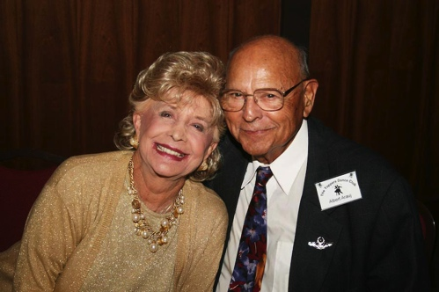

Mickey and Al Arauj

What A Great Dance!

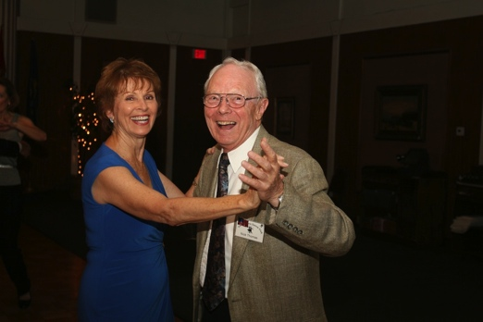

Tripping the light fantastic

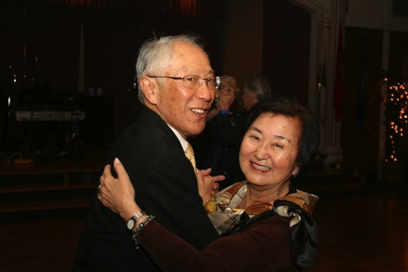

Miles of smiles

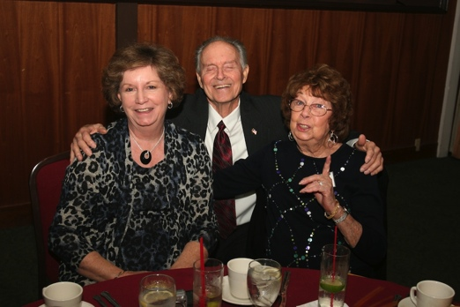Louisiana Pat joined us

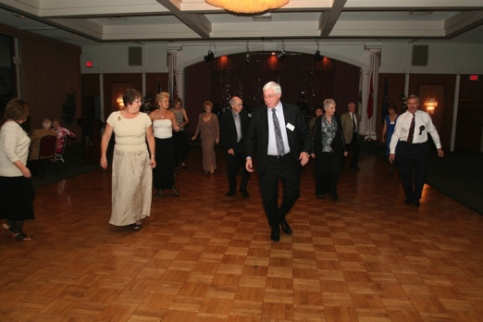Line dancers take the floor

December? How Interesting!

December (Listeni/diːˈsɛmbər/ dee-SEM-bər) is the 12th and last month of the year in the Julian and Gregorian Calendars and one of seven months with the length of 31 days.

December starts on the same day of the week as September every year and ends on the same day as April every year.

December is the month with the shortest daylight hours of the year in the Northern Hemisphere and the longest daylight hours of the year in the Southern Hemisphere.

December in the Northern Hemisphere is the seasonal equivalent to June in the Southern Hemisphere and vice versa.

In the Northern hemisphere, the beginning of the meteorological winter is 1 December. In the Southern hemisphere, the beginning of the meteorological summer is 1 December.

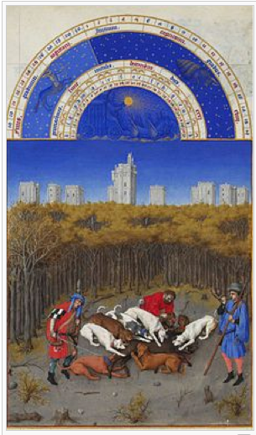

December, from the Très Riches Heures du Duc de Berry

# Bites & Pieces

Jerry and Nancy hosted their sister Pat who joined us directly from Louisiana. Pat assisted Paul Liles in learning some new Louisiana Two-Step maneuvers.

Please consider inviting friends to our future dances as we want to meet new people.

Buck Catlin continues to improve and we look forward to seeing him at a future dance.

The first commercial Christmas card was produced and sold in London in 1843.



# Upcoming Dance Schedule

1/18/2013 – Howard Solomon