Fall Is Here… You Can See It In The Trees

# *Presidents Message…*

Summer temperatures seem to be with us but the trees are saying it’s Autumn. Rakes and brooms will soon be seen around our community!

Put October 19th on your calendar and bring some friends to the next dance. The more the merrier.

Gigi and I enjoyed visiting with you at the last dance. We are looking forward to visiting with you again and perhaps share your scary Halloween plans with us. No tricks; just treats!

We will see you in a few short weeks!

*Larry Isham,  
 President*

# ***Autumn Is Here****…*

Bittersweet October.  The mellow, messy, leaf-kicking, perfect pause between the opposing miseries of summer and winter.  ~ Carol Bishop Hipps.

How beautifully leaves grow old.  How full of light and color are their last days.  ~John Burroughs

**

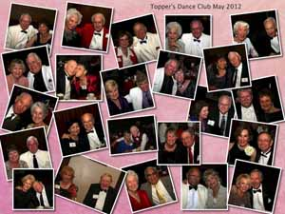

Remember our last dance?

Figure Sea

Figure We danced in a sea of red

# Policy Notes

There are no refunds for cancellations made after the Tuesday before the dance as the arrangements are finalized Tuesday evening.

If you desire to sit with someone please note it with your check so we can attempt to satisfy your seating desires!

# What You Need To Know

The October 19th dance will be at the Petroleum Club and will feature the Phil Anthony Band

The cost is $70/couple (includes tax/tip).

No-host cocktail time is at 6 p.m and the great dance music until 10 p.m.

Dress code is semi-formal.   
  
Toppers Dinner Menu

Green salad with dressings on the table, Stuffed Center Pork Chops or Fish of the Day or Vegetarian Pasta, Red rose potatoes and Mixed Vegetables, Hot bread and butter, Pumpkin Pie, Coffee and tea.

# Mail your checks made out to “Toppers Dance Club” With Dinner Selections on the checks To

Larry Isham   
2023 Ruhland Ave

Redondo Beach Ca 90278

Autumn is a second spring when every leaf is a flower.  ~Albert Camus

**Prepare To Be Greeted**

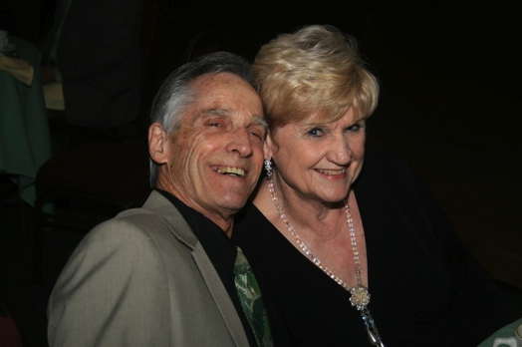

Luck and Carolyn Harrington

What A Great Dance!

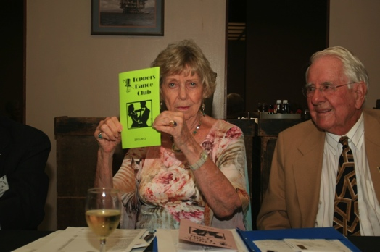

Joyce was completing the roster

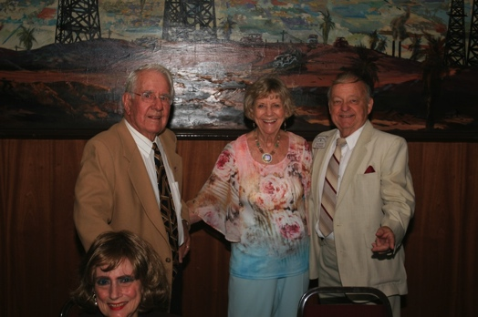Visiting begins!

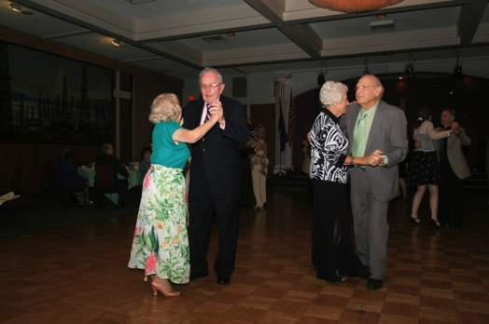Kicking up our heels

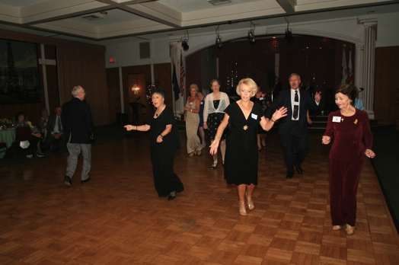

Time to move...

October? How Interesting!

October is the tenth month of the year in the Julian and Gregorian Calendars and one of seven months with a length of 31 days. The eighth month in the old Roman calendar, October retained its name (from the Latin "octo" meaning "eight") after January and February were inserted into the calendar that had originally been created by the Romans.

October is commonly associated with the season of autumn in the Northern hemisphere and spring in the Southern hemisphere, where it is the seasonal equivalent to April in the Northern hemisphere and vice versa.

In common years January starts on the same day of the week as October, but no other month starts on the same day of the week as October in leap years. October ends on the same day of the week as February every year and January in common years only.

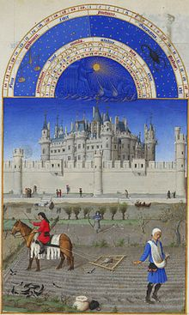

October, from the Très Riches   
Heures du Duc de Berry

# Your Board

President Larry Isham  
Vice President Dean Fronk  
Past President Jerry Ellis  
Secretary Lori Fronk  
Treasurer Diane Schmitz  
Hospitality Neil/Nita Woolston  
Membership Bob Potthast  
Roster Joyce Rothrock  
Newsletter Paul & Sue Liles  
Member At Large Gigi Isham, Dennis Schmitz, Nancy Ellis, Jack Taylor, and Meretta Potthast

The Executive Board meets at 5:30 p.m. before each dance. Need a Toppers name badge? Call Earl Eakle at 310-375-8134.

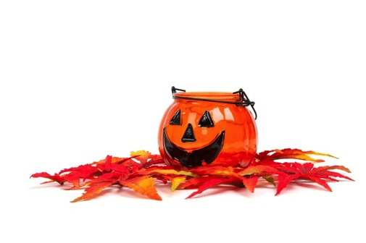

# Bites & Pieces

Joe Ramos has requested a leave of absence while recovering from surgery.

Buck Catlin suffered stroke and is recovering. Bobbie is doing well.

Del Kuhn went to see Mitzi Gaynor for his birthday and was observed wearing his special “Mitzi Necktie” while sitting in the front row.

Make sure you pick up your latest Toppers Roster from Joyce at the next dance.

# Upcoming Dance Schedule

11/16/2012 – Tony Carinio