Presidents Message…

It’s 2012 and another year of seeing and dancing with great friends!

We have a new feature on our website and that is a “visual roster” with our names and pictures from dances in alphabetical order.

We will see everyone in February 17th and dance to the Sam Conti band.

Remember - “Life isn’t about waiting for the storm to be over, it’s about learning how to dance in the rain.”

Happy Valentines Day and see you soon!

Larry Isham
President

Do You Like The Collages?

A collage (From the French: coller, to glue), is a work of formal art, primarily in the visual arts, made from an assemblage of different forms, thus creating a new whole.

We create a “Who Was Here” collage and put it on the website.

You can see who was at the last dance at the following address: http://tinyurl.com/798b78q

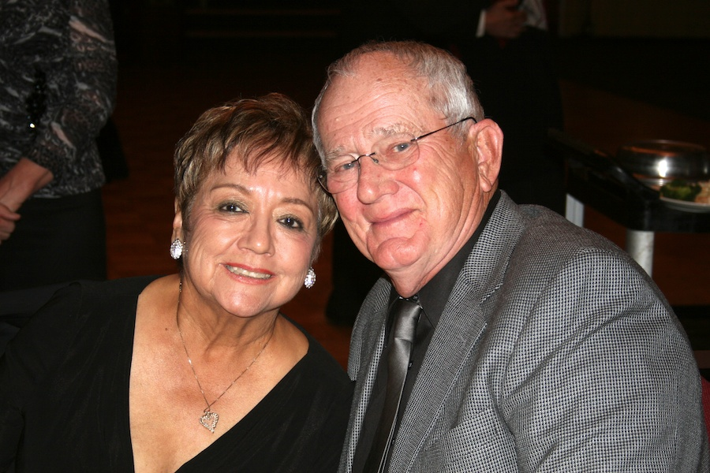
Ernestine Cazares & John Schulte, guests of Paul & Sue Liles

What You Need To Know
The February 17th dance will be at the Petroleum Club and will feature the Sam Conti Band!

The cost is $74/couple (includes tax/tip).

No-host cocktail time is at 6 p.m and the great dance music until 10 p.m.

Dress code is semi-formal.
Toppers Dinner Menu

Green Salad with dressings on the table
Stuffed Pork Chops or Fish of the Day or Vegetarian
Scalloped Potatoes and
Vegetables

Cheesecake with Raspberry Sauce

Hot bread and butter, dessert, coffee and tea.

Mail your checks made out to “Toppers Dance Club” With Dinner Selections on the checks To
Diane Schmitz
3475 Lilly Avenue
Long Beach, CA 90808

Dancing the night away…
  - “There are shortcuts to happiness and dancing is one of them.” - Vicki Baum

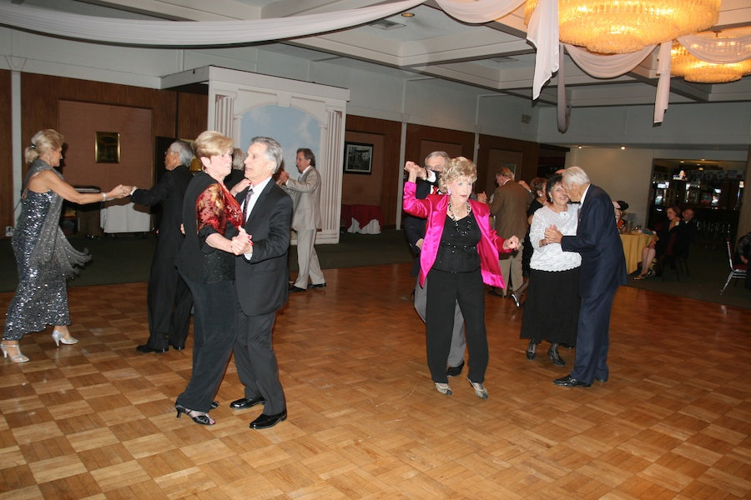

2012 Is Here And It Is Time To Dance…
Prepare To Be Greeted
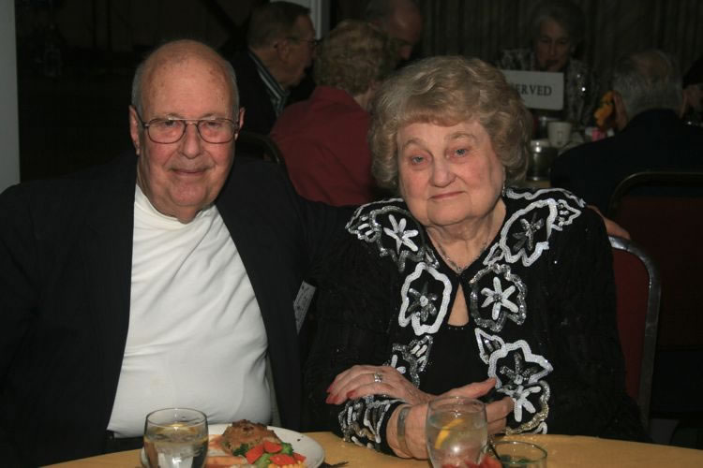
Earl & Jeannine Eakle

Be prepared to be welcomed with a big smile by Earl & Jeannine.

February? How Interesting!
February starts on the same day of the week as March and November in common years, and on the same day of the week as August in leap years. February ends on the same day of the week as October every year and January in common years only. In leap years, it is the only month that ends on the same weekday it begins.

February was named after the Latin term februum, which means purification, via the purification ritual Februa held on February 15 (full moon) in the old lunar Roman calendar. January and February were the last two months to be added to the Roman calendar, since the Romans originally considered winter a monthless period. February remained the last month of the calendar year until the time of the decemvirs (c. 450 BC), when it became the second month.

Historical names for February include the Old English terms Solmonath (mud month) and Kale-monath (named for cabbage) as well as Charlemagne's designation Hornung. In Finnish, the month is called helmikuu, meaning "month of the pearl"; when snow melts on tree branches, it forms droplets, and as these freeze again, they are like pearls of ice. In Polish and Ukrainian, respectively, the month is called luty or лютий, meaning the month of ice or hard frost.

February, from the Très Riches Heures du Duc de Berry

Cocktail Anyone?
The earliest definition of cocktail was in the May 13, 1806, edition of The Balance and Columbian Repository, a publication in Hudson New York in which an answer was provided to the question, "What is a cocktail?". It replied:
Cocktail is a stimulating liquor composed of spirits of any kind, sugar, water, and bitters—it is vulgarly called a bittered sling and is supposed to be an excellent electioneering potion, inasmuch as it renders the heart stout and bold, at the same time that it fuddles the head. It is said, also to be of great use to democratic candidate: because a person, having swallowed a glass of it, is ready to swallow any thing else.

Your Board

President Larry Isham
Vice President Dean Fronk
Past President Jerry Ellis
Secretary Lori Fronk
Treasurer Diane Schmitz
Hospitality Neil/Nita Woolston
Membership Bob Potthast
Roster Joyce Rothrock
Newsletter Paul & Sue Liles
Member At Large Gigi Isham, Dennis Schmitz, Nancy Ellis, Jack Taylor, and Meretta Potthast

The Executive Board meets at 5:30 p.m. before each dance. Need a Toppers name badge? Call Earl Eakle at 310-375-8134.

Spotlight On A Topper

Trying Something New
We have had many members unhappy with seat saving and not being to find a place to sit easily so the board decided to try assigned seating and see what happens.

Instead of getting upset, see this as an opportunity to get to know more of our delightful and charming members.

You will get a chance to mix and meet with “the regulars” during cocktails, while dancing, and of course during the mixers!

Remember – “The shortest distance between new friends is a smile.”

Our Dance Schedule
2/17/2012 – San Conti
3/16/2012 – Phil Anthony
4/20/2012 – Tony Carinio
5/18/2012 – Howard Solomon

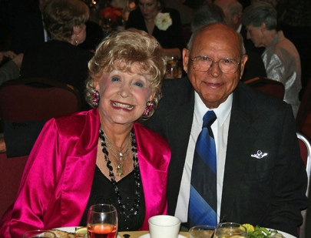
Al & Mickey Arauj
As reported to Vicky Kuhn

It has been stated by pundits throughout the ages that ‘fate is the hunter.’ How else could one explain how two people, who started their life’s journey a continent apart, lead totally different lives as they progressed…would wind up together?

Mickey was born and raised next to Lake Michigan in the small town of New Haven, Michigan across from Chicago, Illinois. She started school in a three story building that housed all the grades in one building. Mickey was a majorette with the local drum and bugle corps. She attained local fame as a champion baton twirler, yes, complete with the fancy uniform consisting of the swirling short skirt, white boots with tassels and the shiny top-speed spinning baton. She subsequently attended Michigan State University and became the state’s #1 baton twirling champion.

Through a twist of fate, after graduating from college Mickey was chosen by TWA Airlines to become a stewardess, today they are called flight attendants. After her intense training, she was hosting in a DC3 airplane and later transferred to a Super G Constellation. There, she continued to be a hostess to many famous celebrities such as the young Frank Sinatra, then married to Nancy. Other celebrities and personalities included actor Leo Carrillo, actor, comic and singer Danny Kaye and the aviation brilliant legend, Howard Hughes.

Mickey became a teacher at a private school in Beverly Hills. Some of the students at this school had celebrity parents such as the great tap dancer and actress Eleanor Powell, the legendary actor Glenn Ford, the great singer Peggy Lee, and cowboy actor Rex Allen whose son Rex Allen Jr. was one of Mickey’s favorite students.

Mickey eventually married her first husband and they became parents of a son and daughter. Her husband died after 42 years of marriage. Both adult children now live nearby and Mickey has 2 granddaughters.

She went on to have another career with a major nutrition company that was just starting. Mickey worked directly with Dr. Forrest Shaklee from the Shaklee Products for 30 years.…. until she met me, Al. Now fate takes another turn!

Al started his journey on the west coast, Fullerton to be exact. From the time Al was a little boy, he dreamed of flying the biggest and fastest airplanes in the world. Al used to climb a nearby tree and watch airplanes coming out of Fullerton airport. At that time, (1930s) Fullerton airport consisted of a couple of small shacks and a dirt runway.

One day, Al managed to convince the owner of two small airplanes called ‘Piper Cubs’ to teach me how to fly, and bless them, they did. Al soloed when he was only 11 and hid mother never knew. Al worked for the man for a long time, doing odd jobs around the airport having written his own first ‘work contract’ in exchange for flying lessons. The guy ended up being dear friend and mentor.

When Al was 17, he wanted to continue to fly and knew that joining the Army Air Corp, (later called the Air Force) would be his ‘flying’ ticket.

Al lied about his age, said he was 19 and enlisted in the Army Air Corp. After training, Al became an aerial gunner on a B26 which was a twin-engine light-bomber towards the end of WW2.

After WW2 ended, Al was sent to flying school in Columbus, Mississippi and became the oldest cadet (at age 26) in pre-flight school. Al ‘cut his teeth’ in gunnery training and combat fighting at Nellis AFB in Las Vegas in an F86. His next assignment was to fly the F86 Sabre in Korea…cold, cold Korea. That’s where Al spent a lot of time in ‘ground support missions’ and on a number of occasions; Al went after the Korean ‘bad guys’ flying their ‘migs.’ Al’s next assignment was flying the first nuclear bomber, the B47, which he considered the most beautiful airplane in the air.

Later on, during 1960s, Al was chosen to do ‘field testing’ for the ‘141 Star Lifter.’ At that time, it was the largest jet transport in the Air Force. It was during this time, that he was flying from Japan to Travis Air Force base near Sacramento, California, Al caught a great tail wind one day and tied a world speed record for jet transports. What a thrill!

From 1964-1968, Al was an air craft commander of the 141 Star Lifter in Saigon, South Viet Nam. His schedule was to pick up the wounded and deceased military personnel. His superior had been killed in Viet Nam while Al was at Clark Field in the Philippines and Al was ordered to proceed immediately to Saigon to join and assist the now historic ‘AIR RESCUE’ Operation transporting the hundreds of South Vietnamese citizens and our military personnel out of Viet Nam. The enemy had invaded South Viet Nam and the capital. These people’s lives had to be saved. Al also had quick training and learned to fly the ‘Jolly Green Giant’, a twin engine helicopter to continue to assist in the rescue operation. Al was given a ‘spot promotion’ to Lt. Colonel.

Upon returning to the United States, having retired from the Air Force in 1968, he began another journey into the world of business. Al started a real estate development company that he based in SF for 26 years. Al sold the company and moved back to Southern California. His old town of Fullerton had changed, the airport had grown, the tree he climbed was gone, even the neighborhood changed…in fact, as he travel the streets of Fullerton that he once knew well…he got lost for a moment.

Fate struck Al again as one night about 1988; he was at Alpine Village in Torrance in their big dance room, when Al spotted a pretty gal that caught my eye, Mickey. She was dancing with ‘some jerk’ and Al told myself that she is ‘the one’ I’m going to marry. Needless to say, she didn’t have a clue who he was or what his plans for her were…at least for now anyway.

So, being the aggressive and focused man that he is, Al managed to be at other dance places he thought she might show up at, knowing she liked to dance as much as he did. Yes, Al spotted her again and asked her for a dance and TWICE, she turned him down. The next time Al saw Mickey was at the Diamond Night Club in Fullerton. The great John Henderson’s band used to play there. Well, Mickey was sitting at this club with a girl friend when Al just went over, took her by the hand and danced with her and no one else that night. They talked for at least 10 hours. Al thinks that was another world record he set that night, having the longest ‘coffee chat’ in history

They dated for two years, married and recently celebrated their 21st anniversary. Today, when people ask Al how long we have been married, he tell them “5 minutes.” Then, they look puzzled and Al says “That one year with Mickey is like a second in time, as that’s how fast time has flown.” This marriage has gone faster and lasted longer that any airplane or jet he has ever flown and it’s all been a thrill.

They have been members of Toppers for about two years and enjoy the very pleasant people and special friendships in this wonderful club. Keep on dancing!

On The Web From Anywhere
You are on the web! Try this URL:
http://tinyurl.com/798b78q for pictures from the January 2012 dance!

The previous newsletters are also available on our website should you be missing a copy.

Quotes To Remember
"Friendship is like a violin; the music may stop now and then, but the strings will last forever."

"You'll always be my best friend, you know too much!"

The January Dance!
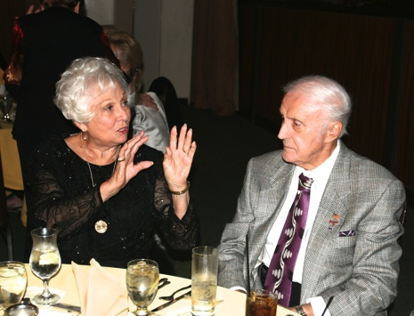
“Picture this….”
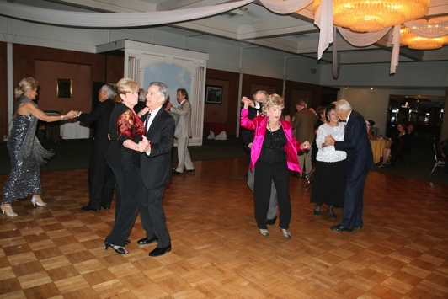
No stopping a Topper
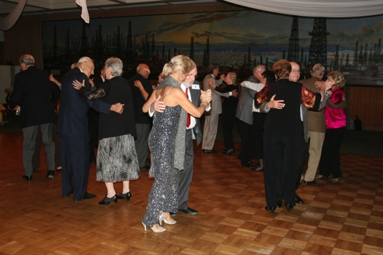
Around and around they go
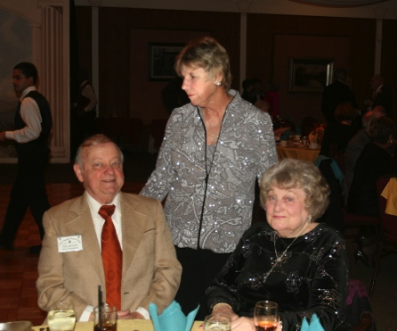
Visiting goes on all night
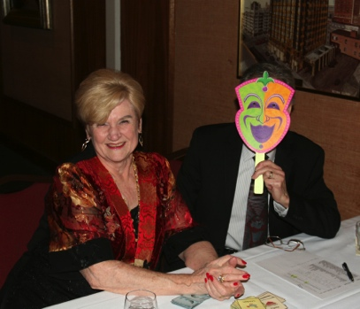
Who is that masked man?

