Presidents Message…

Another fantastic Topper’s Year has been completed and our club just turned 66 years young! We are anticipating another fantastic 66 years!

We are looking forward, as I hope all of you are, to another super year with wonderful friends, excellent food, and of course…. dancing the evenings away!

Welcome Linda and Craig Colby to the Toppers!

We will see everyone in January dance and dance to the Howard Solomon Band.

Gigi and I wish everyone a healthy and prosperous new year.

Happy Holidays!

Larry Isham
President
Larry Isham

Does A Member Need A Card Or Call?
Please let Nita or Neil Woolston (Hospitality) know should a friendly call or card be needed by one of our members!

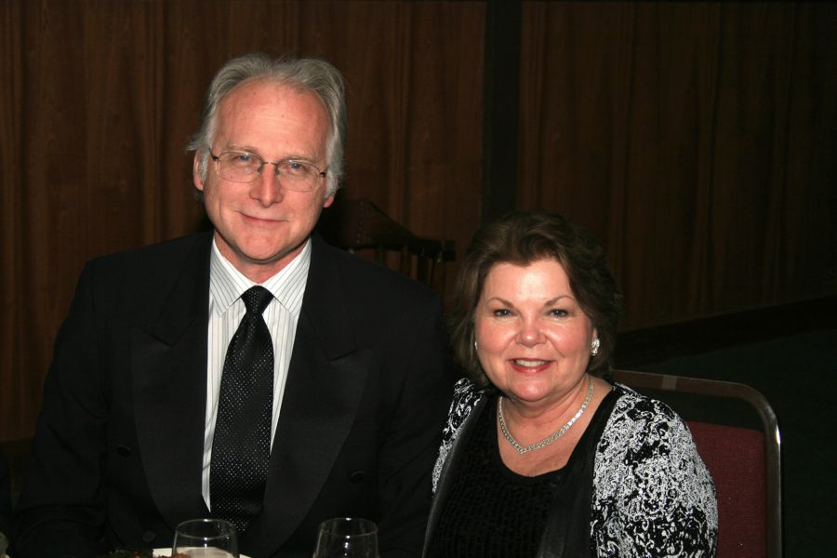
Welcome to our newest members…
Linda and Craig Colby

What You Need To Know
The January 20th dance will be at the Petroleum Club and will feature the Howard Solomon Band!

The cost is $78/couple (includes tax/tip).

No-host cocktail time is at 6 p.m and the great dance music until 10 p.m.

Dress code is semi-formal.
Toppers Dinner Menu

Caesar Salad
Grilled Chicken and Fettuccine or Filet of Halibut or Vegetarian Twice Baked Potatoes
Baby Carrots

Cheesecake with Raspberry Sauce

Hot bread and butter, dessert, coffee and tea.

Mail your checks made out to “Toppers Dance Club” With Dinner Selections on the checks To
Diane Schmitz
3475 Lilly Avenue
Long Beach, CA 90808

The Phil Anthony Band played many Christmas songs
  - Many people look forward to the new year for a new start on old habits. ~Author Unknown

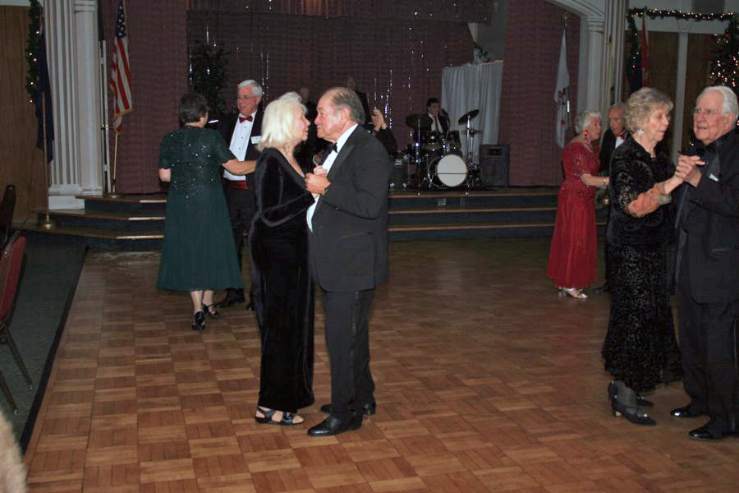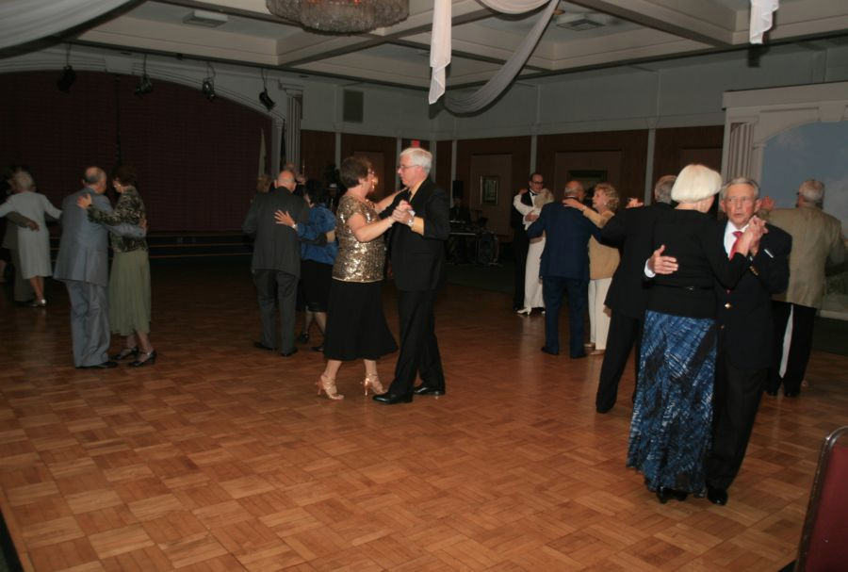

It’s A New Year…
Prepare To Be Greeted
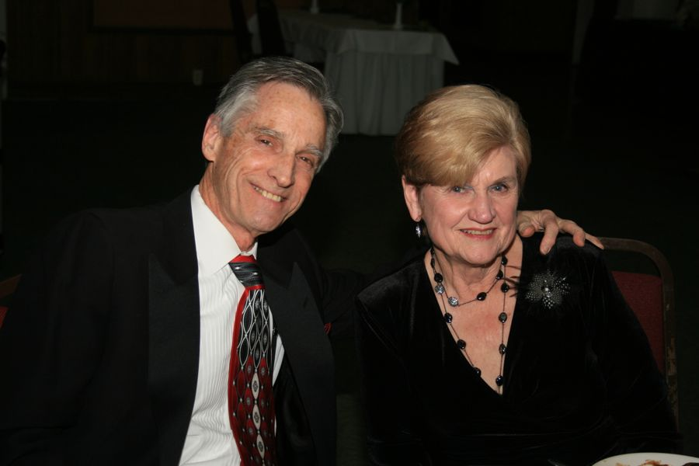
Lucky and Carolyn Harrington

Be prepared to be welcomed with a big smile by Lucky and Carolyn

Did You Know? - It was only relatively recently that 1 January became the first day of the year in Western culture. Up to 1751 in England and Wales (and all the
British King's dominions) the new year started on 25 March - Lady Day, one of the four quarter days (the change to 1 January took place in 1600 in Scotland)[2]. Since then, 1 January
has been the first day of the year. During the Middle Ages several other days were the first (1 March, 25 March, Easter, 1 September, 25 December).

About Auld Lang Syne
The most commonly sung song for English-speakers on New Year's eve, "Auld Lang Syne" is an old Scottish song that was first published by the poet Robert Burns in the 1796 edition of the book, Scots Musical Museum. Burns transcribed it (and made some refinements to the lyrics) after he heard it sung by an old man from the Ayrshire area of Scotland, Burns's homeland.

It is often remarked that "Auld Lang Syne" is one of the most popular songs that nobody knows the lyrics to. "Auld Lang Syne" literally translates as "old long since" and means "times gone by." The song asks whether old friends and times will be forgotten and promises to remember people of the past with fondness, "For auld lang syne, we'll tak a cup o' kindness yet."

The Twelve Grapes
The Twelve Grapes (Sp. Las doce uvas de la suerte, "The twelve grapes of luck") is a Spanish tradition that dates back from at least 1895 but become consolidated in 1909. In December of that year, some alicantese vine growers popularized this custom to better sell huge amounts of grapes from an excellent harvest.

The tradition consists in eating a grape with each bell strike at midnight of December 31. According to the tradition, that leads to a year of
Prosperity. In some areas, it is believed that the tradition wards away witches and general evil. Each grape is eaten with each beat of the bell.

The twelve grapes are linked to the Puerta del Sol tower clock, where this tradition started and from where the change of year is always broadcast.

This tradition was adopted also by places with a broad cultural relation with Spain such as Mexico and other Latin American countries, as well as Hispanic communities in the United States. Countries as far as the Philippines have adopted the tradition.

Your Board

President Larry Isham
Vice President Dean Fronk
Past President Jerry Ellis
Secretary Lori Fronk
Treasurer Diane Schmitz
Hospitality Neil/Nita Woolston
Membership Bob Potthast
Roster Joyce Rothrock
Newsletter Paul & Sue Liles
Member At Large Gigi Isham, Dennis Schmitz, Nancy Ellis, Jack Taylor, and Meretta Potthast

The Executive Board meets at 5:30 p.m. before each dance. Need a Toppers name badge? Call Earl Eakle at 310-375-8134.

Spotlight On A Topper

Our Guests
Jan and Brian Finch (Liles)
Brian and Jan are all the way from the UK and spend much time in the US. Friends of several members including the Roberts, Mongels, Kuhns, Woolstons and Silversteins they often dance at the Elks Lodges in the Southern Orange County area. They are in process of becoming US citizens!

Our Dance Schedule
1/20/2012 – Howard Solomon
2/17/2012 – San Conti
3/16/2012 – Phil Anthony
4/20/2012 – Tony Carinio
5/18/2012 – Howard Solomon

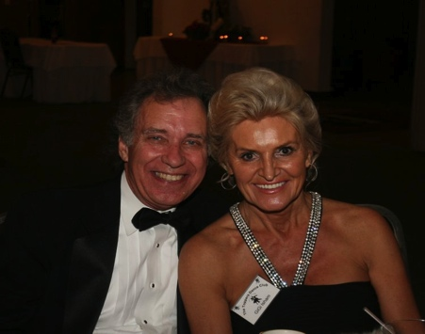
Larry & Gigi
As submitted to Vicky Kuhn

Larry was born and grew up in Pomona, California, and, after going to school in Long Beach, decided he liked living near the ocean. Except for two years in the
army, of which he spent eighteen months just outside of Anchorage, Alaska, he has lived near the beach ever since.

Larry went to work for Western Airlines working in their maintenance records department, then, after obtaining his degree in Financial Management, transferred to the finance department. Later, he worked for a charter airline,
then for an aviation services company that, among other things provided flight crew members for a Japanese airline. While he was at that company, he helped create two startup airlines.

These jobs provided an opportunity for him to travel extensively, an opportunity he took advantage of extensively. In addition to many trips to various destinations in the United States, Europe, Africa, Hawaii and Mexico, he was
able to visit Tahiti, Japan and sail a small boat in Sidney Harbor in Australia. Later, he visited Bogata, Buenos Aires and Santiago, Chile, leaving Antarctica as the only continent he has not yet visited.

After leaving the aviation services company, he went to work for the
commercial airplane division of McDonnell Douglas in Long Beach which was, shortly thereafter, bought by Boeing. There, he worked in marketing and finance, and, after the company ceased production of commercial airplanes in Long Beach, transferred to the Boeing facility in El Segundo where satellites are designed and manufactured.

In addition to travel, Larry’s avocations have included skiing and sailing.

Gigi (Zdzislawa, or Dzidzia in Polish) was born in Poland during the Nazi occupation, and grew up there in Communist era. She attended school and became an esthetician, married and lived and worked in Wroclaw, living in a
house that her parents built for her in Biskupen suburb in the east of the city. She had three children, a boy, Dariush, and two girls, Ewa and Monika. Tragically, Dariush died at the age of 9 after being hit by a car.

Gigi traveled extensively to Russia, Yugoslavia, Greece, Turkey, Hungary, Romania, and to East Germany where some of her cousins lived. In October of
1981, Gigi and her daughters were on a vacation in Vienna when martial law was declared in Poland as a result of labor unrest. The impact of this was that the borders into and out of Poland were closed, so the three of them were stranded. Ewa, age 15, spent most of her time in Vienna reading, while
Monika, age 8, attended school (in German which she did not previously know.) Gigi was able to get by working in the Polish community in Vienna. Although she speaks Polish and Russian fluently, Gigi was never proficient in
German, so she was not able to interact with the Austrians to any degree. After almost nine months and by a stroke of luck, they were sponsored for a visa to the U.S. and were able to travel to Seattle where one of Gigi’s brothers lived
with his family.

Gigi established a business there, and at one time was working two additional jobs. Through her industriousness, she was able to buy a house and support her daughters and put them through school. As her daughters grew into
adults, first Ewa, then Monika, moved to the Manhattan Beach area where Ewa married and had a daughter, Ashley. Gigi came for several visits with her daughters and granddaughter and became convinced, with a little help from
her daughters, that she should move to Southern California also. In 2000, she bought a town home in Redondo Beach, and has lived there since.

Gigi spent the first couple of years in California studying for her esthetician license, a process made all the more onerous by her limited command of the English language. (They don’t give the exams in Polish.) After obtaining her license, she opened her business, GiGi Skin Care, which she continues to operate to this day. Although she works with many different clients in her
business, her specialty is problem skin, and she has often helped, without compensation, people with severe skin afflictions who could not afford her services. Gigi loves people and she loves to help those who are in need. One of the first friends Gigi met after her move was a member of the Redondo Beach Elks lodge, and he convinced her to become a member. Larry was Secretary of the lodge at that time, and that is the first time they met.

Gigi has been an avid dancer all of her life. When she lived in Seattle, as well as her first several years in Southern California, she would go dancing four or five nights per week. Shortly after joining the Elks, Gigi organized weekly
dance classes at the Redondo Beach Elks Lodge which are still ongoing. She also loves flowers and plants, and spends much of her free time (when not dancing) working in her garden. Another of Gigiís passions is opera. She can become completely involved
during a performance, and loves the elaborate costumes as much as the music.

Larry had not done much dancing since high school. After his first wife passed away, Gigi invited him to join him at a couple of dances. One thing led to another, Larry learned to dance a little better, and they eventually fell in love with one another and were married on a Princess (aka Love Boat) cruise in 2008.

Along the way, Ruth Stone invited them to join her and Bill Condit for a Toppers Dance Club dance. After attending their second dance, they joined the club, then, last April, after much encouragement from Jerry Ellis, Larry took on the position of President from him.

On The Web From Anywhere
You are on the web! Try this URL:
http://tinyurl.com/6tsgtxc for pictures from the Mistletoe Ball!

The previous newsletters are also available on our website should you be missing a copy.

Quotes To Remember
“A New Year's resolution is something that goes in one year and out the other. “ ~Author Unknown

The Mistletoe Ball!
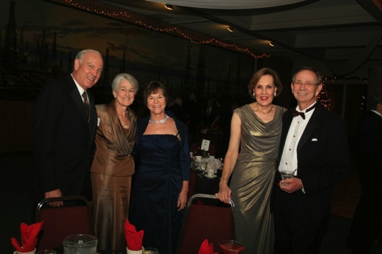
Checking in with friends
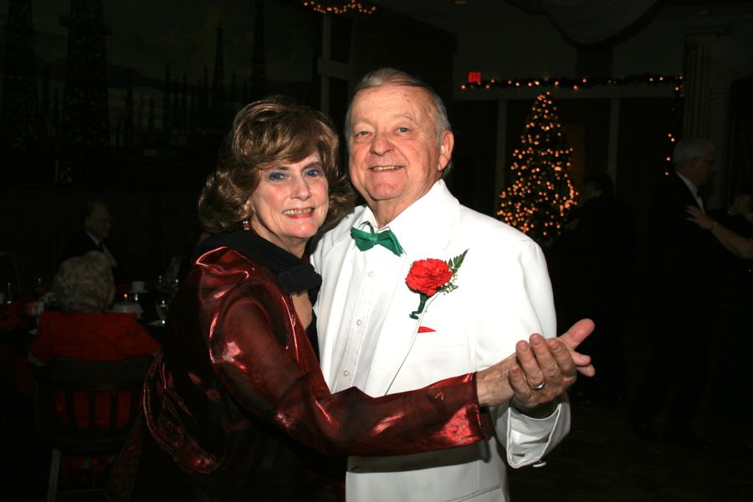
Dressed to the nine’s
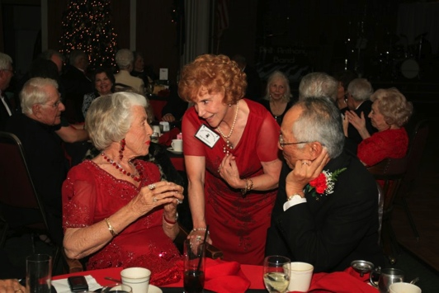
Visiting continues all night
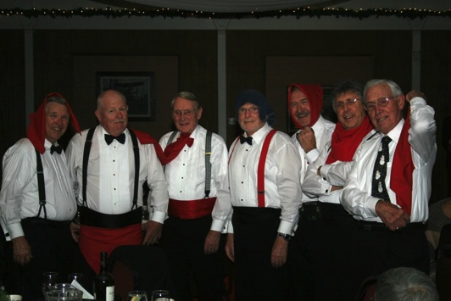
Boys will be boys…
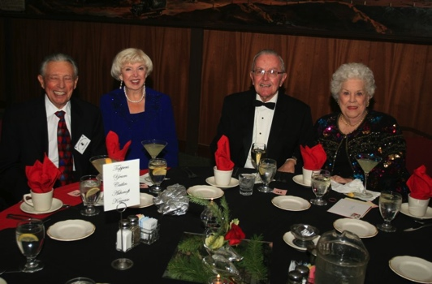
Watching between dances

More To Remember….
"New Year's eve is like every other night; there is no pause in the march of the universe, no breathless moment of silence among created things that the passage of another twelve months may be noted; and yet no man has quite the same thoughts this evening that come with the coming of darkness on other nights”. ~Hamilton Wright Mabie

Who Was There Collage
On our website , we now keep a full sized collage of “Who Was Here” so please enjoy.

A collage (From the French: coller, to glue, is a work of formal art, primarily in the visual arts, made from an assemblage of different forms, thus creating a new whole.

A collage may include newspaper clippings, ribbons, bits of colored or hand-made papers, portions of other artwork or texts, photographs and other found objects, glued to a piece of paper or canvas. The origins of collage can be traced back hundreds of years, but this technique made a dramatic reappearance in the early 20th century as an art form of novelty.

The term collage derives from the French "colle" meaning "glue". This term was coined by both Georges Braque and Pablo Picasso in the beginning of the 20th century when collage became a distinctive part of modern art.
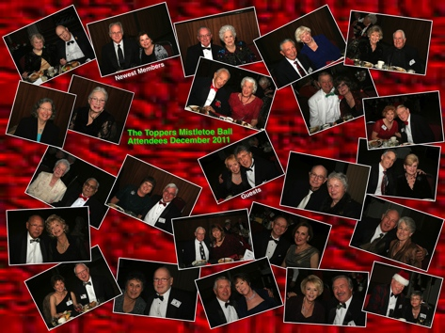
The “Who Was Here” Collage

