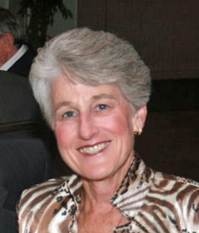
Thank you Diane Schmitz for becoming our new Treasurer!

What You Need To Know
The December 16th dance will be at the Petroleum Club and will feature the Phil Anthony Band!

The cost is $112/couple (includes tax/tip).

No-host cocktail time is at 6 p.m and the great dance music until 10 p.m.

Dress code is formal.
Toppers Dinner Menu

Caesar Salad
Bacon Wrapped Filet Mignon or Orange Roughy or Vegetarian
Twice Baked Potatoes
Baby Carrots

Cheesecake with raspberry sauce

Hot bread and butter, dessert, coffee and tea.

Mail your checks made out to “Toppers Dance Club” With Dinner Selections on the checks To
Diane Schmitz
3475 Lilly Avenue
Long Beach, CA 90808

Presidents Message…

We had a wonderful time at the pre-Thanksgiving November dance. The Tony Carinino band played great music and kept us entertained especially with his ability to play two saxophones at one time! Everybody seemed to enjoy the outstanding dining experience. The food was up to its (very high) standard and the members and guests had fun.

With the loss of our long time Treasurer, Bill Morgan, we asked for a volunteer who could assist the club in filling Bill’s big shoes.

We were very pleased when Diane Schmitz stepped up. She will be an excellent addition to the Board and we are looking forward to working with her to keep the club fiscally sound and running smoothly.

There were fifty people at our dance this time and a second visit by Linda and Craig Colby who we hope decide to join Topper’s.

On December 16th, we will have the Mistletoe Ball with the Phil Anthony band for dancing, and, of course, another great dinner from the Petroleum Club staff. I wonder if the World War II “The Battle Of The Budge” starting on December 16th is a coincidence?

Gigi and I are looking forward to seeing you all there.

Larry Isham
President
Larry Isham

The Tony Carinio Band kept us dancing until the wee hours
  - Christmas is a time when you get homesick - even when you're home. ~Carol Nelson

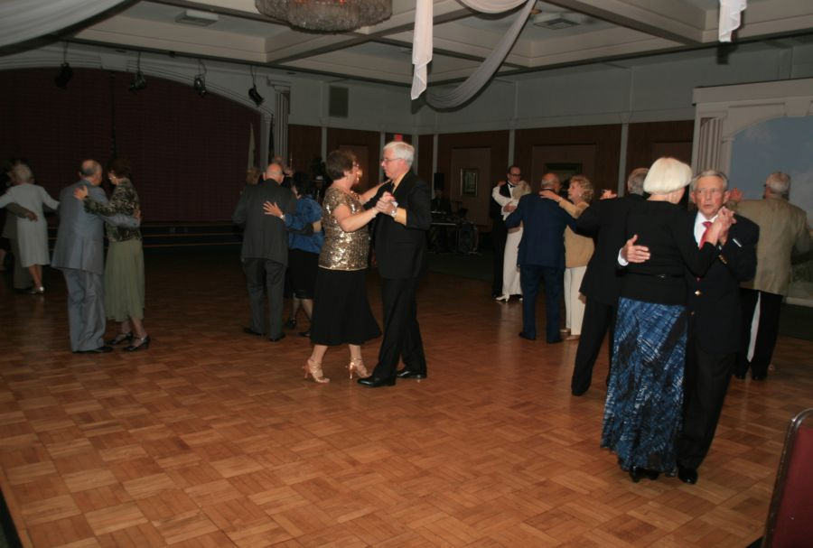

Christmas Time Is Upon Us….

Your Board

President Larry Isham
Vice President Dean Fronk
Past President Jerry Ellis
Secretary Lori Fronk
Treasurer Diane Schmitz
Hospitality Neil/Nita Woolston
Membership Bob Potthast
Roster Joyce Rothrock
Newsletter Paul & Sue Liles
Member At Large Gigi Isham, Dennis Schmitz, Nancy Ellis, Jack Taylor, and Meretta Potthast

The Executive Board meets at 5:30 p.m. before each dance. Need a Toppers name badge? Call Earl Eakle at 310-375-8134.
Prepare To Be Greeted
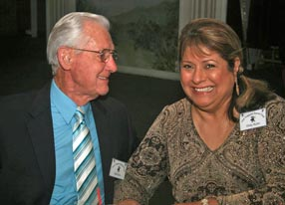
Vicky & Del Kuhn

Be prepared to be welcomed with a big smile by Del and Vicky

Did You Know? - The word Christmas originated as a compound meaning "Christ's Mass". It is derived from the Middle English Christemasse and Old English Cristes mæsse, a phrase first recorded in 1038

The Sacrifice Of Love
by O'henry from "The Gift of the Mage"
One cold winter Christmas Eve, there was a family who lived in the slums of Brooklyn. The family lived in an old run down apartment, suitable for rats.

The wife wanted to buy a chain for her husband's damaged watch, but did not have enough money. She was frantic and overwhelmed in panic. She did not know what to do... Her Christmas would be ruined! She thought and though, until she came up with an idea. She decided to sell her hair at the local salon.

She entered the salon and was quickly examined by the stylist. The hair stylist was astonished in not finding damaged or liced hair. The wife and the stylist bargained and bargained. It resulted in the wife receiving $20 for her hair, which was just enough to buy the chain. She looked at herself and saw that she looked hideous, but she did not care and cloaked her head with a shawl.

She quickly searched and purchased the desired chain and left for home. She wrapped the chain in newspaper and sat quietly awaiting her husband's return from work that afternoon.

The husband had returned and entered the house. He said nothing abThe wife saw that he had a grin upon his face. After dinner, they sat next to the stove for warmth. The wife then pulled out the gift and gave it to the husband. The husband looked confused, but opened it. He was in tears when he saw the gift, because he had sold his watch to buy a gift for the wife. He pulled out his gift, which was a hair brush for his wife's delicate hair. The wife and husband cried and wept. The love within the family had proven that they would sacrifice anything it took to see happiness upon their partner.

The Mistletoe Ball

You know you've grown up when none of the things you want for Christmas can be bought at a store.

Spotlight On A Topper

Our Guests
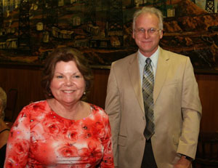
Linda and Craig Colby (Fronk’s)
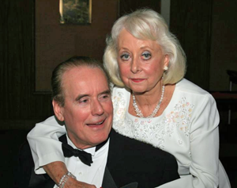
Claude and Noel Parrish (Grosso's)

Our Dance Schedule
12/16/2011 – Phil Anthony
1/20/2012 – Howard Solomon
2/17/2012 – San Conti
3/16/2012 – Phil Anthony
4/20/2012 – Tony Carinio
5/18/2012 – Howard Solomon

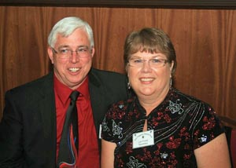
Dean and Lori Fronk
Submitted to Vicky Kuhn

Dean was born in beautiful downtown Burbank, across the street from Walt Disney Studios. His mom always said that he was a character. His middle name is the last name of the Doctor who delivered him. He is the oldest of 4 bothers and a sister.

His mom passed away when he was in Chester W Nimitz Junior High School. His father remarried and his family moved from Maywood to Huntington Beach California to start the 10th grade. Yes, he did have a wicked stepmother, and although he did not run away, he did run Cross Country.

At 19 years of age, he severed a two year mission for the Church of Jesus Christ of Latter-day Saints where he learned to speak Texan.

When he returned home, he fell totally and completely in love with Lori but was afraid to approach her until one day she stopped by the Institute of Religion at Golden West College to show off her new car. Dean was the only one there, but she really wanted to show it off, so she let him drive the car, a fatal mistake. Eleven months later they were married in the Los Angeles Temple of the Church of Jesus Christ of Latter day Saints on March 19, 1977.

They moved to San Luis Obispo, where Dean started Architectural courses. He soon realized that he liked engineering more than architecture and they moved to Westminster and Dean finished his Civil Engineering degree at Long Beach State and worked in the metallurgical department of McDonnell Douglas (now Boeing). When he finished his degree, he moved over to the facilities department and passed his professional exam for Civil Engineering. He has worked there for over 32 years. He also was a Scout Master.

During this time Lori was somewhat busy raising four sons. She has taught piano lessons at home for the past 31 years. She has been PTA President five times, and on the Band Booster Board when her sons were in Westminster High School, her alma mater.

She has been the president of the Relief Society at Church and in the RS presidency as a counselor five times. She ran marathons in Dublin, Ireland, Richmond, Virginia, and St. George, Utah. She loves books, has millions and millions of books stacked on shelves in every room of the house, including the library. Her book group has read a book a month for the last 31 years. The group celebrated their 25th anniversary with a trip to London, England.

Our eldest son, Justin, served a mission in Taiwan. He speaks fluent Mandarin Chinese. He graduated from the United States Air Force Academy. He is recently married (we finally have a daughter) and flies the KC-10 Air Refueling Tanker. He is currently deployed.

Nathan graduated from the University Of Denver School Of Law and is studying for the Bar exam.
Jared severed a mission in Romania. He is working on a doctorate in economics at Georgetown University in Washington D.C.

Michael served a Spanish speaking mission in Salt Lake City, Utah. He works as a product manager for D-Link while he is finishing his education.

Lori loves to travel and Dean loves Lori. Last year we were able to see the passion play in Oberammgau, Germany, and looking forward to visiting Italy again next summer.

Lori loves to dance and Dean loves Lori. Argentine tango is one of our favorite dances.

We danced an Argentine tango at our son’s wedding reception.

We continue to take dance lessons and hope to remember the steps when dancing at Toppers.

Some Thoughts…

Christmas is not a time or a season but a state of mind. To cherish peace and good will, to be plenteous in mercy, is to have the real spirit of Christmas. ~Calvin Coolidge, 1927

I once bought my kids a set of batteries for Christmas with a note on it saying, toys not included. ~Bernard Manning

Our November Dance Was Fun!
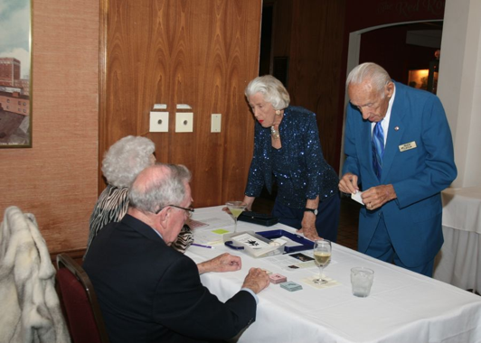
Checking in was easy
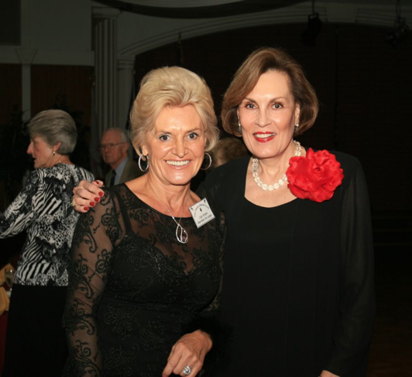
Good evening Gigi and Kathy
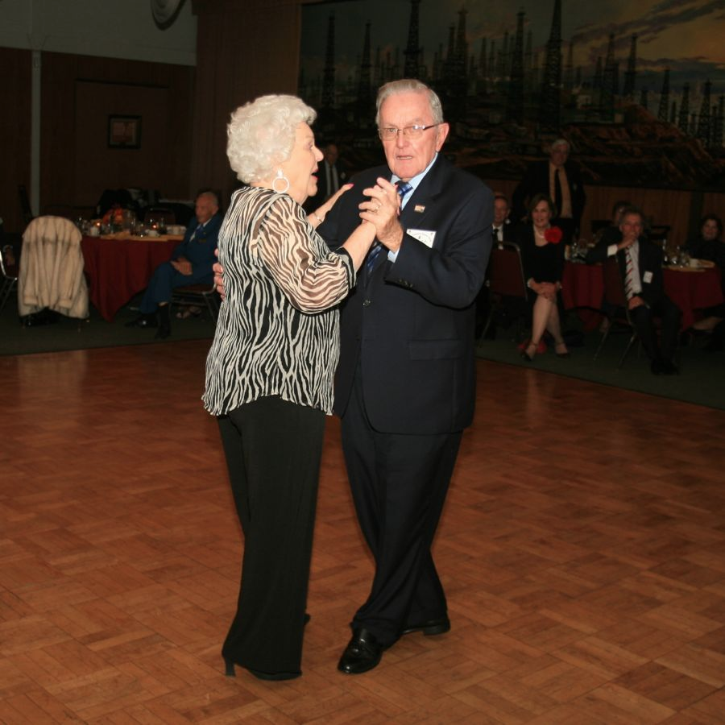
Happy anniversary
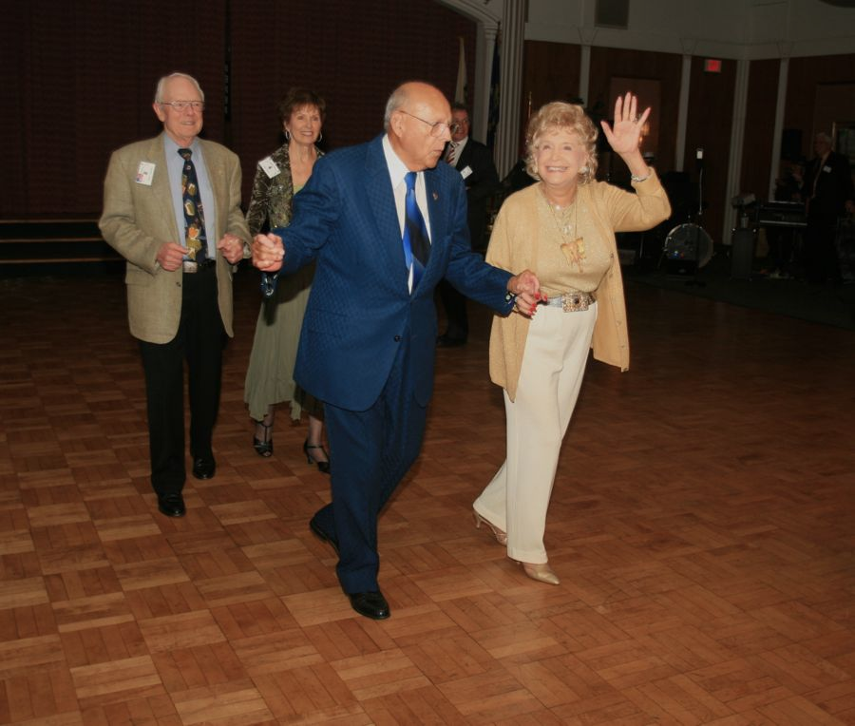
Mixing it up

When Martha And Ace Got Married… Do You Remember?
Federal spending: $1,788.83 B
Federal debt: $5,674.2 billion
Consumer Price Index: 172.2
Unemployment: 4.0%
Cost of a first-class stamp: $0.34
Just eleven years ago….

What To Know About The Civil War??
Vicky and Del Kuhn just spent nineteen days driving allover the south visiting the civil war memorials and many other significant historical places. When she got back home, she called and said “Yawl come over, hear!”

On The Web From Anywhere
You are on the web! Try this URL:
http://tinyurl.com/6v34myt for pictures from the November 2011 dance!

The previous newsletters are also available on our website should you be missing a copy.

Quotes To Remember
“Christmas waves a magic wand over this world, and behold, everything is softer and more beautiful”. ~Norman Vincent Peale

"Christmas is a time when you get homesick - even when you're home.” ~Carol Nelson

"Happy, happy Christmas, that can win us back to the delusions of our childish days; that can recall to the old man the pleasures of his youth; that can transport the sailor and the traveller, thousands of miles away, back to his own fire-side and his quiet home!” ~Charles Dickens, The Pickwick Papers, 1836

"In the old days, it was not called the Holiday Season; the Christians called it 'Christmas' and went to church; the Jews called it 'Hanukkah' and went to synagogue; the atheists went to parties and drank. People passing each other on the street would say 'Merry Christmas!' or 'Happy Hanukkah!' or (to the atheists) 'Look out for the wall!' ~Dave Barry, "Christmas Shopping: A Survivor's Guide

Never Volunteer But If You Do… Do It For A Good Reason
Thank you Diane Schmitz for volunteering to take on the Treasurer’s responsibilities for the club! Your involvement will be a great help!

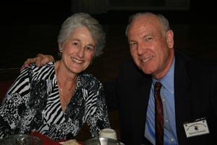
Diane and Dennis Schmitz

Keep Our Roster Up To Date
Thank you and remember, if you spot an error of have a change of information please notify Joyce so we can provide addendums as needed in Toppers Topics,

Addendum: The street address for Donnis Weygandt should be change to 2270 (not 2770)

