From Our President…

We had a wonderful time at the October dance. Phil Anthony and his band were outstanding as usual, the food was up to its (very high) standard and the people were fun to be with. The mood was dampened, however, by the news that our Treasurer, Bill Morgan, had passed away. We will miss him both personally and for the great job he has done over the years of monitoring the fiscal health of the club.

The passing of Bill leaves an opening on the board for the office of Treasurer that we are actively seeking to fill. If anyone is interested in this position, please contact myself or any other member of the board for additional information about what the responsibilities are. Please remember that any organization such as this depends on volunteers to keep it running. This position does not require a lot of time, so if you have any accounting or bookkeeping experience, please consider putting your name in the hat.

On November 18th, we will have the Tony Corinio band for dancing, and, of course, another great dinner from the Petroleum Club staff.

Gigi and I are looking forward to seeing you all there.

Larry Isham
President
Larry Isham

  - An optimist is a person who starts a new diet on Thanksgiving Day. ~Irv Kupcinet
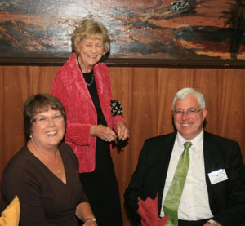
Lori and Dean Fronk chat with Joyce Rothrock who just completed our Topper’s Membership Roster!

Enjoying dinner and powering up for dancing

What You Need To Know
The November 18th dance will be at the Petroleum Club and will feature the Tony Carinio Band!

The cost is $79/couple (includes tax/tip).

No-host cocktail time is at 6 p.m and the great dance music until 10 p.m.

Dress code is semi-formal.
Toppers Dinner Menu

The choice of entrees are Roast Tri-tip, Filet of Salmon, or Vegetarian.

Salad, vegetables, home-made potatoes

Dessert

Hot bread and butter, dessert, coffee and tea.

Mail Your Checks With Dinner Selections To
Jerry Ellis
4507 Faculty Ave
Long Beach, CA 90808

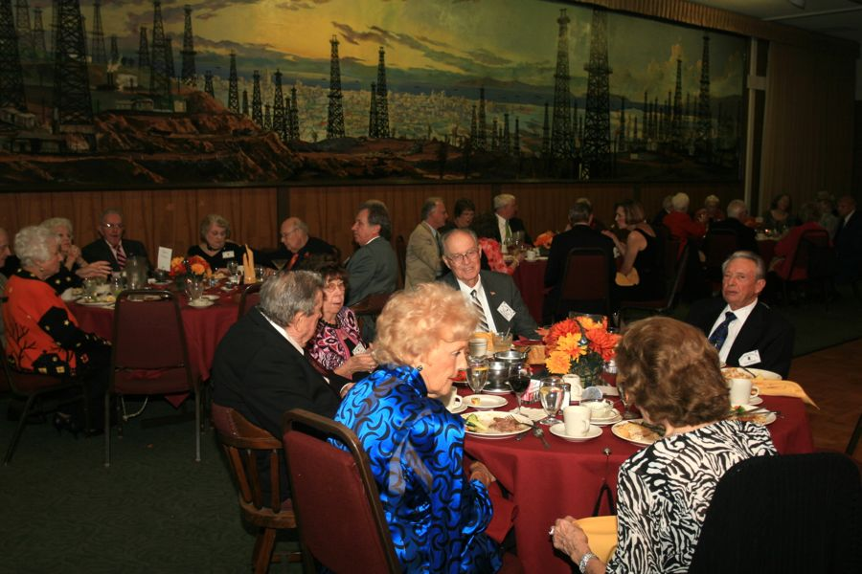

Turkey Time Is Here Again….
Prepare To Be Greeted
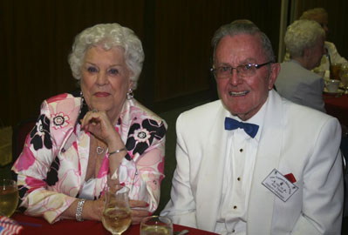
Ace & Martha Yeam

Be prepared to be welcomed with a big smile by Ace and Martha

Did You Know?

The modern Thanksgiving holiday traces its origins from a 1621 celebration at the Plymouth Plantation, where the Plymouth settlers held a harvest feast after a successful growing season. This was continued in later years, first as an impromptu religious observance, and later as a civil tradition.

Thanksgiving or Thanksgiving Day, celebrated on the fourth Thursday in November, has officially been an annual tradition in the United States since 1863, when during the Civil War, President Abraham Lincoln proclaimed a national day of thanksgiving to be celebrated on Thursday, November 26.

As a federal and popular holiday in the U.S., Thanksgiving is one of the "big six" major holidays of the year (along with Christmas, New Year's Day, Memorial Day, the Fourth of July, and Labor Day). Together with Christmas and the New Year, Thanksgiving is a part of the broader holiday season.

The event that Americans commonly call the "First Thanksgiving" was celebrated to give thanks to Native Americans for helping the Pilgrims of Plymouth Colony survive their first brutal winter in New England.

The first Thanksgiving feast lasted three days, providing enough food for 53 pilgrims and 90 Native Americans. The feast consisted of fish (cod, eels, and bass) and shellfish (clams, lobster, and mussels), wild fowl (ducks, geese, swans, and turkey), venison, berries and fruit, vegetables (peas, pumpkin, beetroot and possibly, wild or cultivated onion), harvest grains (barley and wheat), and the Three Sisters: beans, dried Indian maize or corn, and squash

The New England colonists were accustomed to regularly celebrating "thanksgivings"—days of prayer thanking God for blessings such as military victory or the end of a drought.

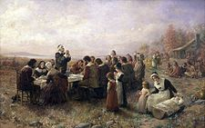
The First Thanksgiving at Plymouth

Thanksgiving Quotes

If the only prayer you said in your whole life was, "thank you," that would suffice. ~Meister Eckhart

Thanksgiving Day comes, by statute, once a year; to the honest man it comes as frequently as the heart of gratitude will allow. ~Edward Sandford Martin

Thanksgiving dinners take eighteen hours to prepare. They are consumed in twelve minutes. Half-times take twelve minutes. This is not coincidence. ~Erma Bombeck

Your Board

President Larry/Gigi Isham
Vice President Dean Fronk
Past President Jerry Ellis
Secretary Lori Fronk
Treasurer Vacant
Hospitality Neil/Nita Woolston
Membership Bob Potthast
Roster Joyce Rothrock
Newsletter Paul & Sue Liles

The Executive Board meets at 5:30 p.m. before each dance. Need a Toppers name badge? Call Earl Eakle at 310-375-8134.

Spotlight On A Topper

Our Guests
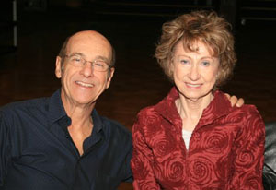
Bart & Sherrill Nicosia
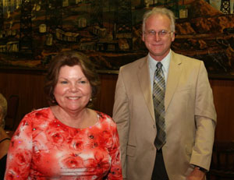
Linda and Craig Colby

Our Dance Schedule
10/21/2011 - Phil Anthony
11/18/2011 – Tony Carinio
12/16/2011 – (TBD)
1/20/2012 – Howard Solomon
2/17/2012 – San Conti
3/16/2012 – Phil Anthony
4/20/2012 – Tony Carinio
5/18/2012 – Howard Solomon
9/21/2012 – Sam Conti
10/19/2012 – Phil Anthony
11/16/2012 – Tony Carinio

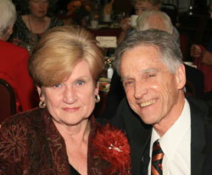
Carolyn and Lucky Harrington
Submitted to Vicky Kuhn

Carolyn Sue Harrison and Roy (aka Lucky) Harrington both moved to Phoenix, AZ in 1945, just after WW II ended. Carolyn, an only child, came from Battle Creek, Michigan, and Lucky (being born on Friday the 13th, his grandfather said “we’ll just have to call him Lucky”) moved from Fairfield (near Napa) California, with an older sister.

Fate brought them together (actually it was Carolyn’s picture in their high school yearbook) in the summer of 1953, and they were dating steady by years end. They attended junior college together in Phoenix, but then Lucky went off to the University of AZ in Tucson. That December they decided the separation was not healthy for the relationship, so they married in December of 1957.

So, here we are, nearly 54 years later, happily ever after. Howsoever, in the interim:

Lucky finished U of A, earning a BSEE, and he and Carolyn moved to Burbank, CA, where Lucky began a long career in aerospace telecommunications.

Lucky worked on a MSEE at UCLA, and earned a MBA from USC. He worked for several companies/organizations, most notably JPL and Hughes Aircraft Co., being privileged to work on many exciting deep space scientific missions, as well as both commercial and military satellite programs. Besides career stuff, Lucky has always been an advocate for lots of play time, so made sure to integrate many favorite school and recreational activities: swimming, football/track, body building/tumbling, GA piloting, scuba diving, handball/volleyball, part time musician, cycling, motorcycling.

After marriage, Carolyn supported herself and Lucky in school as “Traffic Mgr” at KGUN TV (ABC affiliate) in Tucson, being responsible for all daily program schedules – a most difficult job for a 20 year old before computers.

After Lucky graduated, Carolyn always felt privileged to spend the early married years as a stay-at-home wife and mom, raising two beautiful daughters and concentrating on being an excellent seamstress and accomplished gourmet cook. Of course, the prerequisite time as PTA, Girl Scout, and gymnastics mom was thrown in.

As the girls matured she sought outside challenges in the form of part time work as secretary and girl Friday. This eventually morphed into a successful career in real estate sales in Palos Verdes Peninsula/South Bay, which has lasted 33 years and earned recognition through awards and foreign trips.

She still loves cooking and entertaining, especially during the holidays as her favorite hobby of decorating can be most fully utilized. After reading about Victorian era customs, she adopted one and started decorating a small tree with ornaments and such depicting the major holidays and summer and fall seasons.

Together, Carolyn and Lucky have always placed family as top priority, so they have spent many years either visiting or hosting family members for holidays and vacation stints.

With the passing of their parents, the focus is now on the daughters and their children; one daughter lives in PVE and has a son and daughter, while the other daughter lives in Northern Oregon and has one daughter. Carolyn and Lucky have spent much time enjoying the grandkids in PVE, and less time with the granddaughter in Oregon, but have taken many great trips through northern California and all of western Oregon on visits.

And then there’s dancing. What a great activity to enhance a marriage and partnership. It started around 1989 and has been a steady pastime ever since. It started as private studio lessons, dance parties, and minor exhibitions, and has settled on occasional group lessons and as much club dancing as can be managed in a busy schedule, which includes real estate, home owner association duties, cruises now-and-again, motorcycle rides (Carolyn NOT), vacations, and the invariable trips to Oregon. So after a deep breath, Carolyn and Lucky are off to the next event. Oh by the way, we do like to read a bunch, too.

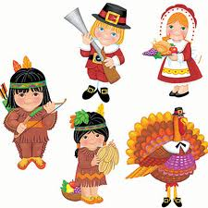

Our October Dance Was Fun!
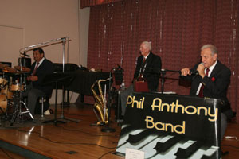
Phil Anthony Band kept us moving
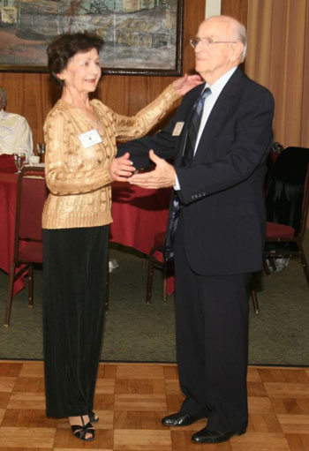
Jan and Jim Mongel celebrate their 50th anniversary
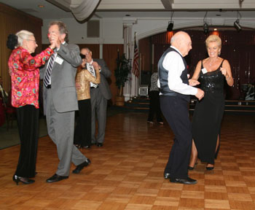
It’s time for the mixer!
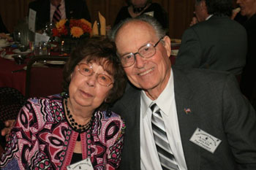
Nancy and Jerry Ellis enjoying the dance

When Jan And Jim Got Married… Do You Remember?
US breaks diplomatic relations with Cuba (Jan. 3).

1,200 US-sponsored anti-Castro exiles invade Cuba at the Bay of Pigs (April 17); the attackers are all killed or captured by Cuban forces.

East Germany erects the Berlin Wall between East and West Berlin to halt flood of refugees (Aug. 13).

USSR detonates 50-megaton hydrogen bomb in the largest man-made explosion in history (Oct. 29).

There are 2,000 US military advisers in South Vietnam. Background: Vietnam War

OPEC (Organization of Petroleum Exporting Countries) formally constituted.

Who Is Behind Spotlight On Topper’s?
We are lucky to have Mrs. Persistent… Vicky Kuhn who goes on the monthly search of willing volunteers to be in the Topper’s Spotlight, Vicky does a great job assisting members in getting their writeup’s ready to go and helping the poor editors make the deadlines. Thank you Vicky!

On The Web From Anywhere
You are on the web! Try this URL:
http://tinyurl.com/3euv8sd for pictures from the October 2011 dance!

The previous newsletters are also available on our website should you be missing a copy.

Quotes To Remember
"We should consider everyday lost in which we don't dance." -Neitzsche

"Life is what we make it, it always has been, always will be." -Grandma Moses

"Either you do the pirouette or you shoot yourself. One or the other, but something must happen." -Monet Robier

"Dance isn't something that can be explained in words. It has to be danced." -Paige Arden

"I don't want life to imitate art. I want life to be art." -Carrie Fisher

"I'm dancing to the music of the madness inside me." -George C. Wolfe

Thanks To Joyce Rothrock We Can Find Ourselves
Lot’s of work goes into creating an accurate and timely roster and Joyce had it ready to go delivered complete with a plastic container for all to pick up on leaving the dance.

We have all the members, past presidents, dance schedules, officers, and even a history of the club packaged in a handy-dandy keep by the phone package!

Thank you and remember, if you spot an error of have a change of information please notify Joyce so we can provide addendums as needed in Toppers Topics,

