From Our President…

Welcome back to another year of dancing at the Toppers Dance Club. Gigi and I are looking forward to getting to know each of you over the upcoming year. This organization is a wonderful resource, and we will work hard to maintain it and, where possible, make it even better.

Our first dance will be on September 16, and it will feature the band of Sam Conti. We will also, of course, have another excellent dinner prepared by the Long Beach Petroleum Club. We hope to see all of you there.

Larry Isham
President
Larry Isham

You new Board now at work

Fall is a few weeks away…

Delicious autumn! My very soul is wedded to it, and if I were a bird I would fly about the earth seeking the successive autumns. ~George Eliot

The ladies lit up the May 2011 evening

2011-2012 Dance Season
Remember to pay your dues for this season. Send your $90 to Bill Morgan.

What You Need To Know
The September dance will be at the Petroleum Club on Friday the 16th.

The cost is $8/couple (includes tax/tip). No-host cocktail time is at 6 p.m.

Sam Condi will be providing great dance music until 10 p.m. Dress code is semi-formal.
Toppers Dinner Menu

Chicken Cordon Bleu or Salmon or Vegetarian served with Green Salad with Ranch and Italian Dressing on the tables;

Mashed Potatoes, Fresh Vegetables,
Warm Bread & Butter, and

French Vanilla Ice Cream with Chocolate Sauce for dessert.

  - A vacation is having nothing to do and all day to do it in. ~Robert Orben

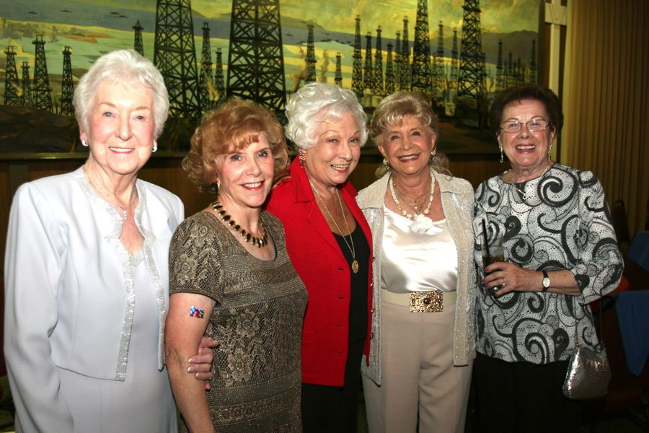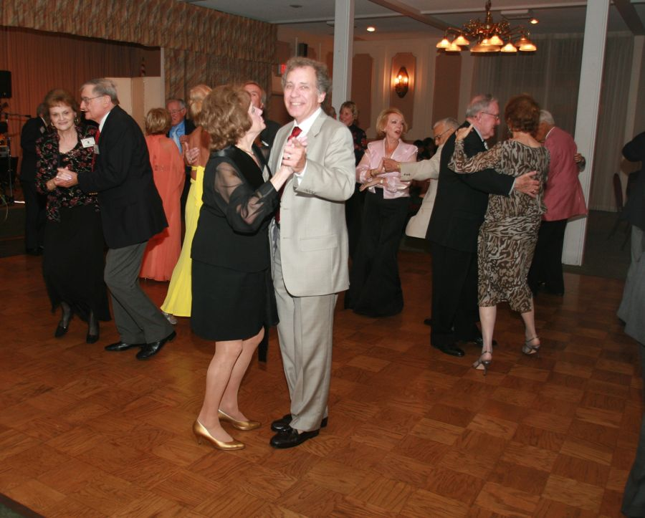

Summer Is Almost Gone…. Almost

Prepare To Be Greeted
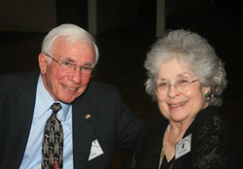
Bob and Edith Daley

Be prepared to be welcomed with a big smile by Bob and Edith Daley. They are from Long Beach and have been members since 2009.

Did You Know? The city of Long Beach is the 39th-largest city in the nation and the seventh-largest in California. The Port of Long Beach is the United States' second busiest container port and one of the world's largest shipping ports.

Autum Is Coming!
The word autumn comes from the Old French word autompne (automne in modern French), and was later normalised to the original Latin word autumnus. There are rare examples of its use as early as the 12th century, but it became common by the 16th century.

Before the 16th century, harvest was the term usually used to refer to the season, as it is common in other West Germanic languages to this day (cf. Dutch herfst and German Herbst). However, as more people gradually moved from working the land to living in towns (especially those who could read and write, the only people whose use of language we now know), the word harvest lost its reference to the time of year and came to refer only to the actual activity of reaping, and autumn, as well as fall, began to replace it as a reference to the season.

A Great Loss
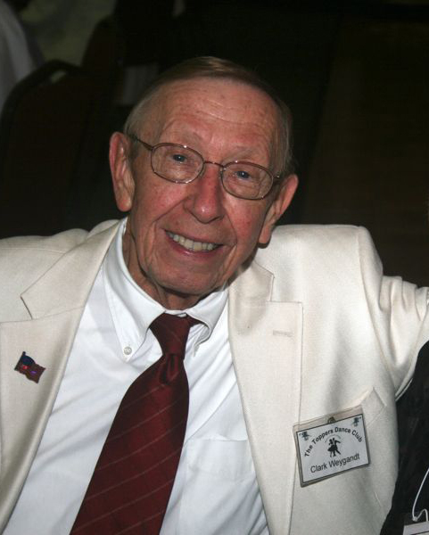
Clark Weygandt
It is with great sadness that we lost Clark suddenly last June suddenly. Clark and Donnis joined Toppers in 2004, and seldom missed a Toppers event since that time.

Donnis has expressed her
appreciation for the concern and cards she has received from her Topper friends, and the large number attending services for Clark on June 25 along with many long time friends and relatives.

As one of our Emeritus members, Donnis assures us we will be seeing her again at our events in the near future.

Another Loss This Summer

We also lost member who joined Toppers in 2009, Bill Condit, passed away in August at the age of 92. Our heartfelt prayers go to his dance partner Ruth Stone.

Your Board

President Larry/Gigi Isham
Vice President Dean Fronk
Past President Jerry Ellis
Secretary Lori Fronk
Treasurer Bill Morgan
Hospitality Neil/Nita Woolston
Membership Bob Potthast
Roster Joyce Rothrock
Newsletter Paul & Sue Liles

The Executive Board meets at 5:30 p.m. before each dance. Need a Toppers name badge? Call Earl Eakle at 310-375-8134.

Spotlight On A Topper

2011-2012 Dance Schedule
10/21/2011 – Phil Anthony
11/18/ 2011 – Tony Carinio
12/18/2011 - TBD
1/20/2012 – Howard Solomon
2/17/2011 – San Conti
3/16/2012 – Phil Anthony
4/20/2012 – Tony Carinio
5/18/2012 – Howard Solomon
9/21/2012 – Howard Solomon
10/19/2012 – Phil Anthony
11/16/2012 – Tony Carinio

New Members
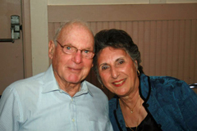
Herb & Irene Silverstein

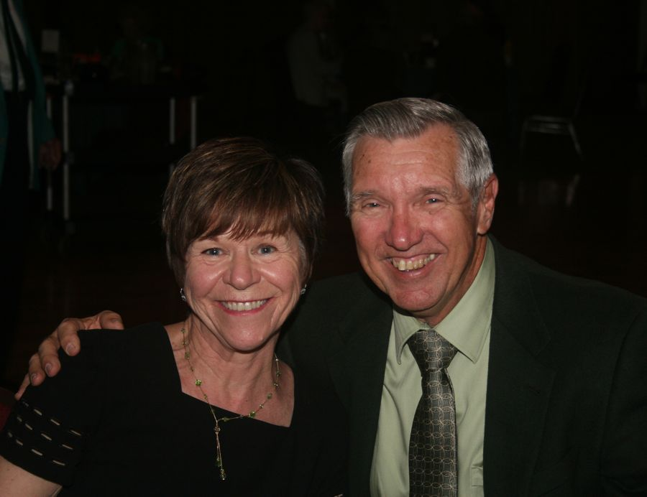
Kathy & Ed Roberts
Submitted to Vicky Kuhn by the Kroy’s

Ed and Kathy have been married for 41 years and have five children plus nine grandchildren! Fortunately, four of their children still reside nearby. Sadly, their oldest daughter lives in Humboldt County with five of their grandchildren. This, of course requires them to take numerous trips up the California coast, and to 'gather medicinal strength for traveling', they stop in at various wineries along the way and have been known to bring back a few wine bottles for others as gifts for those who also need 'medicinal strength.'

Ed is one of those rare native Californians, born in Culver City and raised in Norwalk. Ed served 4 years in the Air Force during the Vietnam Era. He learned the trade of air conditioning, which later would become invaluable. When he left the Air Force, he worked for McDonnell Douglas for a few years, then joined the Union: Local 250 in the refrigeration/air conditioning division and worked in the industry for over 40 years.

In those years he installed or was part of the air conditioning crew on numerous well-known businesses and private residences. Among those were his 'big time consuming jobs' including the STAPLES CENTER in L.A., the J. PAUL GETTY Museum, '1 Wilshire' Blvd. bldg., the L.A. DISNEY CONCERT HALL. He also was on-site at various Hollywood events, like the Emmy's, the Oscars and such as the 'pro a/c back-up', 'just in case' somehow the a/c were to fail. Among his favorites: the Newport Beach Balboa Bay Club (favorite hang out of John Wayne), the (TV mogul)Aaron Spelling Estate, the Playboy Mansion (remember Hugh Hefner's doe-eyed playmate girlfriend, Barbie Benton? Yes Sir-ee, Ed does too.) Ed laughs when Kathy reminded him of 'those nudes'...and he asks "Which ones?" because he reminded Kathy that he also worked a l-o-n-g time on the a/c at the Pasadena Art Institute of Design, where frequently, there were young college age well-toned female nude models posing for artist-students. Yeah, tough job Ed! Someone's gotta do it! But Ed still has that 'sparkle' in his eyes for his own Playboy Bunny, his Kathy!

Kathy grew up in a small town in New Jersey. When her father accepted a job in California, she moved with her family to Whittier. While attending school, she worked for a bank in Los Angeles. Ed and Kathy met each other through her older brother and were married a year later.

BOTH enjoyed riding motorcycles B.C. (before children) and continue to enjoy local car shows. Kathy stayed home to raise their 5 children while Ed was away a lot traveling or spending long work hours doing 'those big jobs.' Kathy eventually returned to the workforce in the dental industry, working for a large company based in Pennsylvania. As grandma, she is called upon frequently to babysit which she does willingly..."for those little darlings."

Newly retired, Ed and Kathy have enjoyed 2 recent trips to Europe. Last October, they traveled throughout the Tuscan area of Italy, staying in a romantic villa situated on an olive orchard. Of course, they stopped at many vineyards to sample the region's wine AND again the purpose was 'gather medicinal strength for their travels.' Then last May they took a cruise through the Mediterranean, beginning in Athens and ending in Barcelona. Yes, they had refills of 'medicinal strength' there before returning home to their families and friends.

Ed and Kathy love time spent with their family and friends. They recently attended Ed's Family REUNION near St. Louis, Missouri where he re-connected with long lost cousins and such. Hot, muggy, and uninvited 'chiggers' were reported to have crashed the Reunion. Kathy and Ed were glad to return to California. They enjoy social dancing, have membership in the Elks and Toppers among others, love to travel, play bridge, wine tastings, and are open to just about any activity with friends and family. .

Fall Is Almost Here
Fall arrives on September 23rd

Fall is almost here

Welcome To Our New Fearless Leader…

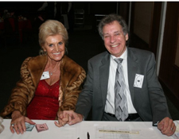
Gigi and Larry Isham
Larry will be the President of the Topper’s Dance Club this season and will bring his leadership skills to bare keeping our club moving forward. A BIG thanks to Jerry Ellis and Nancy Ellis for all the guidance and wisdom provided during the past two years!

Our May Dance Was Fun!

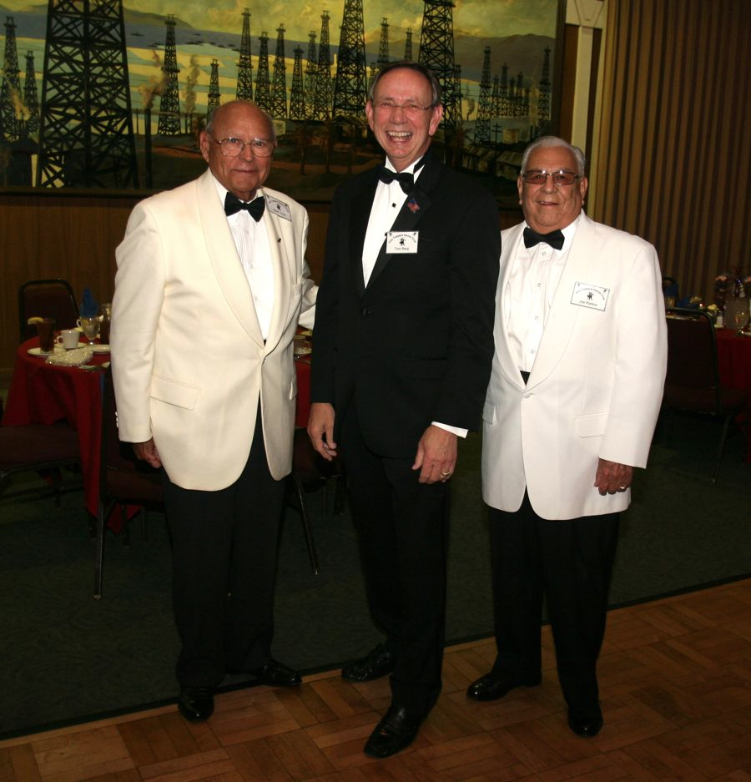
The Dapper Dan’s
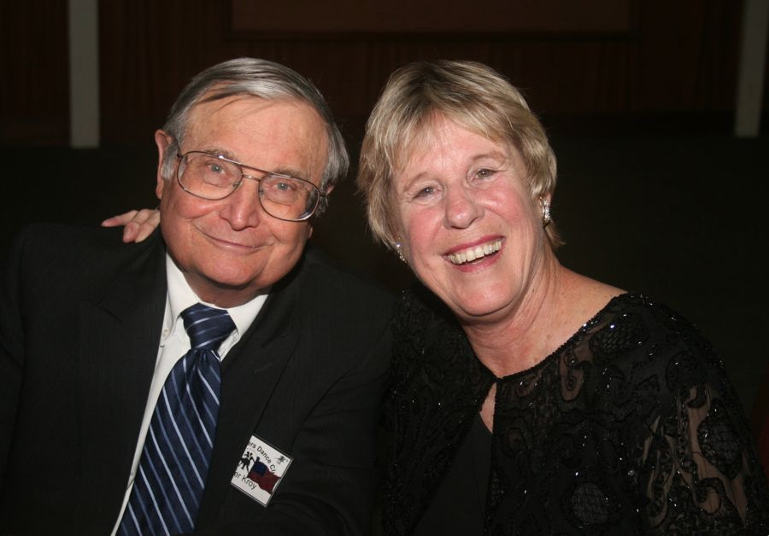
Walt and Terry Froy
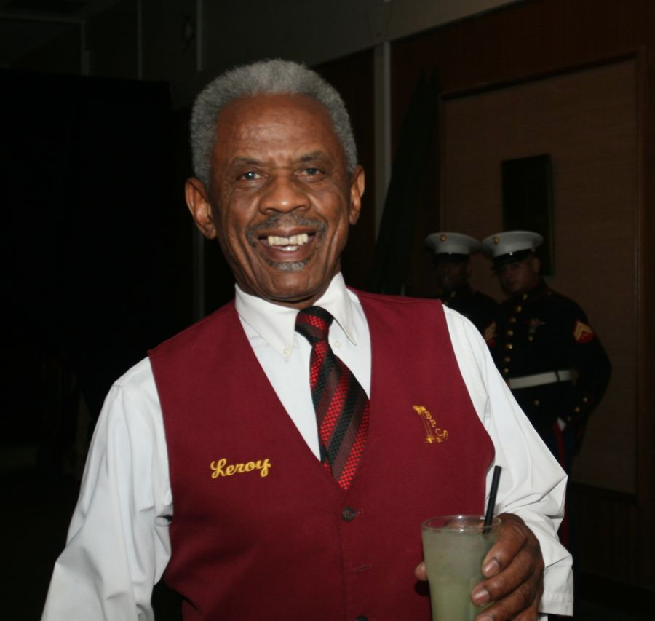
Let's get the party started says Leroy
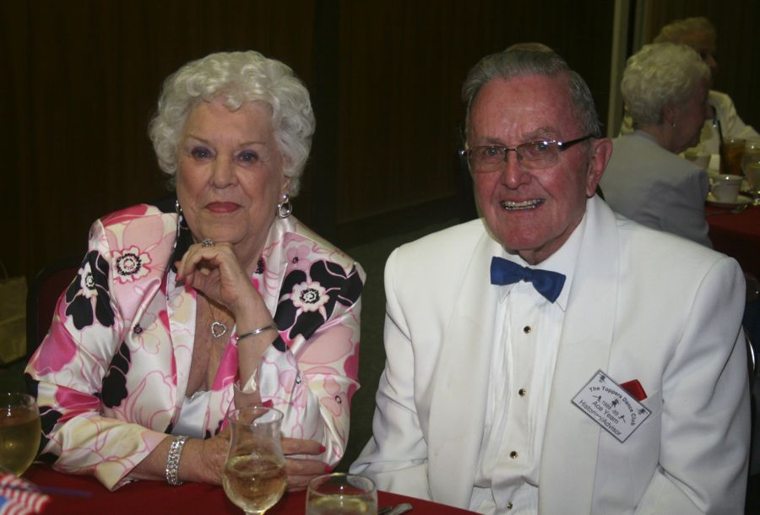
Martha and Ace Yeam

Wine Time
Enjoy wine? In May several of the Topper’s took the “Wine Train” to Santa Barbara. They went on an Amtrak train with two vintage rail cars (circa 1940’s) for a day in Santa Barbara and a lot of visiting. If you have interest, please contact Sue or Paul Liles for next year.

On this trip we have the Ed & Kathy Roberts, Vicky & Del Kuhn, Paul & Sue Liles, Herb Silverstein and Irene Kosmetatos, and Kay Quick and Nick Thomas.

A Little Dance Humor
There is a bit of insanity in dancing that does everybody a great deal of good. ~Edwin Denby

On The Web From Anywhere
You are on the web! Try this URL:
http://tinyurl.com/3hkea3w for pictures from the April 2011 dance!

The previous news letters are also available on our website should you be missing a copy.

Support Your Local Dancing Establishments…
The Alpine Village in Torrance has Big Bands Dancing on Monday Nights. There are several new bands with great Big Band energy including Geo Valli, and Tim Gill! Tracy Wells is there once a month.

There is a five dollar cover charge but the dance floor is big and the music even better. You can even have a good German dinner while you dance the night away. Great fun and your attendance will assure Big Bands music will continue.

833 W. Torrance Blvd , Torrance, CA 90502 (310) 538-3639

Remember
Do what you love to do, and do it so well that those who come to see
you do it will bring others to watch you do it again and again. -- Mark Victor Hansen

