Our president-elect is mixing it up
Welcome Los Alamitos Color Guard Semper Fi

2010-2011 Dance Season
One more dance for this season!

May 20th (Howard Solomon)

What You Need To Know
The May dance will be at the Petroleum Club on Friday the 20th.

The cost is $80/couple (includes tax/tip). No-host cocktail time is at 6 p.m.

Howard Solomon will be providing great dance music until 10 p.m. Dress code is semi-formal.
Toppers Dinner Menu

Prime Rib of Beef,
Fish of the day, or
Veggie Pasta
Scalloped Potatoes
Green Beans
Garden Salad with Ranch and
Italian dressings on the table
Warm bread and butter
Vanilla ice cream with
chocolate sauce

  - A vacation is having nothing to do and all day to do it in. ~Robert Orben

From Our President…

Do you find it as hard to believe, as Nancy and I do, that this May dance is the last of this Dinner-Dance season? I hope you’ve enjoyed this past season as much as we have. Although we’re ready for the summer break (trout fishing time), in no time at all we’ll be happily looking forward to “Toppers time” again in September.
We all know by now that there are a few changes in our Club leadership next September, and I’ve no doubt we will benefit from the fresh ideas and enthusiasm that new Board members will bring to Toppers.

Be sure to try to attend this coming dance, as Ace and Martha Yeam have once again arranged for the Marine Color Guard from Los Alamitos to help us celebrate Armed Forces Week. Nancy and I will be looking forward to seeing you then.

Jerry Ellis

Summer is a few weeks away…

A perfect summer day is when the sun is shining, the breeze is blowing, the birds are singing, and the lawn mower is broken. ~James Dent
Summer afternoon - summer afternoon; to me those have always been the two most beautiful words in the English language. ~Henry James

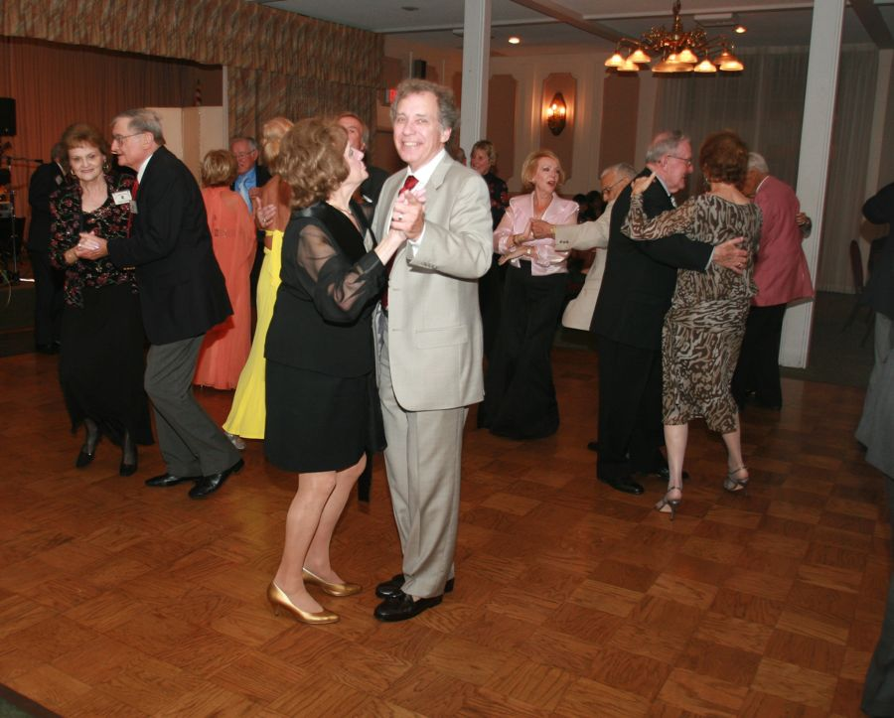

Spring Has Sprung…. Summer Is Near

Your Board

President Jerry Ellis
Vice President Roy Ashcroft
Past President Earl Eakle
Secretary Mary Ruth Ashcroft
Treasurer Bill Morgan
Hospitality Terey & Walter Kroy
Membership Bob Potthast
Roster Joyce Rothrock
Newsletter Paul & Sue Liles

The Executive Board meets at 5:30 p.m. before each dance. Need a Toppers name badge? Call Earl Eakle at 310-375-8134.

Prepare To Be Greeted
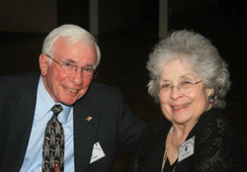
Bob and Edith Daley

Be prepared to be welcomed with a big smile by Bob and Edith Daley. They are from Long Beach and have been members since 2009.

Did You Know? The city of Long Beach is the 39th-largest city in the nation and the seventh-largest in California. The Port of Long Beach is the United States' second busiest container port and one of the world's largest shipping ports.

The Aragon Ballroom Was 20,000 Square Feet!
The Aragon Ballroom is the name of a historic ballroom in Chicago, Illinois.

Located on West Lawrence Avenue approximately five miles (8 km) north of downtown in the Uptown neighborhood. It was built in 1926 and designed to resemble a Spanish village and named for a province of Spain. The Aragon was extravagantly appointed.

The hall was an immediate success, and remained a popular Chicago attraction through the 1940s. The Aragon's proximity to the Chicago 'L' (elevated railway) helped people flock to the hall, and crowds often exceeded 18,000 guests over the six open nights each week.

Powerhouse radio station WGN broadcast an hour-long program from the hall each night to radio audiences throughout the mid-western United States and Canada.

The Summer Break Is Coming!
May is our last dance of this season so September will be our next dance.

Summer is the warmest of the four temperate seasons, between spring and autumn. At the summer solstice, the days are longest and the nights are shortest, with day-length decreasing as the season progresses after the solstice. The date of the beginning of summer varies according to climate, culture and tradition.

Summer is the period from the summer solstice to the autumn equinox. Unofficially, the U.S. summer season is commonly regarded as beginning on Memorial Day weekend in May and ending on Labor Day weekend in September.

For 2011, the Summer Solstice is June 21, 10:16 P.M. PDST and the Fall Equinox is on September 23, 2:05 A.M. PDST.

Nightclub Two Step
Nightclub Two Step (Nightclub Two-step, NC2S, sometimes Disco Two Step or California Two Step) was initially developed by Buddy Schwimmer in the mid-1960s. His daughter Lacey is one of the pro’s on “Dancing With The Stars”.

The dance is also known as "Two Step" and was "one of the most popular forms of contemporary social dance" as a Disco Couples Dance in 1978

It is frequently danced to mid-tempo ballads in 4/4 time that have a characteristic Quick-Quick-Slow beat. A classic example is the song Lady In Red

Spotlight On A Topper

Welcome Guests
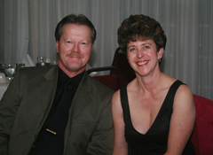
Dan & Valerie Geilich
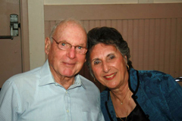
Herb & Irene Silverstein

New Members
Joan & Frank Kawase

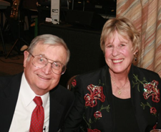
Walt & Terey Kroy
Submitted to Vicky Kuhn by the Kroy’s

Walter was living in California and Terey was living in the Fort Lauderdale area when they met. Walter’s father introduced them.

They were married six months later in Fort Lauderdale. They have been married twenty years. Walter and Terey have five nephews, three nieces, and a new grandnephew.

Walter was born in Detroit, Michigan where he attended Henry Ford Trade School. After graduation he attended MIT in Cambridge, Massachusetts where he earned a degree in Mechanical Engineering and one in Electrical Engineering. Following graduation he was hired by Douglas Aircraft, which became McDonnell Douglas. He moved to California where he also attended UCLA and earned his Doctorate degree in electrical engineering.

Walter worked on control systems for aircraft, rocket bombers and anti-missile missiles. He retired from McDonnell Douglas in 1990 after 35 years and pursued his interests in Ham radios, computers and sailing. He volunteers in the Orange County Sherriff’s Disaster Communication Group and is currently the treasurer of the Orange County Macintosh User Group. He is also actively involved in managing and maintaining their rental properties.

Terey was born in Akron, Ohio. She graduated from high school and attended Akron University. Following graduation she moved to Miami Beach, Florida and was hired by the Dade County Public School system. She went back to school to get a Master’s degree in Special Education and a certification in school administration. This enabled her to become a special education resource teacher and to pursue a position in administration.

Terey enjoyed her twenty years in Miami. The school system at that time was the fifth largest in the country which afforded her many chances to work in a variety of positions in the school district. She taught every elementary grade except kindergarten, was a teacher on special assignment working with a new math program, a Title One Facilitator, and a special education teacher.

When Terey moved to California she applied to the Garden Grove Unified school District and was hired as a special education resource teacher, became a student program facilitator and then became the principal of Earl Warren Elementary School for the past seven years. She will be retiring this June after 35 years in education.

Walter and Terey plan on spending more time with family back east, taking road trips to explore California, sailing, dancing, and enjoying their many friends.

Summer Is Almost Here
Summer arrives on June 21, 2011 at 01:16 A.M.

Summer is almost here

26 Miles Across The Sea
On May 13th, the Silversteins, Skeggs, Liles and some other avid dancers are going to the Avalon Ball for a weekend of dining and dancing. They will dance in the Casino Ballroom to Dean Mora’s 1920’s-1930’s band.

Welcome To Our New Fearless Leader…

Gigi and Larry Isham
Larry will be the President of the Topper’s Dance Club next season and will bring his leadership skills to bare keeping our club moving forward. A BIG thanks to Jerry Ellis and Nancy Ellis for all the guidance and wisdom provided during the past two years!

Lost and Found
Black shawl found from last dance. Call the Liles’ for details.

Our April Dance Was Fun!

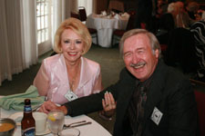
Shirley & Brian Skeggs
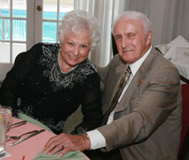
Let's get the party started say Merretta and Bob Potthast
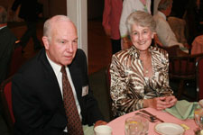
Dennis and Diane Schmitz 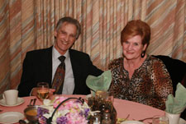

Lucky & Carolyn Harrington also taking a short breather

A Little Dance Humor
There was a dance teacher who talked of a very old dance called the Politician. "All you have to do" she told her class "is take three steps forward, two steps backward, then side-step side-step and turn around."

Which dances do the burgers do best? The burger-loo and the char char!

On The Web From Anywhere
You are on the web! Try this URL:
http://tinyurl.com/3g3p4k3 for pictures from the April 2011 dance!

The previous news letters are also available on our website should you be missing a copy.

Dancing Anyone?
The Alpine Village alternates Big Bands on Monday Nights with Geo Valli, Tim Gill, The Aristocats, and of course Tracy Wells

There is a five dollar cover charge but the dance floor is big and the music even better. You can even have a good German dinner while you dance the night away.

Music begins at 7:30 and goes until about 11:00.

Don’t forget The Phoenix Club on Thursday evenings… 15 piece orchestra and large dance floor. Ten dollar cover for three hours of great dancing.

See you in September

Remember
Do what you love to do, and do it so well that those who come to see
you do it will bring others to watch you do it again and again. -- Mark Victor Hansen

Memorial Day Is May 30th

Green sods are all their monuments; and yet it tells
A nobler history than pillared piles,
Or the eternal pyramids.
~James Gates Percival

And I'm proud to be an American,
where at least I know I'm free.
And I won't forget the men who died, who gave that right to me.
~Lee Greenwood

Peace to each manly soul that sleepeth;
Rest to each faithful eye that weepeth...
~Thomas Moore

