Happiness is never stopping to think if you are.  ~Palmer Sondreal

# From Our President…

Another outstanding event last month with 61 members and guests to celebrate our St. Patrick’s dance with Phil Anthony’s popular big band music. We missed the usual well-presented announcements and introductions by our Master of Ceremonies Ray Ashcroft, but he promises to be back again this month.

As was mentioned at our last dance, our club Executive Board vacancies are nearly filled for our next dance season starting in September, and the latest additions will be announced at this month’s dance.

The music for April will be by Tony Corinio’s band. Plan on another evening of great food and dancing as we once again enjoy Tony and his saxophone strolling among our dancers playing “I Left my Heart in San Francisco.” Nancy and I look forward to seeing you then.

Jerry Ellis

Dance first. Think later. It's the natural order. – Sam Beckett

Dancing with the feet is one thing, but dancing with the heart is another - Unknown

The man who is unable to dance says that the yard is stony – African Proverb

The girl who can't dance says the band can't play – Yiddish Proverb



# 2010-2011 Dance Season

Remember to keep these future dates on your calendar!

April 22nd (Tony Carinio)

May 20th (Howard Solomon)

# What You Need To Know

The April dance will be at the Petroleum Club on Friday the 22nd.

The cost is $78/couple (includes tax/tip). No-host cocktail time is at 6 p.m.

Tony Carinio will be providing great dance music until 10 p.m. Dress code is semi-formal.   
  
Toppers Dinner Menu

Roast Tri-Tip & Chicken Breast Combo

Fish of the day

Roasted red potatoes

Green salad with Ranch & Italian dressings on the table

Fresh veggies of the day

Pasta by request

Warm peach cobbler a la mode

Warm bread and butter

Coffee or Tea

*Everybody is Irish on St Patrick’s Day*

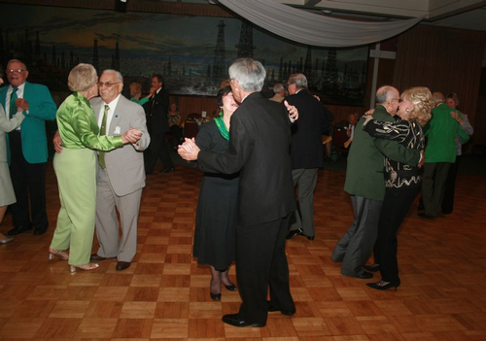

Green Was The Color For March!

# Your Board

President Jerry Ellis  
Vice President Ray Ashcroft  
Past President Earl Eakle  
Secretary Mary Ruth Ashcroft  
Treasurer Bill Morgan  
Hospitality Terey & Walter Kroy  
Membership Bob Potthast  
Roster Joyce Rothrock  
Historian Martha & Ace Yeam  
Newsletter Paul & Sue Liles

The Executive Board meets at 5:30 p.m. before each dance. Need a Toppers name badge? Call Earl Eakle at 310-375-8134.

# Prepare To Be Greeted

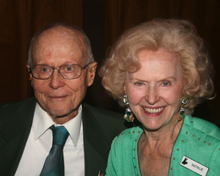

Ed Weyer and Natalie Emery

Be prepared to be welcomed with a big smile by Ed Weyer and Natalie Emey. Ed is from Anaheim and Natalie is a local of Long Beach.

**Did You Know?** The city of Anaheim was founded in 1857 by grape farmers and wine makers from Franconia in Bavaria. The first such settler was Daniel Kraemer. The colony was situated on 1,165 acres (4.71 km2).

Settlers voted to call the community Annaheim, meaning Annahome or more longly "Home in the valley" in German. The name later was changed slightly, to Anaheim. To the Spanish-speaking neighbors, the settlement was known as Campo Alemán (Spanish for German Camp).

# The Bosa Nova Began In The 1960’s

In Brazil, to do something with "bossa" is to do it with particular charm and natural flair, as in an innate ability. In 1932, Noel Rosa used the word in a samba, which went "O samba, a prontidão e outras bossas / São nossas coisas, são coisas nossas" ("The samba, the readiness and other bossas / Are our things, are things from us").

As yet, the exact origin of the term "bossa nova" remains uncertain. What is certain is that the term "bossa" was used to refer to any new "trend" or "fashionable wave" within the artistic beach-culture of late 1950’s Rio de Janeiro.

The term finally became known and widely used to refer to a new music style, a fusion of samba and jazz, when the now famous creators of "bossa nova", referred to their new style of work as "a bossa nova," as in "the new thing."

# Spring Cleaning And Men

Do men just play dumb when it comes to cleaning? Is this an obvious attempt to avoid any sort of housework? I used to think so, but now I think it may have something to do with a brain block or something.

Cheat sheet for men:

Dust pan (DUH) - Contrary to popular belief, this is where you sweep the dirt, not under the hallway area rug.

Mop - (mop) a bundle of coarse yarn, rags or cloth fastened at the end of a stick. You'll remember this as your dance partner at the New Year's Eve party last year.

Toilet Brush (toi' lit brush) - Used for scrubbing the inside of the toilet bowl. I don't care what this looks like, you may NOT use my shower luffa again!

Vacuum (vak' u em) - much like the leaf blower except it sucks in, instead of blowing out. Don't let this alarm you. It isn't broken and doesn't need more torque, speed, RAM or whatever it is you did to the dishwasher.

Broom (brum) - a long handled brush used for sweeping (also doubles as a mode of transportation for your mother)

# Spotlight On A Topper

# Miscellaneous

Our May greeters will be Bob and Edith Daley!

Summer arrives on June 21, 2011 at 01:16 A.M.

# Welcome Guests

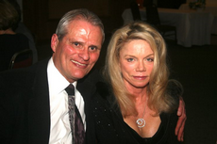

Craig Goll and Marianne Hanlon were second time guests of Paul & Sue Liles 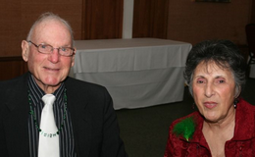

Herb Silverstein and Irene Kosmetatos. were guests of Paul & Sue Liles



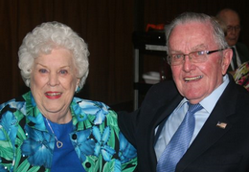

*Martha And Ace Yeam*  
 Submitted To Vicky Kuhn by the Yeam’s

Like so many others have done, Ace and Martha found one another after the death of their respective spouses. Ace and his first wife Janet were members of Toppers from 1985 to her passing away after 49 years of marriage. Martha’s first husband died shortly after celebrating their 50th wedding anniversary.

Some years later, friends invited Martha to the Petroleum Club for Monday Night Football. She had no idea that she would meet Ace that night and that they would have so much in common such as a love of music, singing and dancing to big band music. They dated for a year and married at the Petroleum Club in November 2000.

Ace has a son, daughter and three grand-daughters. Martha has a daughter, step-daughter, grand-daughter and two step-grandsons. All the children live fairly close except Martha’s daughter who lives in .

Ace was born in , and moved to when he was 15 years old. He graduated from . The day before he turned 18, he joined the Marine Corps in Jan. of 1945. Fresh out of 'boot camp' training, he was sent to where the last major battle in the Pacific theatre (WW2) was being fought and eventually won in June of 1945.  The island was eventually returned to in 1972.

Ace had enlisted for 4 years and though WW2 was over, he completed his service in for 15 months and returned to . When he completed his enlistment, Ace wanted to attend college but they were full of returning GIs.

So Ace decided to re-enlist and make the Marine Corps a military career. He then served in and , retiring at the rank of Major in 1967 after serving 22 years.

After retiring from the military, Ace joined Toyota Motor sales, as a National Parts Distribution Manager and retired again after 20 years.

Though retiring from full time work, he continued to work as a consultant for major car companies until he decided to stay home and care for his ill wife Janet.

Martha was born in ,

Martha married at 18 to an ex-Marine who had served in WW2 and he was recalled during the . They eventually settled in . Martha was employed in the accounting field and retired in 1990.

Ace and Martha love dancing, traveling, the Toppers and the Petroleum Club. They have made many dear and treasured friends over the years through these associations.



# Breaking News

Donnis Weygandt went into Long Beach Memorial Hospital Feb. 23rd. for a Lumbar Laminectomy. She is doing quite well and was seen at El Dorado Park recently. They will be joining for the next dance but no dancing yet. Good news!

**When Exactly Is Easter? Well, It’s Not Exact!**

Easter and the holidays that are related to it are *moveable feasts*, in that they do not fall on a fixed date in the Gregorian or Julian calendars (both of which follow the cycle of the sun and the seasons). Instead, the date for Easter is determined on a lunisolar calendar similar to the Hebrew calendar.

In Western Christianity, using the Gregorian calendar, Easter always falls on a **Sunday between March 22 and April 25**, inclusively



# Our St. Patrick’s Day Dance Was A Smash!



Texas tea anyone???

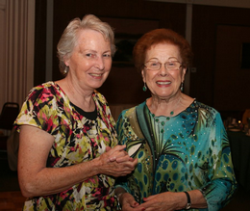

Let's get the party started

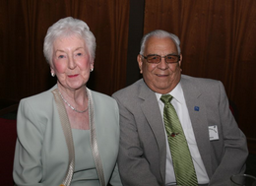

Ella Jolly & Joe Ramos

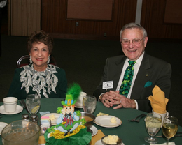

The Meiers are dressed for the occasion

# A Little Dance Humor

Q. What do you have when only one line dancer comes to your party?

A. A One Liner

Q How do they dance in Arabia?

A Sheik-to-sheik (cheek).

# A Call For Volunteers

The board will be changing again this year and we currently have openings for President (Jerry Ellis).

# Stepping Up

Our Vice-President (Ray Ashcroft) and Secretary (Mary Ruth Ashcroft) both have also decided to step down after almost eleven years of outstanding support to the club.

Ray’s melodic voice doing the announcements and Mary Ruth’s outstanding minutes kept the club on the right track! Thanks for a job magnificently done!

We are very lucky to have Lori & Dean Fronk volunteering to fill these vital positions!.

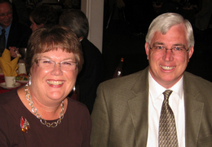

Lori & Dean Fronk

# On The Web From Anywhere

You are on the web! Try this URL:

[**http://tinyurl.com/4gxb5m2**](http://tinyurl.com/4gxb5m2)for pictures from the March 2011 dance!

# Mistletoe Ball 2011 (A Reminder)

Surprise! The Mistletoe Ball is planned for Friday, December 16th 2011. It is NOT on the usual Saturday evening this year! Please mark your calendar.



# The Rules of Chocolate

If you get melted chocolate all over your hands, you're eating it too slowly.

Chocolate covered raisins, cherries, orange slices and strawberries all count as fruit, so eat as many as you want.

The problem: How to get two pounds of chocolate home from the store in a hot car.

The solution: Eat it in the parking lot.

Diet tip: Eat a chocolate bar before each meal.

It'll take the edge off your appetite and you'll eat less.

A nice box of chocolates can provide your total daily intake of calories in one place. Isn't that handy?

If you can't eat all your chocolate, it will keep in the freezer. But if you can't eat all your chocolate, what's wrong with you?

# Remember

"Go out in the world and work like money doesn't matter, Sing as if no one is listening, Love as if you have never been hurt, and Dance as if no one is watching".