# From Our President…

I'm pleased to report that for several years Toppers attendance has well exceeded the minimum agreed upon with the Petroleum Club.  This has resulted in our being able to continue to hold our events at reasonable costs.  It simply is a fact that this couldn't happen without a supporting group of loyal members regularly attending our dinner-dances.

In addition to our sustaining membership, there are two other groups also important in contributing to our Club’s well-being.  Let’s not under estimate the benefits enjoyed through the fine services provided by (1) the Petroleum Club’s kitchen and front office staff, and (2) the ongoing work and dedication of Toppers’ Board of Directors who meet regularly to shape and administer the Club’s programs and policies.

With reference to the Board, if you’ve ever wondered about its purpose and work, and have not done so in the past, Board members would be happy to have you visit one of their monthly sessions.  You are invited to experience the “behind the scenes” planning of the group in action that has contributed to Toppers’ success over the years.  Meetings are efficient and brief (held to a limit of 30 minutes). If you would like to attend, simply mention it to any member of the Board, and a convenient time will be set for your visit.

Nancy and I will be hoping to see you when it’s time to again enjoy Phil Anthony’s band on the 18th.

Jerry Ellis

  
It's always time to dance!

# 2010-2011 Dance Season

Remember to keep these future dates on your calendar!

April 22nd (Tony Carinio)

May 20th (Howard Solomon)

# What You Need To Know

The March dance will be at the Petroleum Club on Friday the 18st of March.

The cost is $72/couple (includes tax/tip). No-host cocktail time is at 6 p.m.

Phil Anthony will be providing great dance music until 10 p.m. Dress code is semi-formal.   
  
Toppers Dinner Menu

Chicken Cordon Bleu or

Fish of the Day

Green Salad with Ranch &

Italian dressings on the table.

Scalloped Potatoes

Fresh Veggies of the day

Pasta by request

Mint Chip Ice Cream

Warm Bread and Butter

Coffee or Tea

There are short-cuts to happiness, and dancing is one of them.  ~Vicki Baum

*Red was everywhere during Valentines week!*

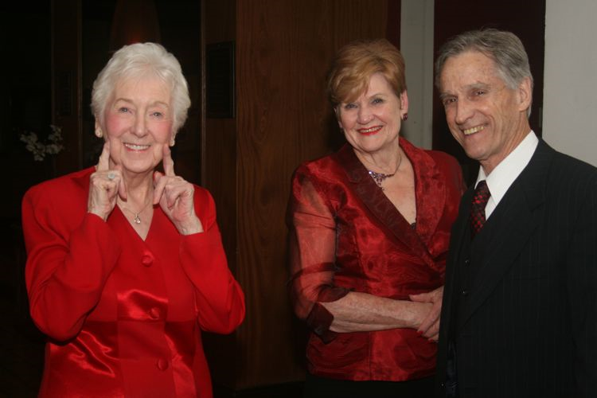

February Dance Was A Sea Of Red!

# Your Board

President Jerry Ellis  
Vice President Ray Ashcroft  
Past President Earl Eakle  
Secretary Mary Ruth Ashcroft  
Treasurer Bill Morgan  
Hospitality Terey & Walter Kroy  
Membership Bob Potthast  
Roster Joyce Rothrock  
Historian Martha & Ace Yeam  
Newsletter Paul & Sue Liles

The Executive Board meets at 5:30 p.m. before each dance. Need a Toppers name badge? Call Earl Eakle at 310-375-8134.

# Prepare To Be Greeted

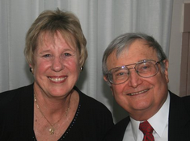

Terey & Walter Kroy

Be prepared to be welcomed with a big smile by Terry & Walter Kroy who are standing in for the Weygandts who are recovering from surgery (see page four). They come all the way from Santa Ana to join us this evening!

**Did You Know?** Members of the Tongva and Juaneño/Luiseño nations long inhabited the area. The Tongva Indians called the Santa Ana area "Hotuuk."

After the 1769 expedition of Gaspar de Portolá out of Mexico City, then capitol of New Spain, Friar Junípero Serra named the area Vallejo de Santa Ana (Valley of Saint Anne, or Santa Ana Valley).

# The Waltz Was Provocative

In the 1771 German novel Geshichte des Fräuleins von Sternheim by Sophie von La Roche, a high-minded character complains about the newly introduced waltz among aristocrats thus:

*"But when he put his arm around her, pressed her to his breast, cavorted with her in the shameless, indecent whirling-dance of the Germans and engaged in a familiarity that broke all the bounds of good breeding—then my silent misery turned into burning rage."*

# Future Greeters Identified

In April our greeters are Ed Weyer and Natalie Emory and in May Bob and Edith Daley!

# Wearing Of The Green

Originally, the color associated with Saint Patrick was blue. Over the years the color green and its association with Saint Patrick's Day grew.

Green ribbons and shamrocks were worn in celebration of St Patrick's Day as early as the 17th century. He is said to have used the shamrock, a three-leaved plant, to explain the Holy Trinity to the pagan Irish, and the wearing and display of shamrocks and shamrock-inspired designs have become a ubiquitous feature of the day.

In the 1798 rebellion, in hopes of making a political statement, Irish soldiers wore full green uniforms on 17 March in hopes of catching public attention. The phrase "the wearing of the green", meaning to wear a shamrock on one's clothing, derives from a song of the same name.



"We dance for laughter, we dance for tears, we dance for madness, we dance for fears, we dance for hopes, we dance for screams, we are the dancers, and we create the dreams."

# Spotlight On A Topper

# Welcome Guests

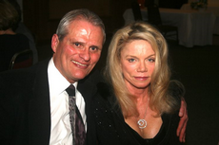

Craig Goll and Marianne Hanlon were guests of Paul & Sue Liles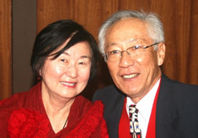

Joan & Frank Kawase were guests of Ray and Mary Ruth Ashcroft



# CORRECTION For Kuhns

Please note, in the latest Toppers directory the phone number for Vicky and Del Kuhn is incorrect. Change the last four digits from 1138 to 1128

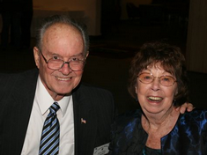

*Jerry & Nancy Ellis*  
 Submitted To Vicky Kuhn by the Ellises

Like so many others have done, Ace and Martha found one another after the death of their respective spouses. Ace and his first wife Janet were members of Toppers from 1985 to her passing away after 49 years of marriage. Martha’s first husband died shortly after celebrating their 50th wedding anniversary. Some years later, friends invited Martha to the Petroleum Club for Monday Night Football. She had no idea that she would meet Ace that night and that they would have so much in common such as a love of music, singing and dancing to big band music. They dated for a year and married at the Petroleum Club in November 2000.

Ace has a son, daughter and three grand-daughters. Martha has a daughter, step- daughter, grand-daughter and two step-grandsons. All the children live fairly close except Martha’s daughter who lives in .

Ace had enlisted for 4 years and though WW2 was over, he completed his service in for 15 months and returned to . When he completed his enlistment, Ace wanted to attend college but they were full of returning GIs. So Ace decided to re-enlist and make the Marine Corps a military career. He then served in and , retiring at the rank of Major in 1967 after serving 22 years.

After retiring from the military, Ace joined Toyota Motor sales, as a national parts distribution manager and retired again after 20 years. Though retiring from full time work, he continued to work as a consultant for major car companies until he decided to stay home and care for his ill wife.

Martha was born in , Kentucky.

Martha married at 18 to an ex-Marine who had served in WW2 and he was recalled during the . They eventually settled in . Martha was employed in the accounting field and retired in 1990.

Ace and Martha love dancing, traveling, the Toppers and the Petroleum Club. They have made many dear and treasured friends over the years through these associations.

# Breaking News

Donnis Weygandt went into Long Beach Memorial Hospital Feb. 23 rd. for a Lumbar Laminectomy. She expects to be home by Feb. 28th. for further recovery and therapy.  She and Clark will not be able to attend the March Topper's event, but hopes she and Clark be able to join Toppers in April.

Laminectomy is a spine operation to remove the portion of the vertebral bone called the lamina. There are many variations of laminectomy. In the most minimal form small skin incisions are made, back muscles are pushed aside rather than cut, and the parts of the vertebra adjacent to the lamina are left intact.

**Meet Joe Barile From The Phil Anthony Band**

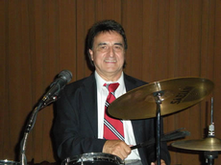

Joe at work behind the drums

Joe Barile...drummer, vocalist, guitarist and published songwriter, is a native of Ischia, an Island off the coast of Naples, Italy.  He has been performing since the age of fifteen.  His career has taken him to Japan and many Euorpean countries, and had a lengthy stint performing and recording with The Ventures and Shango.

He has written many songs for these groups that have been recorded and released worldwide. Joe has been collaborating with numerous songwriters over the past few decades including sax man Tony Giaimo and Phil Anthony and Nina Beck.

Joe's rich, thought-provoking melodies conjure up equally deep, meaningful lyrics by his co-writers, and Joe writes some fine lyrics of his own as well, in the "future standard" and Italian ethnic categories. When not performing, Joe enjoys cooking.



# Our Valentines Dance

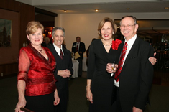

The Harringtons and Bergs

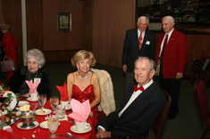

It was a sea of red this evening

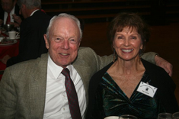

What? No red??

# A Little Irish Humor

Walking into the pub, Patrick said to the bartender, "Pour me a stiff one, Sean. I just had another tiff with the little woman."

"Oh yeah," said Sean. "And how did this one end?"

"Well I'll tell ya now when it was over," Patrick replied, "herself came to me on her hands and knees, she did."

"You don't say? Now that`s a switch! What did she say?"

She said, "Come out from under that bed, you gutless weasel!

# A Call For Volunteers

The board will be changing again this year and we currently have openings for President (Jerry Ellis), Vice-President (Ray Ashcroft) and Secretary (Mary Ruth Ashcroft).

These hard working members who make the club a success need some time off to refresh! If you are interested, please call Jerry Ellis!

It’s easier than you might think and you will have the current board to assist you in the new job!

# Stepping Up

Our Hospitality board member (Terey & Walter Kroy) has also decided to step down after years of performing so well. We are very lucky to have Neal & Nita Woolston volunteering.

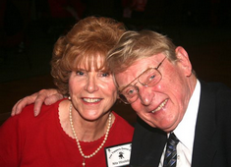

Neal & Nita Woolston

# On The Web

You are on the web! Try this URL:

[**http://tinyurl.com/4khvwm6**](http://tinyurl.com/4khvwm6)for pictures from the February 2011 dance!

# Mistletoe Ball 2011

Surprise! The Mistletoe Ball is planned for Friday, December 16th 2011. It is NOT on the usual Saturday evening this year! Please mark your calendar.