*Pre-dinner visiting is well underway at Toppers*

# From Our President…

Happy New Year to all! I trust it has been a great Christmas and Holiday season for everyone, complete with memories to treasure of good   
times spent with family and friends.

As we begin the New Year, let’s try to remember to mark our new calendars with the Toppers dinner dances that are set for the months ahead. The events for the coming year will continue to be held at the Petroleum Club, with the same excellent facilities and services we’ve enjoyed in the past. The first dance for 2011 will be on January 21 with the music of Howard Solomon’s “Dreamstreet” Band.

Please keep in mind that we must continue to inform our friends and interested couples of the satisfaction we experience as members of Toppers. And inviting friends and acquaintances as guests to our events is an excellent way of introducing them to the enjoyment of being a member.

We are looking forward to seeing everyone on the 21st.

Jerry Ellis



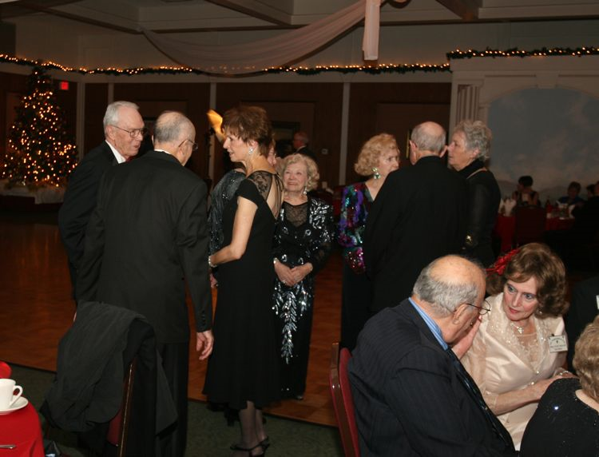

Be always at war with your vices, at peace with your neighbors, and let each New Year find you a better man.  ~Benjamin Franklin

Happy New Year 2011! Let’s Dance!



# 2010-2011 Dance Season

Remember to keep these future dates on your calendar!

February 18th (Sam Conti)

March 18th (Phil Anthony)

April 22nd (Tony Carinio)

May 20th (Howard Solomon)

# What You Need To Know

The January dance will be at the Petroleum Club on Friday the 21st of January.

The cost is $76/couple (includes tax/tip). No-host cocktail time is at 6 p.m.

Howard Solomon will be providing great dance music until 10 p.m. Dress code is semi-formal.   
  
Toppers Dinner Menu

Roast Pork Loin, Fish of the Day or Veggie Pasta

Green Salad w/ Ranch and Italian Dressing on the Table

Mashed Potatoes

Fresh Veggies of the Day

Warm Bread & Butter

Mint Chocolate Ice Cream

Coffee or Tea

May all your troubles last as long as your New Year's resolutions.  ~Joey Adams

# Your Board

President Jerry Ellis  
Vice President Ray Ashcroft  
Past President Earl Eakle  
Secretary Mary Ruth Ashcroft  
Treasurer Bill Morgan  
Hospitality Terey & Walter Kroy  
Membership Bob Potthast  
Roster Joyce Rothrock  
Historian Martha & Ace Yeam  
Newsletter Paul & Sue Liles

The Executive Board meets at 5:30 p.m. before each dance. Need a Toppers name badge? Call Earl Eakle at 310-375-8134.

# The First Greeters Of 2011

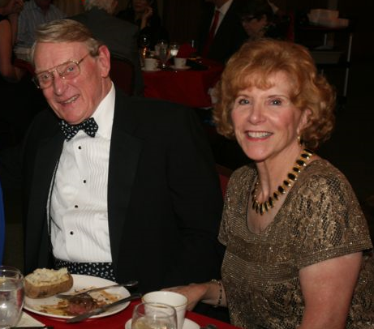

Neal and Nita Woolston

Be prepared to be welcomed with a big smile by Neal and Nita Woolston of Rossmoor. Members since 2003, they will enjoy meeting you, pointing you in the right direction and sharing their infectious smiles!

# New Year’s Resolutions To Assist You!

A New Year's resolution is something that goes in one year and out the other.

* I will no longer waste my time relieving the past, instead I will spend it worrying about the future
* I resolve to work with neglected children -- my own.
* I will not bore my boss with the same excuse for taking leaves. I will think of some new excuses.

Did You Know?  
  
Flamenco dancer José Greco took out an insurance policy through Lloyd's of London against his trousers splitting during a performance.

Ballroom dancing at Oxford University has been upgraded to stand alongside canoeing, cycling, rugby league, judo, karate and lacrosse, considered equal in terms of athleticism and competitive excellence.

# Bill Powell Passes At 98

Long time Toppers member, Bill Powell, passed away this December, at the age of 98. Bill was very active in many civic and social organizations since moving to Southern California in 1970. He was a member of the Virginia Country Club, the Petroleum Club, and during his years with Toppers was President for three terms in the ‘80s and ‘90s. Many will remember his popular dancing partner, Mary Leach, who passed away in August, 2009. Funeral services were held for Bill at Forest Lawn, Cypress, on December 11.

# Did You Know

A top hat, silk hat, cylinder hat, chimney pot hat or stove pipe hat (sometimes also known by the nickname "topper") is a tall, flat-crowned, broad-brimmed hat worn prior to and including the 19th and early 20th centuries.

Now, it is usually worn only with morning dress or white tie, in dressage, as servants' or doormen's livery, or as a fashion statement.

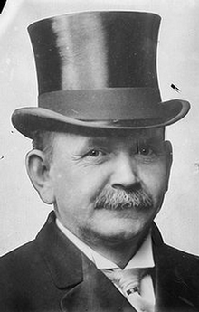

# Spotlight On A Topper

# It’s Now 2011 So We Have Six Dances Remaining This Season

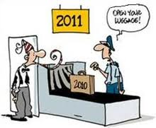

Reality sets in after midnight

# Welcome New Members

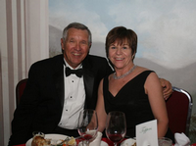

Ed and Kathy Roberts  
La Mirada, California

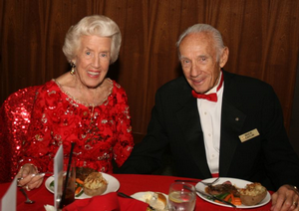

Bobbie and Buck Catlin  
 by Vicky Kuhn Ace Topper Reporter

*Early Years*: Buck was born in Connecticut in 1918 and later moved to Florida where he developed a love of the sea. He became an Eagle Scout and his troop won State-wide honors. Buck graduated with honors from high school in Miami. The Boy Scouts must have touched his heart as decades later Buck served on the Orange County Boy Scouts Council from 1963-1996.

*Buck Joins the Navy***:** He joined the Navy as a sailor but he really wanted to go to Annapolis and become an officer. He didn’t have any ‘connections’ to get an appointment to the academy so he submitted his application to a program that arranged entrances for sailors like him who ‘just might’ be accepted as officer candidates.

*Naval Officer ‘Buck’ Catlin:* Buck won one of the 100 Fleet appointments to the U.S. Naval Academy in 1938. He was recommended by then Captain Chester Nimitz, (Yes, THAT Nimitz) who went on the command the Pacific Fleet in WW2. (Let Buck tell you that story)

*It’s War:*  Following the attack on Pearl Harbor in 1941, Buck’s class graduated early from Annapolis in the Class of 1942. This Class of 1942 still has reunions twice a year. If Buck had not been appointed to the Naval Academy; he would have been on the USS Nevada, which was sunk in Pearl Harbor Dec. 7, 1941.

Buck applied for Submarine Service, where he would serve all his military years in various capacities. It is worth noting that the Submarine Service had the highest percentage of casualties of all of the U.S. forces in WWII.

*After The War:* Buck reported to Pearl Harbor after serving 6 months in occupied Japan where he was gathering members of the Imperial Japanese Submarine Force and was assigned duty as the Flag Lieutenant for Rear Admiral Allan McCann.

*Buck Meets Bobbie*: In 1946 Buck was invited to a school faculty dance in Honolulu. There were many young single female teachers attending. Buck brought 12 of his Navy classmates. There he met Bobbie Jerome and they ‘hit it off’ immediately. Many of the officers, including Buck met their brides-to-be at this dance. Buck and Bobbie still keep in touch with four of those original couples. Congrats to Buck and Bobbie who will be celebrating their 64th anniversary next June.

*Buck’s illustrious military career*:

Buck served in various capacities as a naval officer including being a submarine commander. He graduated from the U.S. Naval Postgraduate School with a degree in Engineering Electronics. He served at the Pentagon and retired in 1961 as Assistant Chief of Staff/Commander Submarine Forces, Atlantic Fleet.

*National Geographic TV Special with Buck***:** For those readers who saw the National Geographic 2009 WW2 television special, Japanese Super Subs, (episode: The Hunt for the Samurai Subs), Buck was interviewed and portrayed in the film for his involvement in escorting the prisoner, Japanese Submarine Commander Mochitsura Hashimoto, to the U.S. to testify on behalf of the commander of the ship he sunk, Captain Charles McVay who was being court-martialed. Hashimoto’s submarine had sunk the USS Indianapolis in July 1945, just weeks before the war ended. That’s another interesting story Buck will have to share. Many books have been written about this tragedy and the survivors still have reunions, remembering those who lost their lives.

It was just after the war that Buck was in command of destroying five Japanese submarines that were now in the hands of the US Navy. There were tensions between Russia and the U.S. especially in technology.  Buck said we didn't want the Russians to know we not only had these hi-tech Japanese submarines but also had three enemy aircraft carriers. Buck laughs and said that he had each submarine taken out to sea, south of Pearl Harbor where he boarded each one, removed the name plate from the periscope, was the last man off and then ordered the Japanese submarine blown up, one by one. He jokingly laughs and says that he has the distinction of being the commander who has the "most enemy submarines destroyed" to date. All five of the name plates were mounted and are now at the Naval Submarine Base School in Connecticut.

For more detailed information see...

[**http://tinyurl.com/25sxar7**](http://tinyurl.com/25sxar7)

[**http://tinyurl.com/yhf376r**](http://tinyurl.com/yhf376r)[**http://tinyurl.com/22wo6pk**](http://tinyurl.com/22wo6pk)

*Into Private Industry*: Buck retired from the military with an impressive and well earned resume. Hughes Aircraft hired him to manage its new operation sea test sonar program. This was a new hi-tech concept back in the day. While at Hughes Aircraft, Buck worked indirectly with Howard Hughes. Buck described Mr. Hughes as 'brilliant.'

*In The Commercial World:* A long time friend contacted Buck and together, they built a construction plant to meet the demands of a growing residential home building industry in L.A. and OC. For the next two years, they built and managed the largest roof truss plant in Southern California. This experience was later to be invaluable. He was appointed the municipal planning commissioner and then elected city councilman, finishing as a three term mayor, serving for 13 years in the City of Fullerton.

*Buck, Now An Educator***:** Buck says that having had a positive experience teaching while in the Navy, he decided to follow Bobbie’s role as a career teacher. In 1964, he started teaching Technical Electronics at Fullerton Junior College. He taught electronics, computer technology, television repair and electrical circuitry for the next 21 years.

*Memberships and Associations***:**

A few of many honors that have been bestowed upon Buck over the years include:

1997 Man of the Year, Fullerton Chamber of Commerce

1996 Who’s Who in America, Fullerton Elks Lodge

1996 Distinguished Citizen of the Year, Fullerton

1994 Humanitarian of the Year, YMCA,

*Their Personal Life***:** Buck and Bobbie will be celebrating their 64th wedding anniversary next June. They make the City of Fullerton their home. Buck, with Bobbie at his side, has accomplished much in his professional, military and public service life, His legacy and pride come from his personal life. He married the girl of his dreams and they went on to have three children, many grandchildren and great grandchildren of whom they are very proud.

Their children are as follows: son James, a project manager in National Security Technologies; daughter, Capt. Jo Dee Catlin USN (Ret), CEO of Girl Scouts of America-San Diego/Imperial Councils; daughter, Janny C. Meyer, teacher of GATE classes and a member of the Board of Trustees with Fullerton School District

Lastly, Buck stated that he tried to live his life in the following way...

"Don't take myself too seriously...Don't associate with skunks, they smell...Be honest, take chances, say what you mean and for goodness sake, take the initiative!"

He added that though he has accomplished much in his life, he gives credit to Bobbie since everything he is and has done is because of her. Though she is a woman of few words, she has been honest and candid with him, giving him her best advice all these years. Buck says he was smart enough to listen to her, unlike some men he's met and that's why their relationship has endured lovingly all these years.

As long time members of the Toppers Dance Club (1960), Buck and Bobbie are grateful for the friendships they’ve had with many of the members and look forward to making new friends.

**Our Last Dance**

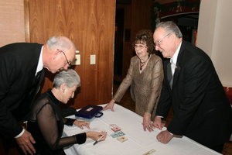

Checking in with a smile

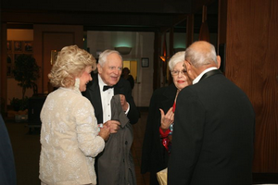

Tracy Wells joins the party tonight

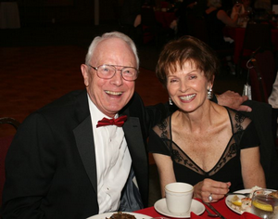

Miles of smiles

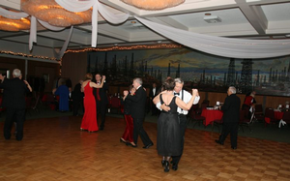

Please E-Mail your photos to Paul & Sue Liles

*Jan Mongell* also likes to greet our members.

Guests *Cathy and Ed Roberts* join right in to the festivities and we hope they come back soon!

Recent members *George and Edith Meier* are welcomed by the Toppers members!

Visiting continues until the end. The *Harringtons, Bergs, Fronks* sharing moments

*Ace and Martha Yeam* celebrating their tenth anniversary. Martha makes the announcement while Ace blushes,

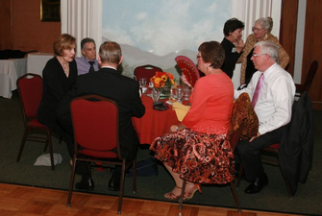

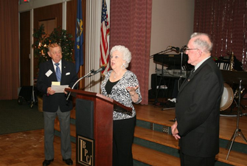

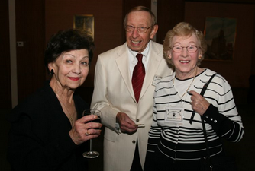

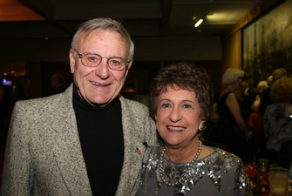

Oh, we also dance!