

# From Our President…

Welcome back to another season with Toppers! This is the 64th year for our dance club since its beginning in 1946. There is every reason to anticipate another fun-filled successful year ahead. We’ll be starting off on September 24th with the music of one of our favorites, Sam Conte, followed by Jim Gilman’s band on October 22. The schedule for the entire 2010-2011 season will be sent to everyone by the time of October’s issue of Toppers Topics.

I think it’s a good time to remind ourselves that it is always satisfying to welcome new members into the club. Not only is it a pleasure to see new faces among our group, but the success of our organization greatly depends on our maintaining membership numbers able to support the high quality of our bands and fine services of the Petroleum Club. Do you know of a couple who shares an interest in what Toppers has to offer? If so, consider obtaining their names and address to forward to our Membership Chairman, Bob Potthast. He will be happy to send them information about the club.

I hope you will be able to help Toppers off to another good year by sharing with your friends another evening of fine dining and great music on the 24th!

Jerry Ellis

**2010-2011 Dance Season Key Dates**

Remember to keep these dates on your calendar!

September 24th

October 22nd

November 19th

December 18th

January 21st

February 18th

March 18th

April 22nd

May 20th

**What You Need To Know**

September dance will be at the Petroleum Club on September 24th. The cost is $80/couple (includes tax/tip) No-host cocktail time at 6 p.m. Sam Conte will be providing great dance music until 10:p.m. Dress-code is semi-formal.   
Your choice of entrees:

**New York Cut Steak au jus**   
or   
**Fish of the day**

Green Salad with Ranch & Italian dressings on the table,

Baked Potato

Fresh Veggies of the day

Hot Apple Cobbler  a la mode Warm Bread and Butter.  Coffee or Tea

Please select your entrée on the last page and send it with a check to “Toppers Dance Club”, Bill Morgan, 840 West 10th Street, San Pedro, 90731 for receipt by Monday September 20th.   
You may call Bill at 310-548-7025. Please leave your name and message if you get the answering machine!

Welcome back to a new season of Dancing With The Toppers!

It’s Time To Dance Again!

# Who Said That???

'I see America dancing, standing with one foot poised on the highest point of the Rockies, her two hands stretched from the Atlantic to the Pacific, her fine head tossed to the sky, her forehead shining with a Crown of a million stars.' - Isadora Duncan

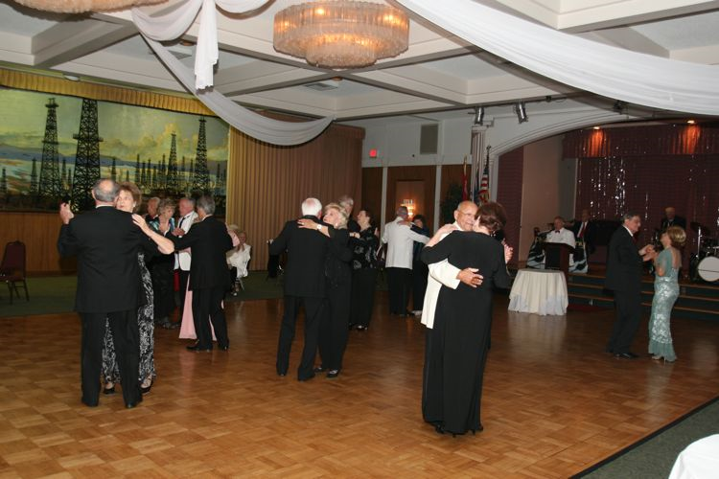May 2010 Memorial Day Dance



**Your Board**

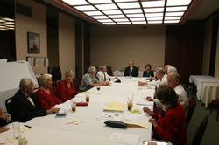

The Board Hard At Work

President Jerry Ellis  
Vice President Ray Ashcroft  
Past President Earl Eakle  
Secretary Mary Ruth Ashcroft  
Treasurer Bill Morgan  
Hospitality Terey & Walker Kroy  
Membership Bob Potthast  
Roster Joyce Rothrock  
Historian Martha & Ace Yeam  
Newsletter Paul & Sue Liles

The Executive Board meets at 5:30 p.m. before each dance

Need a Toppers name badge? Call Earl Eakle at 310-375-8134.

# Spotlight On Toppers

Tom and I are pleased

to be the first couple to be featured in the new “Spotlight on Toppers” column in TOPPERS TOPICS.

We are blessed! That is the first thought that comes to my mind when I think about Tom and me and our life together.

In June, we spent three fabulous weeks in Europe, which included a 15-day cruise from Rome to Southampton with 10 ports of call in seven countries. Cinque Terre on Italy’s northern coast truly exceeded our expectations!! And, seeing the Barbary apes and going inside the Rock of Gibraltar was an awesome and unforgettable experience, too.

On August 7, we will celebrate our 39th Wedding Anniversary! On August 30, or before, we will welcome our third grandchild. Grand parenting truly is everything we hoped for and more.

For those of you who may not already know, Tom has been retired for 11 years (he took early retirement) and Kathy continues to enjoy her PR business, now in its 27th year.

Finally, dancing is our passion. We enjoy dancing with the Toppers each month and cherish the many wonderful new friends we’ve made!



# Dancing Quotes

“Dancing is poetry of the foot. ~ John Dryden

Dancing is wonderful training for girls, it's the first way you learn to guess what a man is going to do before he does it.  ~Christopher Morley, *Kitty Foyle*

Dancing is moving to the music without stepping on anyone's toes, pretty much the same as life.  ~Robert James



About Swing Dancing  
  
"Swing dance" is a group of dances that developed concurrently with the swing style of jazz music in the 1920s, '30s and '40s, although the earliest of these dance forms predate swing jazz music. The best known of these dances is the Lindy Hop, a popular partner dance that originated in Harlem and is still danced today.



# Assistance Needed

As your new Newsletter Editors, Sue and Paul may be asking you for some “input” for the publication! We instigated the “Spotlight On Topper’s” with this edition and the Berg’s were so nice to be first!

Tom & Kathy Berg

**Our Website**

Have you visited our website? Try it at the following address: http://www.lilesnet.com/toppers/.

We have pictures from dances beginning December 2007. Send the link to friends and potential new members so they can see how much fun we have! 

# Our Last Dance

Our last dance was in May and we paid tribute to soldiers by remembering Armed Forces and Memorial Day.

______New Your Steak _______ Fish Of The Day ________Pasta (special Request)

